July 2014 Newsletter
To support the continued operation of the web-site I am soliciting advertising. A space is reserved at the top and bottom of every page for advertising. The bottom space currently displays the Facebook Like button, but since Facebook is not paying for that advertisement they will take a back seat to anyone who is willing to pony up some cash. The top currently displays an invitation to advertise.
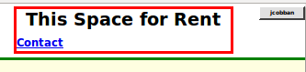Illustration 1: This Space for Rent
One of the changes to the site this month is encouraging more people to become contributors by displaying the option to post a blog entry for any individual in the family tree even if the user is not already signed on. If a user tries to post a blog and is not signed on the signon dialog is presented. A further simplification is permitting the use of an e-mail address as a user id. If the value entered for user-id has the syntax of an e-mail address (that is it contains an '@' sign), then the registration is set up with the same value for both userid and e-mail address.
When you sign on you are presented with a user information page:
This page displays key information including:
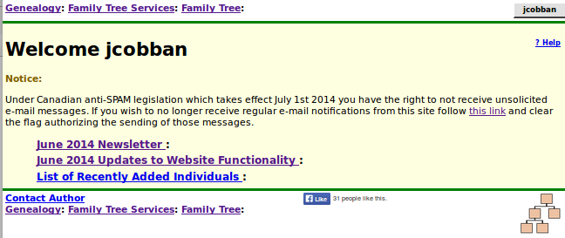Illustration 2: User Information Page
- A link to a copy of the latest monthly newsletter, as was sent to all contributors who accept e-mail messages at the beginning of the month.
- A link to a report on details of the changes to the web-site implementation or database structure.
- A link to a list of individuals added in the past week.
- Any messages that have been sent to you from other contributors.
Observe that the site does not use e-mail to send messages between users, primarily to avoid revealing e-mail addresses to casual visitors to the site. The “Contact Author” link in the page bottom queues a message to the “owners” of the page as discussed in more detail lower down in this newsletter. The “owners” of a page are the site administrators plus those other participants who have explicitly registered as owners of the page. Any message sent to a user in this way appears on this welcome page.
Also note the standard information in the page top, in this case a list of links to key services, and a button, identified with your userid, which provides access to the management page for your account.
Also observe that the page on which you clicked the “contribute” button is refreshed so that any additional capabilities granted by being a signed on contributor are displayed.
Popup dialogs, including Help panels, are now scrolled completely into view as required.
The account administration panel, accessed by clicking on the button displaying your user name at the top right of every page, now also provides the option to turn off or on the display of help information when you hold the mouse over a field. This is because the action of scrolling the possibly extensive help for a field into view is more visually disruptive than when it was permitted to extend off the screen.
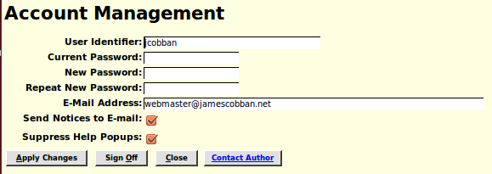Illustration 3: Account Management Dialog with Help Popup Suppression

User Guide: Getting Started with Updating the Family Tree
Users occasionally approach me concerned that they are unfamiliar with using a web-site to update information on the Inernet. Do not think of this site as being some special unfamiliar entity. It is simply an application, like a word processor, that runs on your computer or smart phone, and accesses and manipulates information held on a server, rather than on the disk of your computer. It is no different from accessing your e-mail or using Google Docs to edit office documents. This is simply a new metaphor for providing application services called “cloud computing” which simplifies your life by eliminating the need for you to purchase, install, and maintain software, like Microsoft® Office or Family Tree Maker©, on your computer.
The first step after you sign on before you can see the private details on your family or update the family tree is to identify a common ancestor of the family you wish to contribute to. On that page go to the bottom and click on the “contact author” link at the bottom of the page.
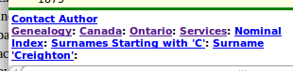Illustration 4: Contact Author Link at Bottom of Any Page
Clicking on this link opens a dialog that permits you to send a message to the site administrators and to each current owner of the individual. This implementation avoids revealing the e-mail addresses of contributors to casual visitors to the site.
The prompt for 'Your E-Mail Address:' does not appear if you are already a signed on contributor, and have therefore registered your e-mail address.
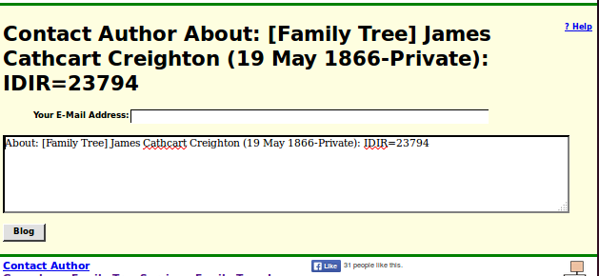Illustration 5: Send a Message to the Page Author
Explain in this note that you wish to be granted shared ownership of the individual on the page, that individual's ancestors, and that individual's descendants, and your reasons for requesting access, in particular your degree of relationship to the individual. Once you are granted shared ownership of the individual and the individual's family, you will receive an e-mail listing all of the individuals in the family tree that you now share ownership of, and can therefore update and see the private information for.
Now when you go to any of the identified individuals you will see a new button on the main page for the individual:
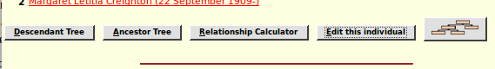Illustration 6: Edit this Individual Button
When you click this button, or use the keyboard short-cut Alt-E, you are presented with the information recorded about the individual presented as an input form.
You can change the contents of any of the input fields and then click on the “Update Individual” button, or use the keyboard short-cut Alt-U, to apply the changes.
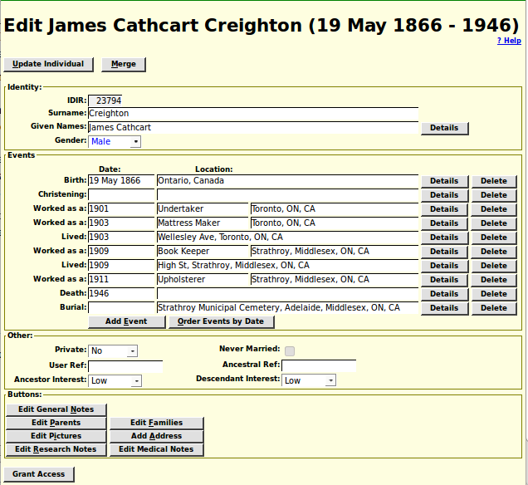Illustration 7: Edit Individual Dialog
At the top right of the form there is a link “? Help” which opens a page of documentation explaining in overall terms the use of this page. More usefully holding the mouse over any input field or button pops up a detailed description of the exact meaning and use of that field or button. Don't worry about entering bad values, since you can always just return to this page and correct the value. If you enter a value in a field that is inconsistent with the expectations, for example if you misspell the name of a month in a date field or enter an unusual character in an address, the color of the text changes to red as a reminder to you to reconsider the value.
Location input fields on the form, as elsewhere on the site, try to guide you in entering values that are as consistent with the standards of the site as possible. It is desirable that each actual location be identified as much as possible in the same way. For example a village name in Canada or the USA is normally entered in explicit form with the township, county name, postal abbreviation for the state or province, and the two-character international country code (as used in Internet domain names). So when you enter a location name that has never been used before anywhere on the site there is a popup dialog to warn you that you have entered a completely new place name. You can then reconsider and change what you entered. Another feature is that you can just enter the beginning of a place name. If only one existing place name starts with that value, or if that value has been explicitly defined as a short-cut, then that one existing place name will replace what you have typed. If there are multiple existing place names starting with the same text then you are presented with a selection list from which you can choose. In addition your web-browser may suggest values that you have previously entered that partially match your text.
I have tried to make this panel as intuitive as possible, but if you have any concerns even after viewing the popup help for a field do not be afraid to click on the “Contact Author” button in the bottom of the page. This queues a message to all of the administrators and all of the current owners of the individual as discussed above.

