August 2014 Newsletter
I hope you have had a good summer.
In order to make my site more convenient for my returning customers you are now permitted to specify when logging on that you wish to subsequently be automatically logged on whenever you visit the site. You are probably already using a similar feature on sites such as Ancestry. When signing on there is a new checkbox:
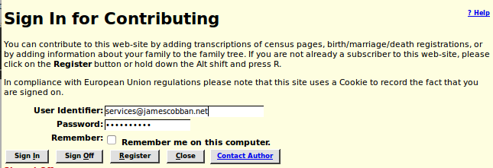Illustration 1: Signon with Remember Me
Bypassing the signon means that you will not be presented with any messages that have been sent to you when you first enter the site, which was part of the user information page presented after signon. The account administration panel, accessed by clicking on the button displaying your user name at the top right of every page, now also displays any messages sent to you:
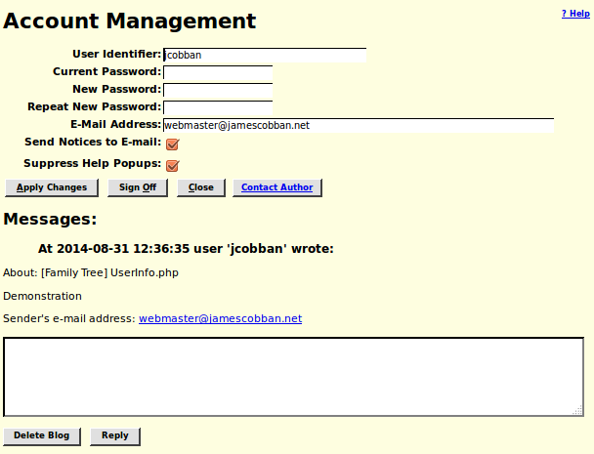Illustration 2: Account Dialog with Messages

User Guide: Source Citations
One of the aspects that distinguishes professional genealogists from amateurs is an obsession with source citations. It is not sufficient to know something about an individual, but you must demonstrate how you come to know that fact, and present that information in a way that someone coming at the site at a later date can verify the information.
At the bottom of each page describing an individual in the family tree there is a section of footnotes:
Each footnote contains four parts:
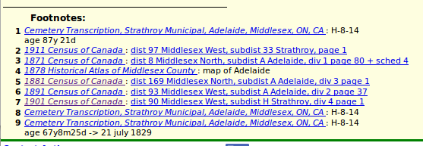Illustration 3: Footnotes
- An index number. This index number appears as a hyper-linked superscript number in the body of the page to identify those footnotes that document the specific fact. Being hyper-linked, although admittedly quite small, means that you can click with your mouse on the superscript number and the footnote is displayed.
- The name of the source. The name is itself a hyper-link to a full description of the source including where a copy of the source is located and the catalogue number within that respository used to locate the source. For electronic sources this full description includes a hyper-link to the electronic source itself. Note that if you just hover the cursor over this hyper-link a “yellow sticky” pops up with a brief description of the source.
- The page identification within the source. In some cases, for example Censuses of Canada and Ontario vital statistics, the page identification is itself a hyper-link to a transcription of the original document, which in turn frequently includes a hyper-link to the original image of the page.
- Notes about or quotations from the source citation.
So far this is not much different from what you will get with most family tree software. It is just moved out into the cloud where it can be more easily shared with other members of your family.

Bi-Directional Citation References
When doing genealogical research it is important to keep track of gaps in your knowledge and try to fill them in. For me, personally, one important objective of the site is to provide a complete inventory of everyone who left a trace in the documentary record of Middlesex County. This means that not only do I wish to identify every piece of documentation for each such individual, but I want to ensure that every individual who appears in a document, whether it is a census enumeration, a vital statistic registration, a cemetery monument, or whatever, is in the tree.
For example if I request a list of death registrations for the township of Adelaide for 1897 I see, among others the following:
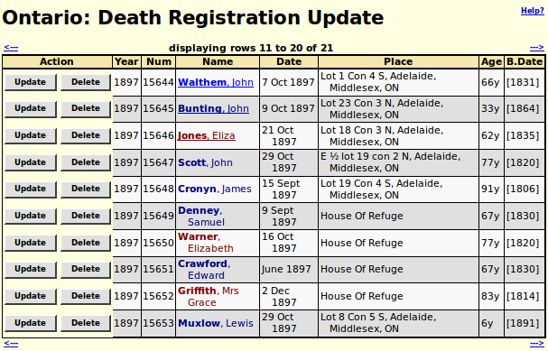Illustration 4: Adelaide Death Registrations 1897
Observe that some of the names are underlined, identifying them as hyper-links to the descriptive page for each individual. But others are not. It is perhaps understandable that the residents of the Middlesex House of Refuge near Strathroy are unaccounted for. If they had children or siblings undoubtedly they would not have been depending upon municipal charity. But the last entry on this page is a member of a common family in the tree. Clicking on the “Update” button displays the details of this particular death registration:
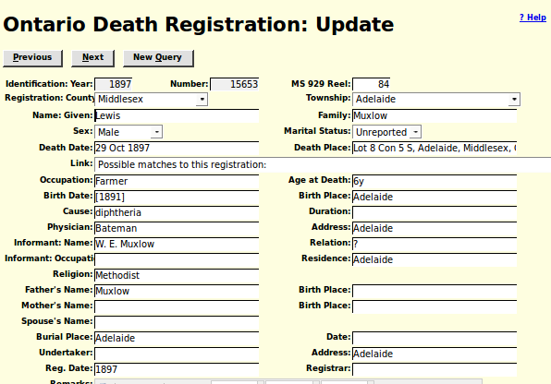Illustration 5: Death Registration with Possible Matches
If you click on the selection list identified as “Link:” you are presented with a list of potential matches to select from. Chooseing the obvious match the dialog now looks like:
Illustration 6: Selected Match for Death Registration
If you now update the death registration, and back up to view it again, you now see:
Illustration 7: Death Registration with Link to Individual in Tree
It is now recorded in the database record for this death registration that it is associated with the specific individual in the Family Tree. Also if you follow the link you will see that there is now a citation in the footnotes for the individual back to the death registration. You do have to manually update the date and place of death because the application does not know whether the existing or the new information is more authoritative. Both directions of the citation link are established with a single operation. The same bi-directionality would have arisen if instead you had gone to the individual and added the citation to the death registration onto the death event.
A couple of little features added to this support this month appeared in the above images but I did not interrupt the flow to point them out.
In Illustration 4: Adelaide Death Registrations 1897 note that on each line there is an “Update” button and a “Delete” button. The “Delete” button is new. It permits you to manually delete the transcription of a birth or death registration. The main reason to do this is if the registration is recorded against the wrong year or registration number, as there is no support for regular users to chang the year or registration number for a vital statistics registration. The “Delete” button only appears where there is an existing record in the database. If you click on the “Delete” button the displayed fields are blanked out and the “Delete” button disappears.
In Illustration 7: Death Registration with Link to Individual in Tree note that there is a “Clear” button after the link to the individual. This is to permit you to remove an incorrect association. This is new this month. After clicking on “Clear” update the record to apply the change.

