October 2014 Newsletter
When I started building this web-site my long term objective was to construct a family tree of everyone who lived, even if just for a short while, in Caradoc township. There are lots of web-sites that facilitate building family trees, for example Geni, but although they accumulate millions of records, there is no way to determine how complete the set of individuals is. On the other hand there are millions of duplications within these family trees. Also a a trained scientist I was not happy with the support for citing sources in any of the sites.
I built my original database from the records my father and two of his cousins had accumulated of the Cobban family from Duffus parish, Morayshire, Scotland. To this I added information about families we had intermarried with, mostly from Caradoc township. Along the way I learned that my family had settled there, along with several other families from the same parish in Scotland, because a related family, the Sutherlands, had obtained a military land grant in the newly surveyed township.
One of the first extensive documents I transcribed to further this research was the 1881 census of Caradoc. This was when I first came up with my objective to build a tree of everyone in Caradoc. But I needed a technique to determine how much progress I had made on this project, and to identify the gaps in the family tree. This led to the unique features of this web-site.
For example start at the 1881 Census of Canada Ontario Transcription Status page. This displays, with color coding to highlight it, the progress of transcribing the 1881 census of Ontario.
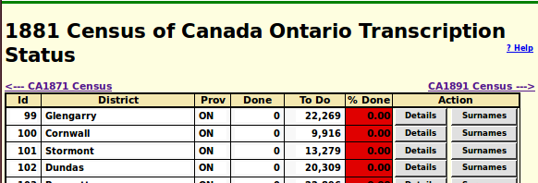Illustration 1: 1881 Census of Canada Ontario Transcription Status
Outside the core area of research I only transcribe individual pages as they are required to support citations. Any subscriber to the site can add to the transcriptions. When you click on the “Details” button for a census district you get a subdistrict by subdistrict summar of the transcription progress and its relationship to the family tree. For example the page CA1881 District 168 Middlesex West Status shows:
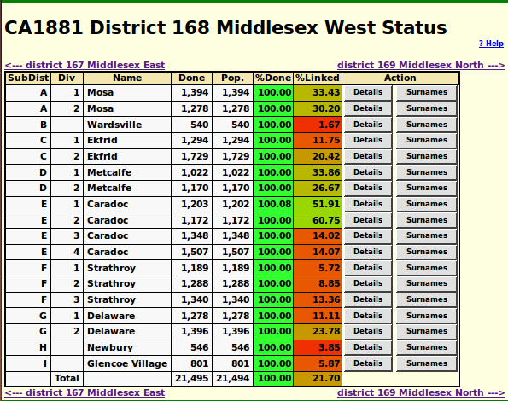Illustration 2: Census District Status
This page has two color coded columns, one for the raw transcription progress, and one for the progress of linking individual lines of the transcription to individuals in the family tree. Lines in the census can be associated with individuals in the family tree in two different ways. Every time you add a citation for date of birth of an individual to a census page, then the site attempts to find an individual in the page who matches the birth year and name of the individual in the family tree. This match has to be approximate since it is unlikely that the given name and surname of the individual are spelled identically in the census and the family tree, and the exact ages were not always reported. For example one unusually vain woman systematically reported her age in census after census so that she only aged 7 years in each decade!
The other way is to explicitly link a line of the transcription back to the family tree. For example lets look at one page of the census transcription:
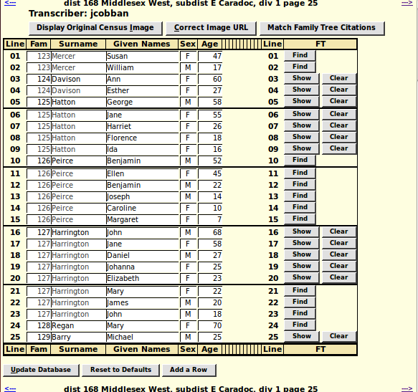Illustration 3: Edit One Page of the 1881 Census Transcription
Note how many of the columns have been hidden. This is done on any of the tabular displays in the site by clicking on the column header. Note the button “Match Family Tree Citations”. This searches all of the existing citations to this specific page from the family tree. This process has to be fairly finicky or else it will match the wrong line on the page. As an example as a result it would not match line 16 of this page to John Harrington in the family tree, even though there is a citation to this page for John Harrington's occupation in 1881, because there is an 8 year age mismatch. It does not match any of the other members of the Harrington family, because they have no citations to the page. Generally children, since they do not have an occupation, have census citations only for birth date derived from the age in the census. That is what the “Find” button is designed to resolve. It uses the name and age of the individual to search the family tree for matches. For example:
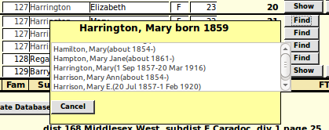Illustration 4: Find Family Tree Matches
Clicking on the Find button displays a pop-up dialog with a list of individuals whose name, gender, and birth date approximately match the name, gender, and age in the census. This is a very loose match because it leaves the choice up to human knowledge to resolve. When you click on the match which is obvious to human intelligence the text in the button changes from “Cancel” to “Select”. When you click on the “Select” button the dialog disappears and the “Find” button changes to display “Show” and a “Clear” button is added. The “Clear” button is used to remove an erroneous link to the family tree.
As you do this process you may find missing facts about an individual. For example clicking on the “Find” button may find a match in the family tree for an individual where there is no existing fact referencing the page in the census. So the process of going over the censuses and performing finds not only only adds additional information to the census, it can also add new information to the family tree.
There are a couple of global changes to the functionality of the site this month. One is the addition of a confirmation popup dialog wherever there is a button to delete information from the database.
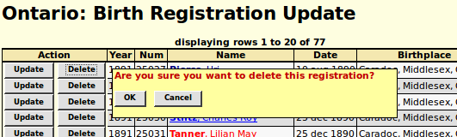Illustration 5: Confirm Deletion of a Birth Registration Transcription
As usual check out the detailed report of changes to the functionality of the web-site, and the list of recent individuals added to the family tree.

