November 2014 Newsletter
There are a number of productivity enhancements this month. In particular more information is displayed about each individual in the nominal index.
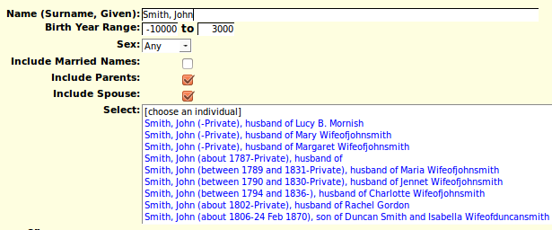Illustration 1: Nominal Index with Names of Parents and Spouse
This dialog adds the new capability to limit the search to individuals or a particular sex. As well by default it now displays the names of the parents and spouse of each individual in the list so you can more efficiently distinguish between individuals with very similar names and birth dates.
The dialog for updating a family as a unit has a number of enhancements which both make it more responsive, and more intuitive.
The support for transcribing vital statistics has been made more generic. Starting at the top there is now support for all US states and Canadian provinces. For each state or province there is a table of Counties. A county, which is not called a county in all states and province, for example in Manitoba, is the level at which vital statistics are administered in most administrations. So the first step in being able to transcribe vital statistics is to define the counties in a state:
Any registered contributor can edit the table of counties for any state or province. As you can see there is not a lot of information recorded about each county. The ID field is a 3 character code which is used in each birth, marriage, or death transcription to identify the county where the information was collected. It is not necessary to record all of the counties in a state or province prior to beginning transcription, just the ones with records of interest.
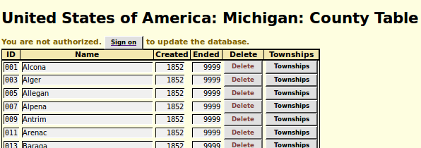Illustration 2: List of Counties in Michigan
Clicking on a “Townships” button takes you to a page for managing the list of townships within the county.
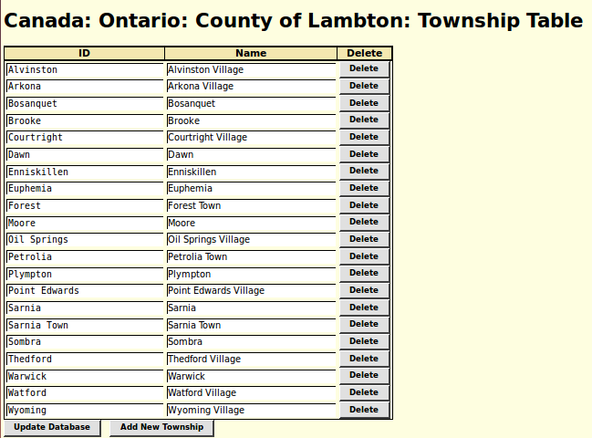Illustration 3: Lambton County Townships
The main purpose of this table is to populate the township selection list in the dialogs for searching for vital statistics. The secondary purpose is to ensure consistency of internal and external representation of place names. The above table demonstrates two common issues that arise:
- Sometimes there are two administrative domains within the same county that have the same name. In the above county there is both a Sarnia township and a town, now city, of Sarnia. Since these were two separate municipalities the vital statistics were collected separately.
- It is desirable to display the type of municipality externally, but it is a waste of effort to record that unchanging information internally. The identifier, displayed in a mono-case (typewriter style) font on the left, is therefore usually a shorter, yet non-ambiguous representation of the name as it is presented to the user both in reports and in the selection lists in dialogs.
When entering a transcription for a vital statistic only the external names of the municipalities as defined in this table are presented in the selection list. However this is only a table which you can modify. If as you are transcribing vital statistics you find that a municipality is missing from the list, just add it to the table, and then refresh the edit dialog for the vital statistic.
As usual check out the detailed report of changes to the functionality of the web-site, and the list of recent individuals added to the family tree.

