December 2014 Newsletter
Although the functional changes this month are not dramatic on the outside almost every single file in the site has been changed, particularly to increase the consistency with which different classes perform similar functionality. This makes the implementation easier to follow and avoids potential future programming mistakes.
The handling of events in the page editIndiv.php has been extensively rewritten. The key driver for this was to make the function of the “Order Events by Date” button much faster. In the past you could click on this button and not observe anything happening for several seconds, and even then all you saw was the browser's busy indicator. This button now updates the display immediately, and the events are not actually reordered in the database until you update the individual. Since the primary events for an individual are being moved the handling of these events is now the same whether they are actually stored inside the instance of LegacyIndiv or in separate instances of LegacyEvent. This means that the instance of LegacyEvent now distinguishes between the preferred version of each event, and any other instances by means of a “Preferred” flag.
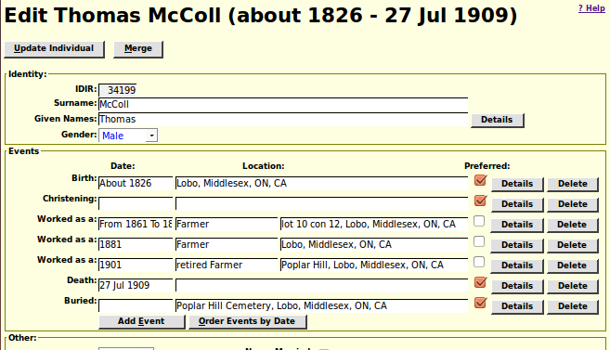Illustration 1: Editing with Preferred Events
You cannot click on the “Preferred” check-box to turn the flag off, because that would leave no preferred instance of the class of events. However if there are multiple instances of a particular event type, for example multiple birth events, then you can click on the unchecked check-box of another instance and make it the preferred instance.
In the past if you wanted to edit the transcription of a page of the census, or if you wanted to compare the transcription to the original image, and you clicked on the button to display the original census image, a new window was opened to display the image. This then required that the user rearrange and resize the two windows in order to take advantage of the full screen space available. Through years of experimentation I have found that the most efficient way to transcribe censuses is a column at a time, with the screen split with the input form using one half of the screen and the original image using the other half of the screen, side by side. The implementation of the display image button is therefore changed to facilitate this. Just make the census window full screen, and clicking on the display image button splits the screen for you into left and right halves.
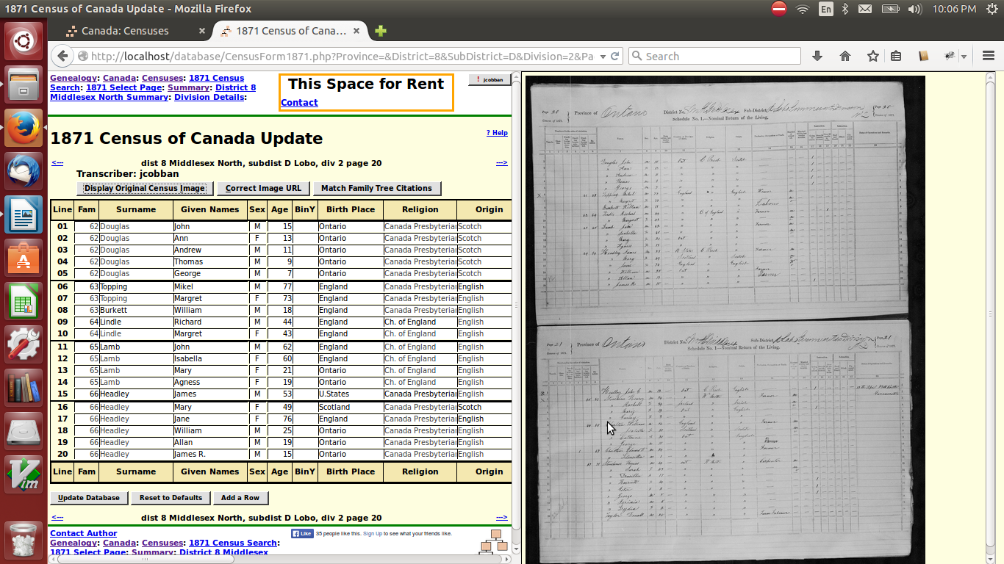Illustration 2: Split Screen Census Transcription Editing
If you forgot to make the transcription page full screen, don't worry, you can change the size of the page at any time and the image will take up half of whatever you give it.
In the past if you pointed your browser at a folder name on the site, for example www.jamescobban.net/Ontario/ instead of a page being displayed you would see the contents of that folder as a list of directory entries. This was not particularly convenient to any legitimate user, and revealed the names of many scripts that are used only by the internal implementation and that would produce strange results if invoked through this listing. Now whenever you directly reference any folder on the site you will be redirected to a useful page instead. For example: www.jamescobban.net/Ontario/ redirects you to http://www.jamescobban.net/Ontario/genOntario.php. Accessing a folder which is present only to provide an administrator with useful tools will result in an error message.
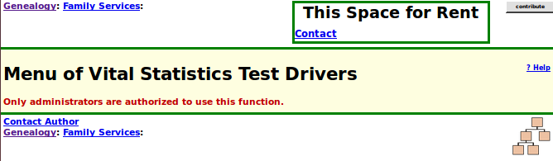Illustration 3: Contents of Folder Hidden
As usual check out the detailed report of changes to the functionality of the web-site, and the list of recent individuals added to the family tree.

Contributing to Census Transcriptions
There are a number of transcriptions of the Canadian Censuses available on the web.
- The transcriptions of the Census of Canada at Ancestry.ca are available for free to non-subscribers as a result of the terms of the agreement between the holding company for Ancestry.ca and the Library and Archives of Canada. These transcriptions were created by a combination of volunteers for the Church or Latter Day Saints, as well as contractors hired by Ancestry. The transcriptions are generally quite good, especially for English Canada.
- An alternate user interface to the same transcriptions is available for free at the Library and Archives Canada web site. This alternate interface in particular permits searching the census using initial strings for given names and surnames, which can sometimes be effective in cases where the heuristic algorithms used by Ancestry fail.
- Some of these transcriptions can also be searched at the Church of Latter Day Saints site www.familysearch.org.
- Completely independent transcriptions, that are particularly good for the 1901 and 1911 censuses are available at www.automatedancestry.com. This site was created by a skilled amateur genealogist and permits contributions and comments from volunteers.
- Partial transcriptions are also available at various sites that are part of the GenWeb network of volunteers.
The transcriptions on my site may therefore appear, at first glance, to be redundant. There are a number of motivations for maintaining these separate transcriptions.
- The first three sites all host exactly the same transcriptions. So the same mistakes, sometimes quite glaring, appear on all three sites. This is only obvious if there are alternatives.
- The proprietors of the first three sites are not interested in outside criticism of their databases. I personally have pointed out some of the glaring mistakes and been completely ignored. I modelled my site partially on the good features of the AutomatedAncestry site. Any contributor can make comments about any field on any census. These comments are available to all visitors, and can be considered by the primary transcriber for incorporation into the transcription.
- The copyright for the shared transcription of the first three sites is held by the holding company for Ancestry.ca. The thousands of contributors get no individual credit.
- The copyright for each page of the transcription on my site belongs to the person who performed the transcription. You do the work, you get the credit. Moreover the original transcriber is the only person authorized to modify the transcription. Anyone else who attempts to modify the transcription only adds a comment. The only limitation imposed by the site on the original copyright is that the transcriber cannot remove a transcription that has been licensed to the site.
- Unlike any of the other transcriptions, the census transcription on this site is an integral part of the family tree, tied together by two-way links. Each line of a census transcription can be linked to an individual in the family tree, and each individual in the family tree can be linked to every census that contains information about that individual. This is a key piece of the functionality of the site. Since the goal of the site is to organize a family tree of every individual who passed through the area of study, the degree of completeness of the project can only be measured by the percentage of entries in the transcribed original sources that have been linked.

Establishing Links between the Census and the Family Tree
When you search a census for the contents of a particular page of the transcription the response looks like the following:
This response contains only the basic information from the actual census, in a form which is consistent across all censuses. The individual names are color coded by gender. For those lines of the census which have been linked to an individual in the family tree, the name of the individual is a clickable hyper-link into the family tree.
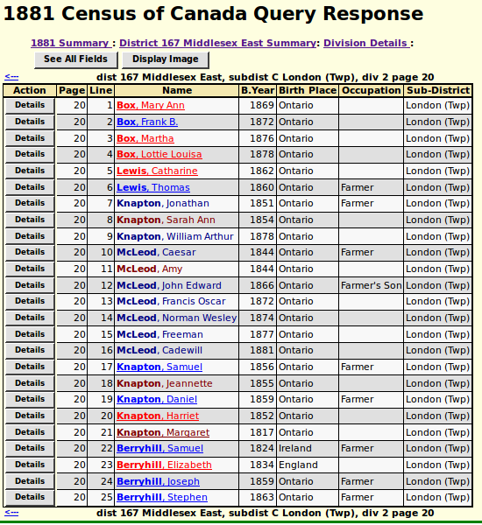Illustration 4: Census Page Query Response
Each time you cite a page of a census as evidence for the date of birth of an individual, the application searches the transcription of that page looking for the closest match on name and age. If a match is found then a link is automatically established to the family tree. This is an imperfect process. The application has relatively limited intelligence. For example it does know that someone recorded in the family tree as “William Smythe” is a reasonable match for someone the census enumerator recorded as “Bill Smith”. But it cannot distinguish between two “John Jones” on the same page with ages less than 3 years apart, and will blindly accept the first match.
Since the application is fallible it is also possible for a contributor to manually link lines. Starting at the above page, click on the “See All Fields” button. This takes you to the form for transcribing or editing the census transcription. As described earlier if you are not the original transcriber, any changes you make to the values of any fields in the transcription itself are recorded as comments. However any contributor can manipulate the links to the family tree. For example note that in family 93 the individual “Jeannette Knapton” is obviously a sister of Samuel, Daniel, and Harriet, who have already been linked, and the daughter of Margaret Knapton, but she is not linked. If you follow the link for any of her siblings, and go up to their parents, you will see that in the family tree this individual is identified as “Jessie Knapton”. The programmed name match does not know that Jessie is sometimes used as a familiar form for Jeannette. If you click on the “Find” button at the end of the line the closest match the application can find is the obviously incorrect “Ann Jane Kingston”. There are two ways to resolve this. If you are authorized to you can change the name of the individual in the family tree to “Jeanette”, and try the linkage again, or you can temporarily change the name of the individual in the census transcription to “Jessie” and try the linkage. Either will deliver the same result. However do not save the census page with the name in the census transcription still appearing as “Jessie” as this will cause a comment to be added to the page. Place the focus on the given name field, hold down the Ctrl key and press the “Z” key. Ctrl-Z on any input field on the page restores the value of the field to the value it had when the page was first displayed.
For each line of the census transcription that has been linked to an individual in the family tree there are two buttons: “Show” and “Clear”. The “Show” button opens a window containing the main page for the individual. If you try this and the result is obviously erroneous, you can click on the “Clear” button, the linkage is broken, and a “Find” button is displayed permitting a new linkage to be established.
There is one last feature related to this. You will notice at the top of the page there is a “Match Family Tree Citations” button. Clicking on this button causes a search of all citations from the family tree to this page, and will attempt to match every individual with an event reference to this page to the corresponding line in the page. If you come across a page that has no existing linkages to the family tree, this button should be used before you attempt any manual linkages. The main reason that this button exists is because the census transcriptions were in many cases created before the automatic linkage on birth citations was added, so there are many lines in these older transcriptions that would have been linked automatically to the family tree if that automatic linkage had existed at the time. If you go to an enumeration division status page, for which there is a link in the top of the census page, you will see something like:
Any page for which the %Linked field displays 0.00 and is dark red is fair game for the “Match Family Tree Citations” button.
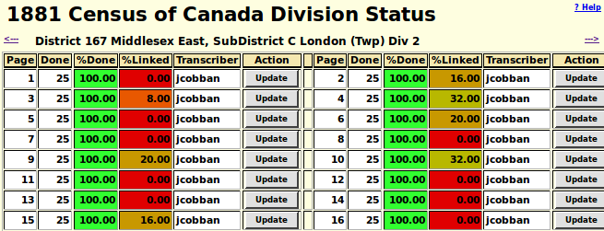Illustration 5: Census Enumeration Division Status Page

