January 2015 Newsletter
The usability of the web-site is a major focus this month.
In the past whenever you requested a new service one of three things would happen:
- The page displaying the results of the request completely replaced the requesting page. This is appropriate when the user no longer needs to see the requesting page, particularly when the original page is used simply to request the results of a report.
- The page displaying the results of the request is opened as a new tab with the same dimensions as the requesting page. Both pages are still available, but only one of the pages can be seen at a time because they both occupy the same space on the screen.
- The page displaying the results is opened as a new window with different dimensions and overlaying only part of the original page. This new window can be dragged around by the mouse and changed in size. There are two issues with these little windows: They can quickly clutter up the screen creating a messy desk, and they may only be displayed if you the user have permitted the browser to open such windows. Typically this permission is withheld because this sort of “popup” window is frequently used by advertising spammers.
This month the site attempts to reduce the clutter and confusion of your screen desk-top by replacing many of the instances of popup windows by explicitly managing the screen space which you have allocated to the web-site. This new implementation works particularly well when you have your browser window occupying the full screen.
This new support currently applies to the main page for displaying information about an individual and the associated page for editing the information about the individual. On the main page there are four buttons displayed to casual visitors, plus an Edit button displayed to authorized registered users. The “Descendant Tree”, “Ancestor Tree”, and “Relationship Calculator” buttons formerly opened new small windows, now they split the browser window horizontally, squeezing the original page information so it is all still visible in the left side of the window, while the report is displayed in the right side of the window. The display tree graphic button and the “Edit Individual” button are unchanged.
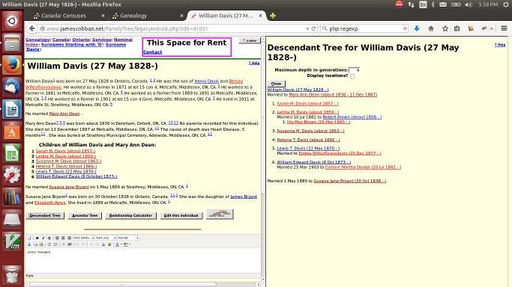Illustration 1: Individual Page with Descendant Tree in Split Screen
On the Edit Individual page all of the “Details” and “Edit” buttons, as well as the “Merge” and “Grant Access” buttons now split the screen in the same way instead of opening new window. In addition there is a new “Search” button which pops down a list of searches which can be performed for matches in the supporting databases or in Ancestry.ca. These also split the screen. For example clicking on a “Details” button for an event appears as:
Similarly clicking on the “Edit Families” button displays the Edit Families dialog in the right side of the window.
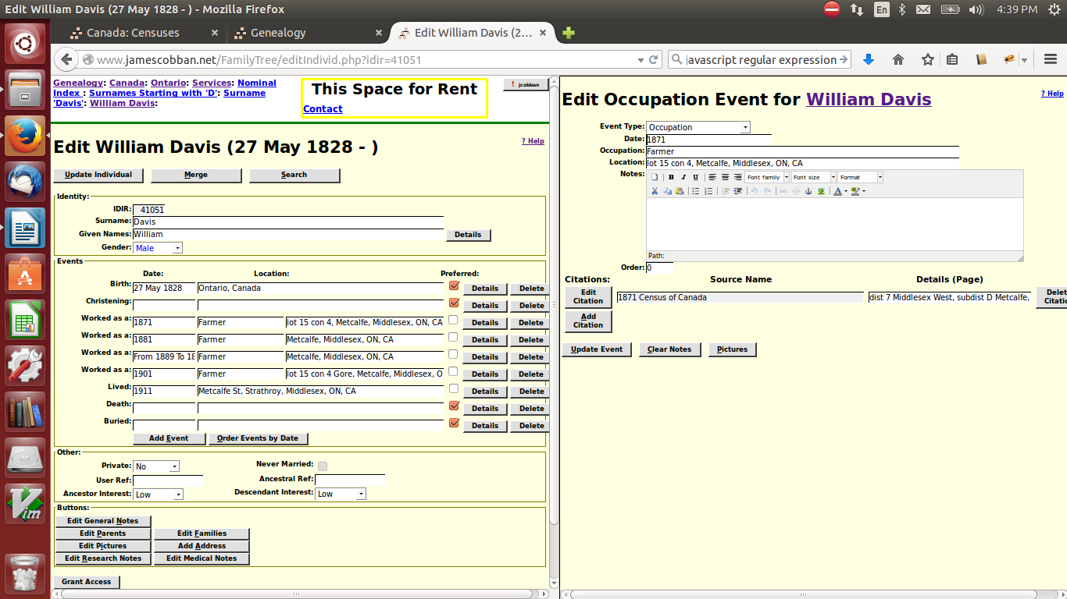Illustration 2: Edit Dialog with Edit Event in Split Screen
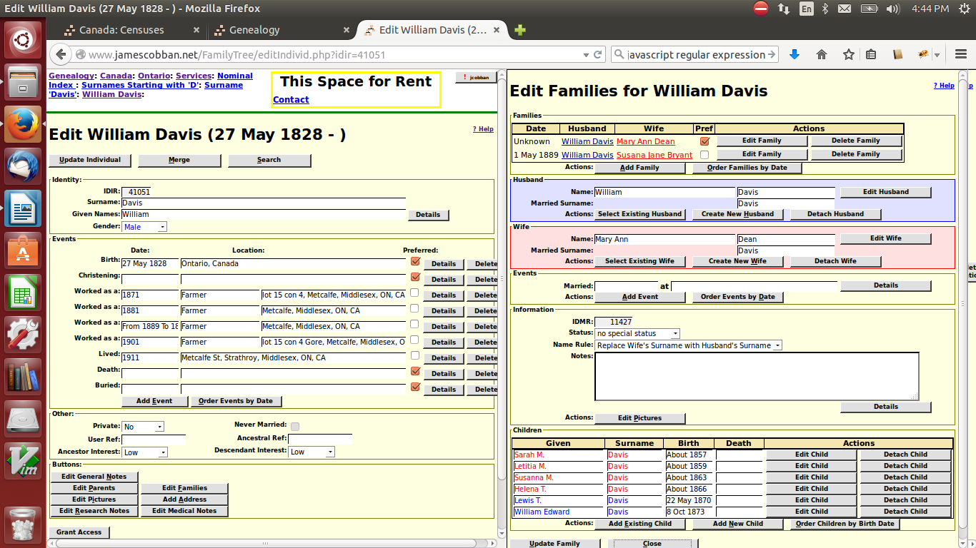Illustration 3: Edit Individual with Edit Families Dialog in Split Screen
Clicking on the “Grant Access” button to authorize another user to contribute to your family tree also opens in the split screen:
The new “Search” button simplifies performing a quick search of either the supporting documents tables on the site itself or of Ancestry.ca, for records which match the individual. When you click on this button three new buttons appear in a drop-down menu.
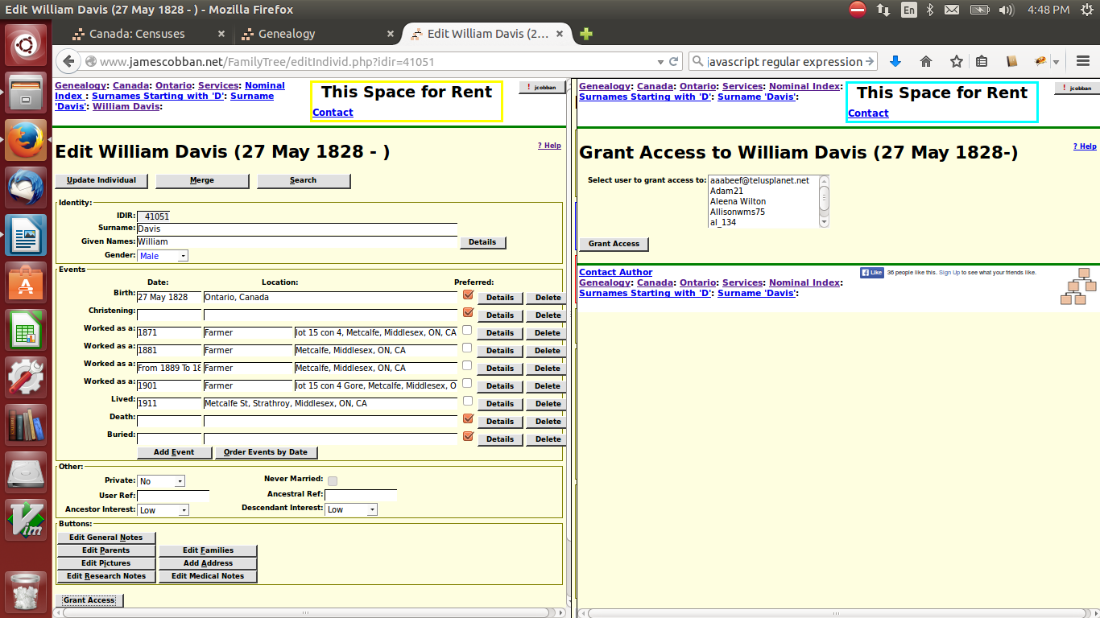Illustration 4: Edit Individual with Grant Access in Split Screen
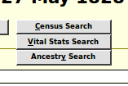Illustration 5: Search Popdown Menu
The “Census Search” button performs a consolidated search of the 1851, 1861, 1871, 1881, 1891, 1901, 1911, and 1921 Census of Canada transcription tables for individuals with similar names and birth years. There is also a new option at the top of the Censuses of Canada page to permit you to manually enter such a query. The “Vital Stats Search” button will eventually perform a consolidated search of the Birth, Marriage, and Death registration tables. At the moment it searches only the Birth registration tables while I add additional information to the other two tables to permit them to be searched in a similar manner. The “Ancestry Search” button requests a search of Ancestry.ca. If you are not a subscriber to Ancestry this will only show you what types of information is available.
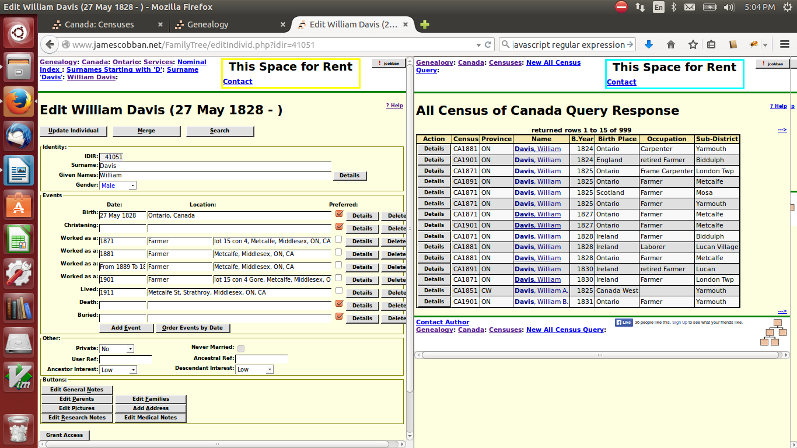Illustration 6: Edit Individual with Census Search in Split Screen

