May 2015 Newsletter
The functional changes this month are minor. There are a number of fixes for flaws in the implementation which could have confused users or left minor problems with data integrity. For details look at the Updates to Website Functionality report.

Support for Old URLs
Prior to the creation of the current dynamic implementation the family tree on the site was created as a set of static web pages. To protect those users who had saved URLs pointing into that static tree I left the last version of that static tree up on the site. However the information on that static tree is now several years out of date. So I have added a feature onto the web site so that any attempt to look at one of those old pages is invisibly redirected to the corresponding page in the new tree. For example if you access the web page http://www.jamescobban.net/FamilyTree/Web/I@I00197@.html what you will actually see is the dynamically generated page http://www/jamescobban.net/FamilyTree/legacyIndivid.php?idir=00197.

Contributing to the Family Tree
To further encourage users to contribute to the site and simplify the process for obtaining permission to see private data a new button is added to the main display page for an individual in the family tree:
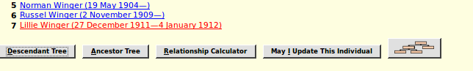Illustration 1: Request to Permit Modifying Family Tree
When you click on this button the screen is split to add a dialog for sending the request to the current owners of the individual:
You should then explain your connection to this family.
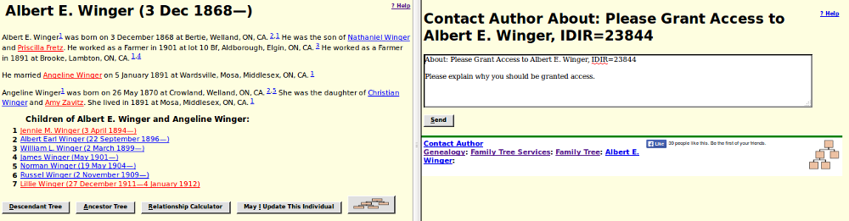Illustration 2: Sending Request to Update to Owners

There is a little trick that you can use in the case where the description of an event includes the name of an individual who is already in the database. For example Joseph Robinson is recorded as working for Darius Coleman, another member of the family tree, in the 1901 census of Caradoc. The event description field, which is used for the description of an occupation in the Occupation event, is now displayed in the Event form using the rich-text editor. This permits you to paste a link to a member of the family tree instead of just typing the name. You can copy the name with its link from any page that references the individual.
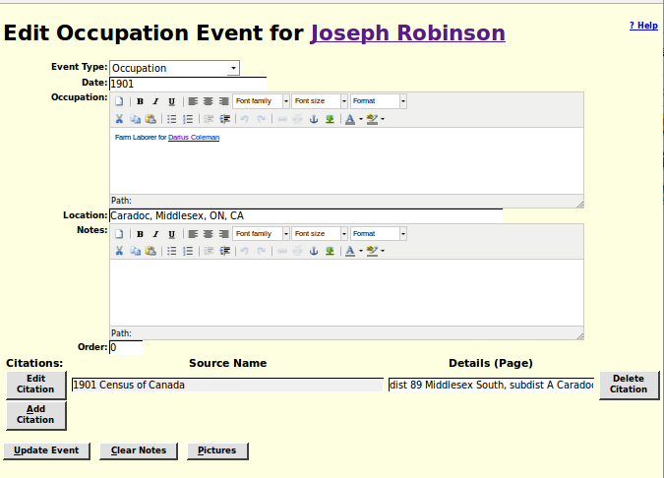Illustration 3: Using Rich Text Editor for Event Description
The name of the associated individual then appears as a link on the page for the individual, and all of the services associated with such a link, including the descriptive popup, apply:
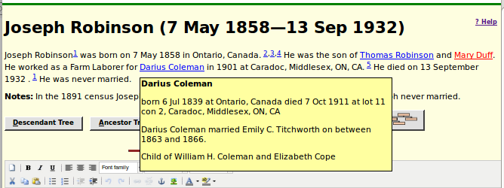Illustration 4: Link to Member of Family Tree from Event Description
The script LegacyNames.php, when called to display all of the individuals who share a surname provides a new feature: the “Edit Surname Record” button.
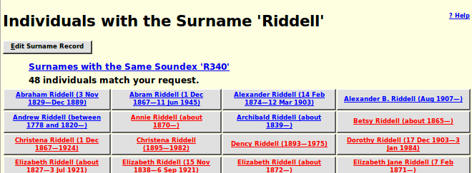Illustration 5: Edit Surname Record Button on Names List Page
Clicking on this button expands the form to provide access to the contents of the surname record:
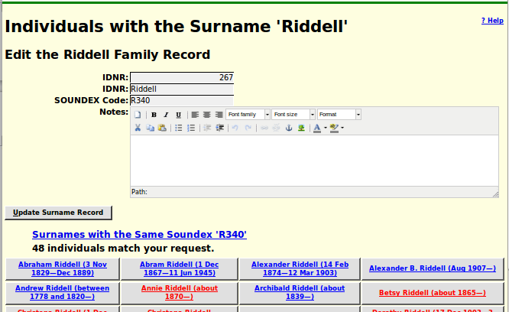Illustration 6: Edit Surname Notes
The Surname notes can be modified using the rich-text editor panel. You can include anything that is relevant to describing the family: the origin of the name, the history of the portion of the family described by this family tree, links to other web sites, even photographs, sound recordings, or video clips. For example I have added some notes to the “Cobban” family record.
Address records are used to represent detailed contact information about an individual or an institution which holds source documents. In particular as an owner of an individual in the family tree you can add an Address record to an individual by clicking on the “Add Address” button. This button appears as “Edit Address” if there is already an Address record for the individual This button opens a form in the right half of the window to permit managing this information.
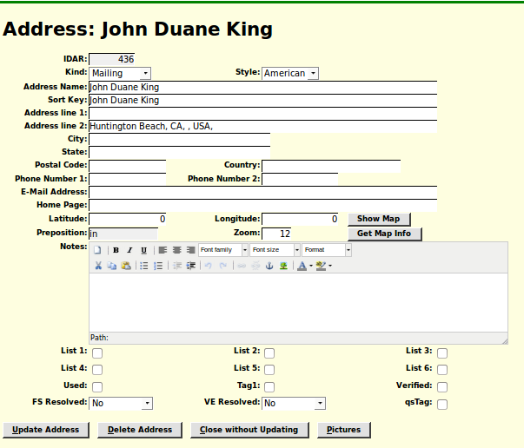Illustration 7: Edit Address Form
The improvements to the functionality of this form are with respect to the four buttons at the bottom of the form.
The “Delete Address” button is added to permit an authorized user to remove address information from the associated individual. If you click on this button you will see the text on the “Edit Address” button in the left hand side of the window change to “Add Address”. Note, however that although clicking on the “Delete Address” button actually deletes the record out of the database, you have to click on the “Update” button for the individual in the left hand side of the window to remove the reference from the record of the individual.
The “Close without Updating” button is added to permit you to change your mind as to whether you wish to make changes to the Address record.

Transcribing Censuses
To page for transcribing a page of the census has a button that formerly opened a new browser window containing the associated image, but has now been changed to split the screen between the input form, which appears like a spreadsheet, and the image. This greatly simplifies the process of transcription by eliminating the need to move and resize the two separate windows. Some transcription web-sites, for example the highly recommended Automated Genealogy, split the screen vertically with the original census image above the data entry form. This arrangement is designed to facilitate transcribing the census one individual at a time. However as a touch-typist I find this method significantly slows down the actual transcription because as you move across each column you have to change your mind-set because of the differences in what constitutes valid data. I find it much faster and more accurate to transcribe a column at a time. For example the sex column can only have two values, 'M' or 'F'. So I position my hand with one finger of my left hand above the letter 'M', one finger above the letter 'F' and the index finger of my right hand over the “Enter” key. I can then ripple down the column without looking at the keyboard. Many of the columns are set up so that entering a single letter expands to one of the most common values for the column so the same technique can be used for them as well.
To determine which image to display for each page of each census there is a pair of tables in the database:
- The SubDistricts table contains all of the descriptive information about a census enumeration division, that is the portion of an enumeration sub-district, for example a township, written down by a single enumerator. This includes the name of the division (township), the number of pages in the division, and the information required to determine the URL of the first original image on a free web-site, usually Library and Archives of Canada, but for the 1921 Census of Canada a free portion of Ancestry.ca. For the vast majority of enumeration divisions in all censuses of Canada this is enough to determine the URL for every page, because the images are in the sequence they were copied off the microfilm, and the microfilm was created in the 1950s from the original documents that were bound into books for reference as soon as the Dominion Bureau of Statistics (later Stats Canada) had copied the information into published reports.
- Since “to err is human” minor mistakes were made along the way. Sometimes the separate pages filled in by the enumerator got out of order. This is particularly a problem with the 1851(2) and 1861 pre-Confederation censuses where the census administrators failed to instruct the enumerators to number the pages as they filled them in. Sometimes the enumerator forgot after filling in one side of the form to flip the page over and continue with the next individual on the back side. Sometimes the pages were bound into the reference books in the wrong order. Sometimes the photographer creating the microfilm accidentally skipped a page, or upon developing the microfilm found that an image was unreadable, and had to go back and re-photograph the page to complete the set. And even, though this process was largely automated, occasionally when the microfilm was digitized an image was skipped and had to be re-scanned. All of these create situations where the URL containing the image of a particular page cannot be determined by a mathematical formula. The main purpose of the Pages table is to contain a humanly-verified image URL for each page of each census. It also contains other useful information such as how many individuals are actually enumerated on a page where this is different from the number of pages on the form.
Until a transcriber actually starts reading the pages of an enumeration division the associated portion of the Pages table does not exist. If that is the case when the transcriber clicks on the “Display Page” button the web-site uses the information in the SubDistricts table to compute the most probable URL, and displays that image.
Oops! I want to transcribe page 32 of this division, but the image contains pages 29 and 36! The fact that not only is it an unexpected page, but that the pages are not even sequentially numbered lets us know that something went wrong along the path between the original enumerator and us. But no problem. Observe that in the heading bar above the image there are a highlighted <--- pointing left and –-> pointing right. If you have not disabled popup Help holding the mouse over either arrow will explain what the link does. In any event your browser will display the URL of the new image if you follow the link. Simply click on either the right or left “arrow” until you see the image for the page you are trying to transcribe. When you save the transcription the associated entry in the Pages table is updated, so any subsequent visitor will see the correct image first thing.
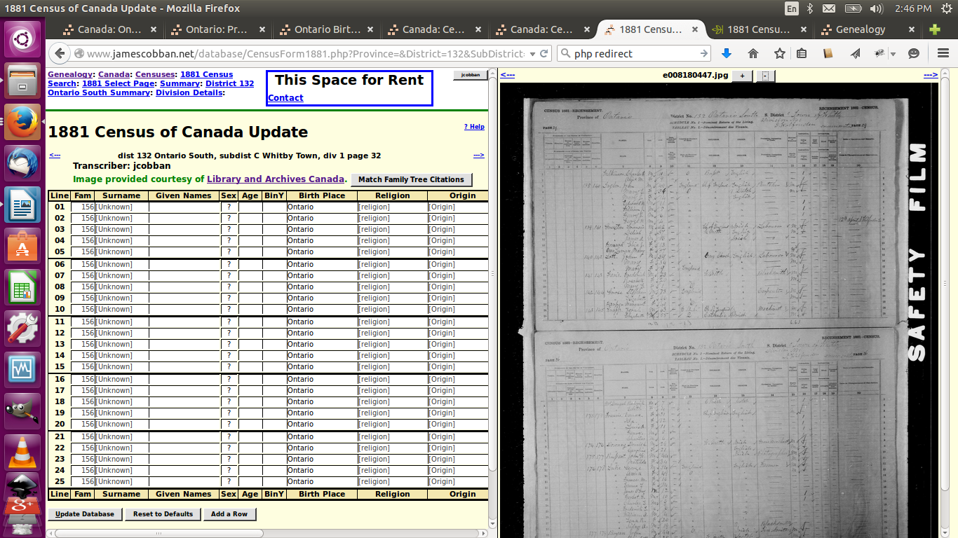Illustration 8: Edit Census Page with Incorrect Image URL
There is a special case with the 1851 census of the Crown Colony of Canada (which was enumerated in 1852 because of the implementation of the Durham Report). For this census only the information to be transcribed spans two images. The first image includes only as far as the gender column. The second image contains the marital status, racial information, membership in the family, education, disabilities, births and deaths, and the construction style of the house. Just click on the “right arrow” to see this image, but before saving the transcription remember to click on the “left arrow” to get back to the original page image so that subsequent visitors to the page will see that first image by default.
If you do not intend to transcribe every page in the enumeration division, but wish to do a favor for anyone who later wishes to contribute to this division, you can also fix up all of the image URLs using the “Edit Census Page Table” tool on the main census page.
This tool permits authorized users (which at the moment is all registered users) to manually update the description of any or all of the pages in an enumeration division. In particular this form permits you to verify and correct the URL of the image for any page. Just click on the “View” button for the page. If the correct image is displayed then you are done. If it is not, because of any of the issues previously described, just use the forward and back arrows until the correct image is displayed. As you do so you will see that the URL for the selected page changes in the left-hand frame as you move through the set of images in the right-hand frame. When you have finished just click on the “Update Database” button at the bottom of the form to apply all of the changes.
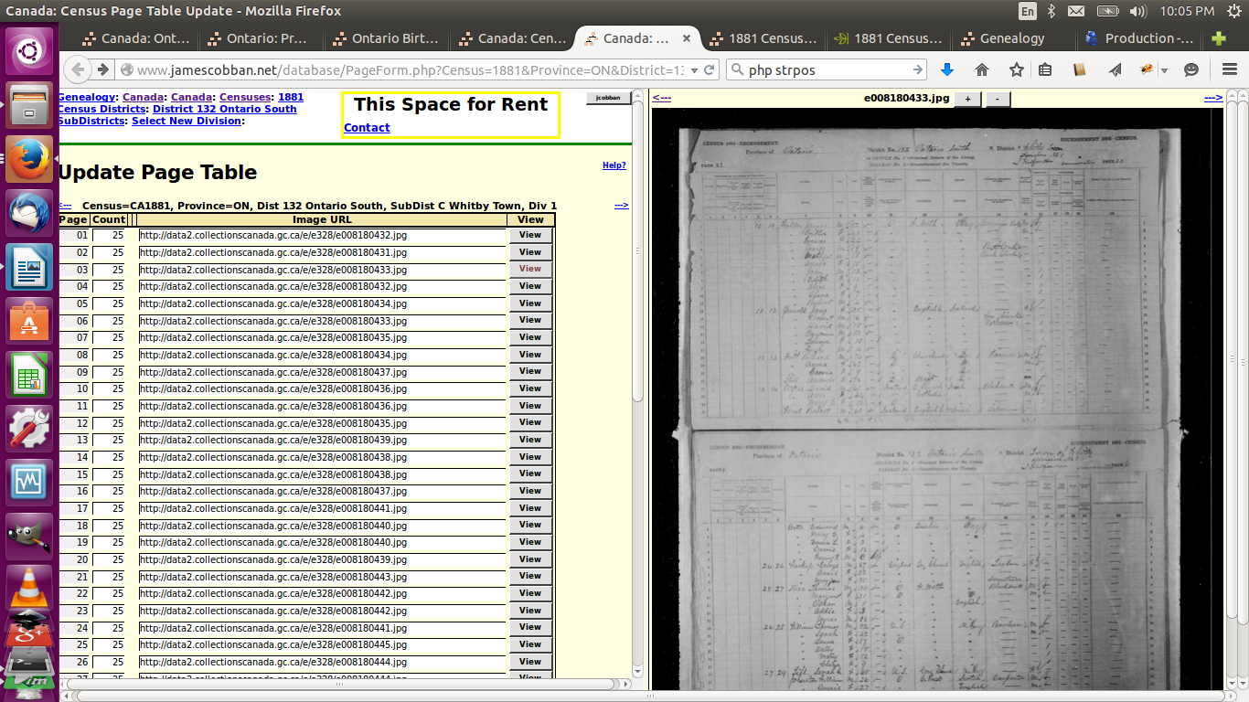Illustration 9: Update All Page Descriptions in a Division with Image

In conclusion:
As usual check out May 2015 Updates to Website Functionality for details on the changes made to the implementation of the site during the past month. Also check out List of Recently Added Individuals for information on the recent growth of the tree which currently holds 85,261 individuals, 24,196 families, 58,822 events, and 263,330 citation.

