June 2015 Newsletter
Searching through death certificates frequently reveals little nuggets of our common history.
Five of the individuals currently in the family tree died on 24th May 1881 when the steamer Victoria, carrying over 700 passengers on a tourist excursion along the Thames between the City of London and Springbank Park, capsized and sank. 181 death certificates were issued, carrying on for page after page in the reports from the registrars not only of the City of London, but of the surrounding areas as well. See Victims of the 1881 Steamboat Victoria Disaster. Unfortunately this kind of accident continues all too frequently, even in the “developed” world.
When I was researching John Turner I was struck by his unusual cause of death: Accidentally Killed at City Hall. I leaned back and looked at the entire page of death registrations. They all died accidentally on January 3rd 1898 at London City Hall! Altogether there were 18 of these death registrations. A quick search of the web revealed news stories clipped from newspapers all over North America about this tragedy. Apparently there was a political rally at City Hall and the hall was jammed with hundreds of enthusiastic participants when the floor collapsed and they fell into the basement.
Or how about Phoebe Schram (about 1798—23 Nov 1824)? She fought in a battle of the War of 1812!
If you wish to explore this area use the Report on Individuals Tool. This permits you to search on a range of criteria, including cause of death, and even occupations. For example a search for individuals born in Delaware with an occupation (event description) of Teacher presents:
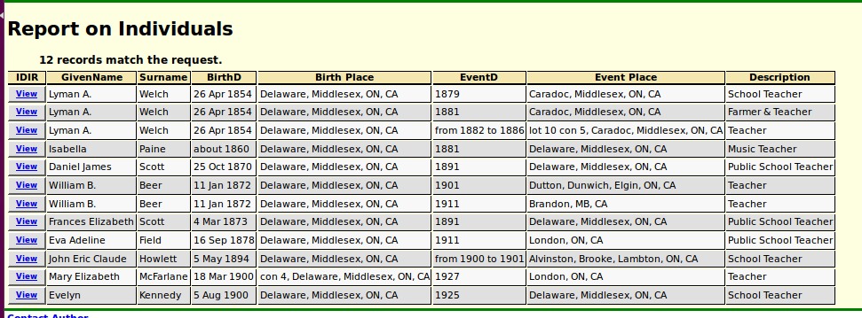Illustration 1: Report on Individuals including information from both the Individual and the Event tables
The functional changes this month are minor. There are a number of fixes for flaws in the implementation which could have confused users or left minor problems with data integrity. For details look at the Updates to Website Functionality report.

In conclusion:
As usual check out June 2015 Updates to Website Functionality for details on the changes made to the implementation of the site during the past month. Also check out List of Recently Added Individuals for information on the recent growth of the tree which currently holds 86,241 individuals, 24,484 families, 61,086 events, and 266,012 citations.

