July 2015 Newsletter
There are a few new capabilities on this family history site. In particular:
- There are a series of video tutorials on various features of the web-site. Viewing these will show you how to use the site more effectively, and demonstrate how to add and modify information in the family tree. In particular I hope that these will make you more comfortable in adding information onto the site.
- The order in which information is displayed on the main page for an individual for both the individual and the individual's spouses has been slightly changed to simplify the implementation. I believe this order of presentation is also more intuitive.
- Anyone can now post a blog entry on the page that contains information on a surname. Registered subscribers can also edit information about the surname. For example you could describe the origin of the name or the history of the family.
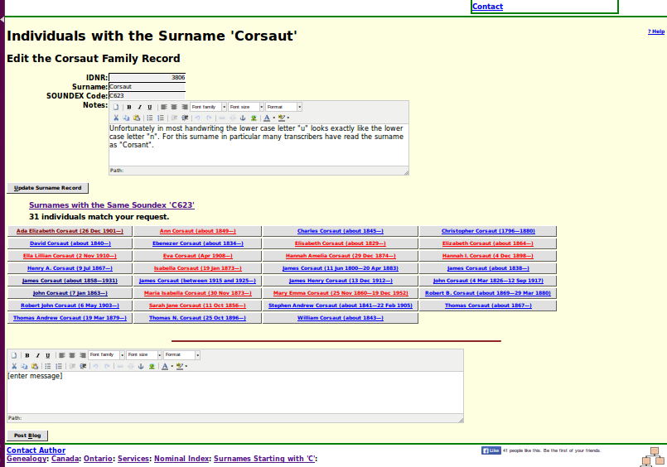
- Registered subscribers are now offered the ability to directly edit the description of a location from the page on an individual.
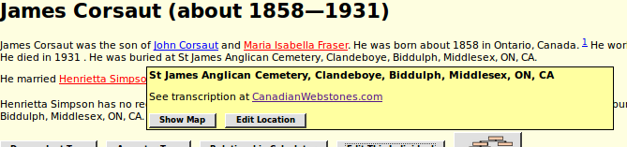
For details look at the Updates to Website Functionality report.

In conclusion:
As usual check out July 2015 Updates to Website Functionality for details on the changes made to the implementation of the site during the past month, and a list of bugs that have been fixed. Also check out List of Recently Added Individuals for information on the recent growth of the tree which currently holds 86,875 individuals, 24,657 families, 62,605 events, and 267,954 citations.

