August 2015 Newsletter
The major new capability on the site this month is the ability to manage multiple family trees. The existing tree is now identified as “South-Western Ontario”, but if you wish to perform research on a family which is unlikely to have any connection to the families of south-western Ontario, then you can create a new family tree and edit that. As a demonstration I have created a small tree, called “Royals” which currently contains the relatives of Robert the Bruce, also known as King Robert I of Scotland.
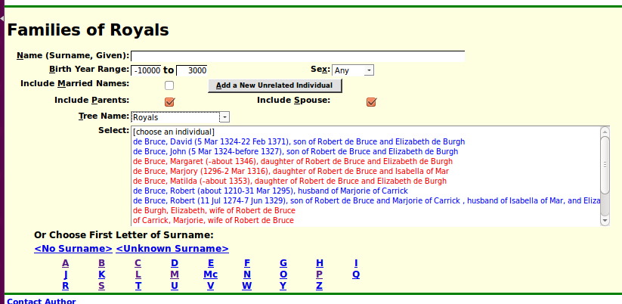Illustration 1: Nominal Index of an Alternate Family Tree
For details look at the this month's Updates to Website Functionality report.

Family of the Month:
One of the interesting families documented on the site is the Gooderham family, founders of the Gooderham and Worts distillery of Toronto. This family appears on the site due to a family scandal which I first learned about from my uncle Donald Ballantine. My uncle and his wife, my Father's twin sister, lived in one of the finest and oldest homes in the township of Caradoc on N ½ lot 12 con 4. The house was notable for its 14-foot ceilings and the fine oak doors and moldings. The question was, why was this almost palatial home way out in the middle of nowhere? One of the Gooderham daughters, Mildred Gooderham, apparently eloped, taking the ferry to Rochester, New York to marry a servant, the driver of the family carriage! Her father built this fine house for her.

Open Data Access
Almost every piece of information on this site can be accessed in machine-readable form as eXtended Markup Language (XML) documents, for use in other applications, for example in smart-phone apps.

In conclusion:
As usual check out August 2015 Updates to Website Functionality for details on the changes made to the implementation of the site during the past month, and a list of bugs that have been fixed. Also check out List of Recently Added Individuals for information on the recent growth of the tree which currently holds 86,875 individuals, 24,657 families, 62,605 events, and 267,954 citations.

