January 2016 Newsletter
If you don't know why you know something, then you don't really know it. That is the reason why citations are a critical part of any family tree. One of the reasons I do not trust much of what I find in family trees on Ancestry is that most of them have no citations to actual documents, only to other, unidentified, family trees on Ancestry. The new and improved FamilySearch.org is also weak because when you are looking at a document on their web-site the only citation information it generally provides is a reference to their web-site. A citation should identify the document that the information comes from, preferably with identification which will permit a later researcher to gain access to a copy of the document, along with information that identifies the page in the original document, so the researcher does not have to start at the beginning of the book and work through to the end.
A particular issue that I have been wrestling with is the Ancestry database of citations to the pre-Confederation Ontario marriages. These registrations have a common format for the whole period, but can be further divided into Militia District registrations from prior to the implementation of the Durham Report, and County registrations thereafter. However for the vast majority of these marriages the Ancestry database provides only information extracted from the original documents, with no citation information. For a small subset of these registrations Ancestry does provide access to an image of the original from which you can extract the identification of the book and the page information.
For marriage registrations from 1872 on the Ontario Registrar has established an identification for each individual registration by the year the registration was filed and a sequential number within that year. Since these post-Confederation registrations can be individually identified, I want to be able to similarly identify each pre-Confederation marriage registration.
The pre-Confederation marriages are stored by the Ontario Archives in the original registration books in which they were bound in the distant past. Each volume is identified by a number in a series that actually continues until early 1872. Prior to 1869, when Ontario introduced new procedures as a result of the constitutional changes from Confederation, each clergyman (supposedly) filed a report at the end of each year listing the marriages he had performed during that year. These reports are sketchy, containing little genealogical value aside from the names of the bride and groom and the date of the marriage. In particular unlike later marriage registrations these do not contain the ages of the partners, the names of the parents, or even the place where the marriage took place. The contents of each of these volumes was apparently accumulated by the clerk of the Militia District or later of the County.
As the clerk received reports from clergymen he copied the information from those reports into the registration book, assigning a sequential number within the volume to the reports. To be able to uniquely identify each marriage, consistent with the post-Confederation marriage registrations, requires three numbers:
- The volume number, which collects geographically related registrations as accumulated by the District or County clerk.
- The report number assigned by the District or County clerk in the order that the clerk copied them into the volume or registrations.
- The item number within the report, which is a conceptual representation of the position of the record of an individual marriage within the clergyman's report. Each item represents two lines, one for the groom and one for the bride.
On the web-site the transcription of one of these reports looks like:
If a particular marriage record has been cited from the family tree then the button in the column “Link” takes you to the family in the tree. Otherwise it does a search of the family tree looking for potential matches assuming the individual was between 18 and 70 years of age at the time of the marriage.
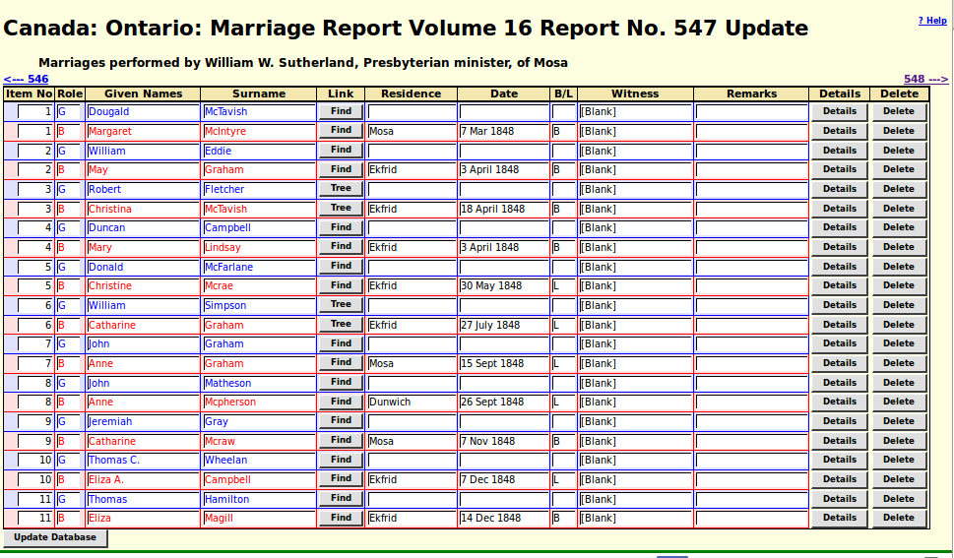Illustration 1: Transcription of a Clergyman's Report of Marriages
If you cite the pre-Confederation Ontario Marriages, the name of the source is “Marriage Register, CA, CW, County Registers” and the detail information should look roughly like “Vol nn No nnn Item nnn”. If you do this then the above table will be updated to point at the husband and wife of the marriage, and the footnote version of the citation will contain a hyper-link to the transcription.
If you wish to transcribe some of these marriage registrations either from the microfilm or the few images that Ancestry has made available go to http://www.jamescobban.net/Ontario/ CountyMarriageReportEdit.php which looks like:
Fill in the information about the report in the empty line and click on “Update Database”. That adds the report to the database, and you can then click on the “Marriages” button at the end of the row to start transcribing.
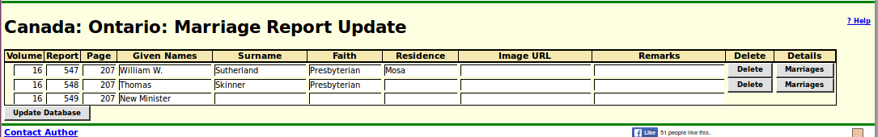Illustration 2: List of Clergymen's Reports

In conclusion:
As usual check out January 2016 Updates to Website Functionality for details on the changes made to the implementation of the site during the past month, and a list of bugs that have been fixed. Also check out List of Recently Added Individuals for information on the recent growth of the tree which currently holds 91,376 individuals, 25,891 families, 72,935 events, and 281,928 citations.

