February 2016 Newsletter
The most significant change to the web-site this month is one that you will not notice if I did not bring it to your attention. From now on access to the web-site is through secure HTTP. This means two things: Firstly the identity of the web-site is protected by an authentication key which proves that it really is my web-site and not something that just looks like my web-site. Your browser will flag this authentication by an indicator next to the URL. On Firefox this is a green padlock symbol. Secondly all information exchanged between your browser and the web-site is encrypted. This is, of course, particularly important when you are signing on and providing your password.
The Ancestor Tree tool is improved to present the ancestors in an order which makes the result look like a tree:
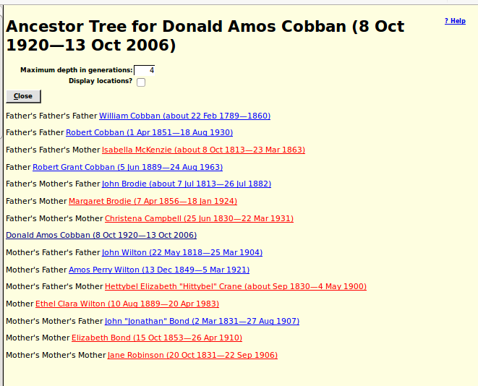Illustration 1: Ancestor Tree

The table of Wesleyan Methodist Baptisms was clumsy to use because each line of the response to a search was much wider than a browser window. So the display is now split into a summary and a detail page:
Clicking on a “Details” button displays:
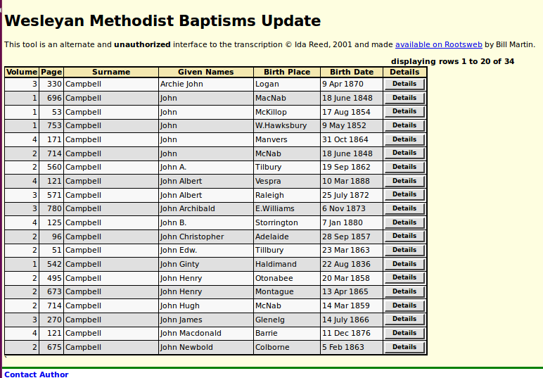Illustration 2: Summary of Response to a Search of the Wesleyan Methodist Baptisms
This page includes a list of potential matches in the family tree.
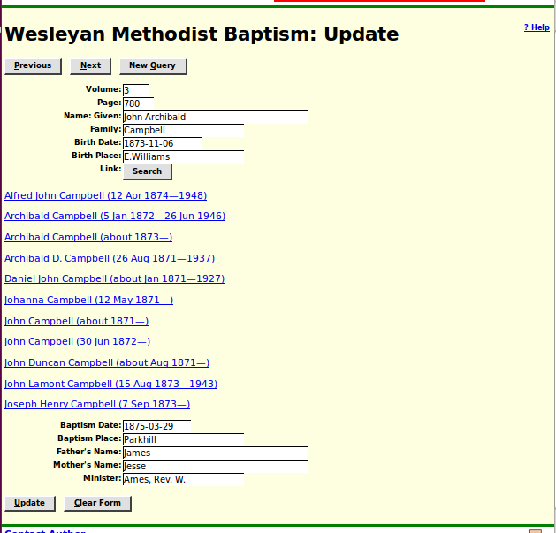Illustration 3: Details of a Wesleyan Methodist Baptism Transcription

In conclusion:
As usual check out February 2016 Updates to Website Functionality for details on the changes made to the implementation of the site during the past month, and a list of bugs that have been fixed. Also check out List of Recently Added Individuals for information on the recent growth of the tree which currently holds 91,376 individuals, 25,891 families, 72,935 events, and 281,928 citations.

