March 2016 Newsletter
The primary objective of this web-site is to create a family tree of everyone who lived in Middlesex County up to a century ago (1916). When I sat down to do that I first had to figure out how I could measure progress toward that goal. The goal is huge, tens of thousands of people passed through Middlesex in that period, but it is not infinite since obviously some specific number of people did so. I decided that the goal would be achieved when every individual identified in a public document from that period as a resident of Middlesex had been connected to the family tree. This necessitated designing a system that went beyond what traditional family history research software does.
All genealogical software, whether run as an application program on your own computer, or accessed on a web-site such as Ancestry or FamilySearch, provides the ability to cite to original source documents. This is essential not only so that other researchers can verify your research or establish a confidence level in your conclusions, but also so you can keep track of what you have done and what further work you can do.
To achieve the goal of my web-site I realized that it needed to go beyond this and track, at the level of individual records within each source document, which records had been analyzed and used to support the family tree and which had not yet been used. For example let's look at the set of marriages that were registered in Middlesex County in 1903:
A total of 814 marriages were registered in Middlesex County in 1903, providing information on 1,628 individuals. Looking at the line of totals you can see that information on 1,058 of those individuals has been transcribed into the database, which is just over 65% of all of the registrants. The column %Linked indicates that almost 48% of those 1,058 individuals have been identified in the family tree. From this we can conclude that approximately 48% of all of the individuals in Middlesex County in 1903 who were of an age to get married are already in the family tree. One could apply statistical methods to determine the standard deviation of this conclusion, based on the fact that it is drawn from a sample of about 1,000 individuals out of a population of about 100,000 that the county had according to the 1901 census.
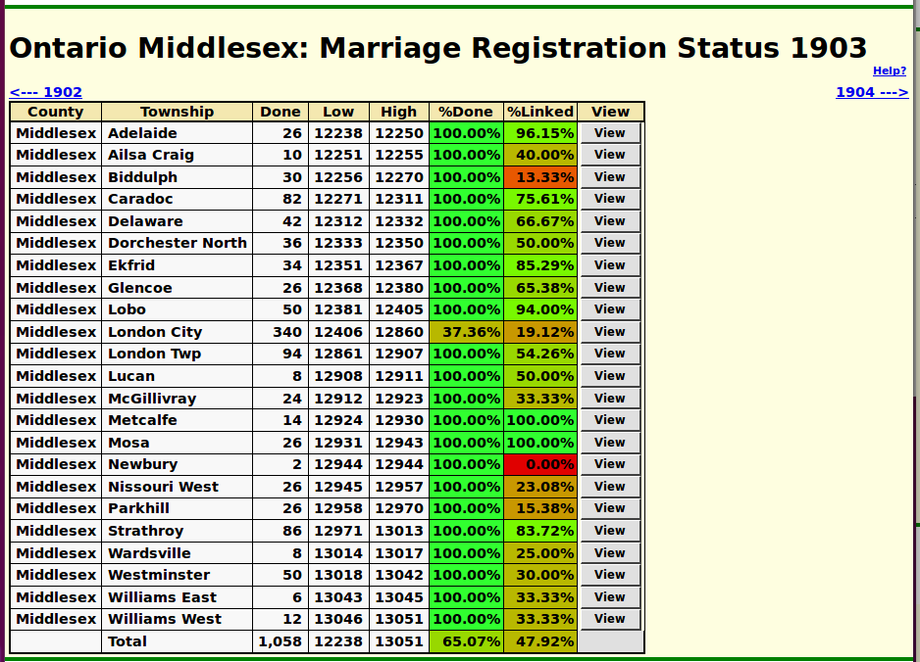Illustration 1: Status of Marriage Registrations from Middlesex County for 1903
This table also shows where more work needs to be done to approach completion. My main focus has been on the part of the county that my own family is from, so you can see that the townships in the south-west of the county mostly have completion rates above 75%, while those in the north-east are generally below 25%. The remaining gaps in the south-west are largely a consequence of the lack of intermarriage between European immigrants and natives. Most of the missing 25% in Caradoc and 33% in Delaware are marriages in the Muncey, Chippewa, and Oneida communities. The city of London is a special situation since the families I am researching were mostly rural in this period, but members of rural families still sometimes like to get married in the “big city”. The 170 marriages I have transcribed for 1903 in the city are not a random statistical sample, but rather a selection biased toward specific families.
Similar progress summaries are available on the site for each of the classes of source documents. Advancing this project requires:
- Adding citations to the family tree. Many citations automatically create a link from the transcription of the original documents to the family tree. For example: citing a birth registration as the source for the date of birth, citing a page of a census as evidence for date of birth, and so on. When editing an individual there is also a tool which permits searching the document transcriptions for potential matches.
- Adding to the transcriptions of original source documents. All of the transcriptions are made through the web-site, and all subscribers have authority to add transcriptions.
- Explicitly linking a transcription to an individual in the family tree. Each of the transcription edit pages include a button to search the tree for potential matches. You can then select from the matches to establish a link.

In conclusion:
As usual check out March 2016 Updates to Website Functionality for details on the changes made to the implementation of the site during the past month, and a list of bugs that have been fixed. Also check out List of Recently Added Individuals for information on the recent growth of the tree which currently contains: 93,292 individuals, 26,476 families, 77,254 events, and 287,780 citations.

