ABSTRACT

“School Management System” is an internet based Java application that automates the working of a school, school center that manage and maintain records of the students. This application is created as a product and can be customized according the specific needs of the client.
The objective of “School Management System” is designing a scheduling system for a education centre. Scheduling is such a tool with which the process of intimating activities and notifications will be easy and even online in the organization where it is installed. But these task of scheduling the different activities if manually done whether they may be personal or official is time consuming and also may lead to confusion if not properly scheduled.
The supervisor which holds the various activities like Manage database, mark attendance , and deleting the student and on the other hand student view their details, view schedule and view attendance and other details as well.

INTRODUCTION

This project “School Management System” provides us a simple interface for maintainance of student information.It can be used by educational institutes to maintain the records of students easily. Achieving this objective is difficult using a manual system as the information is scattered, can be redundant and collecting relevant information may be very time consuming. All theseproblems are solved using this project.

School Management System can be used by education institutes to maintain the records of students easily. Achieving this objective is difficult using a manual system as the information is scattered, can be redundant and collecting relevant information may be very time consuming. All these problems are solved using this project.

Problem statement
The objective of School Management System is to allow the administrator of any organization to edit and find out the personal details of a student and allows the student to keep up to date his profile .It’ll also facilitate keeping all the records of students, such as their id, name, mailing address, phone number, DOB etc. So all the information about an student will be available in a few seconds. Overall, it’ll make Student Information Management an easier job for the administrator and the student of any organization.
The main purpose of this SRS document is to illustrate the requirements of the project Student information System and is intended to help any organization to maintain and manage its student’s personal data.

Scope

Without a School Management System, managing and maintaining the details of the student is a tedious job for any organization. Student Information system will store all the details of the students including their background information, educational qualifications, personal details and all the information related to their resume .

Architecture
“School Management System” will be adopting 3-Tier Architecture. The front- end will be HTML pages with Java Script for client side validation where as all business logics will be in Java reside at middle layer. And these layers will interact with third layer of database, which will be MYSQL database. The web server will be Apache Tomcat 8.5. To start working on this project environment required is a server having Tomcat as web server, Oracle as database and Java Runtime Environment (JRE) as development environment.

Platform

“School Management System” software shall be designed and developed on Open Platform i.e. J2EE. MYSQL Server shall be used to maintain the database. To achieve a high degree of modularity, scalability and maintainability , it is recommended to adopt n- tierarchitecturewhiledesigningEmployeeManagementSystem.Accordingly,itis

proposed that the entire application development logic, the database logic and presentation logic shall besegregated.
It is proposed that EMS software package shall be running on Apache Tomcat Web Server. The Web Server will be responsible for rendering the JSP pages and result is shown back to the end-user.

OBJECTIVE
This report documents the process of designing, building and testing a software system to be used in a company. The piece of software, and therefore the project, is known as a “School Management System”. This project basically includes two modules i.e. Supervisor and Employee.
The system will do the following:

Admin:
  - Admin can Add/Edit/delete the Student.
  - Admin can Add/Edit/delete the schedule the work of the Student.
  - Admin can Add/Edit/delete record of Faculty.
  - Admin can Add/Edit/delete record and results of the Student.
  - Admin can Add/Edit/delete Record of the Accountant.

Student:
  - Student can register in the application.
  - Student can view his/her schedule set by Admin.
  - Student can check his/her attendance.
  - Student can update his/her details.
  - Student can re-setpassword.
- Faculty
- Faculty can Add/Edit/delete Marksheet of Student.
- Faculty can Add/Edit/delete Attedance of Student.
- Faculty can See the Marit List of Student.

ANALYSIS AND FEASIBILITYOFSTUDY

INTRODUCTION
The objective of “School Management System” is designing a Scheduling System for a work Organization. Scheduling is such a tool with which the process of intimating activities and notifications will be easy and even online in the organization where it is installed. But these task of scheduling the different activities if manually done whether they may be personal or official is time consuming and also may lead to confusion if not properly scheduled.
Scheduling becomes such an easy task such that it reduces much time when compared to previous methods. This enables for the employee to check the task that is assigned to them.
System Analysis is the first and foremost phase for the large scale development project, and for this to achieve we start from the basic need of the system mentioned above. In this phase, we normally jotted down all the exact requirements of the system. This task may be performed by the customer, the developer, a marketing organization, or any combination of the three. System Analysis process generally involves these two phases: problem understanding or analysis and requirement specification.
In System Analysis, the analyst has to understand the problem and its whole descriptions and definations .And on the other hand, In requirements analysis the analyst has to analyse the wholesome requirements of the system which is to be developed.

IDENTIFICATION OFNEED
This is the most indispensable phase of the system which is to be developed, In this firstly we have mentioned our need which we want to develop. Here, the need and specification phase of system analysis is done to exactly find out the need and the requirements by the customers, and hence all the requirements is collected by the customers.

PRELIMINARYINVESTIGATION
To evaluate and to define the problem in hand quickly, the preliminary investigation is carried out, to see if it is worthy of the following study and also it suggests some courses of actions if possible.
Following steps are involved in the preliminary investigation:

    - The ProblemUnderstanding
    - Determining the project boundaries andconstraints
    - Feasibilitystudy
    - Estimation of the time andcost.
    - Documentation of PreliminaryReport.

FEASIBILITY OFSTUDY
Feasibility study generally determines the need and solutions considered to accomplish the requirements are practically implementable in the software or not, information such as availability of the resource, estimation of cost for the development of the project and the cost which would be incurred on maintenance of the project is carried out in feasibility study.
There are different types of feasibility:
    - Technical Feasibility
    - Operational Feasibility
    - Economic Feasibility

Operational Feasibility
      - This site is operational feasible because in this all users can easily operate access the facilities and module meant for according to the type of user.
      - The well-planned architecture would ensure the optimal utilization of the resources and will be secure for threats.
      - Thus provides easy access to all the users with their registered mail Id and password.

Technical Feasibility
Project is technical feasible due to following reasons:
      - This site is technical feasible because in this site, technology which is used to develop the site is efficient and is easily upgraded time to time and separated module makes it easy to implement andmaintenance.
      - Technical guarantees of accuracy, reliability, ease of access and the datasecurity.
      - The database’s purpose is to create, establish and maintain a workflow among various entities in order to facilitate all concerned users in their various capacities or roles.

Economical Feasibility
Project is technical feasible due to following reasons:
      - The system is economically feasible and based on all freely licensed software. It does not require any additional hardware or software. There is nominal expenditure and economical feasibility forcertain.
      - This can be added to the official website of the college/institution as a module and does not require any separatespace.[8]

PROJECT PLANNING
It is a process which includes the activities required for the successful completion of the project. Project planning generally prevents obstacles that arise in the project such as non-availability of the resources and it also determines project constraints.
Planning is generally done by the project and senior management team.
Senior Management is responsible for employing team members whereas the project management is responsible for making decisions and planning.
In this system also planning is executed for developing the whole project and meeting the requirements of the user.

DESIGNANDARCHITECTURE

INTRODUCTION
The purpose of System Design is to create a technical solution that satisfies the functional requirements for the system. At this point in the project lifecycle there should be a Functional Specification, written primarily in business terminology, containing a complete description of the operational needs of the various organizational entities that will use the new system.
Design is the first step in the development phase for any engineered product or system. The designer’s goal is to produce a model or representation of an entity that will later be built. At Beginning, once system requirement have been specified and analyzed, system design is the first of the three technical activities -design, code and test that is required to build and verify software.
The importance can be stated with a single word “Quality”. Design is the place where quality is fostered in software development. Design provides us with representations of software that can assess for quality. Design is the only way that we can accurately translate a customer’s view into a finished software product or system.
During design, progressive refinement of data structure, program structure, and procedural details are developed reviewed and documented. System design can be viewed from either technical or project management perspective.
Systems design is the process or art of defining the architecture, components, modules, interfaces, and data for a system to satisfy specified requirements.

DATA FLOWDIAGRAM
In an Information system, the flow of the data around the system is graphically represented by the data flow diagram.
A graphical tool used to describe and analyze the moment of data through a system manual or automated including the process, stores of the data and delays in the system. Data flow diagram the central tool and the basis from which other components are developed.
DFDs are the model of the proposed system. They clearly show the requirements on which the new system should be built. Later during the design activity this is taken as the basis for drawing the system’s Structure charts.

The various components of DFDs are:

Dataflow: Data movement form the source to destination is shown by the arrows.


Process: The various activities and the actions performed on the data is represented through circle.

Entities: External sources or information of the data is represented by rectangle.


Data Flow Diagram for Admin

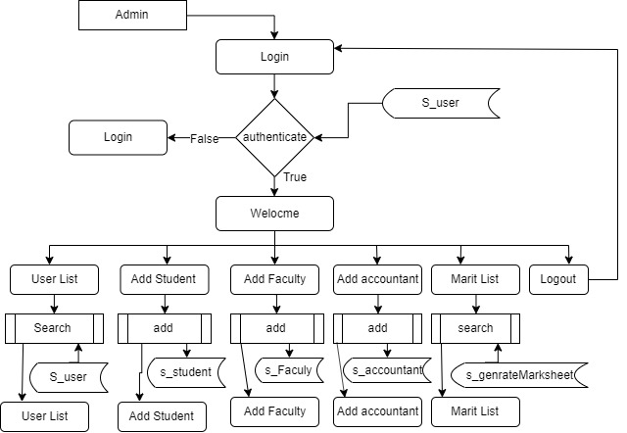

DFD For Faculty

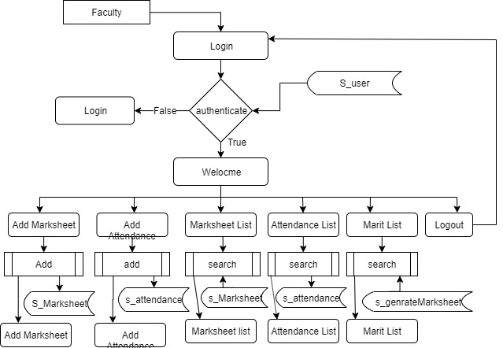

DFD For Accoutant

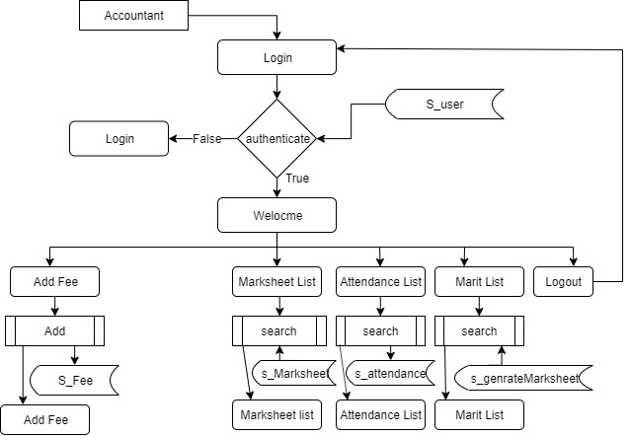

DFD for student

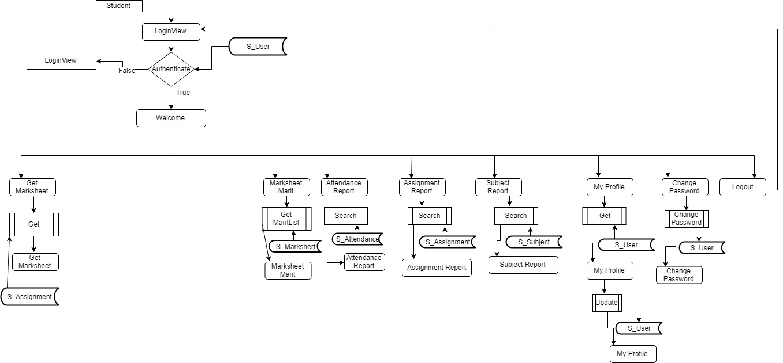

E-RDIAGRAM
An E-R model is an abstract way to describe a database. Describing a database usually starts with a relational database, which stores data in tables. Some of the data in these tables point to data in other tables - for instance, your entry in the database could point to several entries for each of the phone numbers that are yours. The ER model would say that you are an entity, and each phone number is an entity, and the relationship between you and the phone numbers is 'has a phone number'. Diagrams created to design these entities and relationships are called entity–relationship diagrams or ER diagrams.
Entity Relationships are three kinds:
- One-One
- One-Many
- Many-Many

- One-One : One instance of an entity (A) is associated with one other instance of another entity (B). For example, in a database of employees, each employee name (A) is associated with only one social security number(B).
- One-Many: One instance of an entity (A) is associated with zero, one or many instances of another entity (B), but for one instance of entity B there is only one instance of entity A. For example, for a company with all employees working in one building, the building name (A) is associated with many different employees (B), but those employees all share the same singular association with entityA.
- Many-Many: One instance of an entity (A) is associated with one, zero or many instances of another entity (B), and one instance of entity B is associated with one, zero or many instances of entity A. For example, for a company in which all of its employees work on multiple projects, each instance of an employee (A) is associated with many instances of a project (B), and at the same time, each instance of a project (B) has multiple employees (A) associated within.

ER-Diagram for the system

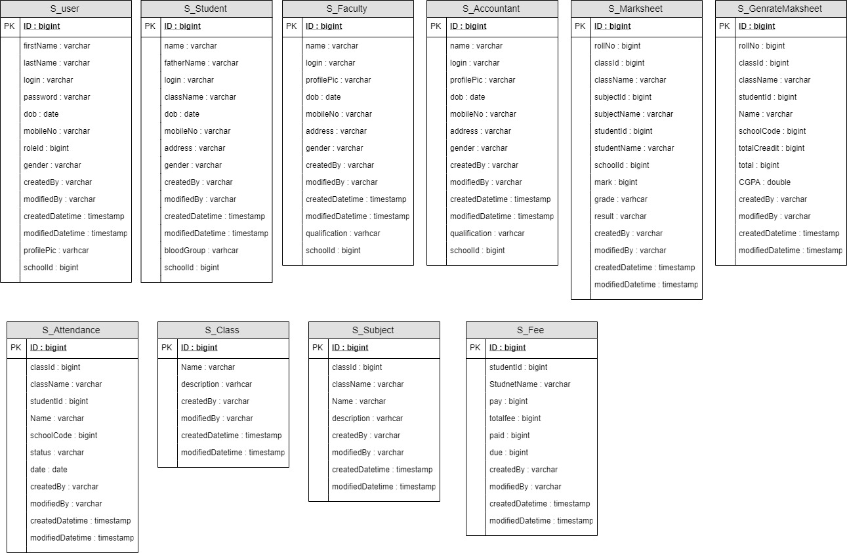

DATA INTEGRITY ANDCONSTRAINTS
Data Integrity
It is way through which access to the software or data can be controlled by the unauthorized persons. Through data integrity we can enforce data integrity rules on the data of the database. This also prevents and takes measures to protect the data from the various attacks. Attacks can be made on all three components of software: Programs, data and software. To measure integrity two additional attributes must be defined that is threats and security. The system under consideration does not allow the unauthorized access to the data as well as the document.

Data Constraints
Constraints means we enforce some rules to enter the data in a correct formatted way which gives the desired output to the user. This attribute measures the system ability to calculate and generate the desired and the correct output for the user.
    - Here, this system provides both integrity and constraints to the user.

    - In this system, wrong data entry can’t be permissible as no fields cannot be left blank, password should be greater than 6 digitsetc.

DATABASE DESIGN ANDTABLES
Database is the collection of the data, the database used for this system is Oracle Server. Oracle allocates logical database space for all data in a database. The units of database Allocation are data blocks, extents and segments. Oracle manages the space in data files of database in units called data blocks. Data block is the smallest unit of data in database.
The snapshots of the structure of tables used in this system are given below:

USER
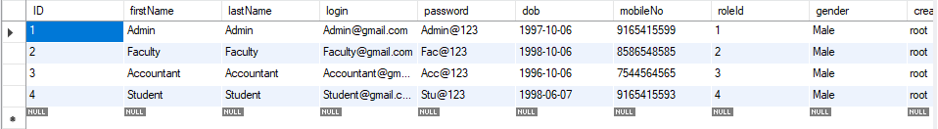

SUBJECT
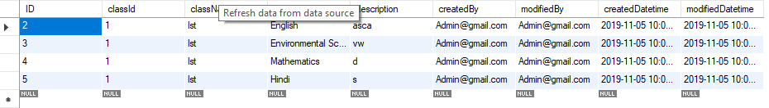

MARKSHEET
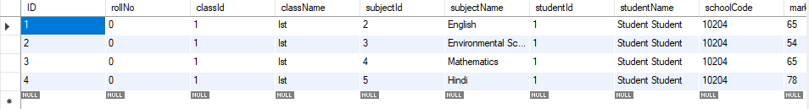

FEES

ATTENDANCE

Tables used in Student Management System

HARDWARE AND SOFTWARE REQUIREMENTS

Hardware Requirements
Processor : Pentium (orabove)
RAM : 2 GB
Hard Disk : 40 GB

Software Requirements
Operating System : Windows XP or above Java Runtime Environment : JDK/JRE 1.8 or above Database Server : MYSQL
WebServer : ApacheTomcat
Browser : Java ScriptBrowser

CODINGANDIMPLEMENTATION

TECHNOLOGYOVERVIEW
The most common types of programs written in the Java programming language are applets and applications. If you've accessed the Web, you're probably already familiar with applets. An applet is a program that adheres to certain conventions that allow it to run within a Java-enabled browser.

Java
Java is a programming language and computing platform first released by Sun Microsystems in 1995. There are lots of applications and websites that will not work unless one has installed java and more are created every day. Java is fast, secure and reliable. From laptops to data centers, game consoles to scientific supercomputers, cell phones to the Internet, Java is everywhere!
Java is an object-oriented programming language in the tradition of C and C++. But it is different from other languages in several aspects. One of the main reasons Java is so popular is its platform independence, which means that java programs can be run on different computers. The Java language itself is very simple. However, Java comes with a library of classes that provide commonly used utility functions that most java programs can’t do without. This class library, called the java API, is as much a part of Java as the language itself.
However, the Java programming language is not just for writing cute, entertaining applets for the Web. The general-purpose, high-level Java programming language is also a powerful software platform. Using the generous API, you can write many types of programs.
An application is a standalone program that runs directly on the Java platform. A special kind of application known as a server serves and supports clients on a network. Examples of servers are Web servers, proxy servers, mail servers, and print servers. Another specialized program is a servlet. A servlet can almost be thought of as an applet that runs on the server side. Java Servlets are a popular choice for building interactive web applications, replacing the use of CGI scripts. Servlets are similar to applets in that they are runtime extensions of applications. Instead of working in browsers, though, servlets run within Java Web servers, configuring or tailoring the server.

Java is a powerful platform that includes a complete set of APIs for distributed applications, allows programs to run anywhere on the network, runs on top of existing platforms (“WORA”) and reduces desktop administration costs. These features make java ideal for programming in the networked, heterogeneous world, realizing web/E- Commerce applications, integrating several technologies and programming handheld devices (PDAs, phones etc). Because of its rich set of API's, similar to Macintosh and Windows, and its platform independence, Java can also be thought of as a platform in itself. Java also has standard libraries for doing mathematics.[4]

About J2EE
The multi-tier architecture such as COBRA has got its own advantages in terms of scalability, performance and reliability. In a multi-tier architecture, a client does not interact directly with the server. Instead, it first contacts another layer called Middleware. The middleware instantiates the server applications and messages the server object. It returns results to the clients. The presence of a middleware layer allows programmers to concentrate on business logic of application. The middleware handles low-lever services, such as thread handling, security, and transactions management.
Sun Microsystems introduced the J2EE application server and the enterprise Java Bean (EJB) specifications as a venture into the multi-tier component architecture. J2EE functions as a middle tier server in three tier architectures. It provides certain specifications that can be used to implement enterprise solutions for certain all types of business requirements. J2EE also offers cost effective solution for business solution.
J2EE is used for developing, deploying and executing applications in a distributed environment. The J2EE applications server acts as a platform for implementing various server side technologies Servlets, Java Server Pages (JSP) and Enterprise Java Bean (EJB). J2EE allows you to focus on your business logic program. The business logic is coded in java program, which are reusable component that can be accessed client program EJB runs on J2EE server. In J2EE security is handled almost entirely by platform and its admin. The developer does not have to worry about writing the security logic.

J2EE Architecture
The J2EE SDK architecture consists of the following components:
      - The J2EEserver

- The EJB Container
- The Web Container
The J2EE server provides the EJB and web containers. The J2EE server enforces authenticating users. The either service provided by the J2EE server are listed here below.
- It allows client to interact with Enterprise Bean.
- It enables a web browser to access servlets and JSP files
- It provides naming and directory services to enable users and various services to locate and search for services and components.
The EJB container manages the execution of Enterprise Bean for J2EE server. EJB is a specification for making server side component that enable and simplifies the task of creating distributed objects. EJB component provide services such as transaction and security management and can be customized during deployment.
The web container manages the executing of JSP and servlets for J2EE applications web components and their container run on the J2EE server. Servlets of the java program that can be deployed on a java enable web server to enhances and extend the functionality of the web server for example you can write a servlets to add a manager service to a website.
Servlet can also be used to add dynamic content to web pages. Java Server Page (JSP) adds server side programming functionality to java. JSP consists of regular Html tags representing the static content and code enclosed within special tags representing the dynamic content. After compilation, a JSP generates a servlets and therefore incorporates all the servlets functionalities.

J2EE Application
J2EE applications access data from a variety of source and cater to a variety of client. To manage these applications the business function conducted in the middle tier. The J2EE platform acts as a middle tier and provides the necessary environment needed by the application. The J2EE platform provides” write once, run anywhere”, portability and scalability for multi-tier application. It also minimizes complexity for building multi-tier application. To create a J2EE application we need to create following threecomponents:
- J2EE application client
- Enterprise Bean
- Web component

Each of these components is packaged into a file with a specified file format. A J2EE application client is a Java application that run in a environment that enable it to access to the J2EE services. A J2EE application client is packaged into a .jar (Java archive) file. An Enterprise Bean consists of three files: the EJB class, Home and Remote Interfaces. The Enterprise Beans are bundled into an EJB.jar file. The .jar, .war and EJB.jar are assembled into a J2EE application, which is an .ear file. The .ear file is then deployed to the J2EE server.
Enterprise Bean (.jar file)
Component (.jar file)

Assembled
J2EE Application Server

Deployed

J2EE
Server

Fig-4.1: Shows Process of creating a J2EE application

J2EE Technologies
The J2EE includes many technologies such as:
  - Enterprise Java Beans(EJB)
  - Remote Method Invocation(RMI)
  - Java Naming and Directory Interface(JNDI)
  - Java Database Connectivity(JDBC)
  - Java Transaction API(JTA)
  - Java Messaging Services(JMS)
  - Java Servlet & Java Server Pages(JSP)
  - Extensible Markup Language(XML)

The J2EE Security
The architecture of the J2EE is such that it enforces security in the application. In order to access the J2EE services, a user need to prove his/her identity. Such users are called J2EE users and process is called authentication. The J2EE authentication services are different from security of the operating system. The users of the operating system and the users of the J2EE belong to a different realm. A realm is a group of users that have the same authentication policy. The users of J2EE belong to a two different realms that are respectively authentication by certificates and defaults. J2EE certificate to authenticate a web browser client. In most cases, the J2EE services use the default realm to authenticate a user. J2EE users may also belong to a group. A group is a collection of users who have common feature for example, the user belonging to a group may all belonging to a group coding same module. Similarly project managers might belong to a different group.
When client execute J2EE application it request that you enter login id and password. If the combination of both username and password correct the J2EE allow you to access the services.

Oracle10g
The race for market share in the database industry has increased with the advent of client-server platforms. Oracle 10g is one of the most successful companies that has released a number of development tools including SQL *PLUS, PL/SQL that enables faster and easier application development and its management. Oracle 10g is the robust Database System, it support very large database. Moreover Oracle 10g is widely used as back end for client / server applications. Administrative tools of Oracle 10g help in securing the Data / Information.

Some of the merits of using Oracle 10g (RDBMS) are as under:
      - Centralization of database.
      - Client Server Technology.
      - Security.
      - Normalization of DataBase.
      - Relationship.
Hence because of these features we are using Oracle 10g as a back-end technology. Whether you are working on LAN projects or Distributed projects, there are two sides of it:-

        - FrontEnd

        - BackEnd
Front End remains on client side. Front end is made for end user who uses our application. Basically in front end, our input-output forms reside which takes the input from the client and gives output back to client. Backend remains on server side and has two components viz.

REQUIREMENT ANDANALYSIS
Requirements analysis consist of following:
- Discuss with the Guide and other team members about the functionality and implementation of project: Employee Management System
- Analyzed detailed descriptions for each functionality.
- Documented all the required analysis and findings.

Functional requirements
Functional Requirements defines a function of a software system and how the system must behave when presented with specific inputs or conditions.
      - Login in website.
      - Registration of employee
      - Various requests and their handling.
      - Showing result to users.
      - Recovering password.
      - Set Schedule.
      - Mark Attendance.

Non-functional requirements
Non-Functional, are those requirements that are not directly concerned with the specific functions delivered by the system. They may relate to emergent system properties such as reliability response time and store occupancy. Alternatively, they may define constraints on the system such as the capability of the Input Output devices and the data representations used in the system interfaces. The key, non-functional requirements are:
      - Website should have pleasant look and feel.
      - Easy way navigation through webpages.
      - Attractive user interface.

TESTING

INTRODUCTION
Testing is vital to the success of any system. Testing is done at different stages within the development phase. System testing makes a logical assumption that all parts of the system is correct and the goals will be achieved successfully.
Inadequate testing or no testing leads to errors that may come up after a long time when correction would be extremely difficult.
Another objective of testing is its utility as a user-oriented vehicle before implementation.
The testing of the system was done on both test and user data. The following tests are performed.
Software testing is a critical element of software quality assurance and represents the ultimate review of specification, design and coding. In fact, testing is the one step in the software engineering process that could be viewed as destructive rather than constructive.
A strategy for software testing integrates software test case design methods into a well- planned series of steps that result in the successful construction of software. Testing is the set of activities that can be planned in advance and conducted systematically. The underlying motivation of program testing is to affirm software quality with methods that can economically and effectively apply to both strategic to both large and small-scale systems.

STRATEGIC APPROACH TO SOFTWARETESTING
The software engineering process can be viewed as a spiral. Initially system engineering defines the role of software and leads to software requirement analysis where the information domain, functions, behavior, performance, constraints and validation criteria for software are established. Moving inward along the spiral, we come to design and finally to coding. To develop computer software we spiral in along streamlines that decrease the level of abstraction on each turn.
A strategy for software testing may also be viewed in the context of the spiral. Unit testing begins at the vertex of the spiral and concentrates on each unit of the software as implemented in source code. Testing progress by moving outward along the spiral to

integration testing, where the focus is on the design and the construction of the software architecture. Talking another turn on outward on the spiral we encounter validation testing where requirements established as part of software requirements analysis are validated against the software that has been constructed. Finally we arrive at system testing, where the software and other system elements are tested as a whole.[2]

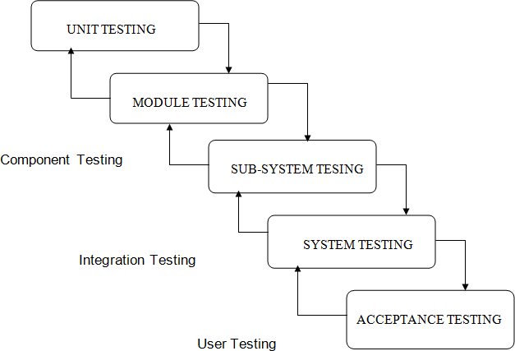

Fig. 5.1: Diagram Types of Testing

  - UNITTESTING
In unit testing the focuses is on the verification of the smallest unit of the project that is a module or a function. In unit testing we work according to white box testing that is providing the input set and checking the output is in accordance with the expected output or not.

White BoxTesting
This type of testing ensures that

  - All the independent modules and function should be executed at least once in the testing phase.
  - All the inputs of must include the boundary values & middle values.
  - All the logical decisions must be have output as true or false.
To follow the concept of white box testing we have tested each of the above mentioned forms. Tests are done to ensure correct flow of data in the system. All conditions of the system are exercised to check their accuracy

Conditional Testing
In Conditional testing, each condition is tested to both true and false aspects. And all the resulting paths of true and false output are tested. So that each path that may be generate on particular condition is traced to uncover any possible errors in the system.
All the conditions like selecting the option button for pdf and word document, not selecting the option button, providing the file path, not providing the file path etc.

Data Flow Testing
Data Flow Testing selects the path of the program according to the location of definition and use of variables. This kind of testing is used only when some local variable were declared and their scope in the program is to be tested. The definition-use chain method is used in this type of testing. It is used in situations like selecting the word document option button and then checking file is converted to .pdf format or not.[1]

TESTINTRODUCTION
The test gives a brief idea of the correct expected output and the incorrect output. This test confirms proper behavior of the GUI during system initialization and startup. The unit under test should initialize without any errors.

Test Cases
The test cases should be written to get the basic idea of the input provided to the system and the expected output to be received from the system.

In Employee module
When employee logins
  - If click on Update Details
Expected-New data saved.
  - If click on View Schedule
Expected-navigate to view schedule page.

    - If click on View Attendance
Expected- Navigate to related page.
    - If click on View Details
Expected- Navigate to related page.
    - If click on Forgot Password
Expected- Navigate to related page.

In Supervisor Module
  - When click on Delete Employee
Expected- Navigate to empdelete1 & empdelete2 to delete employee.
  - When clicks on Set Schedule.
Expected- Navigate to empeventdesc1 to finally setting the schedule.
  - When clicks on Mark Attendance.
Expected- Navigate to the related pages.
  - When clicks on View Details.
Expected- Navigate to details, details process, detailsprocess2 to view detail

CONCLUSION

CONCLUSION
Overall, the system is useful for all the users to maintain information at various levels. It connects supervisor and employee and thus easy to maintain.
Now supervisor can easily set the schedule or any notifications to the respective employees without having a person to send to employees.
It has been a great pleasure for me to work on this exciting and challenging project. This project proved good for us as it provided practical knowledge of not only programming in J2EE and Oracle Server Developer working of web based application, but also about all handling procedure related with Advance and new technology. It also provides knowledge about the latest technology used in developing web enabled application and client server technology that will be great demand in future. This will provide better opportunities and guidance in future in developing projects independently.

FUTURESCOPE
The developed system is flexible and changes can be made easily. The system is developed with an insight into the necessary modification that may be required in the future. Hence the system can be maintained successfully without much rework.
Any product despite of its meticulous design and features needs enhancement with time.EMS being no exception needs active enhancement of features and functionality. Following features are proposed to be implemented in future to make the product more feature rich.
Moreover, it is just a beginning; further the website can be enhanced by adding following facilities in the existing software:
    - Email: In each organization, there is always a need of efficient paperless, secure, and private communication medium that has the retention capabilities. We are proposing to add Intranet messaging facility to fill this requirement as an independent module in future release.
    - Template Based Look & Feel: Being a product, it is proposed to be implemented at the site of different clients. Each client has different setoff preferences for look feel of the application. To minimize the customization

process, look and feel of the application is proposed to be based on templates in future releases.
- Complete Employee Record Management: In future we propose to do all record management online or web based automated system which only requires officially needed paper work not more than that.
- Attendance through email: A complete email module for sending the attendance to respective employees which is developed separately can be integrated to the system.

REFERENCES

- Gray and Reuter, "An Introduction to Database Systems” Fifth Edition, Wesley Publication.
- Pressman, Roger S, "Software Engineering: A Practitioner's Approach" 6th Edition, Mass: McGraw-Hill Publication.
- George Franciscus and Danilo Gurovich, “Struts Recipes”, Manning Publications Company
- Emmanuel Bernard, John Griffin, ”Hibernate Search in Action”, Manning PublicationsCompany.
- Simon Singh, “The Code Book”, WileyPublication
- www.java.sun.com (Official JavaWebsite).
- www.java.sun.com/developer/onlineTraining/J2EE/Intro2/j2ee.html
- www.java.sun.com/j2se/1.4.2/docs/api/index.html
- www.w3schools.com
- www.javatpoint.com

Screen Shots

Login Page(Student/Faculty/Student)
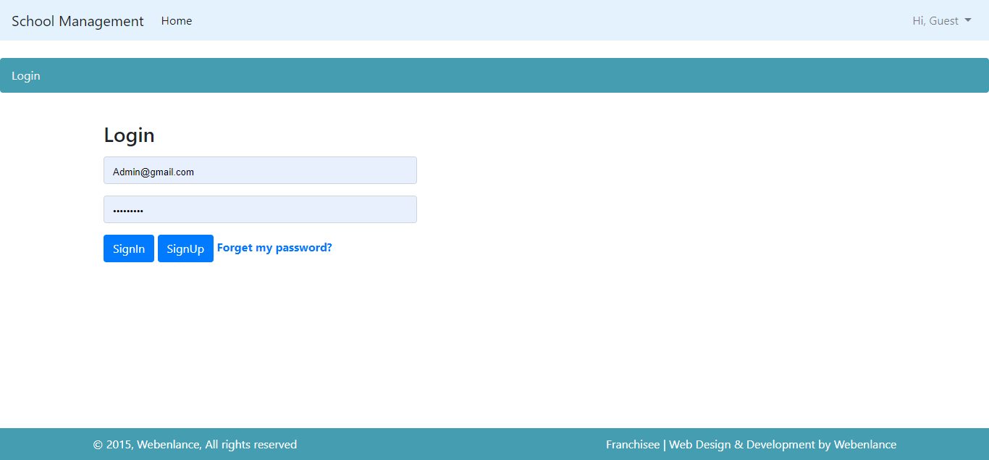

Admin Dashboard
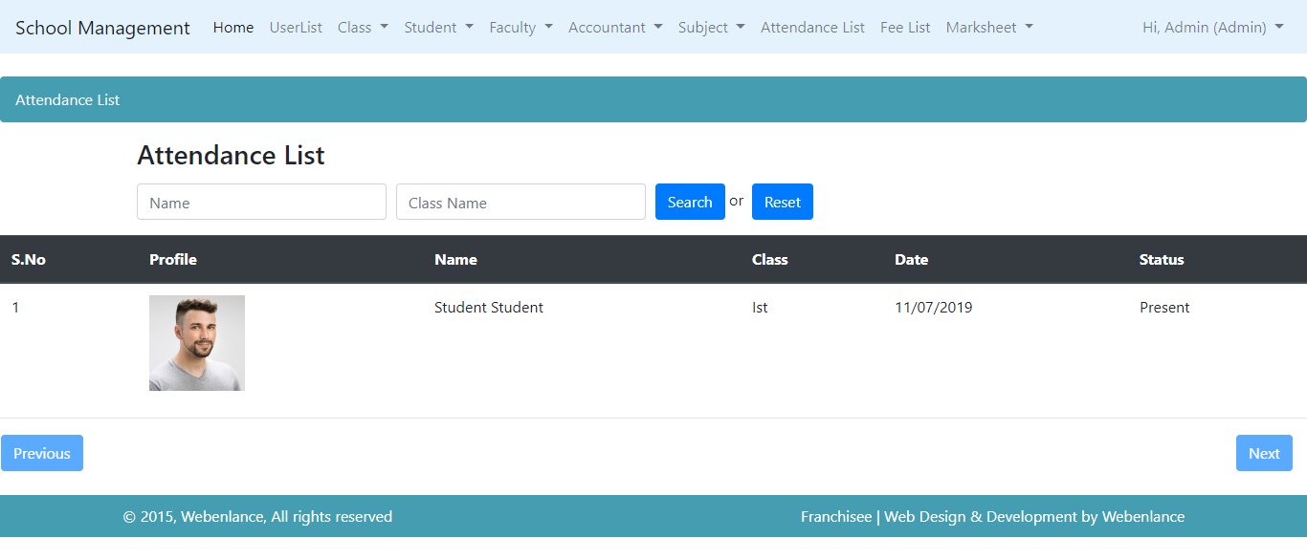

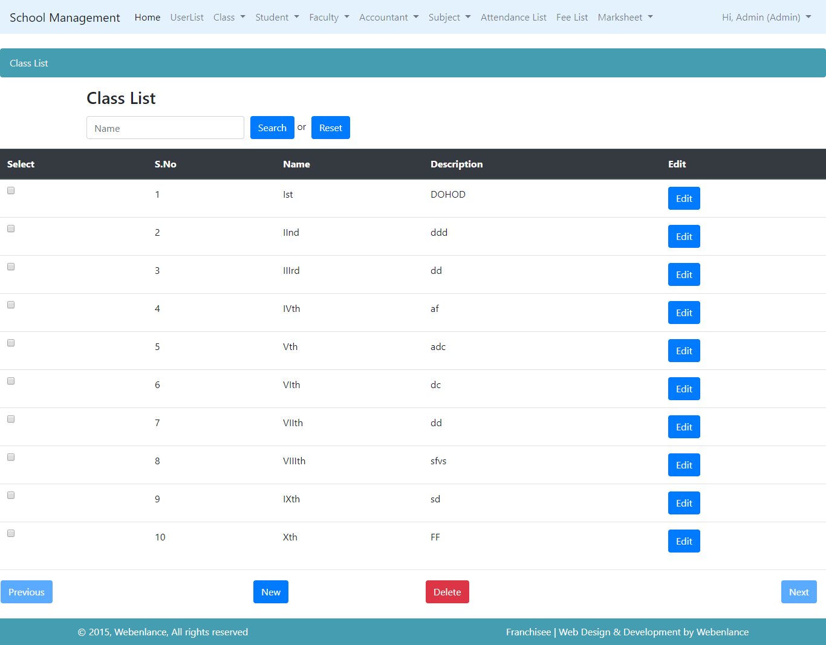

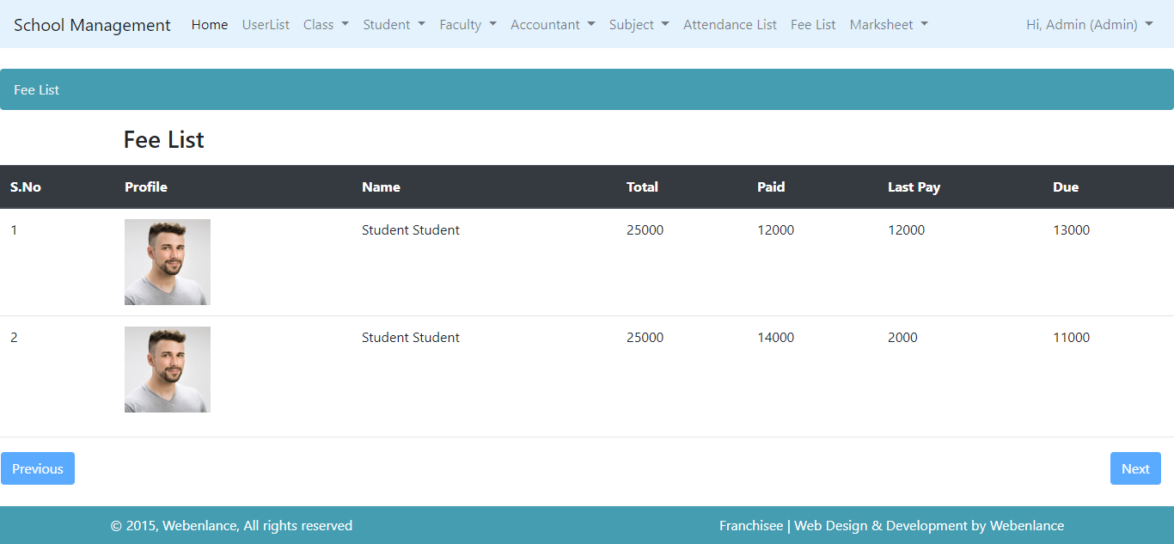

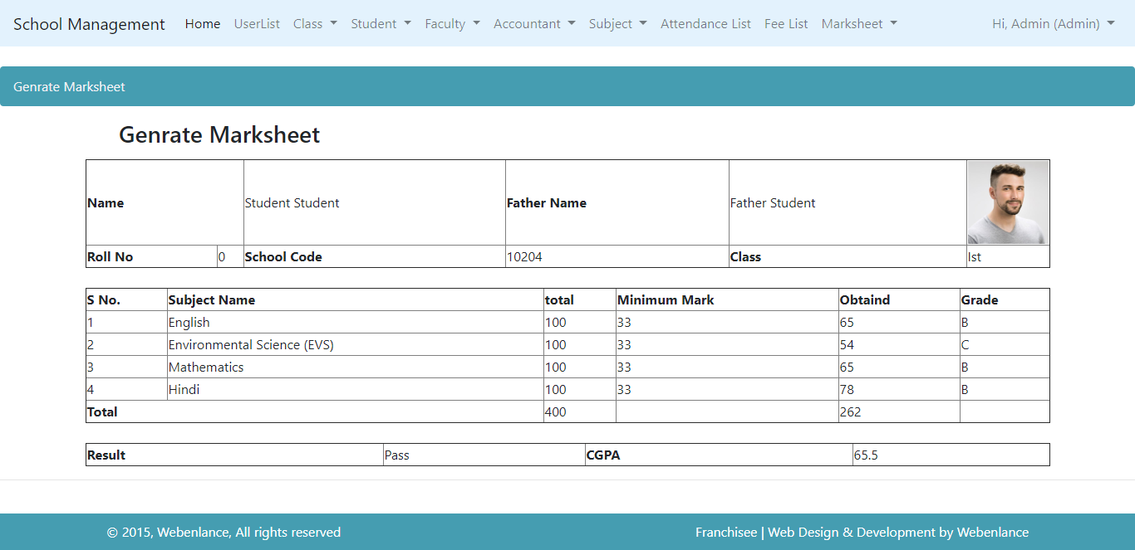

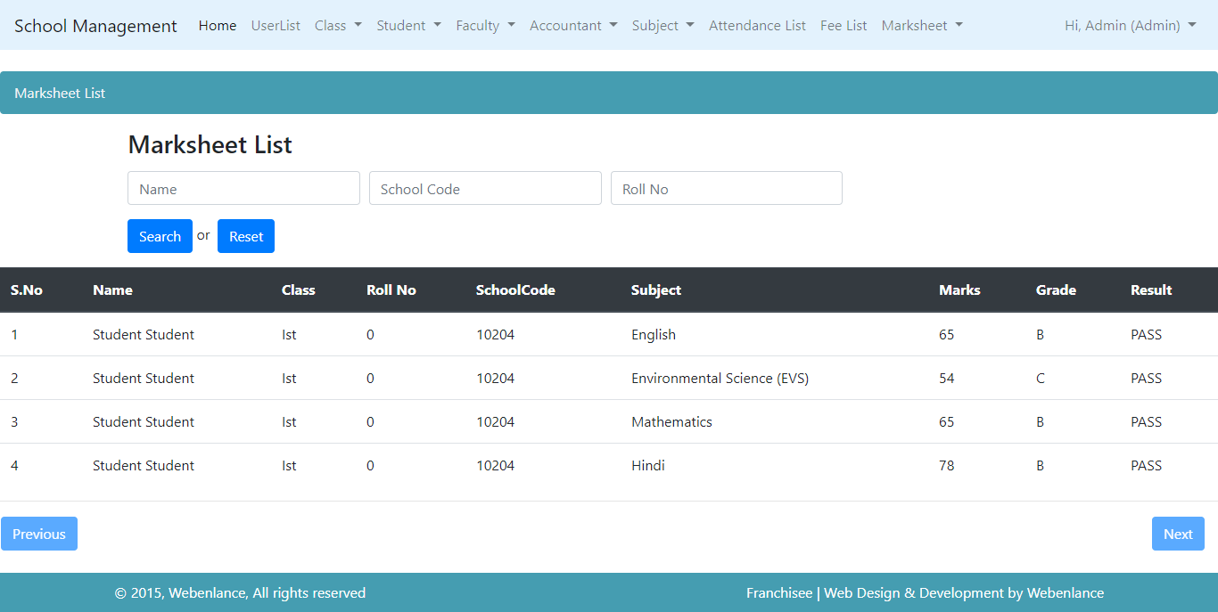

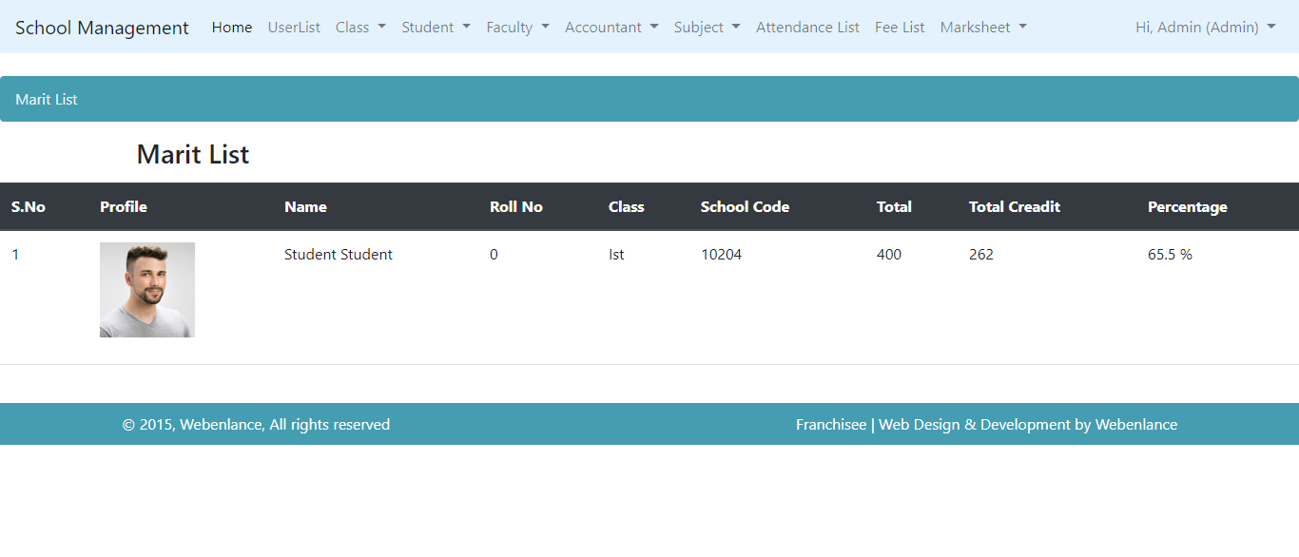
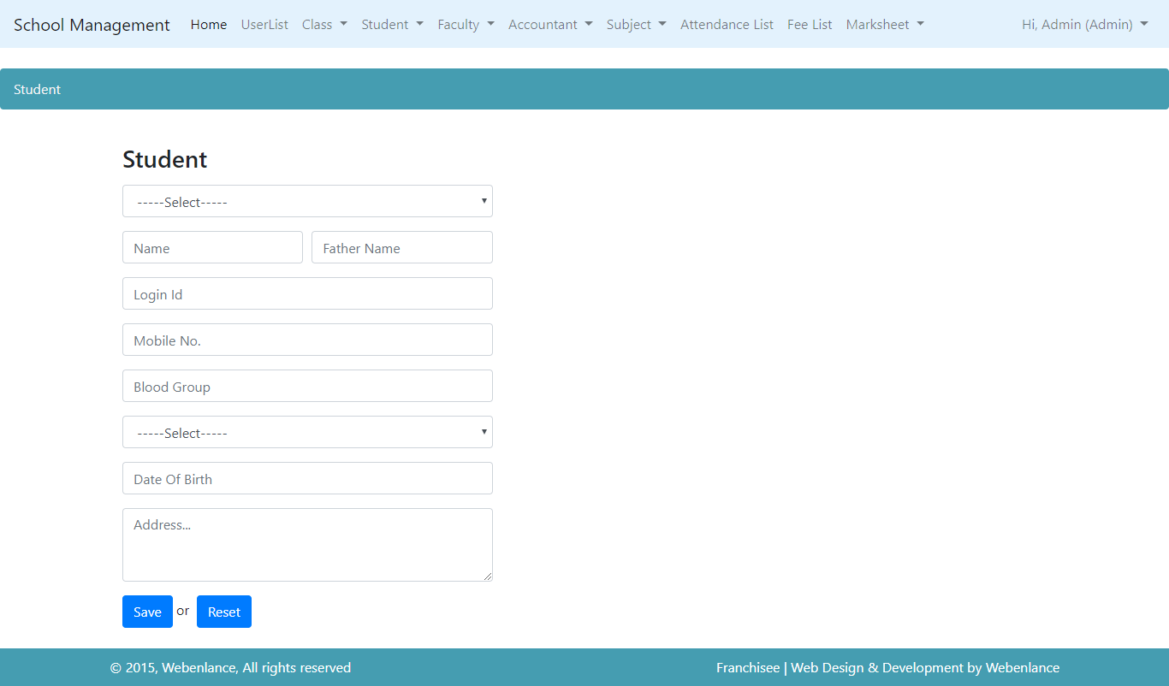

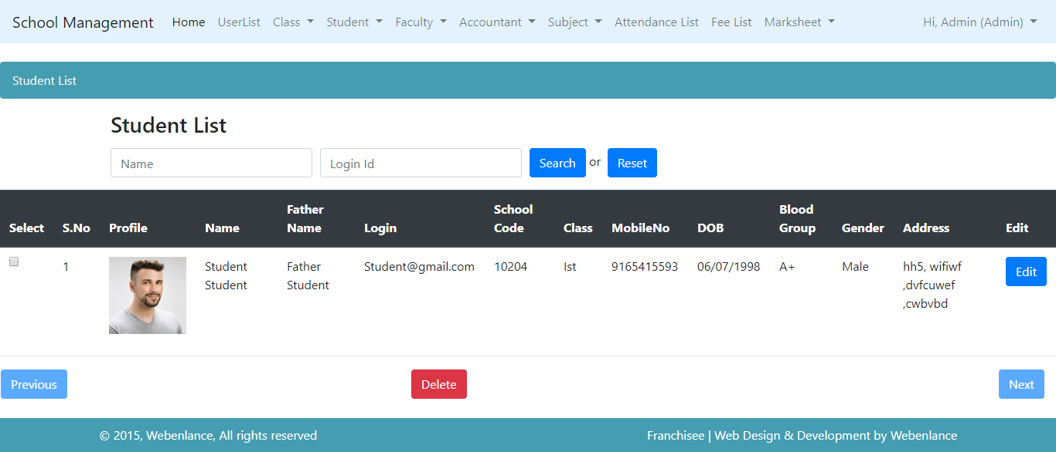

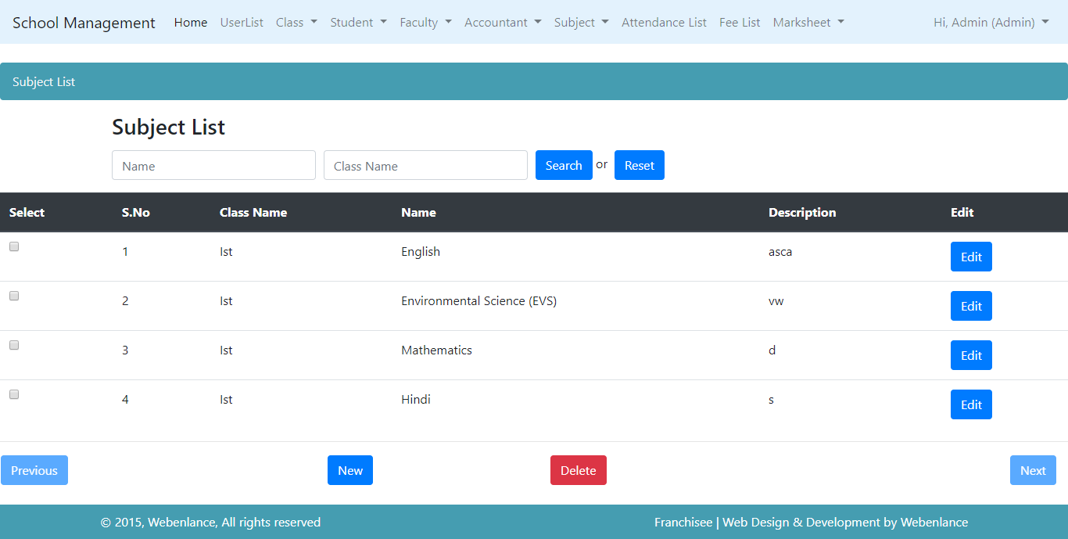

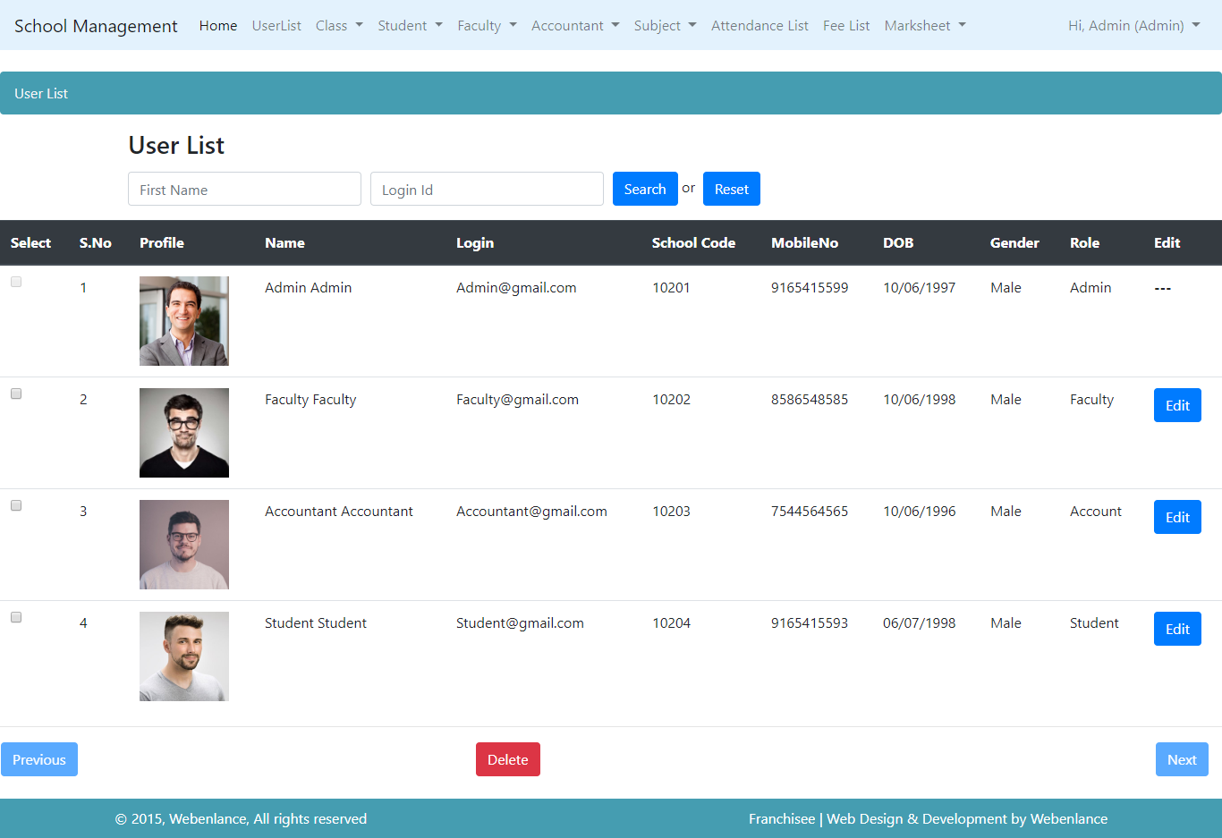

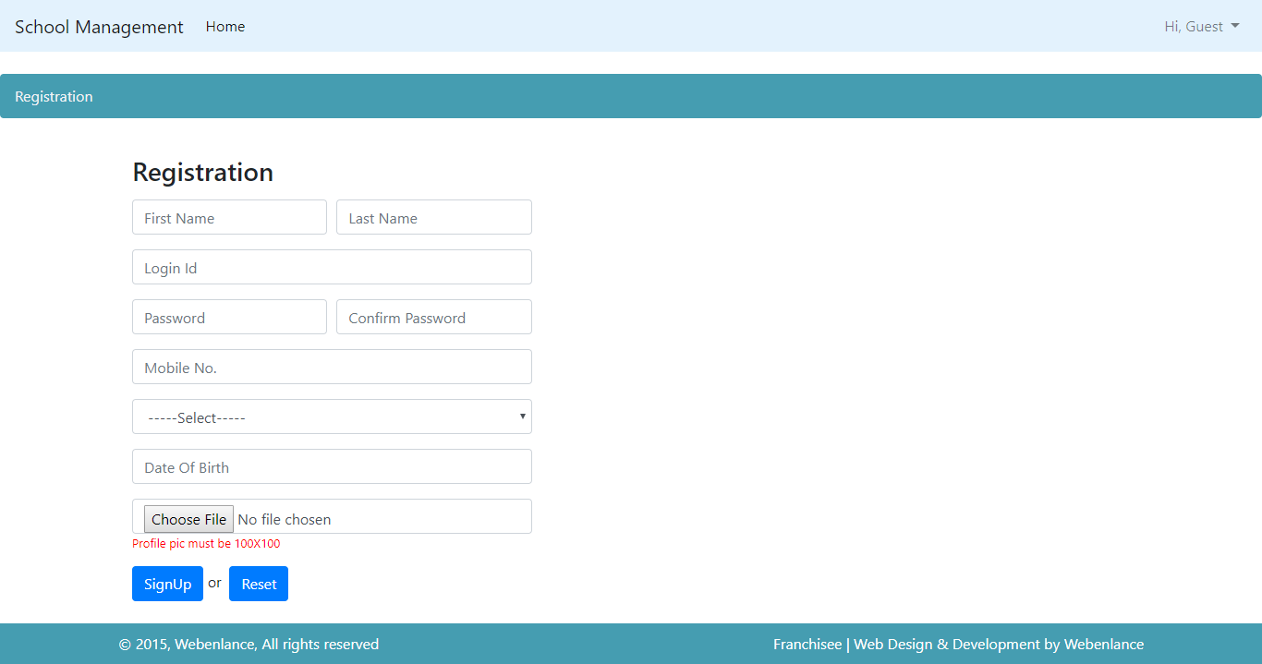

Source code
Front end:

<%@page import="in.co.school.mgt.controller.UserCtl"%>
<%@page import="java.util.HashMap"%>
<%@page import="in.co.school.mgt.util.HTMLUtility"%>
<%@page import="java.util.List"%>
<%@page import="in.co.school.mgt.util.ServletUtility"%>
<%@page import="in.co.school.mgt.util.DataUtility"%>
<%@ page language="java" contentType="text/html; charset=ISO-8859-1"
pageEncoding="ISO-8859-1"%>
<!DOCTYPE html PUBLIC "-//W3C//DTD HTML 4.01 Transitional//EN" "http://www.w3.org/TR/html4/loose.dtd">
<html>
<head>
<meta http-equiv="Content-Type" content="text/html; charset=ISO-8859-1">
<title>User</title>
</head>
<body>
<%@ include file="Header.jsp" %>
<br>
<nav
aria-label="breadcrumb" role="navigation">
<ol class="breadcrumb">

<li class="breadcrumb-item active" aria-current="page"> User</li>
</ol>
</nav>

<div col-md-5 img-thumbnail">
<div id="feedback"> <div class="container">
<div class="col-md-5">
<div class="form-area">
<form role="form" action="<%=SCMView.USER_CTL%>" method="post" >

<jsp:useBean id="bean" class="in.co.school.mgt.bean.UserBean"
scope="request"></jsp:useBean>

<input type="hidden" name="id" value="<%=bean.getId()%>">

<input type="hidden" name="createdBy" value="<%=bean.getCreatedBy()%>">
<input type="hidden" name="modifiedBy" value="<%=bean.getModifiedBy()%>">
<input type="hidden" name="createdDatetime" value="<%=DataUtility.getTimestamp(bean.getCreatedDatetime())%>">
<input type="hidden" name="modifiedDatetime" value="<%=DataUtility.getTimestamp(bean.getModifiedDatetime())%>">

<br style="clear:both">
<h3 style="margin-bottom: 15px; text-align: left: ;">Update User</h3>
<b><font color="red"> <%=ServletUtility.getErrorMessage(request)%>
</font></b>

<b><font color="Green"> <%=ServletUtility.getSuccessMessage(request)%>
</font></b>
<% List list=(List)request.getAttribute("roleList"); %>
<div class="form-group">
<%=HTMLUtility.getList("roleId",String.valueOf(bean.getRoleId()), list)%>
<font color="red"><%=ServletUtility.getErrorMessage("roleId", request)%></font>
</div>
<div class="form-row">
<div class="form-group col-md-6">
<input type="text" class="form-control" name="firstName"
placeholder="First Name" value="<%=DataUtility.getStringData(bean.getFirstName())%>" >
<font color="red"><%=ServletUtility.getErrorMessage("firstName", request)%></font>
</div>
<div class="form-group col-md-6">
<input type="text" class="form-control" name="lastName"
placeholder="Last Name" value="<%=DataUtility.getStringData(bean.getLastName())%>" >
<font color="red"><%=ServletUtility.getErrorMessage("lastName", request)%></font>
</div>
</div>
<div class="form-group">
<input type="text" class="form-control" name="login"
placeholder="Login Id" value="<%=DataUtility.getStringData(bean.getLogin())%>" >
<font color="red"><%=ServletUtility.getErrorMessage("login", request)%></font>
</div>
<div class="form-row">
<div class="form-group col-md-6">
<input type="password" class="form-control"
name="password" placeholder="Password" value="<%=DataUtility.getStringData(bean.getPassword()) %>" >
<font color="red"> <%=ServletUtility.getErrorMessage("password", request)%></font>
</div>

<div class="form-group col-md-6">
<input type="password" class="form-control"
name="confirmPassword" placeholder="Confirm Password" value="<%=DataUtility.getStringData(bean.getConfirmPassword()) %>" >
<font color="red"> <%=ServletUtility.getErrorMessage("confirmPassword", request)%></font>
</div>
</div>

<div class="form-group">
<input type="text" class="form-control" name="mobile"
placeholder="Mobile No." value="<%=DataUtility.getStringData(bean.getMobileNo())%>" >
<font color="red"><%=ServletUtility.getErrorMessage("mobile", request)%></font>
</div>

<%

HashMap map = new HashMap();
map.put("Male", "Male");
map.put("Female", "Female");
%>

<div class="form-group">
<%=HTMLUtility.getList("gender",String.valueOf(bean.getGender()), map)%>
<font color="red"><%=ServletUtility.getErrorMessage("gender", request)%></font>
</div>

<div class="form-group">
<input type="text" class="form-control" id="datepicker" name="dob"
placeholder="Date Of Birth" value="<%=DataUtility.getDateString(bean.getDob())%>" >
<font color="red"><%=ServletUtility.getErrorMessage("dob", request)%></font>
</div>

<input type="submit" name="operation"
class="btn btn-primary pull-right" value="<%=UserCtl.OP_SAVE%>">&nbsp;or&nbsp;
<input type="submit" name="operation"
class="btn btn-primary pull-right" value="<%=UserCtl.OP_RESET%>">
</form>
</div>
</div>
</div> </div> <!--feedback-->
<br>

<%@ include file="Footer.jsp"%>
</body>
</html>

Database connectivity:

package in.co.school.mgt.model;

import java.sql.Connection;
import java.sql.PreparedStatement;
import java.sql.ResultSet;
import java.util.ArrayList;
import java.util.Date;
import java.util.HashMap;
import java.util.List;
import org.apache.log4j.Logger;

import in.co.school.mgt.bean.UserBean;
import in.co.school.mgt.exception.ApplicationException;
import in.co.school.mgt.exception.DatabaseException;
import in.co.school.mgt.exception.DuplicateRecordException;
import in.co.school.mgt.exception.RecordNotFoundException;
import in.co.school.mgt.util.JDBCDataSource;

/**
* JDBC Implementation of UserModel
*
* @author Navigable Set
* @version 1.0
* @Copyright (c) Navigable Set
*/
public class UserModel {
private static Logger log = Logger.getLogger(UserModel.class);

public Integer nextPK() throws DatabaseException {
log.debug("Model nextPK Started");
Connection conn = null;
int pk = 0;

try {
conn = JDBCDataSource.getConnection();
PreparedStatement pstmt = conn.prepareStatement("SELECT MAX(ID) FROM S_USER");
ResultSet rs = pstmt.executeQuery();
while (rs.next()) {
pk = rs.getInt(1);
}
rs.close();

} catch (Exception e) {
log.error("Database Exception..", e);
throw new DatabaseException("Exception : Exception in getting PK");
} finally {
JDBCDataSource.closeConnection(conn);
}
log.debug("Model nextPK End");
return pk + 1;
}

public long nextSchoolCode() throws DatabaseException {
log.debug("Model nextPK Started");
Connection conn = null;
long pk = 0;

try {
conn = JDBCDataSource.getConnection();
PreparedStatement pstmt = conn.prepareStatement("SELECT MAX(schoolId) FROM S_USER");
ResultSet rs = pstmt.executeQuery();
while (rs.next()) {
pk = rs.getInt(1);
}
rs.close();

} catch (Exception e) {
log.error("Database Exception..", e);
throw new DatabaseException("Exception : Exception in getting PK");
} finally {
JDBCDataSource.closeConnection(conn);
}
log.debug("Model nextPK End");
if(pk>0) {
return pk + 1;
}else {
return 10201;
}
}

/**
* Add a User
*
* @param bean
* @throws DatabaseException
*
*/
public long add(UserBean bean) throws ApplicationException, DuplicateRecordException {

Connection conn = null;
int pk = 0;
long schoolCode=0;

UserBean existbean = findByLogin(bean.getLogin());

if (existbean != null) {
throw new DuplicateRecordException("Login Id already exists");
}

try {
conn = JDBCDataSource.getConnection();
pk = nextPK();
schoolCode=nextSchoolCode();
// Get auto-generated next primary key
System.out.println(pk + " in ModelJDBC");
conn.setAutoCommit(false); // Begin transaction
PreparedStatement pstmt = conn.prepareStatement("INSERT INTO S_USER VALUES(?,?,?,?,?,?,?,?,?,?,?,?,?,?,?)");
pstmt.setInt(1, pk);
pstmt.setString(2, bean.getFirstName());
pstmt.setString(3, bean.getLastName());
pstmt.setString(4, bean.getLogin());
pstmt.setString(5, bean.getPassword());
pstmt.setDate(6, new java.sql.Date(bean.getDob().getTime()));
pstmt.setString(7, bean.getMobileNo());
pstmt.setLong(8, bean.getRoleId());
pstmt.setString(9, bean.getGender());
pstmt.setString(10, bean.getCreatedBy());
pstmt.setString(11, bean.getModifiedBy());
pstmt.setTimestamp(12, bean.getCreatedDatetime());
pstmt.setTimestamp(13, bean.getModifiedDatetime());
pstmt.setString(14, bean.getProfilePic());
pstmt.setLong(15,schoolCode);
pstmt.executeUpdate();
conn.commit(); // End transaction
pstmt.close();
} catch (Exception e) {
e.printStackTrace();
try {
conn.rollback();
} catch (Exception ex) {
ex.printStackTrace();
throw new ApplicationException("Exception : add rollback exception " + ex.getMessage());
}
throw new ApplicationException("Exception : Exception in add User");
} finally {
JDBCDataSource.closeConnection(conn);
}

return pk;
}

/**
* Delete a User
*
* @param bean
* @throws DatabaseException
*/
public void delete(UserBean bean) throws ApplicationException {

Connection conn = null;
try {
conn = JDBCDataSource.getConnection();
conn.setAutoCommit(false); // Begin transaction
PreparedStatement pstmt = conn.prepareStatement("DELETE FROM S_USER WHERE ID=?");
pstmt.setLong(1, bean.getId());
pstmt.executeUpdate();
conn.commit(); // End transaction
pstmt.close();

} catch (Exception e) {

try {
conn.rollback();
} catch (Exception ex) {
throw new ApplicationException("Exception : Delete rollback exception " + ex.getMessage());
}
throw new ApplicationException("Exception : Exception in delete User");
} finally {
JDBCDataSource.closeConnection(conn);
}

}

/**
* Find User by Login
*
* @param login
* : get parameter
* @return bean
* @throws DatabaseException
*/

public UserBean findByLogin(String login) throws ApplicationException {
log.debug("Model findByLogin Started");
StringBuffer sql = new StringBuffer("SELECT * FROM S_USER WHERE LOGIN=?");
UserBean bean = null;
Connection conn = null;
System.out.println("sql" + sql);

try {
conn = JDBCDataSource.getConnection();
PreparedStatement pstmt = conn.prepareStatement(sql.toString());
pstmt.setString(1, login);
ResultSet rs = pstmt.executeQuery();
while (rs.next()) {
bean = new UserBean();
bean.setId(rs.getLong(1));
bean.setFirstName(rs.getString(2));
bean.setLastName(rs.getString(3));
bean.setLogin(rs.getString(4));
bean.setPassword(rs.getString(5));
bean.setDob(rs.getDate(6));
bean.setMobileNo(rs.getString(7));
bean.setRoleId(rs.getLong(8));
bean.setGender(rs.getString(9));
bean.setCreatedBy(rs.getString(10));
bean.setModifiedBy(rs.getString(11));
bean.setCreatedDatetime(rs.getTimestamp(12));
bean.setModifiedDatetime(rs.getTimestamp(13));
bean.setProfilePic(rs.getString(14));
bean.setSchoolId(rs.getLong(15));

}
rs.close();
} catch (Exception e) {
e.printStackTrace();
log.error("Database Exception..", e);
throw new ApplicationException("Exception : Exception in getting User by login");
} finally {
JDBCDataSource.closeConnection(conn);
}
log.debug("Model findByLogin End");
return bean;
}

/**
* Find User by PK
*
* @param pk
* : get parameter
* @return bean
* @throws DatabaseException
*/

public UserBean findByPK(long pk) throws ApplicationException {
log.debug("Model findByPK Started");
StringBuffer sql = new StringBuffer("SELECT * FROM S_USER WHERE ID=?");
UserBean bean = null;
Connection conn = null;

try {
conn = JDBCDataSource.getConnection();
PreparedStatement pstmt = conn.prepareStatement(sql.toString());
pstmt.setLong(1, pk);
ResultSet rs = pstmt.executeQuery();
while (rs.next()) {
bean = new UserBean();
bean.setId(rs.getLong(1));
bean.setFirstName(rs.getString(2));
bean.setLastName(rs.getString(3));
bean.setLogin(rs.getString(4));
bean.setPassword(rs.getString(5));
bean.setDob(rs.getDate(6));
bean.setMobileNo(rs.getString(7));
bean.setRoleId(rs.getLong(8));
bean.setGender(rs.getString(9));
bean.setCreatedBy(rs.getString(10));
bean.setModifiedBy(rs.getString(11));
bean.setCreatedDatetime(rs.getTimestamp(12));
bean.setModifiedDatetime(rs.getTimestamp(13));
bean.setProfilePic(rs.getString(14));
bean.setSchoolId(rs.getLong(15));

}
rs.close();
} catch (Exception e) {
e.printStackTrace();
log.error("Database Exception..", e);
throw new ApplicationException("Exception : Exception in getting User by pk");
} finally {
JDBCDataSource.closeConnection(conn);
}
log.debug("Model findByPK End");
return bean;
}

/**
* Update a user
*
* @param bean
* @throws DatabaseException
*/

public void update(UserBean bean) throws ApplicationException, DuplicateRecordException {
log.debug("Model update Started");
Connection conn = null;

UserBean beanExist = findByLogin(bean.getLogin());
// Check if updated LoginId already exist
if (beanExist != null && !(beanExist.getId() == bean.getId())) {
throw new DuplicateRecordException("LoginId is already exist");
}

try {
conn = JDBCDataSource.getConnection();
conn.setAutoCommit(false); // Begin transaction
PreparedStatement pstmt = conn.prepareStatement(
"UPDATE S_USER SET FIRSTNAME=?,LASTNAME=?,LOGIN=?,PASSWORD=?,DOB=?,MOBILENO=?,ROLEID=?,"
+ "GENDER=?,"
+ "CREATEDBY=?,MODIFIEDBY=?,CREATEDDATETIME=?,MODIFIEDDATETIME=?,profilePic=?,schoolId=? WHERE ID=?");
pstmt.setString(1, bean.getFirstName());
pstmt.setString(2, bean.getLastName());
pstmt.setString(3, bean.getLogin());
pstmt.setString(4, bean.getPassword());
pstmt.setDate(5, new java.sql.Date(bean.getDob().getTime()) );
pstmt.setString(6, bean.getMobileNo());
pstmt.setLong(7, bean.getRoleId());
pstmt.setString(8, bean.getGender());
pstmt.setString(9, bean.getCreatedBy());
pstmt.setString(10, bean.getModifiedBy());
pstmt.setTimestamp(11, bean.getCreatedDatetime());
pstmt.setTimestamp(12, bean.getModifiedDatetime());
pstmt.setString(13, bean.getProfilePic());
pstmt.setLong(14,bean.getSchoolId());
pstmt.setLong(15, bean.getId());
pstmt.executeUpdate();
conn.commit(); // End transaction
pstmt.close();
} catch (Exception e) {
e.printStackTrace();
log.error("Database Exception..", e);
try {
conn.rollback();
} catch (Exception ex) {
throw new ApplicationException("Exception : Delete rollback exception " + ex.getMessage());
}
throw new ApplicationException("Exception in updating User ");
} finally {
JDBCDataSource.closeConnection(conn);
}
log.debug("Model update End");
}

/**
* Search User
*
* @param bean
* : Search Parameters
* @throws DatabaseException
*/

public List search(UserBean bean) throws ApplicationException {
return search(bean, 0, 0);
}

/**
* Search User with pagination
*
* @return list : List of Users
* @param bean
* : Search Parameters
* @param pageNo
* : Current Page No.
* @param pageSize
* : Size of Page
*
* @throws DatabaseException
*/

public List search(UserBean bean, int pageNo, int pageSize) throws ApplicationException {
log.debug("Model search Started");
StringBuffer sql = new StringBuffer("SELECT * FROM S_USER WHERE 1=1");

if (bean != null) {
if (bean.getId() > 0) {
sql.append(" AND id = " + bean.getId());
}
if (bean.getFirstName() != null && bean.getFirstName().length() > 0) {
sql.append(" AND FIRSTNAME like '" + bean.getFirstName() + "%'");
}
if (bean.getLastName() != null && bean.getLastName().length() > 0) {
sql.append(" AND LASTNAME like '" + bean.getLastName() + "%'");
}
if (bean.getLogin() != null && bean.getLogin().length() > 0) {
sql.append(" AND LOGIN like '" + bean.getLogin() + "%'");
}
if (bean.getPassword() != null && bean.getPassword().length() > 0) {
sql.append(" AND PASSWORD like '" + bean.getPassword() + "%'");
}
if (bean.getDob() != null && bean.getDob().getDate() > 0) {
sql.append(" AND DOB = " + bean.getGender());
}
if (bean.getMobileNo() != null && bean.getMobileNo().length() > 0) {
sql.append(" AND MOBILENO = " + bean.getMobileNo());
}
if (bean.getRoleId() > 0) {
sql.append(" AND ROLEID = " + bean.getRoleId());
}
if (bean.getSchoolId() > 0) {
sql.append(" AND SchoolID = " + bean.getSchoolId());
}

}

// if page size is greater than zero then apply pagination
if (pageSize > 0) {
// Calculate start record index
pageNo = (pageNo - 1) * pageSize;

sql.append(" Limit " + pageNo + ", " + pageSize);
// sql.append(" limit " + pageNo + "," + pageSize);
}

System.out.println("user model search :"+sql);
ArrayList list = new ArrayList();
Connection conn = null;
try {
conn = JDBCDataSource.getConnection();
PreparedStatement pstmt = conn.prepareStatement(sql.toString());
ResultSet rs = pstmt.executeQuery();
while (rs.next()) {
bean = new UserBean();
bean.setId(rs.getLong(1));
bean.setFirstName(rs.getString(2));
bean.setLastName(rs.getString(3));
bean.setLogin(rs.getString(4));
bean.setPassword(rs.getString(5));
bean.setDob(rs.getDate(6));
bean.setMobileNo(rs.getString(7));
bean.setRoleId(rs.getLong(8));
bean.setGender(rs.getString(9));
bean.setCreatedBy(rs.getString(10));
bean.setModifiedBy(rs.getString(11));
bean.setCreatedDatetime(rs.getTimestamp(12));
bean.setModifiedDatetime(rs.getTimestamp(13));
bean.setProfilePic(rs.getString(14));
bean.setSchoolId(rs.getLong(15));

list.add(bean);
}
rs.close();
} catch (Exception e) {
log.error("Database Exception..", e);
throw new ApplicationException("Exception : Exception in search user");
} finally {
JDBCDataSource.closeConnection(conn);
}

log.debug("Model search End");
return list;
}

/**
* Get List of User
*
* @return list : List of User
* @throws DatabaseException
*/

public List list() throws ApplicationException {
return list(0, 0);
}

/**
* Get List of User with pagination
*
* @return list : List of users
* @param pageNo
* : Current Page No.
* @param pageSize
* : Size of Page
* @throws DatabaseException
*/

public List list(int pageNo, int pageSize) throws ApplicationException {
log.debug("Model list Started");
ArrayList list = new ArrayList();
StringBuffer sql = new StringBuffer("select * from S_USER");
// if page size is greater than zero then apply pagination
if (pageSize > 0) {
// Calculate start record index
pageNo = (pageNo - 1) * pageSize;
sql.append(" limit " + pageNo + "," + pageSize);
}

System.out.println("sql in list user :"+sql);
Connection conn = null;

try {
conn = JDBCDataSource.getConnection();
PreparedStatement pstmt = conn.prepareStatement(sql.toString());
ResultSet rs = pstmt.executeQuery();
while (rs.next()) {
UserBean bean = new UserBean();
bean.setId(rs.getLong(1));
bean.setFirstName(rs.getString(2));
bean.setLastName(rs.getString(3));
bean.setLogin(rs.getString(4));
bean.setPassword(rs.getString(5));
bean.setDob(rs.getDate(6));
bean.setMobileNo(rs.getString(7));
bean.setRoleId(rs.getLong(8));
bean.setGender(rs.getString(9));
bean.setCreatedBy(rs.getString(10));
bean.setModifiedBy(rs.getString(11));
bean.setCreatedDatetime(rs.getTimestamp(12));
bean.setModifiedDatetime(rs.getTimestamp(13));
bean.setProfilePic(rs.getString(14));
bean.setSchoolId(rs.getLong(15));

list.add(bean);
}
rs.close();
} catch (Exception e) {
log.error("Database Exception..", e);
throw new ApplicationException("Exception : Exception in getting list of users");
} finally {
JDBCDataSource.closeConnection(conn);
}

log.debug("Model list End");
return list;

}

/**
* @param id
* : long id
* @param old
* password : String oldPassword
* @param new
* password : String newPassword
* @throws DatabaseException
*/

public UserBean authenticate(String login, String password) throws ApplicationException {
log.debug("Model authenticate Started");
StringBuffer sql = new StringBuffer("SELECT * FROM S_USER WHERE LOGIN = ? AND PASSWORD = ?");
UserBean bean = null;
Connection conn = null;

try {
conn = JDBCDataSource.getConnection();
PreparedStatement pstmt = conn.prepareStatement(sql.toString());
pstmt.setString(1, login);
pstmt.setString(2, password);
ResultSet rs = pstmt.executeQuery();
while (rs.next()) {
bean = new UserBean();
bean.setId(rs.getLong(1));
bean.setFirstName(rs.getString(2));
bean.setLastName(rs.getString(3));
bean.setLogin(rs.getString(4));
bean.setPassword(rs.getString(5));
bean.setDob(rs.getDate(6));
bean.setMobileNo(rs.getString(7));
bean.setRoleId(rs.getLong(8));
bean.setGender(rs.getString(9));
bean.setCreatedBy(rs.getString(10));
bean.setModifiedBy(rs.getString(11));
bean.setCreatedDatetime(rs.getTimestamp(12));
bean.setModifiedDatetime(rs.getTimestamp(13));
bean.setProfilePic(rs.getString(14));
bean.setSchoolId(rs.getLong(15));
System.out.println("Usermodel here");
}
} catch (Exception e) {
log.error("Database Exception..", e);
throw new ApplicationException("Exception : Exception in get roles");

} finally {
JDBCDataSource.closeConnection(conn);
}

log.debug("Model authenticate End");
return bean;
}

/**
* @param id
* : long id
* @param old
* password : String oldPassword
* @param newpassword
* : String newPassword
* @throws org.omg.CORBA.portable.ApplicationException
* @throws DatabaseException
*/

public boolean changePassword(Long id, String oldPassword, String newPassword)
throws RecordNotFoundException, ApplicationException {

log.debug("model changePassword Started");

boolean flag = false;

UserBean beanExist = null;

beanExist = findByPK(id);

if (beanExist != null && beanExist.getPassword().equals(oldPassword)) {
beanExist.setPassword(newPassword);
try {
update(beanExist);
} catch (DuplicateRecordException e) {
log.error(e);
throw new ApplicationException("LoginId is already exist");
}
flag = true;
} else {
throw new RecordNotFoundException("Old password is Invalid");
}

log.debug("Model changePassword End");
return flag;

}

public UserBean updateAccess(UserBean bean) throws ApplicationException {
return null;
}

/**
* Register a user
*
* @param bean
* @throws ApplicationException
* @throws DuplicateRecordException
* : throws when user already exists
* @throws org.omg.CORBA.portable.ApplicationException
*/

public long registerUser(UserBean bean)
throws ApplicationException, DuplicateRecordException {

log.debug("Model add Started");

long pk = add(bean);

return pk;
}

/**
* Reset Password of User with auto generated Password
*
* @return boolean : true if success otherwise false
* @param login
* : User Login
* @throws ApplicationException
* @throws org.omg.CORBA.portable.ApplicationException
* @throws RecordNotFoundException
* : if user not found
*/

/*public boolean resetPassword(UserBean bean)
throws ApplicationException, org.omg.CORBA.portable.ApplicationException {

String newPassword = String.valueOf(new Date().getTime()).substring(0, 4);
UserBean userData = findByPK(bean.getId());
userData.setPassword(newPassword);

try {
update(userData);
} catch (DuplicateRecordException e) {
return false;
}

HashMap<String, String> map = new HashMap<String, String>();
map.put("login", bean.getLogin());
map.put("password", bean.getPassword());
map.put("firstName", bean.getFirstName());
map.put("lastName", bean.getLastName());

String message = EmailBuilder.getForgetPasswordMessage(map);

EmailMessage msg = new EmailMessage();

msg.setTo(bean.getLogin());
msg.setSubject("Password has been reset");
msg.setMessage(message);
msg.setMessageType(EmailMessage.HTML_MSG);

EmailUtility.sendMail(msg);

return true;
}*/

/**
* Send the password of User to his Email
*
* @return boolean : true if success otherwise false
* @param login
* : User Login
* @throws ApplicationException
* @throws RecordNotFoundException
* : if user not found
*
*/

public boolean forgetPassword(String login)
throws ApplicationException, RecordNotFoundException, ApplicationException {
UserBean userData = findByLogin(login);

boolean flag = false;

if (userData == null) {
throw new RecordNotFoundException("Email ID does not exists !");

}

flag = true;

return flag;
}
}

View Management interface:

package in.co.school.mgt.controller;

public interface SCMView {

public String APP_CONTEXT = "/School-Management";

public String LAYOUT_VIEW = "/BaseLayout.jsp";
public String PAGE_FOLDER = "/jsp";

public String JAVA_DOC_VIEW = APP_CONTEXT + "/doc/index.html";

public String ERROR_VIEW = PAGE_FOLDER + "/Error.jsp";

public String MARKSHEET_VIEW = PAGE_FOLDER + "/MarksheetView.jsp";
public String MARKSHEET_LIST_VIEW = PAGE_FOLDER + "/MarksheetListView.jsp";

public String GET_MARKSHEET_VIEW = PAGE_FOLDER + "/GetMarksheetView.jsp";
public String MARKSHEET_MERIT_LIST_VIEW = PAGE_FOLDER + "/MarksheetMaritListView.jsp";

public String GENRATE_MARKSHEET_VIEW = PAGE_FOLDER + "/GenrateMarksheetView.jsp";

public String MARKSHEET = PAGE_FOLDER + "/Marksheet.jsp";

public String USER_VIEW = PAGE_FOLDER + "/UserView.jsp";
public String USER_LIST_VIEW = PAGE_FOLDER + "/UserListView.jsp";
public String USER_REGISTRATION_VIEW = PAGE_FOLDER + "/UserRegistrationView.jsp";

public String CLASS_VIEW = PAGE_FOLDER + "/ClassView.jsp";
public String CLASS_LIST_VIEW = PAGE_FOLDER + "/ClassListView.jsp";

public String FEE_VIEW = PAGE_FOLDER + "/FeeView.jsp";
public String FEE_LIST_VIEW = PAGE_FOLDER + "/FeeListView.jsp";

public String SUBJECT_VIEW = PAGE_FOLDER + "/SubjectView.jsp";
public String SUBJECT_LIST_VIEW = PAGE_FOLDER + "/SubjectListView.jsp";

public String STUDENT_VIEW = PAGE_FOLDER + "/StudentView.jsp";
public String STUDENT_LIST_VIEW = PAGE_FOLDER + "/StudentListView.jsp";

public String FACULTY_VIEW = PAGE_FOLDER + "/FacultyView.jsp";
public String FACULTY_LIST_VIEW = PAGE_FOLDER + "/FacultyListView.jsp";

public String ACCOUNTANT_VIEW = PAGE_FOLDER + "/AccountantView.jsp";
public String ACCOUNTANT_LIST_VIEW = PAGE_FOLDER + "/AccountantListView.jsp";

public String ATTENDANCE_VIEW = PAGE_FOLDER + "/AttendanceView.jsp";
public String ATTENDANCE_LIST_VIEW = PAGE_FOLDER + "/AttendanceListView.jsp";

public String LOGIN_VIEW = PAGE_FOLDER + "/LoginView.jsp";
public String WELCOME_VIEW = PAGE_FOLDER + "/Welcome.jsp";
public String CHANGE_PASSWORD_VIEW = PAGE_FOLDER + "/ChangePasswordView.jsp";
public String MY_PROFILE_VIEW = PAGE_FOLDER + "/MyProfileView.jsp";
public String FORGET_PASSWORD_VIEW = PAGE_FOLDER + "/ForgetPasswordView.jsp";

public String ERROR_CTL = "/ctl/error";

public String USER_CTL = APP_CONTEXT + "/ctl/user";
public String USER_LIST_CTL = APP_CONTEXT + "/ctl/userList";

public String CLASS_CTL = APP_CONTEXT + "/ctl/class";
public String CLASS_LIST_CTL = APP_CONTEXT + "/ctl/classList";

public String FEE_CTL = APP_CONTEXT + "/ctl/fee";
public String FEE_LIST_CTL = APP_CONTEXT + "/ctl/feeList";

public String SUBJECT_CTL = APP_CONTEXT + "/ctl/subject";
public String SUBJECT_LIST_CTL = APP_CONTEXT + "/ctl/subjectList";

public String STUDENT_CTL = APP_CONTEXT + "/ctl/student";
public String STUDENT_LIST_CTL = APP_CONTEXT + "/ctl/studentList";

public String FACULTY_CTL = APP_CONTEXT + "/ctl/faculty";
public String FACULTY_LIST_CTL = APP_CONTEXT + "/ctl/facultyList";

public String ACCOUNTANT_CTL = APP_CONTEXT + "/ctl/accountant";
public String ACCOUNTANT_LIST_CTL = APP_CONTEXT + "/ctl/accountantList";

public String ATTENDANCE_CTL = APP_CONTEXT + "/ctl/attendance";
public String ATTENDANCE_LIST_CTL = APP_CONTEXT + "/ctl/attendanceList";

public String MARKSHEET_CTL = APP_CONTEXT + "/ctl/marksheet";
public String MARKSHEET_LIST_CTL = APP_CONTEXT + "/ctl/marksheetList";

public String USER_REGISTRATION_CTL = APP_CONTEXT + "/register";
public String LOGIN_CTL = APP_CONTEXT + "/login";
public String WELCOME_CTL = APP_CONTEXT + "/welcome";
public String LOGOUT_CTL = APP_CONTEXT + "/login";
public String GET_MARKSHEET_CTL = APP_CONTEXT + "/ctl/getMarksheet";
public String CHANGE_PASSWORD_CTL = APP_CONTEXT + "/ctl/changePassword";
public String MY_PROFILE_CTL = APP_CONTEXT + "/ctl/myProfile";
public String FORGET_PASSWORD_CTL = APP_CONTEXT + "/forgetPassword";
public String MARKSHEET_MERIT_LIST_CTL = APP_CONTEXT + "/ctl/marksheetMeritList";

}

Bean Class
package in.co.school.mgt.bean;

import java.util.Date;

/**
* User JavaBean encapsulates TimeTable attributes
*
* @author Navigable Set
* @version 1.0
* @Copyright (c) Navigable Set
*
*/
public class UserBean extends BaseBean {

/**
* First Name of User
*/
private String firstName;
/**
* Last Name of User
*/
private String lastName;
/**
* Login of User
*/
private String login;
/**
* Password of User
*/
private String password;
/**
* Confirm Password of User
*/
private String confirmPassword;
/**
* Date of Birth of User
*/
private Date dob;
/**
* MobielNo of User
*/
private String mobileNo;
/**
* Role of User
*/
private long roleId;

/**
* Gender of User
*/
private String gender;

public String getProfilePic() {
return profilePic;
}

public void setProfilePic(String profilePic) {
this.profilePic = profilePic;
}

/**
* Last login timestamp
*/

private String profilePic;

private long schoolId;

public long getSchoolId() {
return schoolId;
}

public void setSchoolId(long schoolId) {
this.schoolId = schoolId;
}

/**
* @return FirstName Of User
*/

public String getFirstName() {
return firstName;
}

/**
* @param FirstName
* To set User FirstName
*/
public void setFirstName(String firstName) {
this.firstName = firstName;
}

/**
* @return LastName Of User
*/
public String getLastName() {
return lastName;
}

/**
* @param LastName
* To set User LastName
*/
public void setLastName(String lastName) {
this.lastName = lastName;
}

/**
* @return Login id Of User
*/
public String getLogin() {
return login;
}

/**
* @param Login
* Id To set User Login ID
*/
public void setLogin(String login) {
this.login = login;
}

/**
* @return Password Of User
*/
public String getPassword() {
return password;
}

/**
* @param Password
* To set User Password
*/
public void setPassword(String password) {
this.password = password;
}

/**
* @return Confirm Password Of User
*/
public String getConfirmPassword() {
return confirmPassword;
}

/**
* @param Confirm
* PAssword To set User Confirm Password
*/
public void setConfirmPassword(String confirmPassword) {
this.confirmPassword = confirmPassword;
}

/**
* @return Date Of Birth Of User
*/
public Date getDob() {
return dob;
}

/**
* @param Date
* Of Birth To set User Date Of Birth
*/

public void setDob(Date dob) {
this.dob = dob;
}

/**
* @return Mobile No Of User
*/
public String getMobileNo() {
return mobileNo;
}

/**
* @param Mobile
* No To set User Mobile No
*/
public void setMobileNo(String mobileNo) {
this.mobileNo = mobileNo;
}

/**
* @return ROle Id Of User
*/
public long getRoleId() {
return roleId;
}

/**
* @param Role
* Id To set User ROle Id
*/
public void setRoleId(long roleId) {
this.roleId = roleId;
}

/**
* @return unSuccessfulLogin Of User
*/
public String getGender() {
return gender;
}

/**
* @param Gender
* To set User Gender
*/
public void setGender(String gender) {
this.gender = gender;
}

public String getKey() {
return id + "";
}

public String getValue() {

return firstName + " " + lastName;
}
}

