Abstract
The Transport Management Project, developed on the Spring Boot framework with the integration of JPA, Hibernate, and MySQL, presents an innovative solution for optimizing transportation operations. This dynamic platform caters to three distinct user roles: Admin, Customer, and Driver, facilitating seamless communication and efficient management of transportation services. Admins, as system architects, oversee the network, adding Drivers and managing routes. Customers engage through an intuitive interface, booking services and providing feedback, while Drivers access assignments and route information. The MVC architecture ensures a modular and organized codebase, while ERD and DFD enhance database and system design. The project leverages Java technologies to enable responsive and scalable solutions, with MySQL ensuring efficient data management. Transparent source code on GitHub encourages collaboration, and screenshots showcase user interfaces. The Transport Management Project stands as a testament to the power of modern Java technologies in addressing complex transportation challenges, offering a user-friendly and scalable solution for Admins, Customers, and Drivers.

Introduction:
In an era characterized by dynamic urbanization and increased mobility, efficient transportation management emerges as a critical component of modern infrastructure. The Transport Management Project represents a forward-thinking solution developed on the Spring Boot framework, integrating Java Persistence API (JPA), Hibernate, and MySQL technologies. This innovative platform is designed to revolutionize the logistics and coordination involved in transportation operations. With a focus on user roles—Admin, Customer, and Driver—the project aims to streamline communication and enhance the overall efficiency of transportation services. Through the utilization of the Model-View-Controller (MVC) architecture, meticulous database design with an Entity Relationship Diagram (ERD), and a seamless integration of Java technologies, the project stands as a testament to the transformative potential of modern software solutions in addressing the intricate challenges of transportation logistics. This introduction sets the stage for a comprehensive exploration of the Transport Management Project, highlighting its significance in the ever-evolving landscape of transportation management.

Project Overview:
The Transport Management Project is a comprehensive and innovative solution developed on the Spring Boot framework, employing Java Persistence API (JPA), Hibernate, and MySQL technologies. With a primary focus on optimizing transportation operations, the project introduces a dynamic platform that caters to three distinct user roles: Admin, Customer, and Driver.
Admin Functionality:
Administrators play a pivotal role as system architects, overseeing the entire transportation network. Their responsibilities include adding and managing Drivers, overseeing routes, and ensuring the seamless functioning of the platform.
Customer Interaction:
The platform provides an intuitive interface for Customers to engage with transportation services effortlessly. Customers can book services, provide feedback, and access relevant information through a user-friendly interface.
Driver Operations:
Authenticated users, or Drivers, utilize the platform to access assignments, receive route information, and update their availability. The system facilitates effective communication between Admins, Customers, and Drivers.
Technological Framework:
Built on the Model-View-Controller (MVC) architecture, the project ensures a modular and organized codebase. The database design is fortified with an Entity Relationship Diagram (ERD), and data flow intricacies are captured through a Data Flow Diagram (DFD).
Java Technologies Integration:
The project leverages the capabilities of Java technologies such as JPA and Hibernate, ensuring seamless data persistence and retrieval. MySQL serves as the backend database, offering efficient storage and management of data.
Collaborative Development:
With transparency at its core, the project's source code is accessible on GitHub, fostering collaboration and community engagement. Key features are visually represented through screenshots, providing a comprehensive overview of the user interfaces for Admins, Customers, and Drivers.
In essence, the Transport Management Project is poised to redefine the landscape of transportation logistics, offering a user-friendly, scalable, and technologically advanced solution that addresses the diverse needs of Admins, Customers, and Drivers in the modern era of transportation management.

Technologies Used:

The Transport Management Project embraces a diversified technology stack to cater to both frontend and backend requirements, fostering a seamless and responsive user experience.

1. Frontend Technologies
a. JSP (JavaServer Pages):
- Purpose: JSP is employed for dynamic generation of web pages based on HTML.
- How: JSP allows for the integration of Java code within HTML, facilitating the creation of
dynamic web pages that can adapt to changing data and user inputs.
b. HTML (HyperText Markup Language):
- Purpose: HTML provides the fundamental structure for creating web pages.
- How: HTML is used to define the structure and content of web pages, ensuring
compatibility across various browsers and devices.
c. CSS (Cascading Style Sheets):
- Purpose: CSS is utilized for styling and layout, enhancing the visual presentation of the web application.
- How: By defining styles and layouts, CSS ensures a consistent and aesthetically pleasing
user interface across different pages and devices.
d. JavaScript (JS):
- Purpose:JavaScript enhances the interactivity and responsiveness of the user interface.
- How: Leveraging JavaScript, the project incorporates client-side scripting to enable dynamic content updates, form validation, and other interactive features, contributing
to a more engaging user experience.

2. Backend Technologies:
a. Spring Boot (Java):
- Purpose: Spring Boot serves as the backend framework for building Java-based enterprise
applications.
- How: Utilizing the power of Java, Spring Boot handles the application's business logic, data processing, and interaction with the database. It provides a robust and
convention-over-configuration approach to backend development.

b. Java Persistence API (JPA) and Hibernate:
- Purpose: JPA and Hibernate facilitate seamless data persistence and interaction with the relational database.
- How: These technologies streamline the communication between Java objects and the database, ensuring efficient data storage and retrieval.
c. MySQL Database:
- Purpose:MySQL is employed as the backend database for storing and managing data securely.
- How: By providing a reliable and scalable database solution, MySQL supports the storage 4
and retrieval of information critical to transportation management.
By integrating these frontend and backend technologies, the Transport Management Project achieves a well-rounded and effective solution, ensuring a responsive, user-friendly, and functionally rich transportation management platform.

System Architecture:

The Transport Management Project adopts a robust and modular system architecture, following the widely recognized Model-View-Controller (MVC) design pattern. This architectural choice enhances code organization, maintainability, and scalability, providing a clear separation of concerns within the application.

1. Model-View-Controller (MVC) Pattern:
- Purpose: MVC divides the application into three interconnected components to manage complexity and promote efficient collaboration among developers.
- How:
  - Model (M): Represents the application's data and business logic. In the Transport Management Project, the model includes entities such as vehicles, routes, and schedules, encapsulating the data-related operations.
- View (V): Manages the presentation and user interface. Views in the project include the interfaces for Admins, Customers, and Drivers, ensuring a responsive and intuitive display of information.
- Controller (C): Handles user input, manages the flow of data between the model and view, and orchestrates the overall application behavior. Controllers in the project govern actions such as route planning, vehicle tracking, and user authentication.

2. Advantages of MVC Architecture:
- Modularity: The separation of concerns allows developers to focus on specific components without impacting others, promoting modular development and easy maintenance.
- Scalability: MVC facilitates the addition of new features or modifications to existing ones without disrupting the entire application, promoting scalability.
- Code Reusability: Components are loosely coupled, enabling the reuse of models, views, and controllers in different parts of the application or even in other projects.
- Parallel Development: Developers can work concurrently on different components, accelerating the development process and ensuring timely project delivery.

3. Application in Transport Management:
- Model: Entities such as vehicles, routes, and schedules are encapsulated in the model, managing the application's data and business logic.
- View: User interfaces for Admins, Customers, and Drivers represent the views, ensuring a visually appealing and user-friendly experience.
- Controller: The application's logic, such as route planning and user authentication, is orchestrated by controllers, ensuring a seamless flow of data between the model and view.

The adoption of MVC architecture in the Transport Management Project reflects a strategic approach to system design, fostering maintainability, extensibility, and collaboration among developers. This well-structured architecture contributes to the project's overall efficiency and adaptability in addressing the complexities of transportation management.

Development Process
Requirements gathering and analysis:

The initial phase of the Transport Management Project involves a meticulous process of requirements gathering and analysis. This critical stage lays the foundation for the entire development process, ensuring a clear understanding of the stakeholders' needs and expectations.

1. Objective:
- Understand and Define Project Scope: The primary objective is to comprehensively understand the requirements of the Transport Management System. This includes identifying both functional and non-functional aspects and defining the scope of the project.

2. Approach:
- Stakeholder Engagement:
  - Admins, Customers, and Drivers: Engage with key stakeholders to elicit their requirements. Admins provide insights into system management, Drivers contribute operational perspectives, and Customers share their expectations for a user-friendly interface.
  - In-Depth Interviews: Conduct in-depth interviews and workshops to gather detailed information. This interactive approach allows for a nuanced understanding of user needs and challenges.

- Documentation:
  - Use Cases and User Stories: Document specific use cases and user stories to capture the different scenarios and interactions within the system. This aids in translating abstract requirements into tangible functionalities.
  - Functional and Non-functional Requirements: Clearly define both functional requirements, such as route planning and vehicle tracking, and non-functional requirements, such as system performance and security.

3. Outputs:
- Requirements Document:
  - Compile all gathered information into a comprehensive requirements document. This document serves as a roadmap for the development team, providing a detailed understanding of what needs to be achieved.
  - Include a prioritized list of features, system constraints, and any specific regulatory or compliance requirements.

4. Benefits:
- Alignment with Stakeholder Expectations: By engaging stakeholders in the requirements gathering process, the project ensures that the final product aligns with their expectations and addresses their specific needs.
- Reduced Ambiguity: Clearly defined requirements minimize ambiguity and misunderstandings, providing a solid foundation for subsequent development stages.
- Risk Mitigation: Identifying potential challenges and constraints early in the process allows for proactive risk mitigation strategies.

5. Challenges:
- Changing Requirements: In dynamic environments, requirements may evolve over time. Regular communication and iterative reviews help address changes efficiently.
- Balancing Stakeholder Interests: Different stakeholders may have conflicting priorities. The challenge lies in finding a balance that meets the overall project objectives.

The meticulous approach to requirements gathering and analysis sets the stage for a successful and targeted development process. It ensures that the Transport Management Project is not only technically robust but also closely aligned with the real-world needs of its diverse user base.

Database design
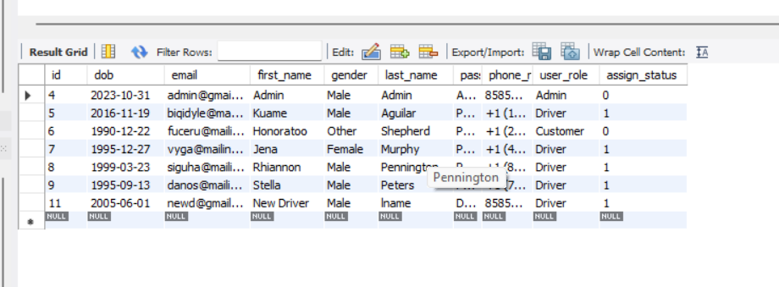

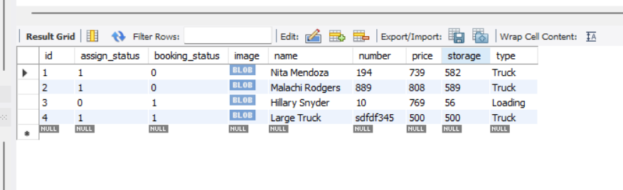

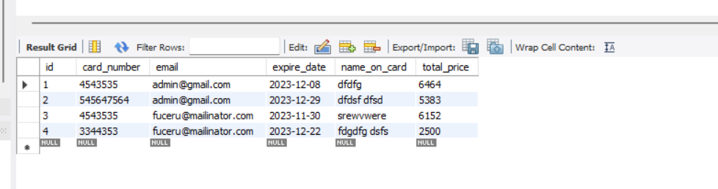

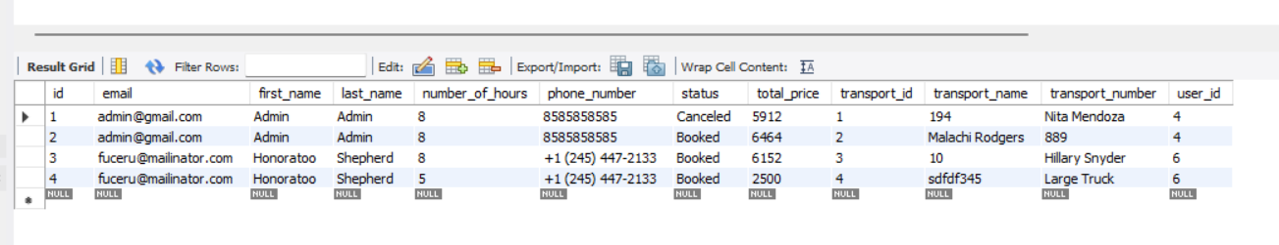

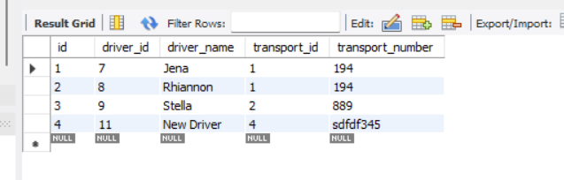

Entity Relationship Diagram
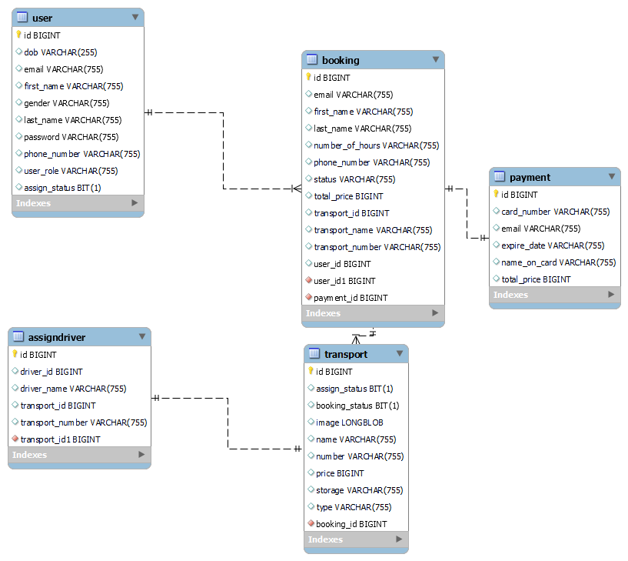

Data FlowDiagram
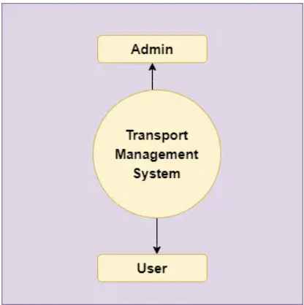
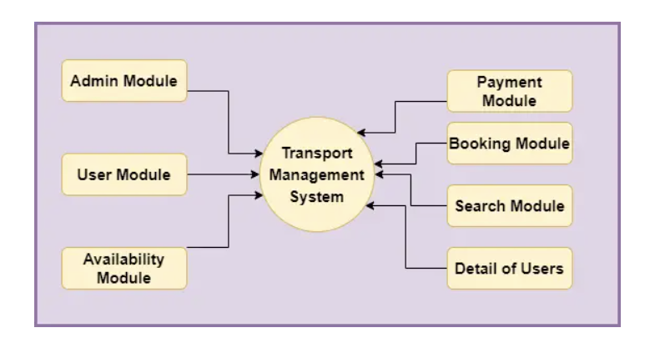
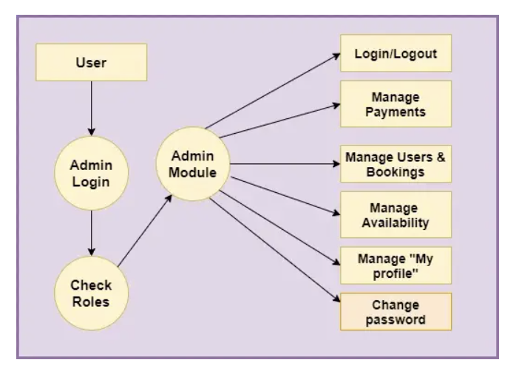
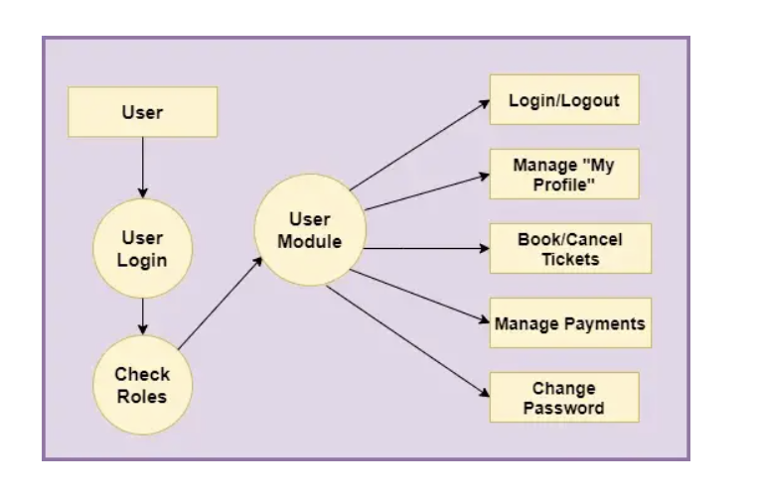

Development

Following the thorough process of requirements gathering and analysis, the Transport Management Project transitions into the development phase. This pivotal stage involves translating the identified requirements into a functional and efficient system. The development process is guided by the principles of modularity, adherence to best coding practices, and continuous collaboration between the development team and stakeholders.

1. Implementation of Backend Logic:
- Technology Stack:
  - Spring Boot, JPA, Hibernate, MySQL: Leveraging the Spring Boot framework, the backend logic is implemented using Java. JPA and Hibernate facilitate seamless interaction with the MySQL database, ensuring efficient data persistence.
- Modular Design:
  - Controller Layer: Handles user input, manages the flow of data between the model and view, and orchestrates overall application behavior.
  - Service Layer: Contains business logic, ensuring the separation of concerns and enhancing code maintainability.
  - Repository Layer: Manages the interaction with the database using JPA repositories, abstracting the underlying data access complexities.

2. Frontend Development:
- Technology Stack:
  - JSP, HTML, CSS, JavaScript: JSP dynamically generates web pages based on HTML, while CSS enhances the visual appeal. JavaScript contributes to interactive features, ensuring a dynamic and user-friendly frontend.
- User Interface (UI) Design:
  - Admin Interface: Tailored to accommodate system management functionalities, providing Admins with a comprehensive view of transportation operations.
  - Customer Interface: User-friendly design for Customers, enabling easy booking, feedback provision, and access to relevant information.
  - Driver Interface: Optimized for operational efficiency, presenting Drivers with assignment details, route information, and availability updates.

3. MVC Architecture Implementation:
- Organization of Codebase:
  - Model: Represents entities such as vehicles, routes, and schedules, encapsulating data-related operations.
  - View: User interfaces for Admins, Customers, and Drivers, ensuring a responsive and intuitive display of information.
  - Controller: Orchestrates the flow of data between the model and view, handling user input and application behavior.
- Benefits of MVC:
  - Modularity: Code is organized into distinct components, promoting ease of maintenance and scalability.
  - Separation of Concerns: Different aspects of the application (data, presentation, control) are handled independently, reducing complexity.

4. Iterative Development:
- Agile Methodology:
  - Sprints: Adopt an iterative approach with regular sprints, allowing for continuous integration of features and feedback from stakeholders.
  - Adaptability: Embrace changes and refinements to requirements, ensuring that the system evolves in response to user needs.

5. Version Control:
- Git:
  - Repository Management: Utilize Git for version control, allowing collaborative development and tracking changes to the codebase.
  - GitHub Integration: Host the project on GitHub to enhance collaboration, transparency, and version management.

The development phase of the Transport Management Project is characterized by a structured and iterative approach, embracing modern technologies and best practices. The emphasis on modularity, collaboration, and continuous improvement ensures the creation of a robust and user-friendly transportation management system.

Testing:

The testing phase is pivotal in ensuring the robustness and reliability of the Transport Management Project. Key objectives include confirming system reliability, validating specified functionalities, and securing sensitive data. Various testing types and tools are employed:

1. Testing Types:
- Unit Testing: Validates individual components, identifying and addressing issues at an early stage.
- Integration Testing: Verifies cohesive interaction between modules to ensure accurate data sharing.
- System Testing: Conducts end-to-end tests simulating real-world scenarios to validate overall system functionality.
- User Acceptance Testing (UAT): Engages stakeholders for feedback, ensuring the system aligns with business requirements.

2. Testing Tools:
- JUnit (Unit Testing): Identifies issues in individual Java components early in development.
- Postman (API Testing): Ensures APIs respond correctly and handle requests appropriately.
- Selenium (End-to-End Testing): Automates testing to validate overall functionality and user experience.

3. Performance Testing:
- Objective: Assesses system performance under varying conditions.
- Approach: Utilizes tools like Apache JMeter to simulate user activity and measure system response.

4. Security Testing:
- Objective: Identifies and addresses potential security vulnerabilities.
- Approach: Conducts thorough security assessments, including penetration testing.

5. Documentation:
- Testing Plan and Cases: Outlines the scope, objectives, and methodologies for each testing phase. Documents detailed test cases.

6. Bug Tracking and Resolution:
- Usage: Tracks and prioritizes bugs and issues for resolution.
- Approach: Collaborates with developers to promptly address and resolve identified bugs.

7. User Feedback Incorporation:
- Purpose: Integrates stakeholder feedback obtained during UAT.
- Approach: Implements necessary adjustments for an enhanced user experience.

Thorough testing contributes to a reliable and user-friendly transportation management system, meeting the highest quality standards before deployment.

Screen Shots
Add Latest SS after project configuration

Conclusion:
The Transport Management Project represents a comprehensive and innovative solution for optimizing transportation operations. Developed on the Spring Boot framework with integration of Java Persistence API (JPA), Hibernate, and MySQL, the project demonstrates a commitment to efficiency, scalability, and user-friendly design.
The systematic approach to requirements gathering, meticulous database design with Entity Relationship Diagrams, and a robust system architecture following the Model-View-Controller (MVC) pattern lay a strong foundation for the development process. The implementation phase showcases a seamless integration of backend logic using Spring Boot and frontend development with JSP, HTML, CSS, and JavaScript.
Testing, a critical phase, ensures the reliability, functionality, and security of the system. From unit and integration testing to user acceptance testing and security assessments, the project undergoes rigorous evaluation using tools such as JUnit, Postman, Selenium, and Apache JMeter.
The collaboration between development teams, stakeholders, and the incorporation of user feedback contribute to an iterative and adaptive development process. The use of Git for version control enhances transparency and collaborative development.
In conclusion, the Transport Management Project stands as a testament to the power of modern Java technologies in addressing complex transportation challenges. With a user-friendly interface for Admins, Customers, and Drivers, and a robust backend system, the project offers a scalable and efficient solution for transportation management. The emphasis on testing ensures a reliable and secure platform, meeting the highest standards of quality. As the project moves towards deployment, it is poised to revolutionize the landscape of transportation logistics, offering a streamlined and technology-driven approach to managing transportation services.

