Instructions:
- Download the Java-.jar-File under: http://www.mediafire.com/download/pkmtcw1gb5cgqs6/bfmeResFix_v1.4.0+Final.jar
Tested for viruses: https://www.virustotal.com/de/url/f01fafcf82a15e6494b9172f6f97f4065766879cb6c8c12da93c7c5f7f33eb7d/analysis/
Browsers like Google Chrome demand a security check.

- Start the downloaded Java-.jar-File with Java Platform SE binary.
You might need to install the latest Java-version: https://www.java.com/en/download/
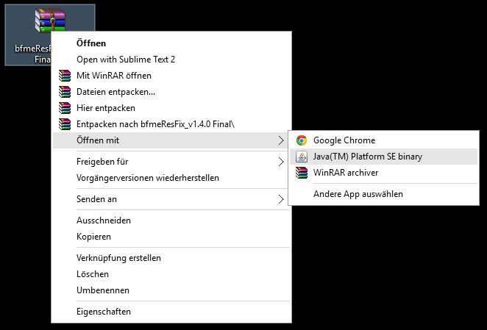

- Choose the Language in which you’ve installed the game and select your preferred resolution.
Note:
- Your current monitor-resolution is auto-selected.
- Your preferred resolution should not be larger than your monitors resolution, because the game has no support for Decimation like Nvidia DSR.

- Apply changes
A pop-up will appear (see Figure).
- „Done! (Created + Path)“ – The file did not existed before and has been generated .
- „Done! (Edited + Path)“ – The file existed before and has been edited.

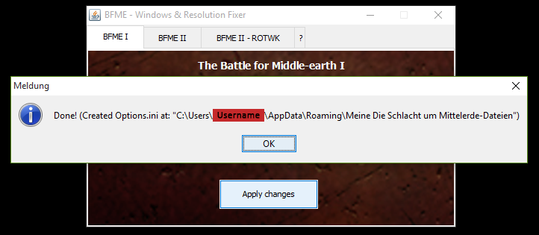

- Start the game
Note:
If you have a computer with two graphics processing units you need to start the game with your dedicated GPU (In this example: use the „NVIDIA High-performance-processor“)
Hint:
If you want to manually patch the game, just go to my Mediafire-Folder:
https://www.mediafire.com/folder/s50wrxf0a7w0s/Patches_for_The_Battle_for_Middle-Earth-Trilogy

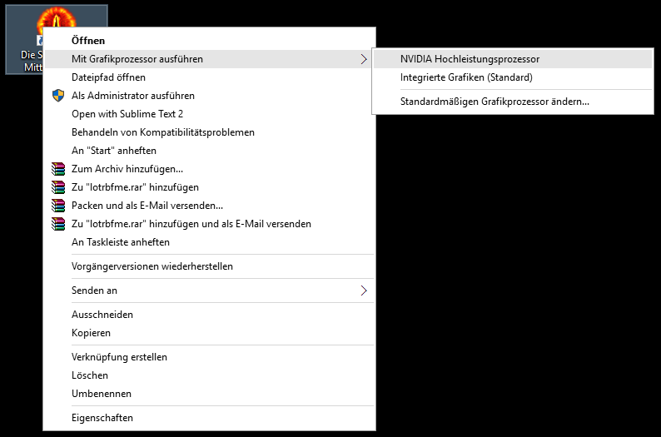
You need additional help? Send me an Email: MorgulLord29isback@gmail.com

https://en.wikipedia.org/wiki/Decimation_(signal_processing)
http://www.geforce.com/hardware/technology/dsr/technology

