to routing

CSS

Enter

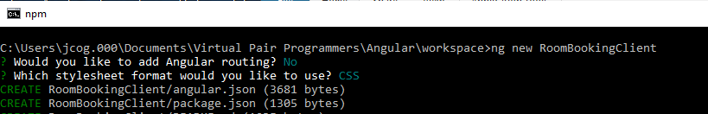

Setup Bootstrap:

Should be on every page:

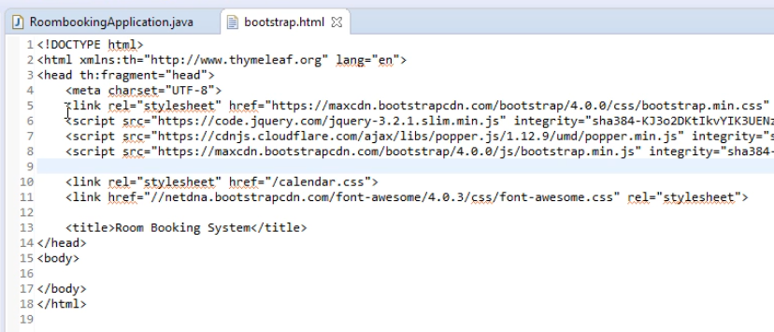

Open the Folder named RoomBookingClient in the Workspace:

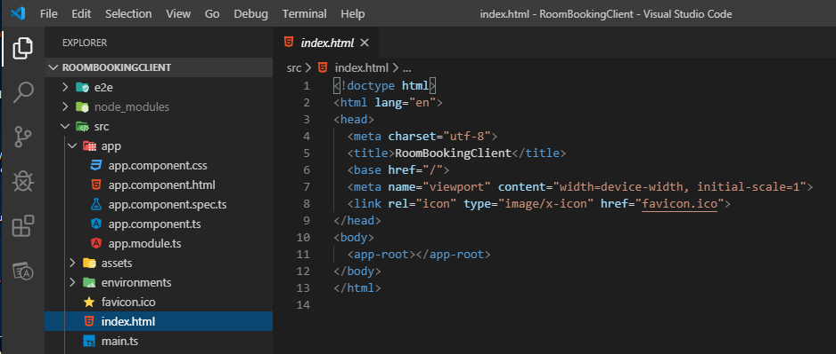

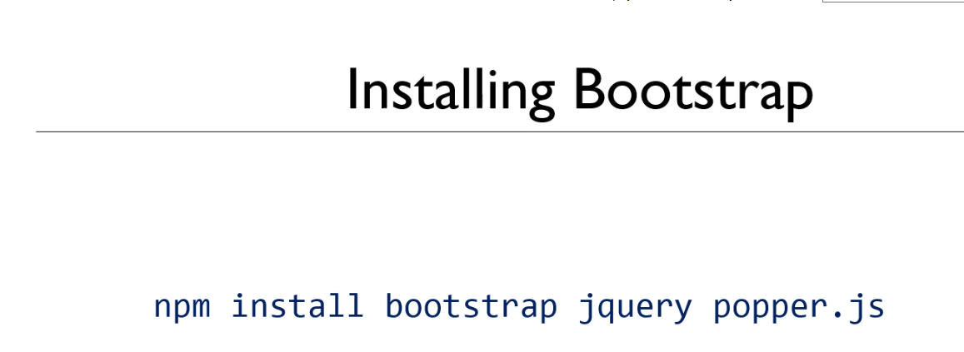

This installs the latest Bootstrap right into your application:

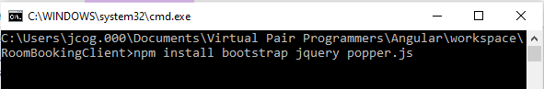

Inside the package.json file are the dependencies for the downloaded files:

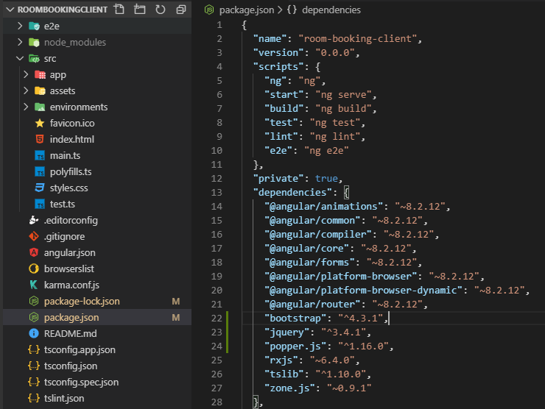

Build the app

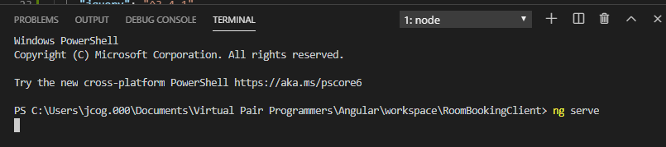

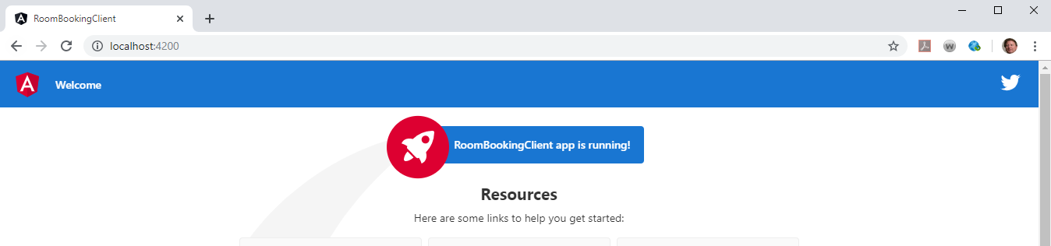

angular.json provides configuration locations

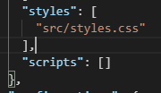

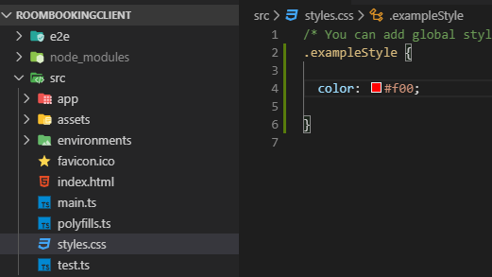

Now let us see this in the console

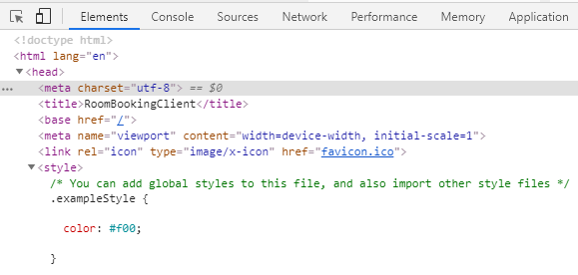

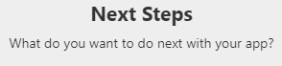

Apply Style:

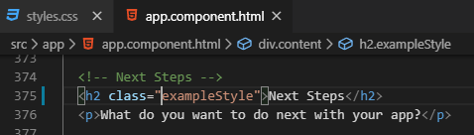

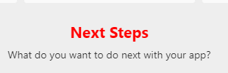

Add the bootstrap configurations:

In the angular.json file

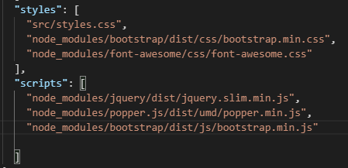

Restart with terminal ng serve

Notice the Font changed

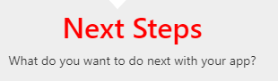

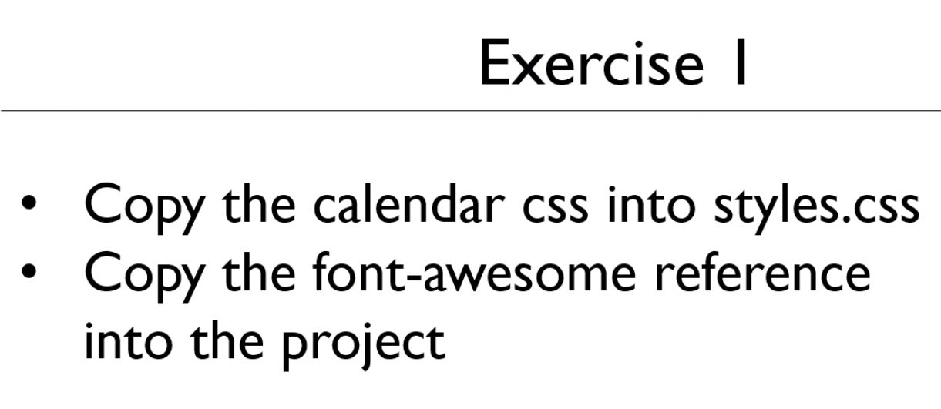

Installing bootstrap calendar

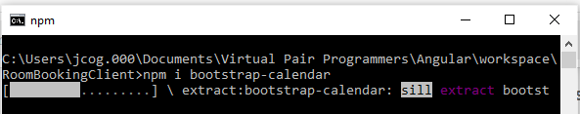

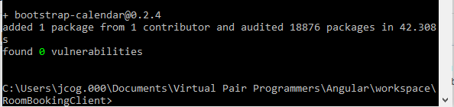

Installing font-awesome

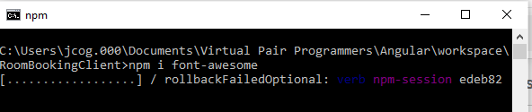

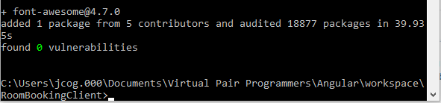

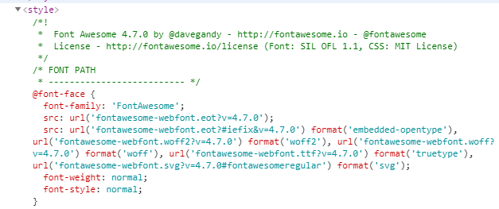

Did not use the Bootstrap calendar:

Followed the code copy into the style.css file

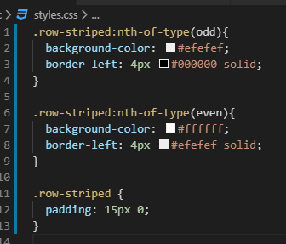

The entire angular.json file

{

  "$schema": "./node_modules/@angular/cli/lib/config/schema.json",

  "version": 1,

  "newProjectRoot": "projects",

  "projects": {

    "RoomBookingClient": {

      "projectType": "application",

      "schematics": {},

      "root": "",

      "sourceRoot": "src",

      "prefix": "app",

      "architect": {

        "build": {

          "builder": "@angular-devkit/build-angular:browser",

          "options": {

            "outputPath": "dist/RoomBookingClient",

            "index": "src/index.html",

            "main": "src/main.ts",

            "polyfills": "src/polyfills.ts",

            "tsConfig": "tsconfig.app.json",

            "aot": false,

            "assets": [

              "src/favicon.ico",

              "src/assets"

            ],

            "styles": [

              "src/styles.css"

            ],

            "scripts": []

          },

          "configurations": {

            "production": {

              "fileReplacements": [

                {

                  "replace": "src/environments/environment.ts",

                  "with": "src/environments/environment.prod.ts"

                }

              ],

              "optimization": true,

              "outputHashing": "all",

              "sourceMap": false,

              "extractCss": true,

              "namedChunks": false,

              "aot": true,

              "extractLicenses": true,

              "vendorChunk": false,

              "buildOptimizer": true,

              "budgets": [

                {

                  "type": "initial",

                  "maximumWarning": "2mb",

                  "maximumError": "5mb"

                },

                {

                  "type": "anyComponentStyle",

                  "maximumWarning": "6kb",

                  "maximumError": "10kb"

                }

              ]

            }

          }

        },

        "serve": {

          "builder": "@angular-devkit/build-angular:dev-server",

          "options": {

            "browserTarget": "RoomBookingClient:build"

          },

          "configurations": {

            "production": {

              "browserTarget": "RoomBookingClient:build:production"

            }

          }

        },

        "extract-i18n": {

          "builder": "@angular-devkit/build-angular:extract-i18n",

          "options": {

            "browserTarget": "RoomBookingClient:build"

          }

        },

        "test": {

          "builder": "@angular-devkit/build-angular:karma",

          "options": {

            "main": "src/test.ts",

            "polyfills": "src/polyfills.ts",

            "tsConfig": "tsconfig.spec.json",

            "karmaConfig": "karma.conf.js",

            "assets": [

              "src/favicon.ico",

              "src/assets"

            ],

            "styles": [

              "src/styles.css"

            ],

            "scripts": []

          }

        },

        "lint": {

          "builder": "@angular-devkit/build-angular:tslint",

          "options": {

            "tsConfig": [

              "tsconfig.app.json",

              "tsconfig.spec.json",

              "e2e/tsconfig.json"

            ],

            "exclude": [

              "**/node_modules/**"

            ]

          }

        },

        "e2e": {

          "builder": "@angular-devkit/build-angular:protractor",

          "options": {

            "protractorConfig": "e2e/protractor.conf.js",

            "devServerTarget": "RoomBookingClient:serve"

          },

          "configurations": {

            "production": {

              "devServerTarget": "RoomBookingClient:serve:production"

            }

          }

        }

      }

    }},

  "defaultProject": "RoomBookingClient"

}