**Routing:**

Create the menu component

>ng g c menu

Create the admin/users component

>ng g c admin/users

Create the admin/rooms component

>ng g c admin/rooms

Create the calendar component

>ng g c calendar

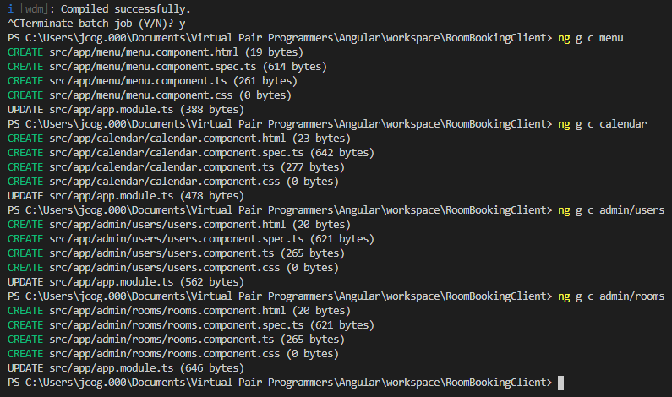

After copying in the menu.html code into the menu.component.html file

Paste the <app-menu> into the app.component.html file

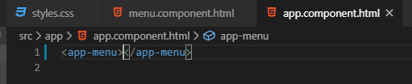

Test it >ng serve

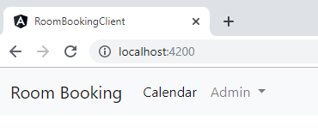

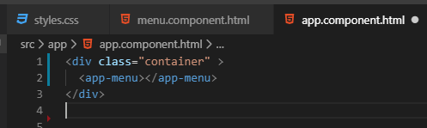

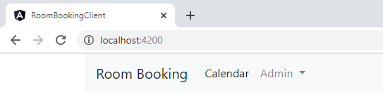

**Setting up base routing:**

Add the RouterModule.forRoot(routes) to the imports: [

Then, create the routes: Routes = [ { [path : ‘admin/users ’, component: UserComponent ) }]

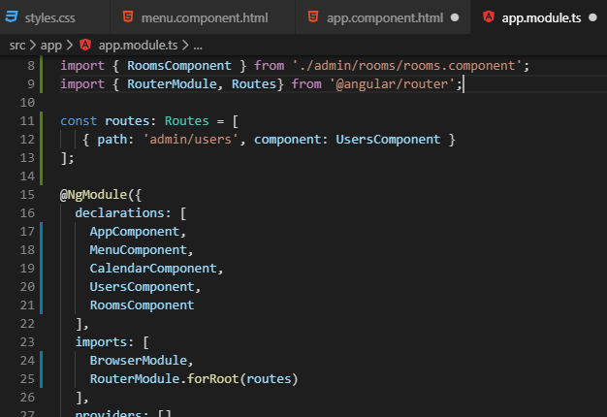

Then get the import statement import { RouterModule, Routes } from ‘@angular/router’;

Let the router show the path using the <router-outlet></router-outlet> tags

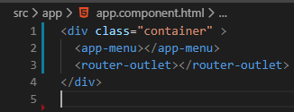

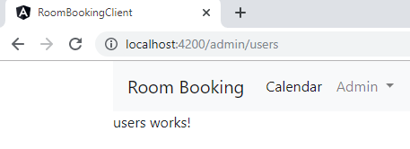

**Create a 404 page**

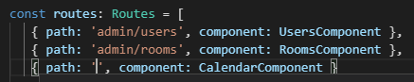

Test these routes

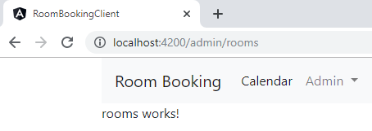

Click on the Calendar

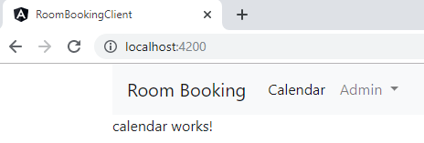

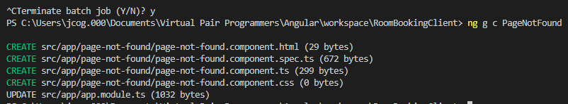

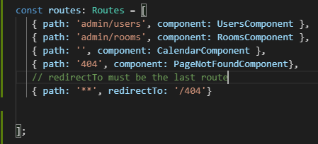

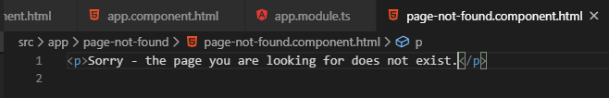

Test this

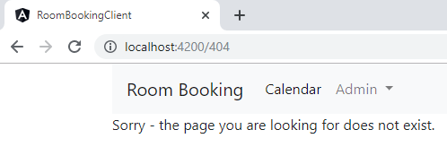

Both localhost:4200/users or localhost:4200/rooms both are 404

**Making Links work with routing:**

**Remove all the hrefs from the menu.component.html (except href=”#”)**

**Before:**

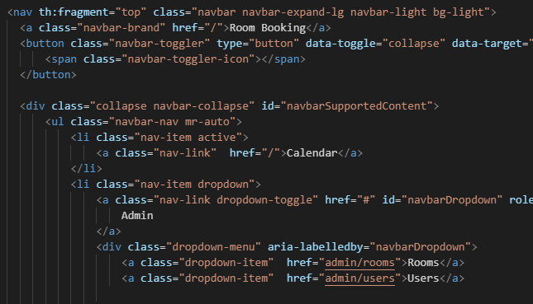

**After:**

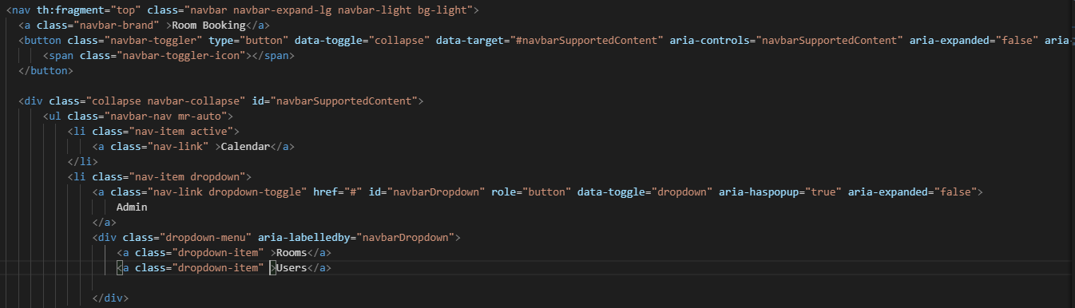

**Add link look to former href elements:**

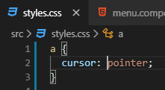

**See the link shadow on the Rooms**

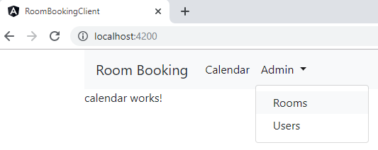

**Add the constructor injection for router**

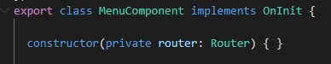

**navigateToRoomsAdmin() { } on the menu.component.ts file**



**The completed navigation for the menu.component.ts file**

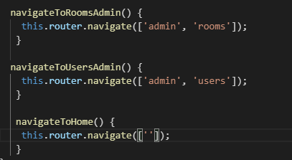

Next, add click events for the navigation methods







**The Completed navigation for the menu.component.html**

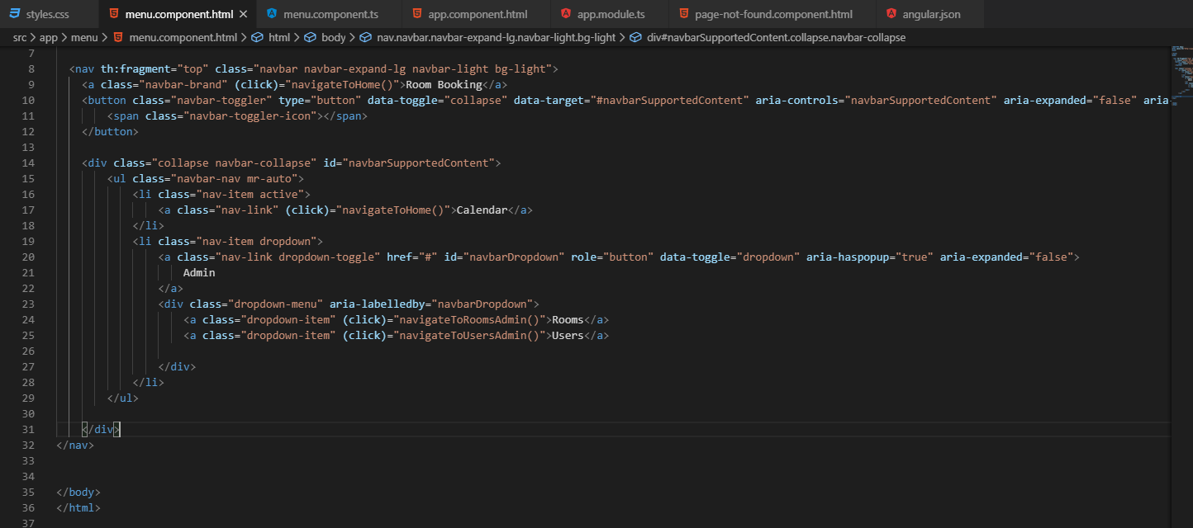

More focused

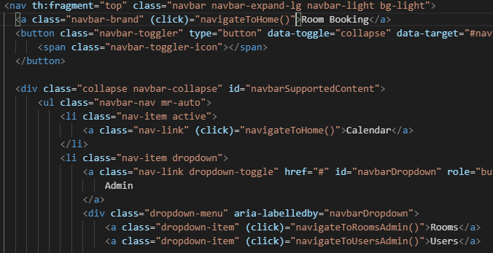

How links work

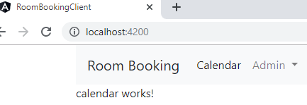

Click on Admin and then Rooms

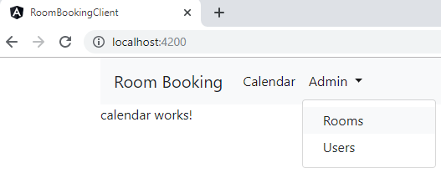

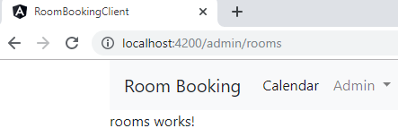

Click on Admin and then Users

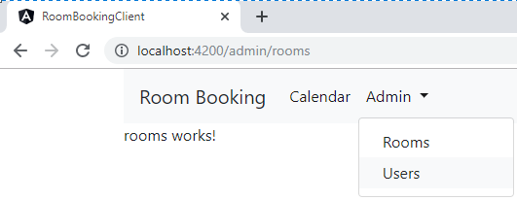

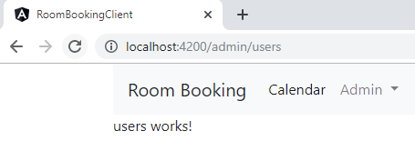

Click on Calendar or Room Booking

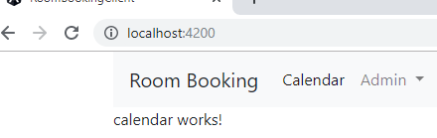

**Code for menu.component.html**

<!DOCTYPE html>

<html lang="en">

<head>

</head>

<body>

<nav th:fragment="top" class="navbar navbar-expand-lg navbar-light bg-light">

    <a class="navbar-brand" (click)="navigateToHome()">Room Booking</a>

    <button class="navbar-toggler" type="button" data-toggle="collapse"

data-target="#navbarSupportedContent"

     aria-controls="navbarSupportedContent"

    aria-expanded="false" aria-label="Toggle navigation">

        <span class="navbar-toggler-icon"></span>

    </button>

    <div class="collapse navbar-collapse" id="navbarSupportedContent">

      <ul class="navbar-nav mr-auto">

            <li class="nav-item active">

                <a class="nav-link" (click)="navigateToHome()">Calendar</a>

            </li>

         <li class="nav-item dropdown">

   <a class="nav-link dropdown-toggle" href="#" id="navbarDropdown"

role="button"

              data-toggle="dropdown" aria-haspopup="true" aria-expanded="false">

                    Admin

            </a>

           <div class="dropdown-menu" aria-labelledby="navbarDropdown">

            <a class="dropdown-item" (click)="navigateToRoomsAdmin()">Rooms</a>

            <a class="dropdown-item" (click)="navigateToUsersAdmin()">Users</a>

           </div>

          </li>

        </ul>

    </div></nav>

</body>

</html>

