**Dynamic Forms require RxJS or REACT code:**

Generate Form based on the values of an enum

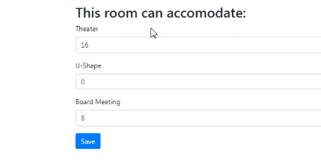

Create a new component



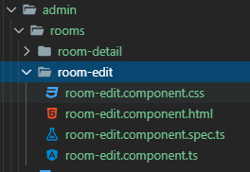

Create a room variable and bind it

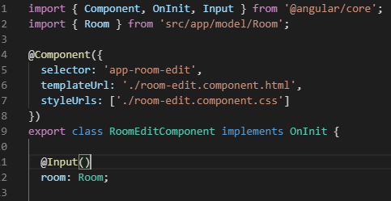

Put some output in the room-edit.component.html file

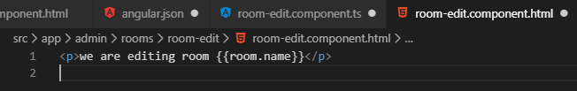

In the room-detail.component.ts file we need a method, editRoom(), that we can bind to click event

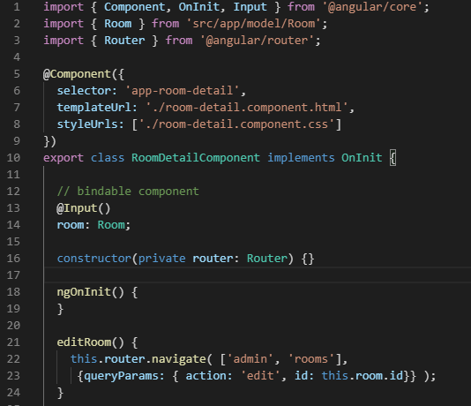

Now in the room-detail.component.html we want to bind the method to the Edit button

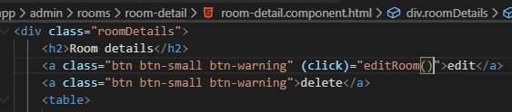

Add the action to the rooms.component.ts file

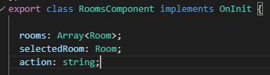

Go to the subscription and set the action

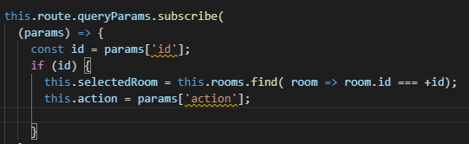

If the action is add, then set up a new room

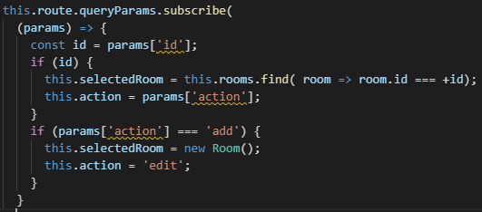

Let us add action into the setRoom() method

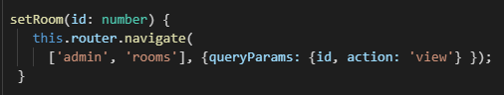

Add an addRoom() that we can add to the ADD button

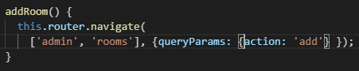

Finally, in the rooms.component.html let us add the click event



Where we are showing the view as the action and add the app-room-edit component

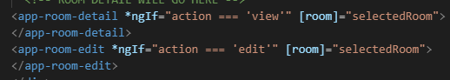

Test it notice the action=view

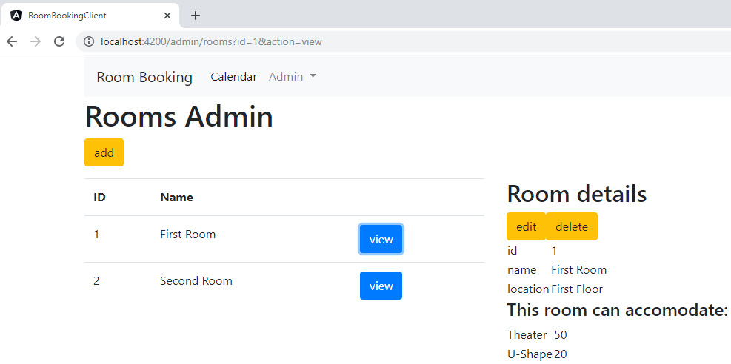

Now, try the add button

Notice the action=add

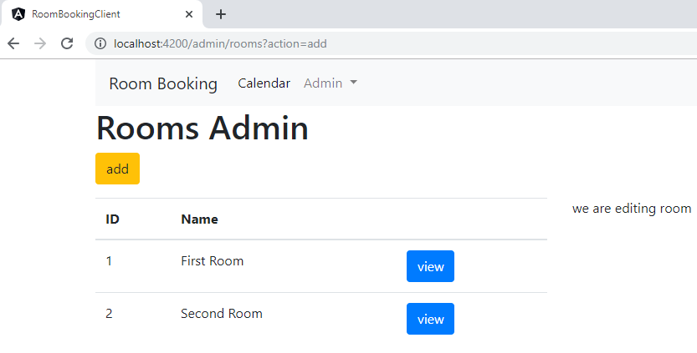

Now, try the edit option

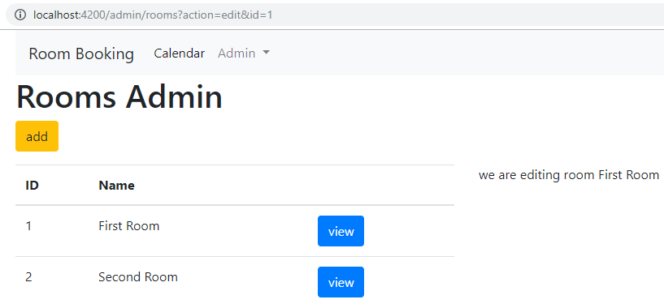

Now we start building the Form

Paste the html code into the room-edit.component.html.

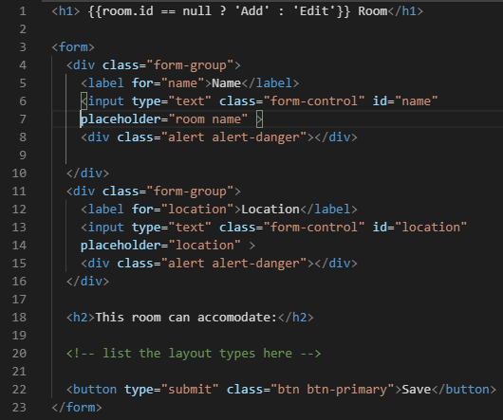

Now, import the Reactive forms module into the app.module.ts file

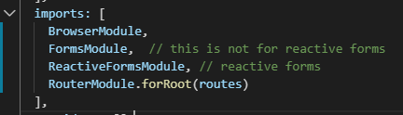

Create a variable in the RoomEditComponent roomName a FormControl object

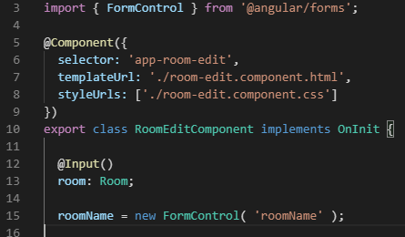

In the room-edit.component.html let us bind the form control



We a Form Group



Go back into the class and create the roomForm variable

Move the roomName into the FormGroup

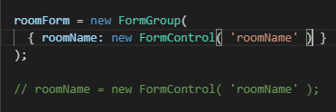

Now, remove the [] from the formControlName



Now let us do the location like the roomName

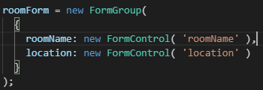

In the html page

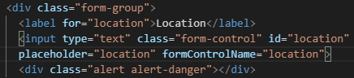

Create a onSubmit() to check the code in the same class

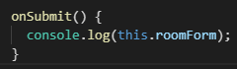

Bind the method on the room-edit.component.html

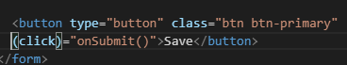

Test it

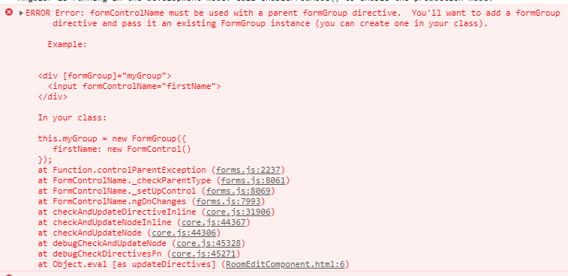

Fix

/*

<div [formGroup]="myGroup">

      <input formControlName="firstName">

    </div>

In your class:

this.myGroup = new FormGroup({

    firstName: new FormControl()

});

*/

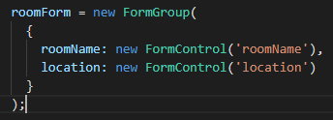

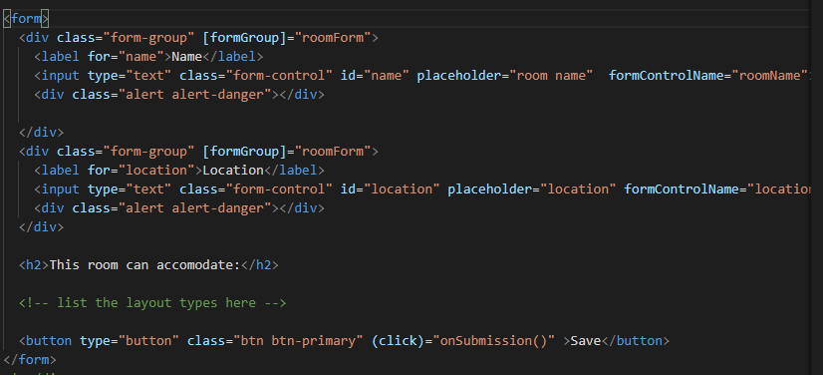

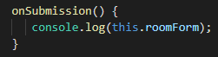

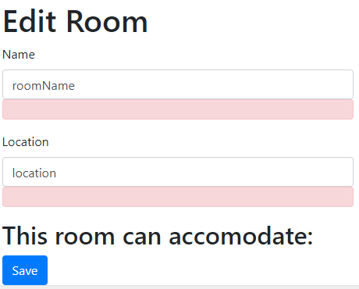

Type in some room and somewhere

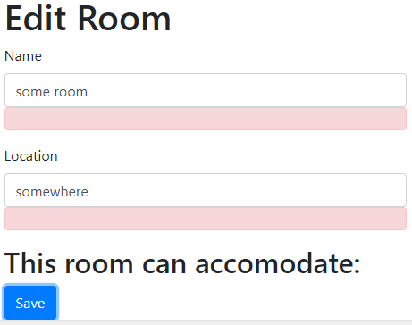

Press Enter

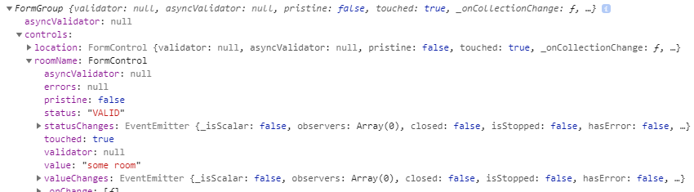

Value for roomName = “some room”

Is it pristine and has it been touched? The status is “VALID”

Now, add the required html attribute to change the pristine, touched and status

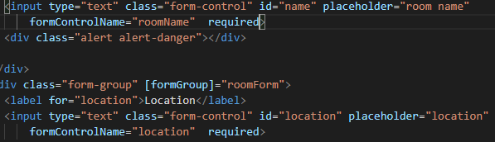

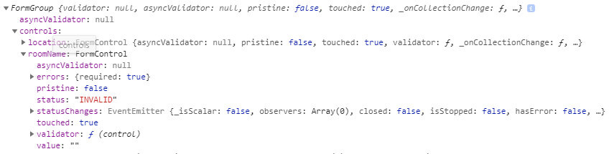

For required the value = “” empty So, status = “INVALID” pristine: false, and touched: true