**FormBuilder**

Inject the formBuilder and import it into the room-edit.component.ts file



Check the import



Change roomForm declaration

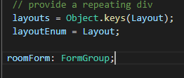

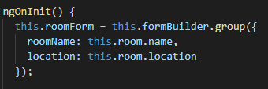

You can now remove the patchValue method and rework the for loop

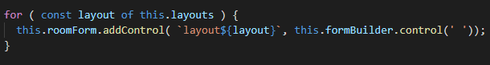

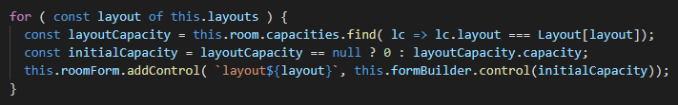

Test the prepopulation for the room accomodations:

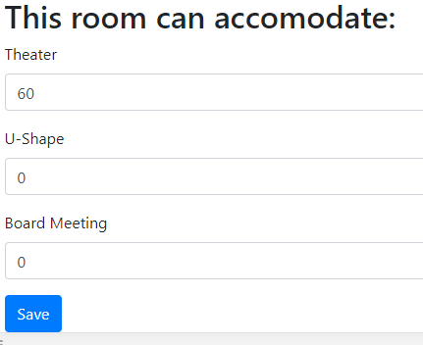

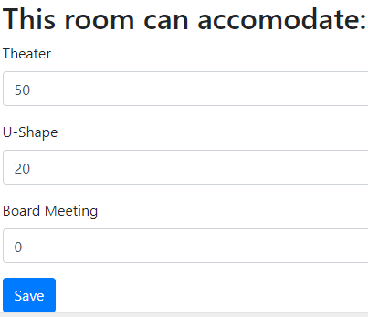

It works!