Not only can the parent act on the child, but the child can act on the parent

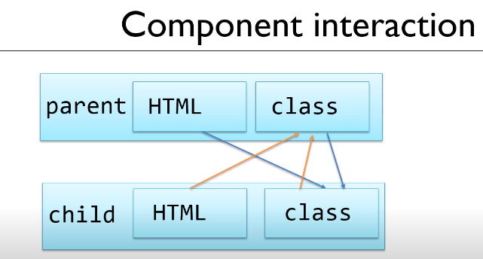

Now, let us create a Hit counter: Add hits variable to Page2Component.ts in the DemoApp

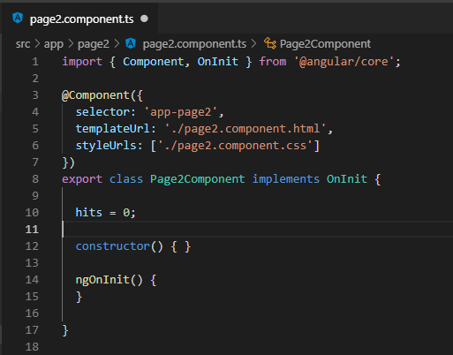

Add a place to display the counter:

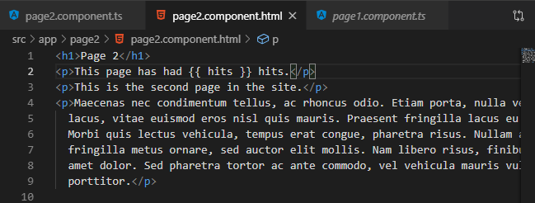

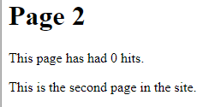

Add a method to increment the hit counter: incrementHitCounter()

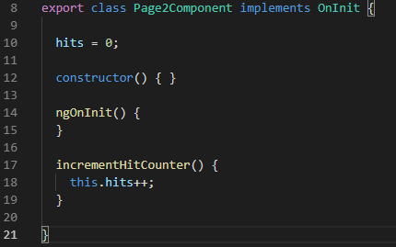

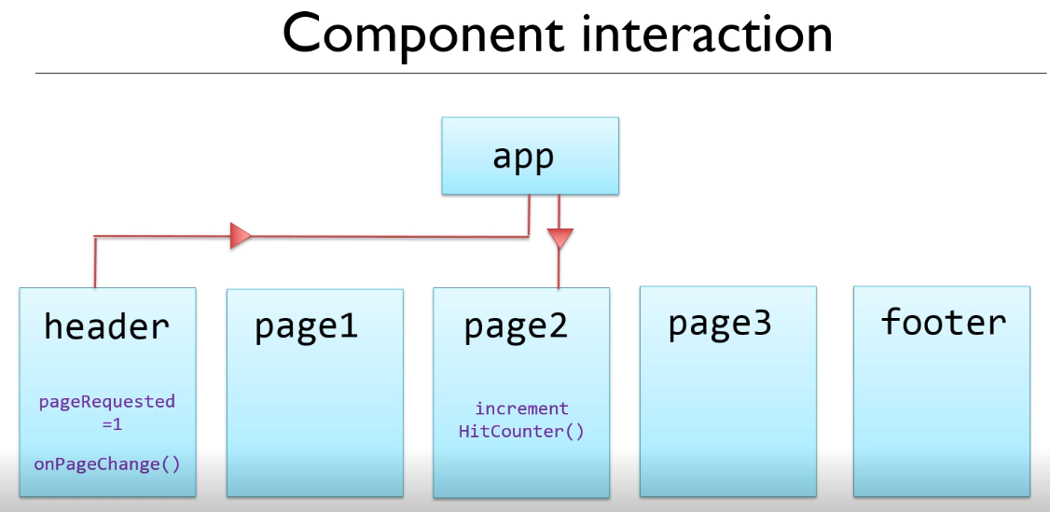

App to page2 property binding parent to child

Header to app message is sent to the parent on the event

**Create an event emitter:**

**On the header.ts page add the pageChangeEvent which is of type EventEmitter**

**Add the binder @Output**

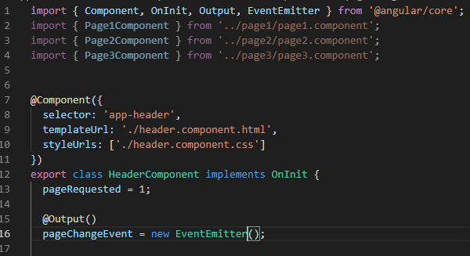

**At input lets a parent set a property in html**

**At output lets a child send an event to the parent**

**Go the app component.html and do the binding**

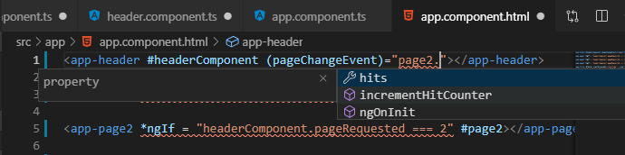

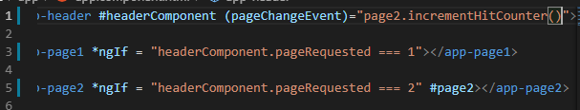

**Now, this reference to page2 does not work due to the order of compilation.**

**So, we need a local app variable.**

**Put a reference to page2 in the app.component.ts**

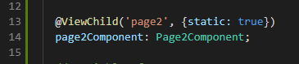

**Put a local method in the app.component.ts**

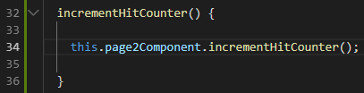

**Use a local method in the app.component.html**

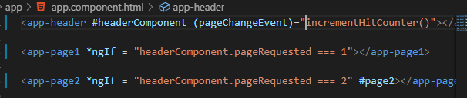

**Trigger the Event**

**Add the event.emit() for all pages to header.component.ts !**

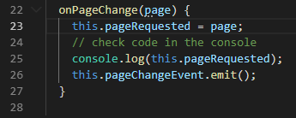

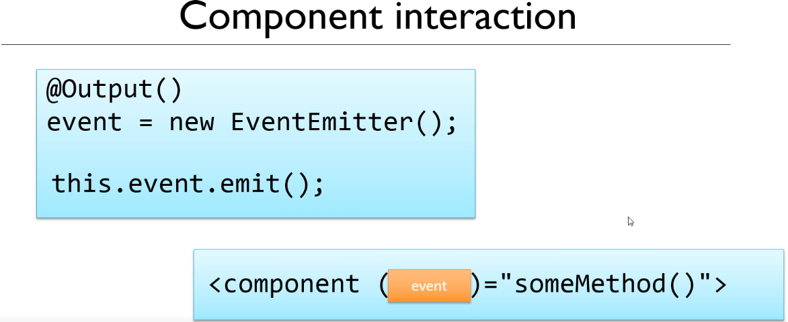

**Temporarily, change the header.component.ts file to hidden to avoid ng errors:**

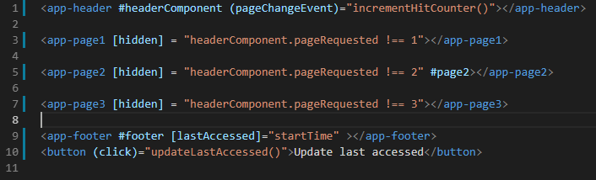

**Test the counter:**

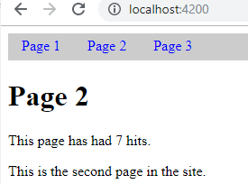

**Let us isolate the event to page2 only:**

**Use Generics and set the type for the emitter to number, pass the page to the emit as a param**

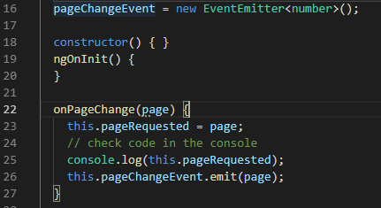

**Use the $event to pass data in the page variable through the pageChangeEvent($event)**



**Check the page event for the page number and see if it is 2, otherwise ignore the event**

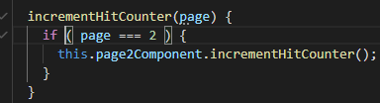

**The counter now only works on selecting page 2**

**Remove the template #headerComponent and use currentPage variable since we know the page number now.**

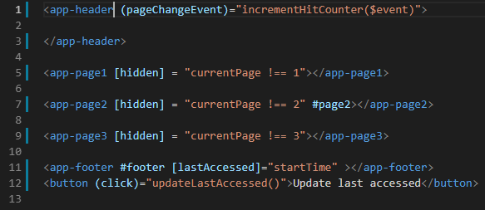

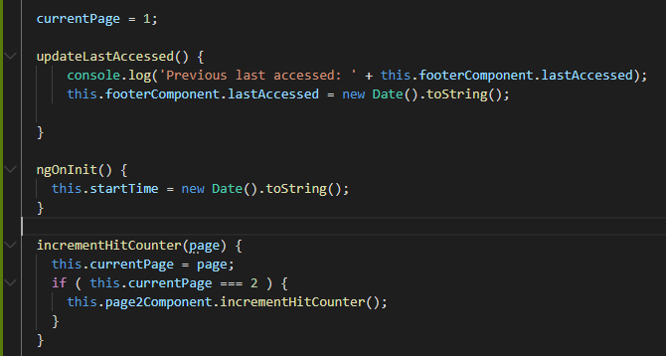

**\*ngIf hides the page number from the DOM, so it is undefined and the <undefined>.emit(page) will fail. NullPointerException <null>.emit(page);**

**So, you have to use [hidden] for displays that use #page or any template #<var>!!!**