**Creating Enums**

**Enum file is called SubjectArea.ts in the model directory:**

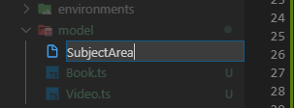

**There will be 4 String to number values:**

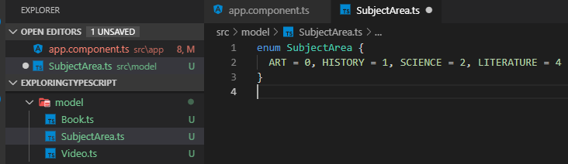

**Let us make it publicly accessible by adding export:**

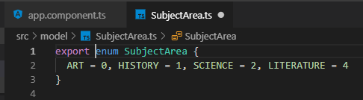

**Let us import the enum into the class:**

**Alt + Enter after the code line for the enum SubjectArea:**

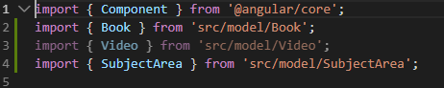

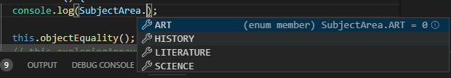



**Ctrl + S**

**Check the output in the Developer view for the browser**

**Expected output is 1**



**To get the label for the value number:**





**Looping through an enum:**

Loop through the indices (labels) use **in** and not the values using **of:**

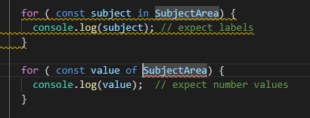

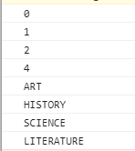

**This works with Errors!!!**

**Errors removed by using arrays and using splice(start, how many) and slice(start) methods**

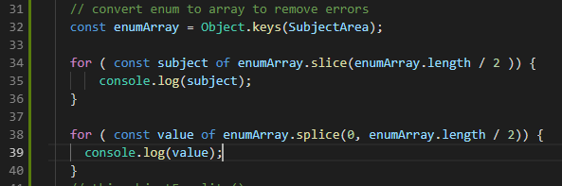



**Enums with custom values:**

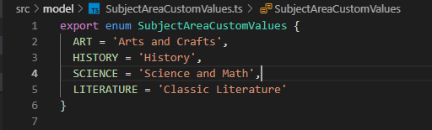

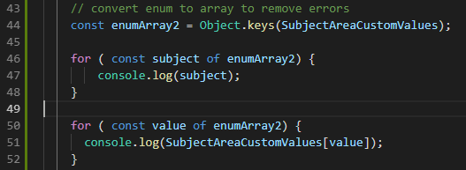

**Outputs:**

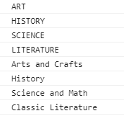

**Lookup label from its value:**

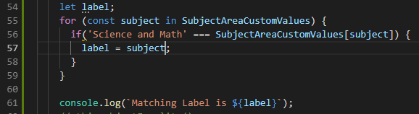



**Using arrow function**

