**Data Types**

**Simple DataTypes:**

1)number - which is similar to java double

2)boolean – which is the same as java boolean

3)string – which is the same as java String

symbol – not used in course

null – means does not have a valid value

4)undefined – means has not been initialized

Always write variables starting with **a lowercase letter** is the convention.

**Object DataTypes:**

1)Arrays – which are more like ArrayLists in java (dynamically resized)

2)Tuples – which are fixed size arrays similar to java Arrays

Always write variables starting with **an uppercase letter** is the convention.

**Return types:**

1)any – object datatype, used most often

2)object – non-primitive datatype similar to the java Wrapper types

3)void – similar to the java void return type

Always write variables starting **with a lowercase letter** is the convention.

**Create a Demo Project called ExploringTypescript:**

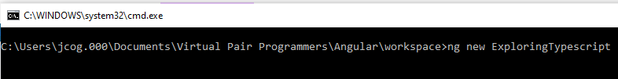

**N to routing and Enter on CSS**

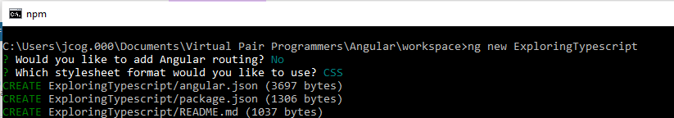

**Open the folder in the workspace:**

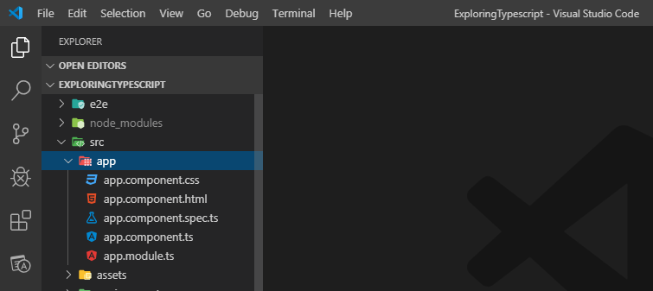

Dashboards:

A KPIs are key performance indicators:

**Working with number type:**

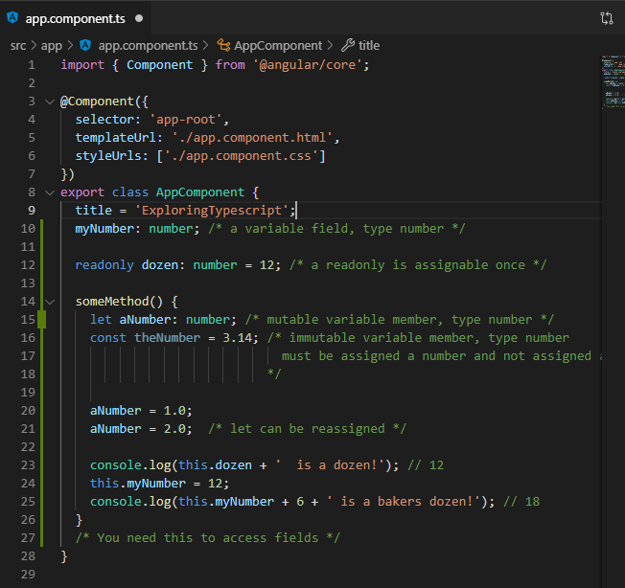

**Using the exploringArrays() method in a constructor we can output the console.log values to**

**the console in a browser.**

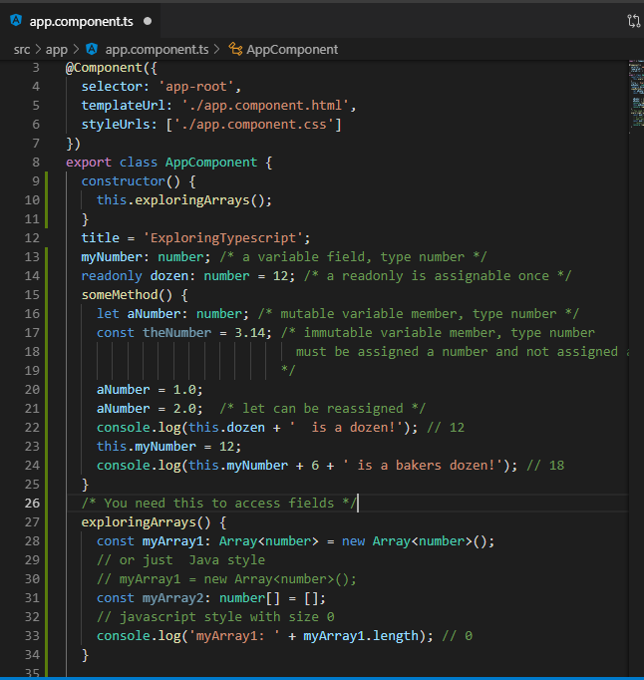

**Compile and run the class in a terminal using ng serve**

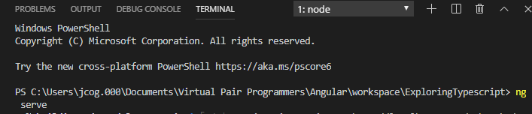

**You see the myArray has length 0**

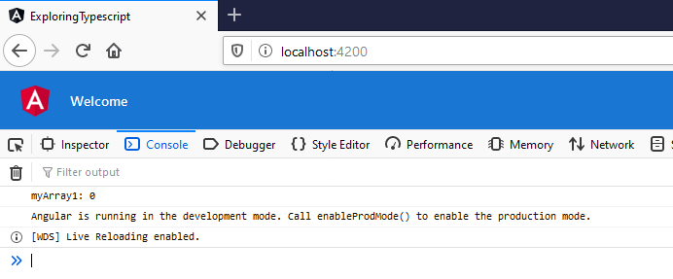

**Update the myArray1 to get length 5 as 5 undefined members**



**Save Ctrl + S and just like java the array is length 5!**

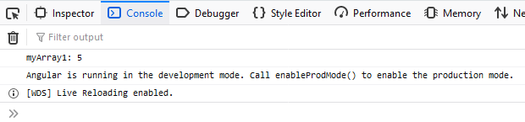



**Change the console.log(myArray1);**

**Save Ctrl + S results in showing an empty array**

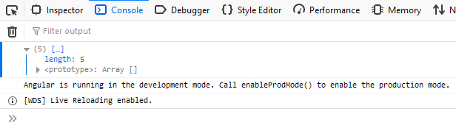





**Save Ctrl + S results in showing the stored values**

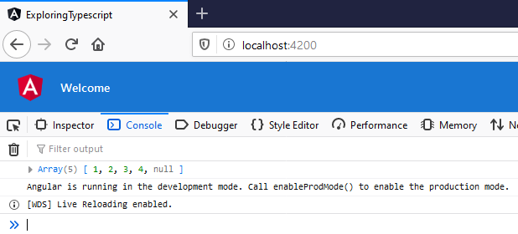

**Expanding the array shows the values and the length**

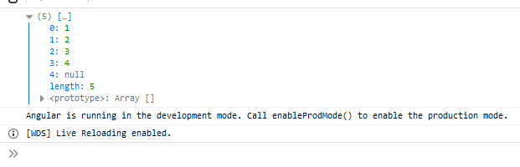

**Get the 2nd element in myArray2 highlighted in blue**



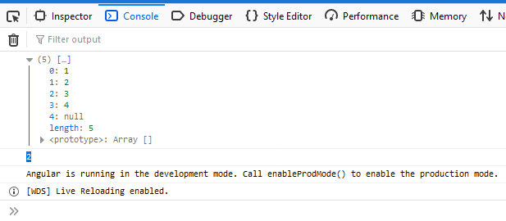

Or use slice start at 1 and end at 2 index





**Sublist with only one element:**

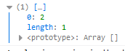

**Now, add data to the list at the end. Use push()**





**Now, remove data from the end of the list (use splice to remove from within the list )**





**Start at index 2 or position 3 and remove only 1 element**





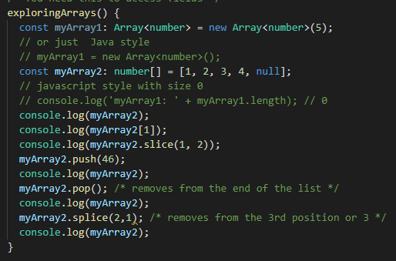

**Loops and if conditions:**

