**Java and Java Spring application examples:**

**Drools:** a rule engine

**Drools** as an interpreter between the rules and the facts.

Rules + Facts create Decisions.

**3 Stages**

1) Pattern Matching is done using the Rete algorithm (Which ruleset to use)

2) Resolution occurs (Prioritize Rules in set and select the most effective rule to apply)

3) Execution occurs (Execute the selected rule )

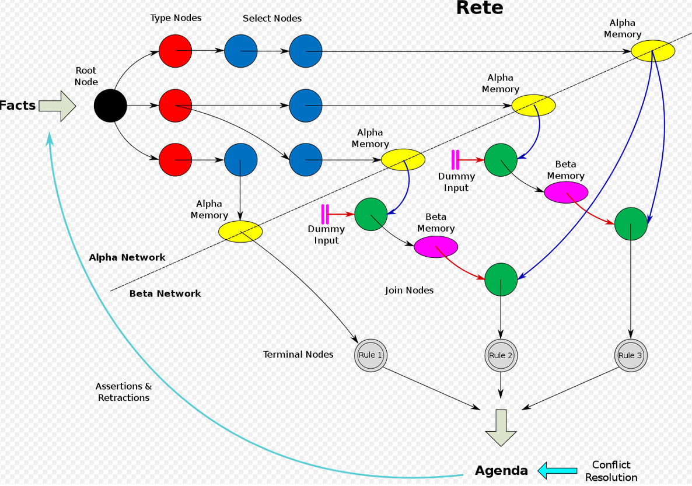

**Typical Drools Program Design:**

1) Facts or data is coming from the customer

2) The developer creates the rule sets

3) Drools runs the Matcher, Resolver, and Execution against the Facts

**Drools Features:**

1) Drools can use rules that the developer has not created

2) Drools uses Declarative Programming instead Imperative Programming

Declarative does not care about the steps needed to get to the result or the Flow.

Imperative means the steps or flow is most important.

3) Drools keeps data separate from Flow or Logic

4) You also achieve Speed, Scalability, and Centralization of the Rules

5) Rules written in English are easy to customize for Business Users

**Drools History:**

Bob McWhirter **in 2001** created the Drools Project – Brute Force Linear Search (too slow)

Nobi Y was the Project lead that create the first release

**Drools** was incorporated in **JBOSS Rules – 2005**

**In 2006 Red Hat acquired JBoss**

In 2007 Drools was reclaimed from JBOSS as an independent application

**In 2009 Drools version 5 was released - Rete Algorithm in use**

Stateless vs Stateful session

**A knowledge session** is the all the rules and facts that required.

To trigger the rules, facts are inserted into the session and when a condition is met, the subsequent rule gets fired.

A Stateless session is expected to produce the same result each time it accessed

**A new session is created for each request.**

A Stateful session may not produce the same result each time it is accessed because each access is altering the state.

**The session continues from whatever state the session was when the previous command ended.**

A stateless session is the same as a function that you pass data to and results are returned

Examples

Validation

Calculation

Routing and Filtering

A stateful session typically has a longer life, it will change iteratively over time.

Examples (typically predictions)

Monitoring - semiautomatic buying

Diagnostics – fault finding

Logistics = Parcel tracking

Drools Language

Drools Syntax:

Keywords

1) Package

2) Import statement

3) Rule Definition

In a separate file you would write the rules

**Rules in this file are known as a package**

**Import the packages with import statements**

**Code the rule definition:**

package rules

import com.drools.model.product

rule “Offer for Tea”

when

productObject: product(type===”Packaged tea”)

then

productObject: setGet(5);

end

**when leads to a condition**

**then leads to an action**

**end terminates the program**

**You can have global variables like you do in Java**

**You use the $ symbol to create variables**

**$p is a symbol for Product{} (product class)**

**Comments:**

**#, // are used for single line comments**

**/* */ are used for multiline comments**

**Functions in Rules:**

function double

add

(add value)

{

Return value +5;

}

**Dialects of Drools:**

There are 2 **- Java** or MVEL

We will use Java

**Salience:**

**Higher numbers have priority** over smaller numbers