**VueJs 2**

**Course: MasteringVuex**

**Ch02_State_and_Getters**

[**https://www.vuemastery.com/courses/mastering-vuex/intro-to-vuex**](https://www.vuemastery.com/courses/mastering-vuex/intro-to-vuex)

**Without vuex you could use Event emitters and Props**

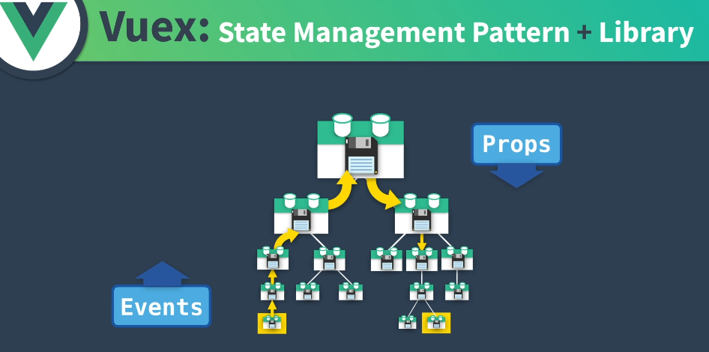

**Instead use a global state, vuex**

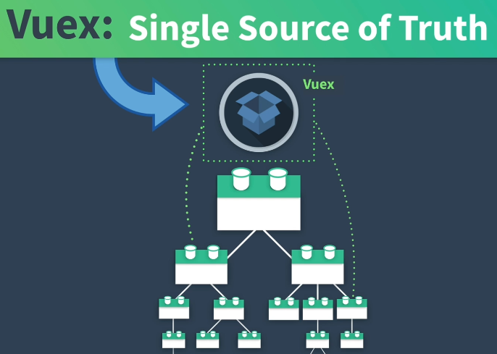

**Vuex is reactive:**

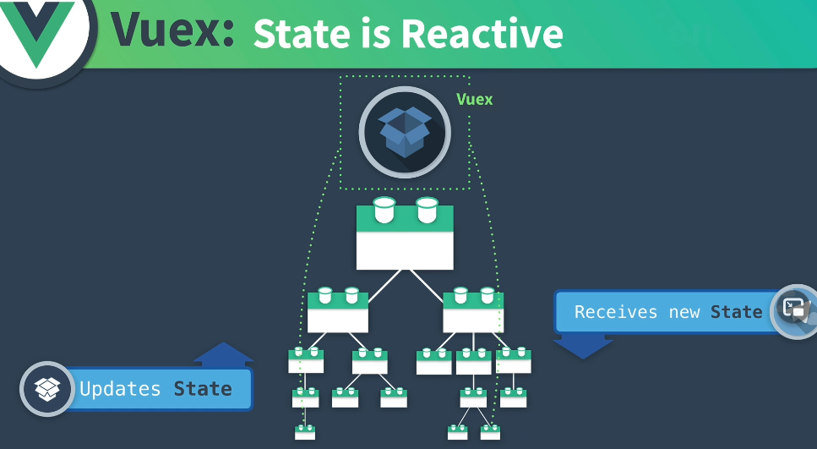

**How does vuex differ from vue? Data==State, Methods=Actions Computed = Getters, but mutations track changes**

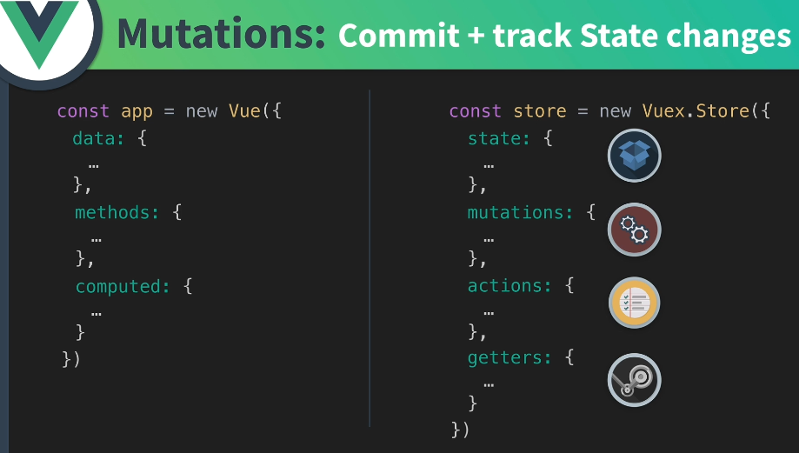

**In fact, actions update mutations which update state:**

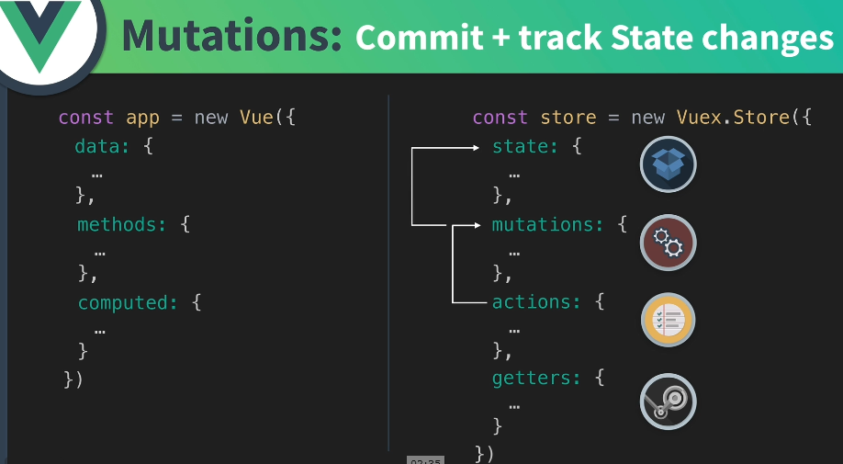

**Walk through some code:**

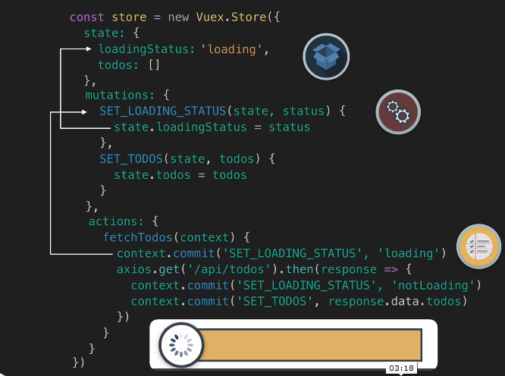

**Next, the api call is made and the return is coming back:**

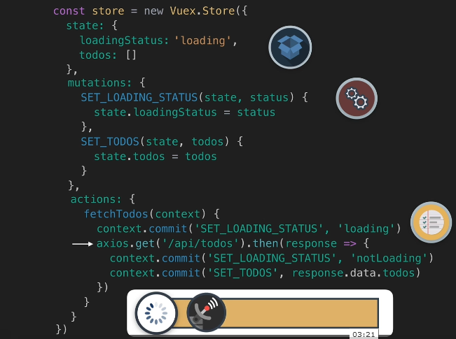

**The call returns and sets the loadingStatus: ‘notLoading’**

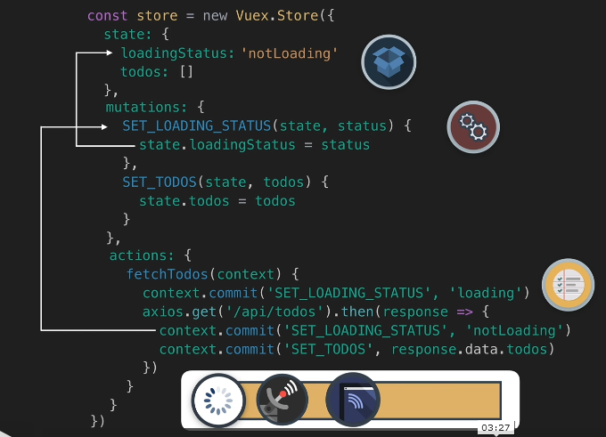

**Set the todo states from the api call:**

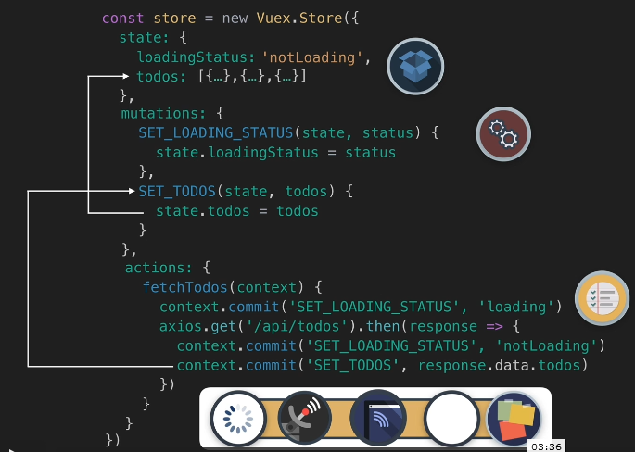

**If you only need a specific state then use getters:**

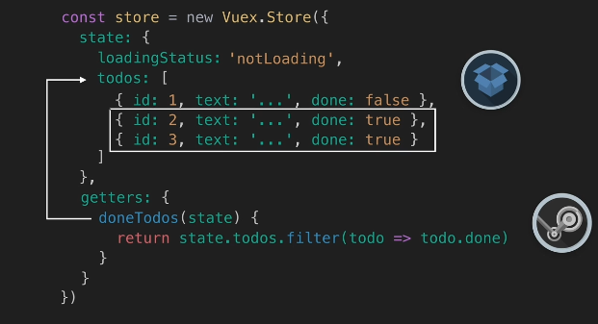

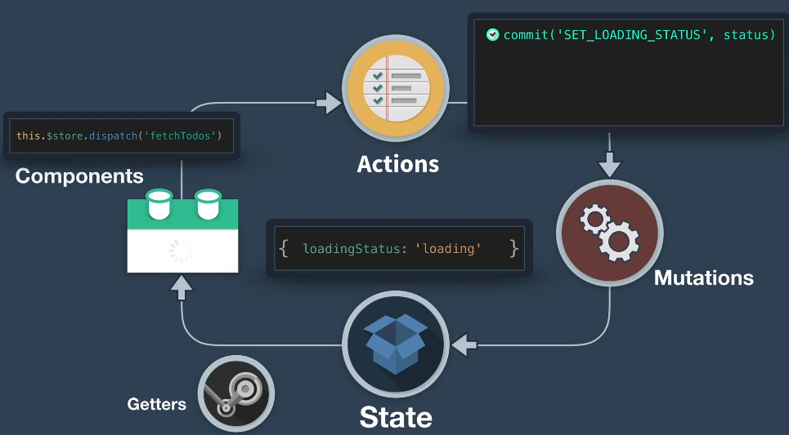

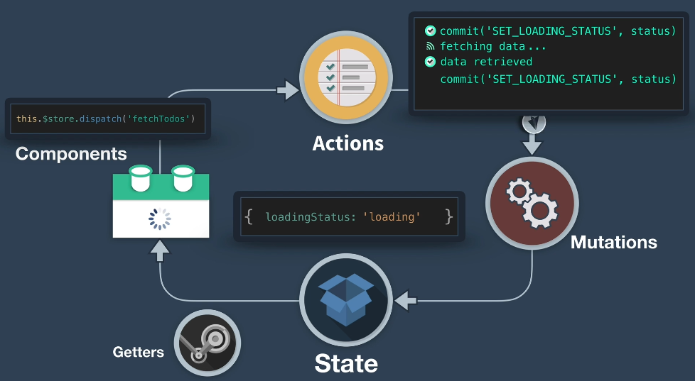

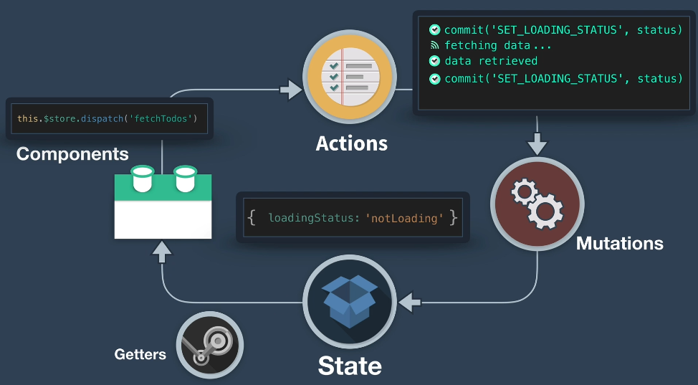

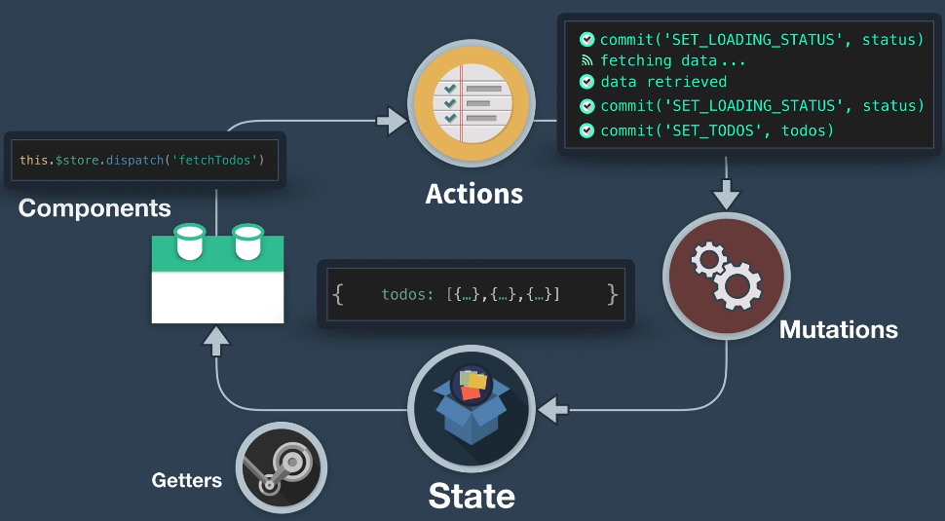

**Use specific todos or the done todos: use Getters**

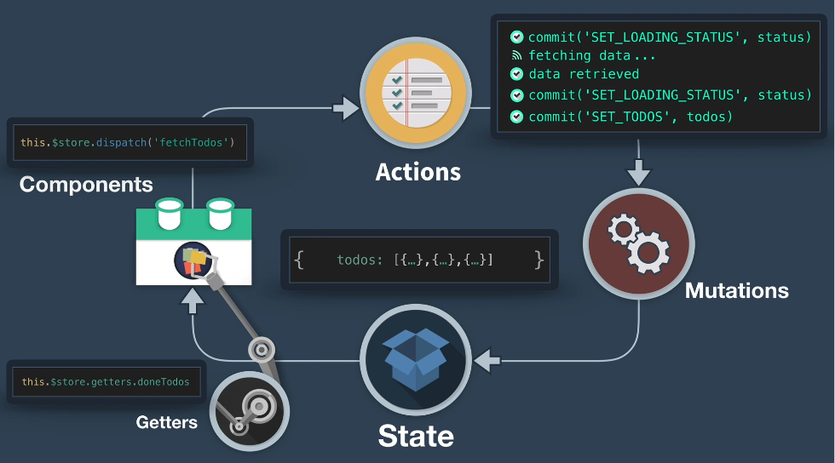

**In vue-tools we see a timestamped of the events:**

