**VueJs 2**

**Course: MasteringVuex**

**Ch03_Mutations_and_Actions_Part1**

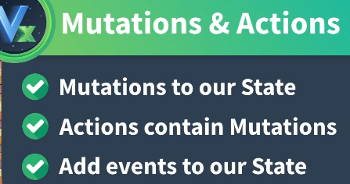

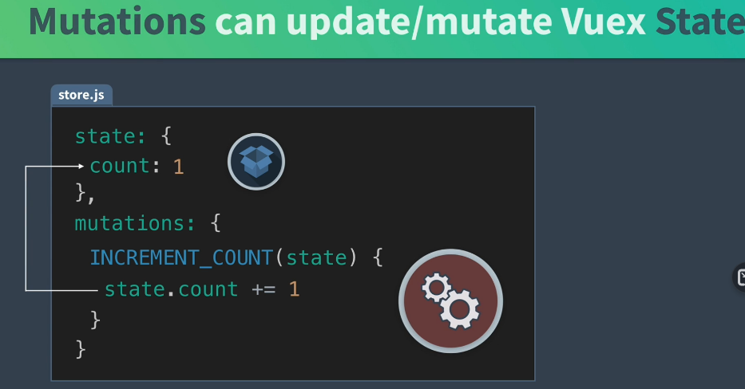

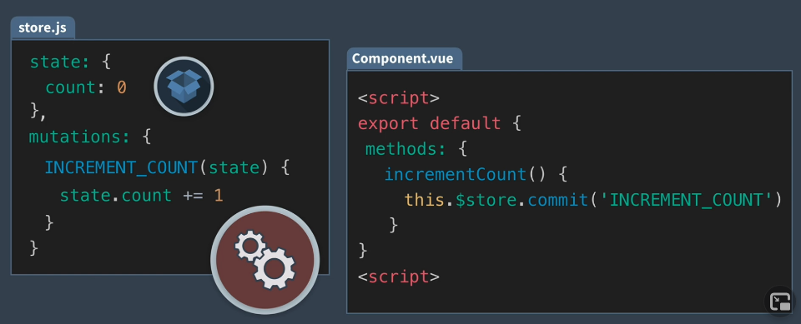

**Clicking a button, updates the incrementCount() and sets the count to 1:**

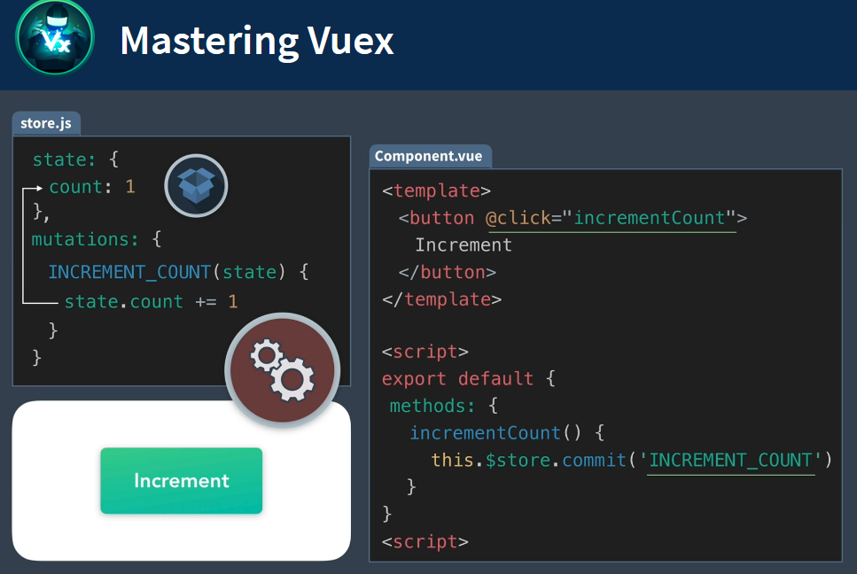

**Flux Space Patterns, which is React pattern, using all upper case text**

**for Mutations:**

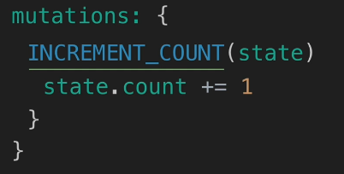

**Dynamic Mutations: allow for params to any value (payload)**

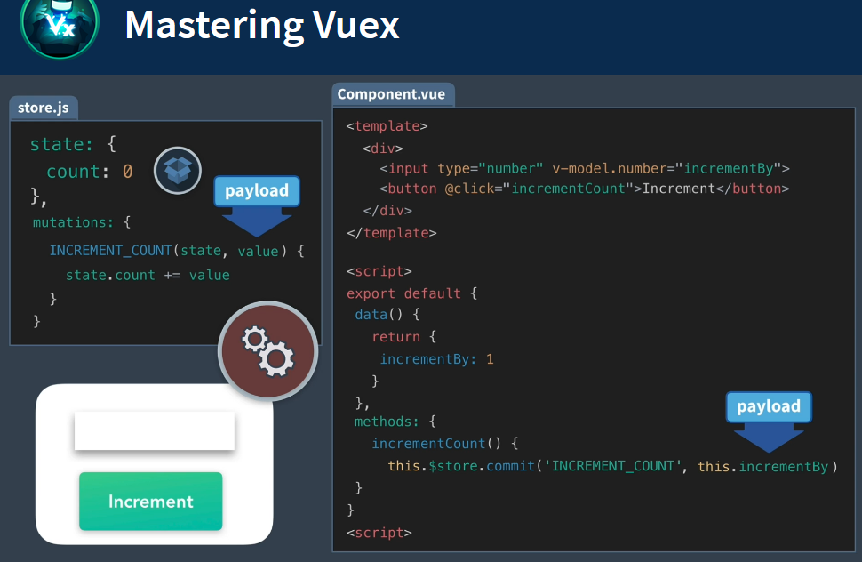

**So, if the user puts in 10, the output is incremented by 10**

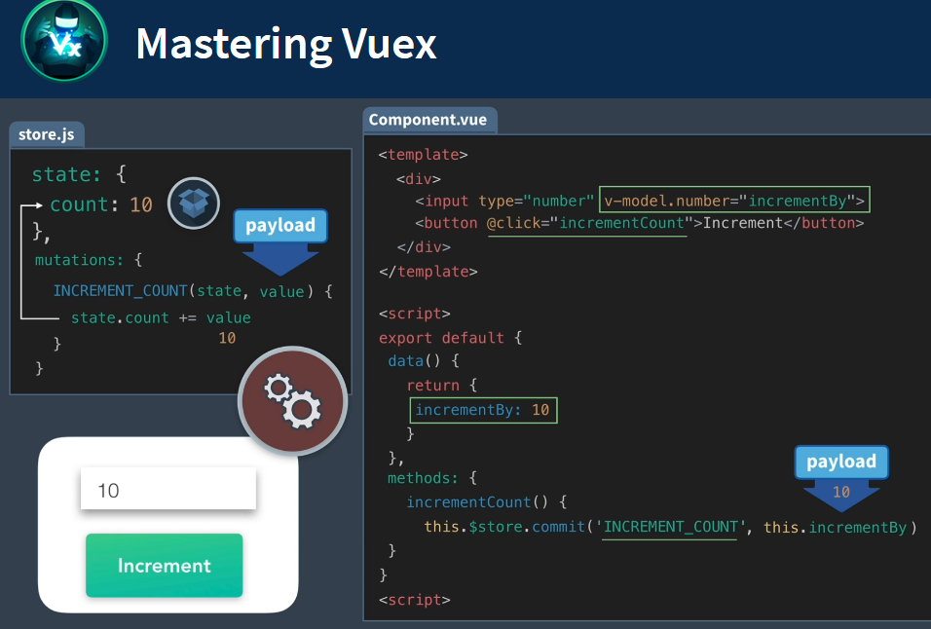

**Actions versus Mutations:**

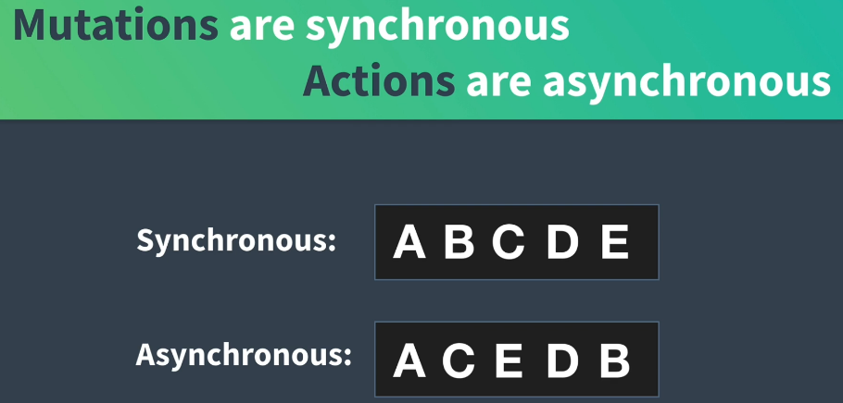

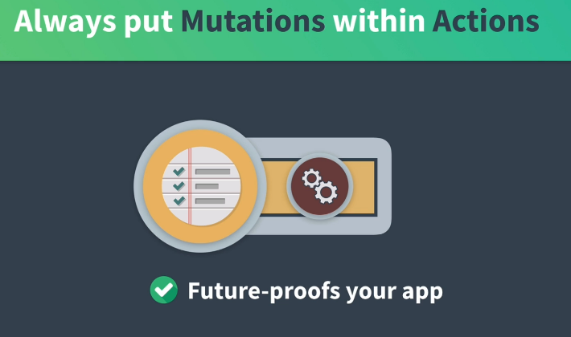

**Adding an Action to a Mutation:**

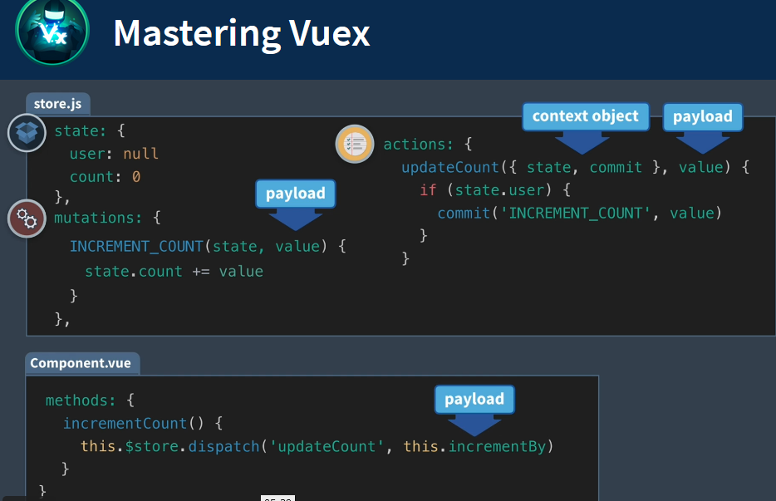





**Refactor EventCreate.vue**

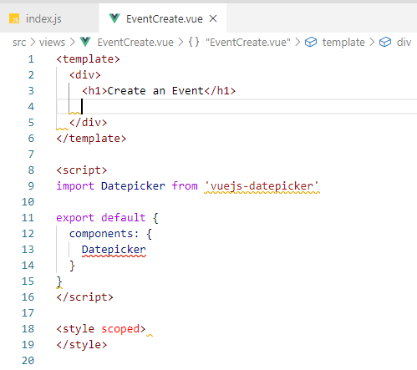

**Insert Form code: into the template empty space**

<form>

<label>Select a category</label>

<select v-model="event.category">

<option v-for="cat in categories" :key="cat">{{ cat }}</option>

</select>

<h3>Name & describe your event</h3>

<div class="field">

<label>Title</label>

<input v-model="event.title" type="text" placeholder="Add an event title"/>

</div>

<div class="field">

<label>Description</label>

<input v-model="event.description" type="text" placeholder="Add a description"/>

</div>

<h3>Where is your event?</h3>

<div class="field">

<label>Location</label>

<input v-model="event.location" type="text" placeholder="Add a location"/>

</div>

<h3>When is your event?</h3>

<div class="field">

<label>Date</label>

<datepicker v-model="event.date" placeholder="Select a date"/>

</div>

<div class="field">

<label>Select a time</label>

<select v-model="event.time">

<option v-for="time in times" :key="time">{{ time }}</option>

</select>

</div>

<input type="submit" class="button -fill-gradient" value="Submit"/>

</form>

**Display:**

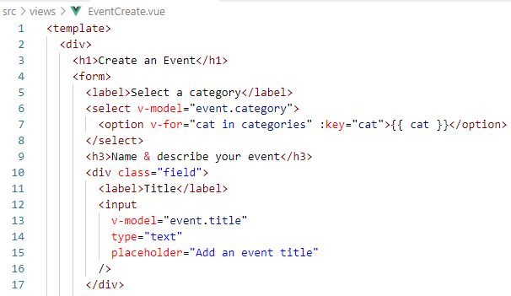

**DatePicker Code in the Form:**

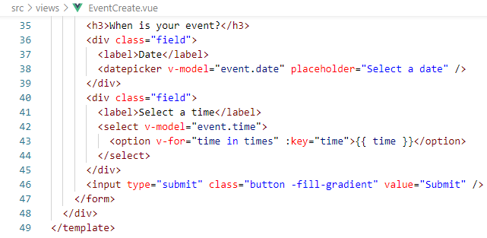

**Add some style:**

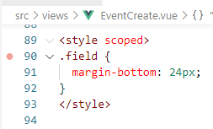

**Add data() elements:**

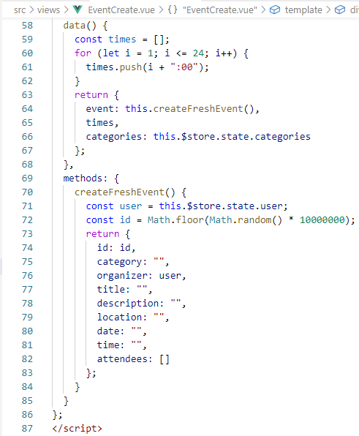

**Add the categories:**

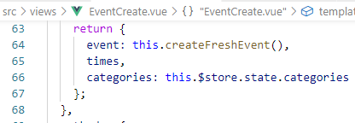

**In the Browser:**

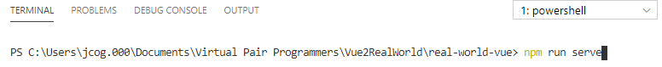

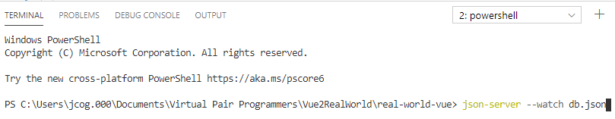

**Select Create:**

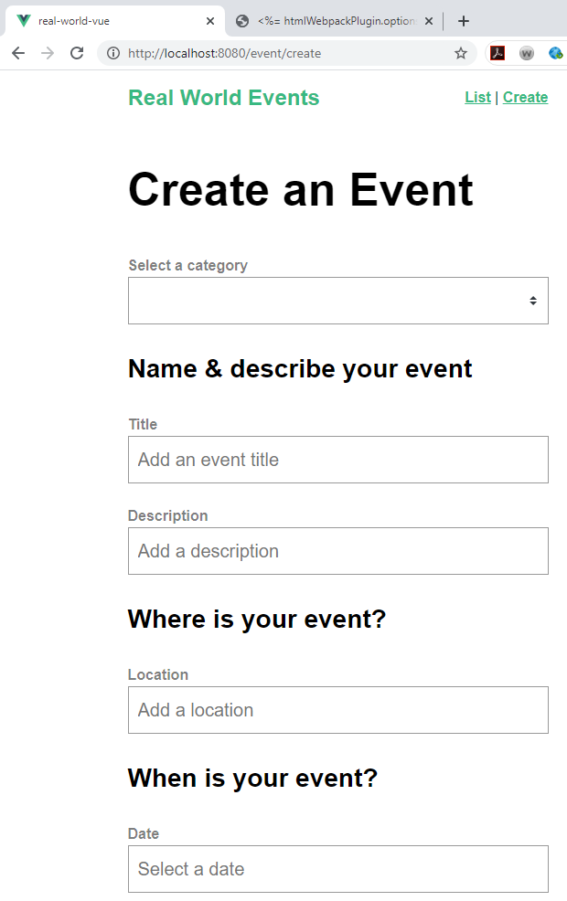

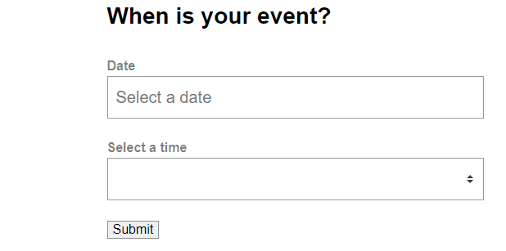



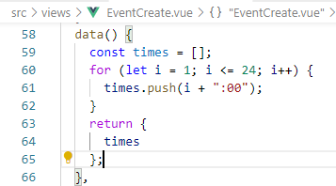



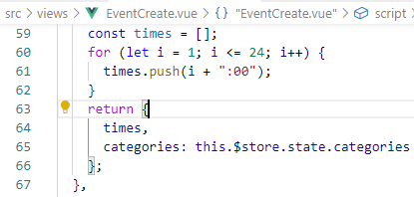

**Adding the View Options:**

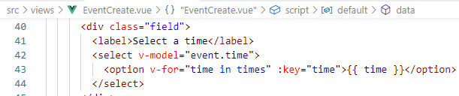

**Selecting Categories:**

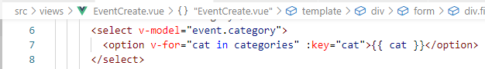

**Add the Event definition:**

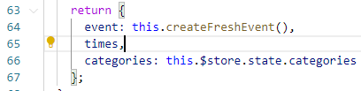

**In the Browser:**

**Categories:**

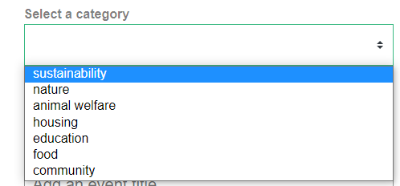

**Times:**

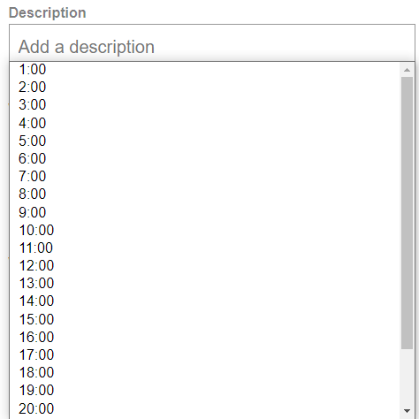



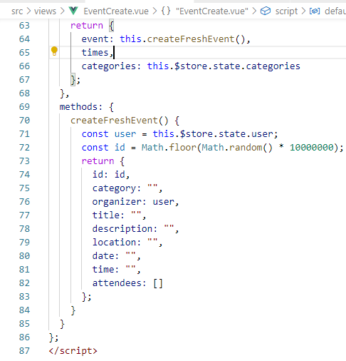





**Add mutation to the store:**



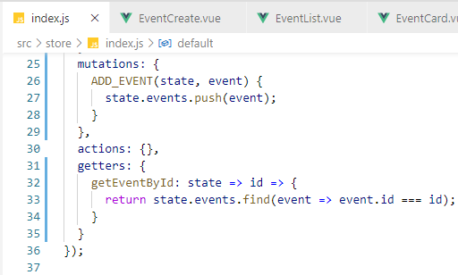



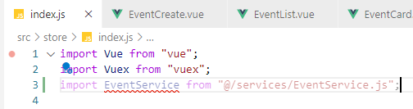



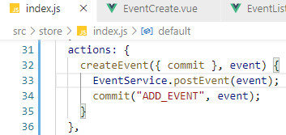

**In the EventService.js file, add the post:**

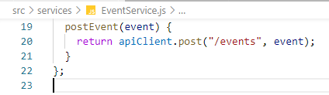



**Create the createEvent() method:**

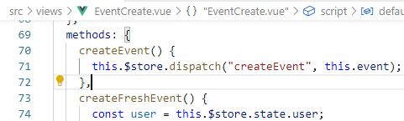

**Call the method from the form:**

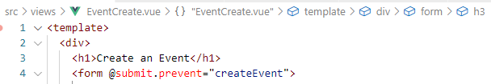

**Testing in Browser:**

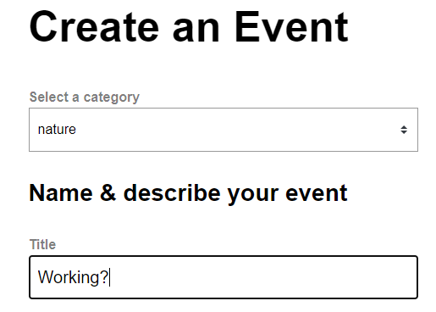

**Click Submit:**

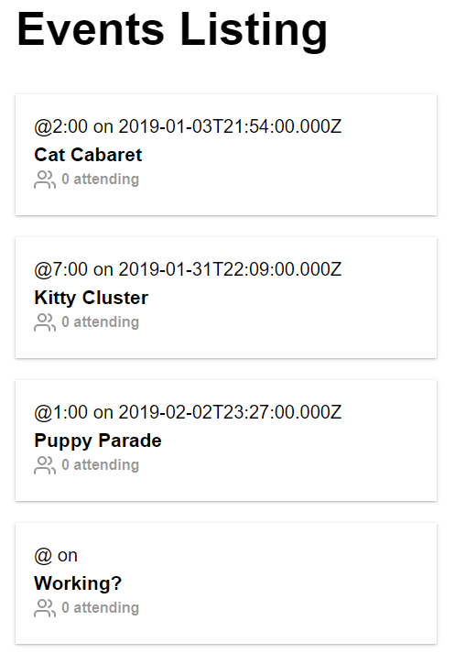

**List is updated with Working?**



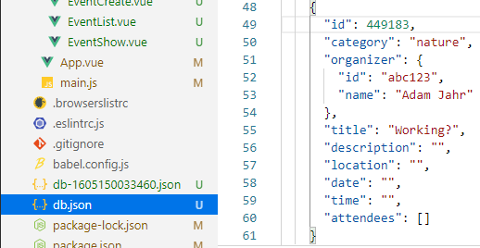



**To clear out any user input from db:**



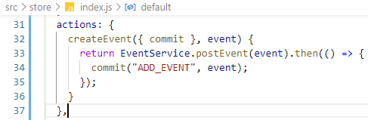



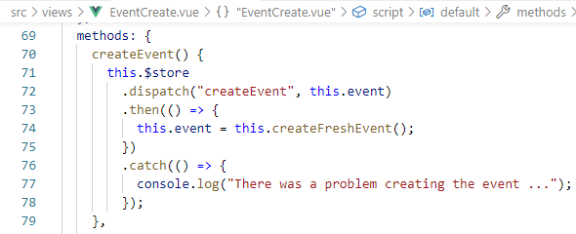



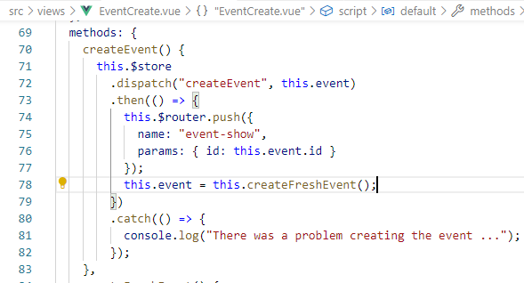

**Testing in the Browser:**

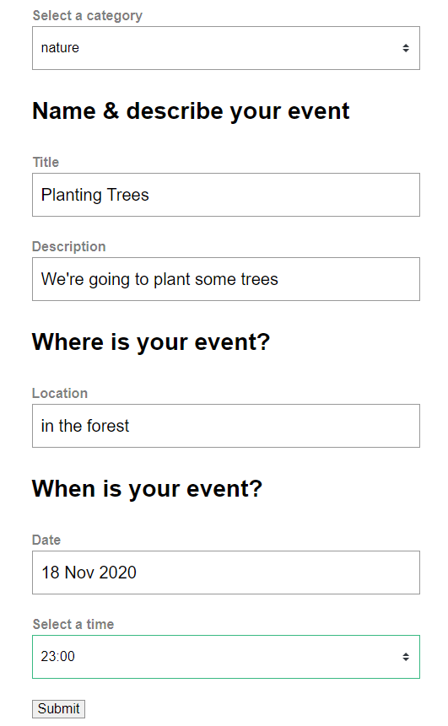

**Click Submit:**

**Routed to the Event**

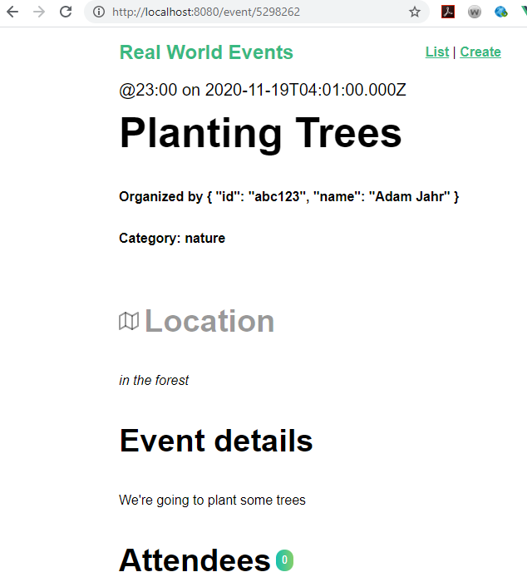

**Clean up the “Organized by:”**

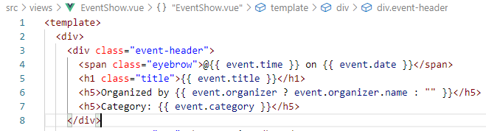

**Refresh the Browser:**

