**VueJs 3**

**Course: Intro to Vue 3**

**Ch03_Attribute_Binding**

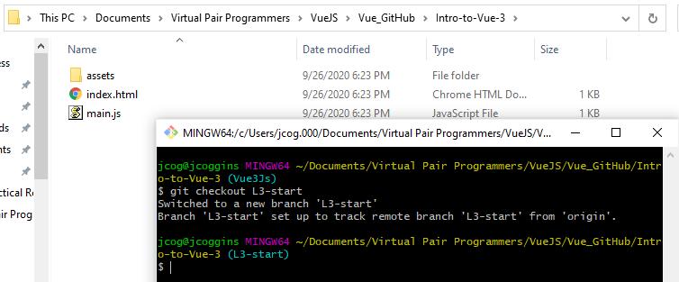

By running the command **git checkout L3-start**

you have the starting code to Attribute_Binding

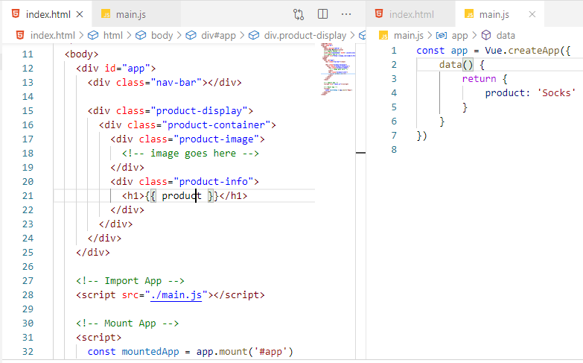

We have images that we need to target:

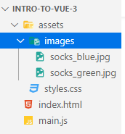

Add the targeting to the const app = Vue.createApp() structure

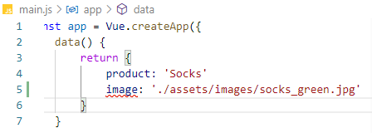

This is the relative path under Copy Relative Path (make sure to include a comma)

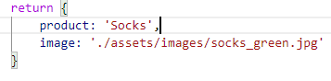

Next we want to use the targeting item image in the html template (body)

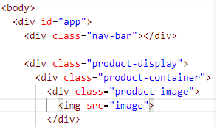

**How do we bind the src to the image?**

We used the div id before for Data items, here we have an image item

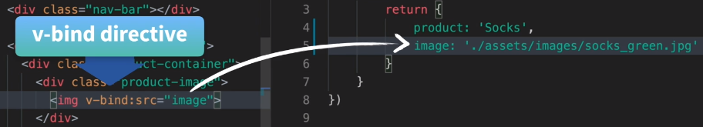



**We use the v-bind directive**

Let us check the browser:

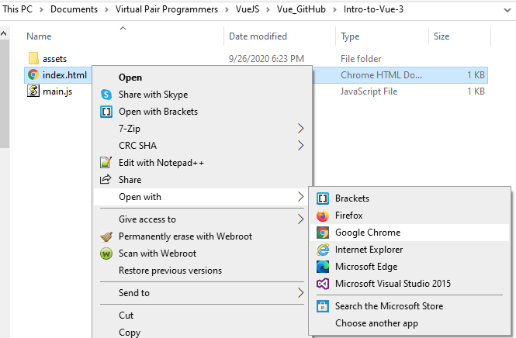

Or Launch Chrome against Localhost:

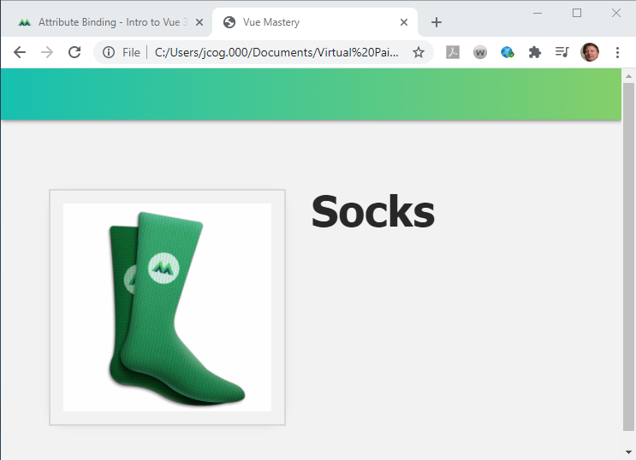

We use v-bind

To Dynamically bind an attribute to an expression

Attribute is src

Expression is “image”

Or this is the same as a {{}} example

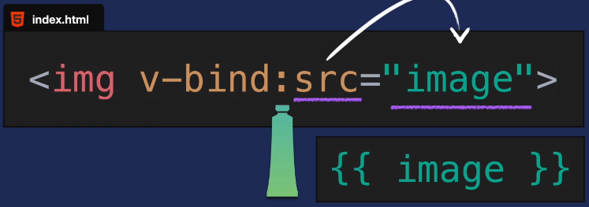

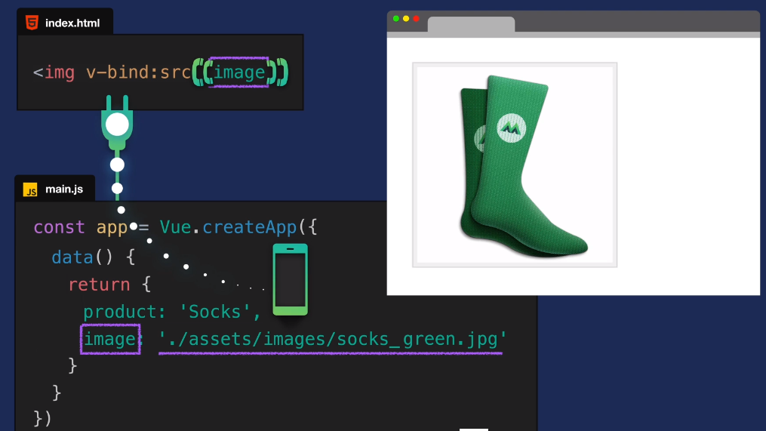

There is a shorthand for v-bind expressions:



Other examples for v-bind

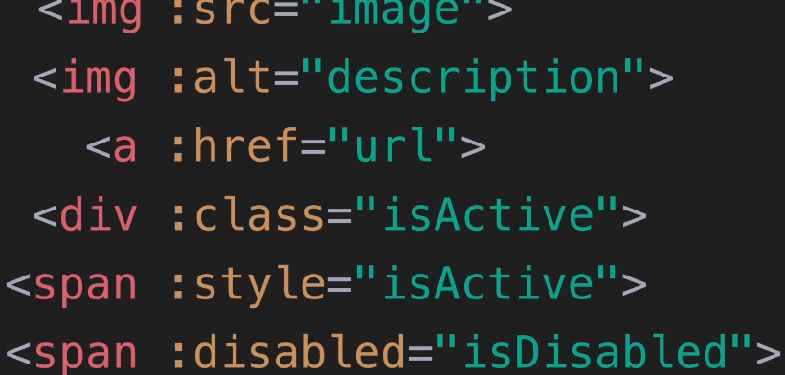

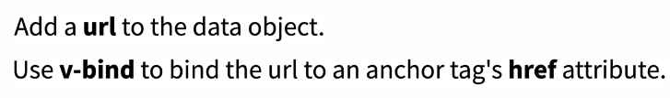

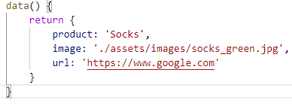

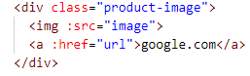

Using the File Path:

file:///C:/Users/jcog.000/Documents/Virtual%20Pair%20Programmers/VueJS/Vue_GitHub/Intro-to-Vue-3/index.html

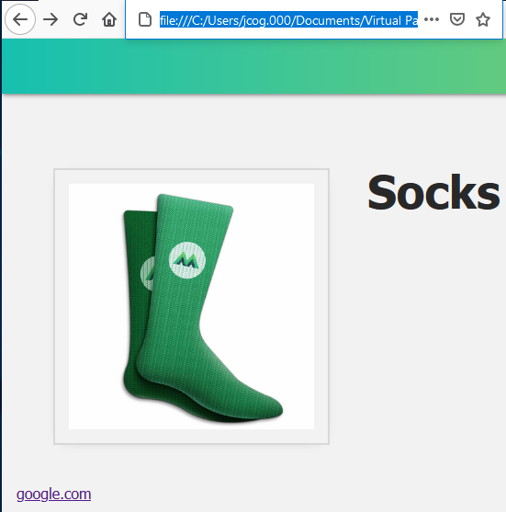

Click the google.com

