**VueJs 3**

**Course: Intro to Vue 3**

**Ch04_Conditional_Rendering**

Looking at the condition of InStock vs OutOfStock:

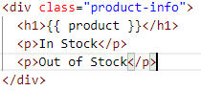

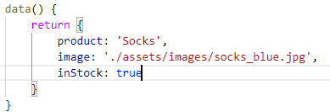

**If-else condition:**

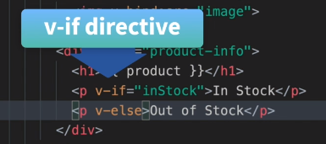

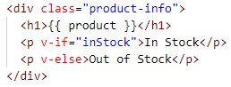

Let us look in the Browser:

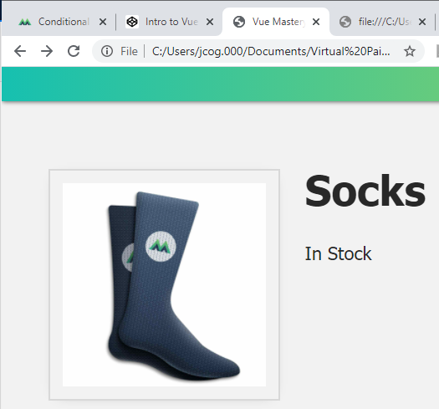

Let us set the condition to false for the else show up: Out of Stock

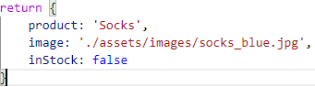

Let us look in the Browser:

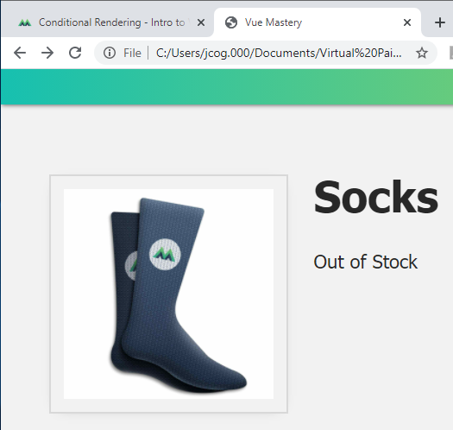

You might use just the if condition

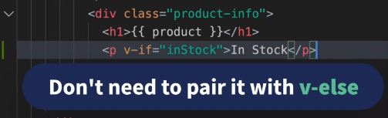

Another option is

v-show This is a toggle option

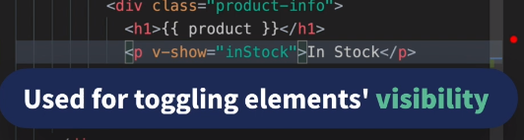

Style is hidden and no message seems to appear when false is the default

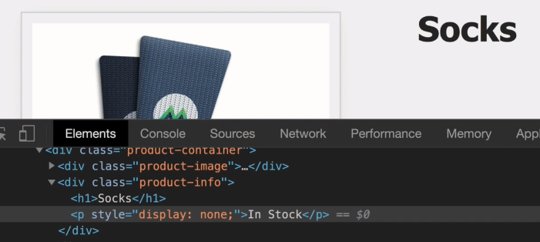



If inventory is greater than 10 the condition is true so, the In Stock message should appear:

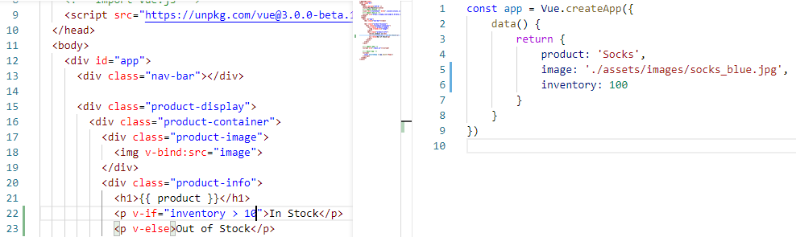

Let us check the browser:

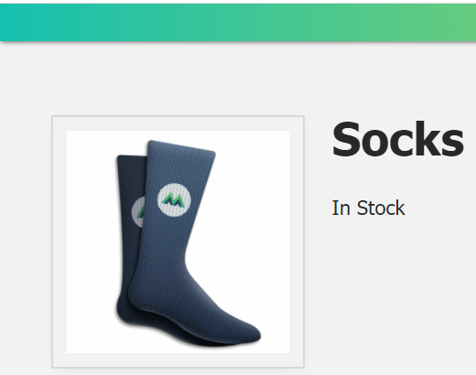

Middle layer condition Almost sold out

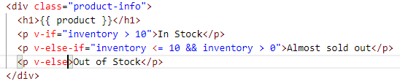

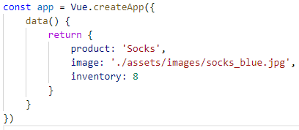

Let us check the Browser:

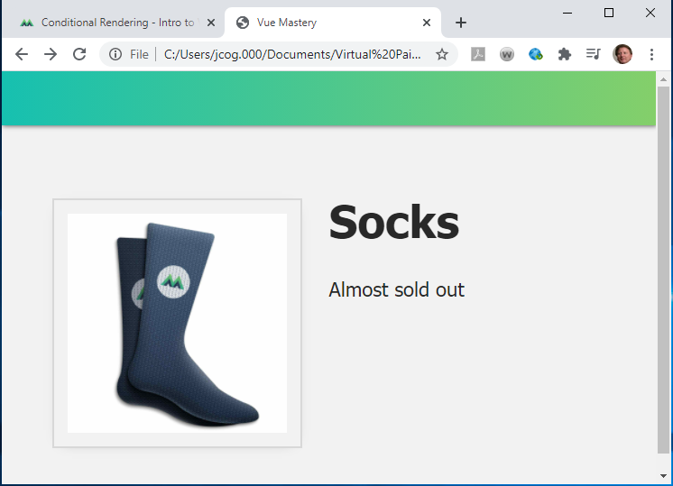

If inventory is 0, then Out of Stock

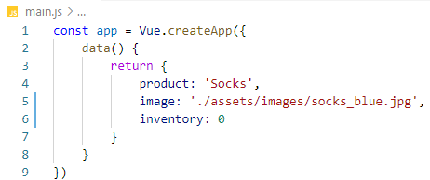

Let us check the Browser:

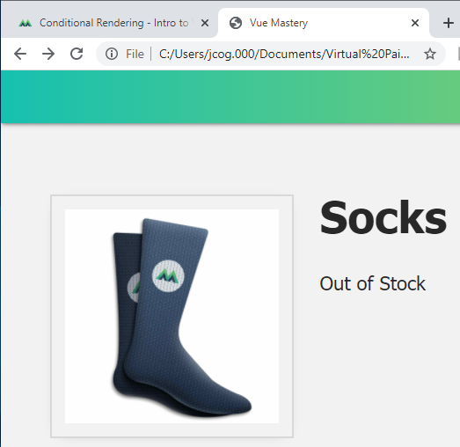

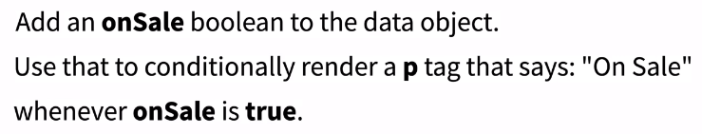

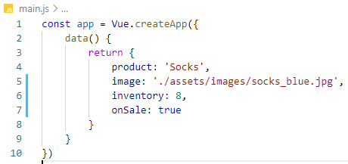

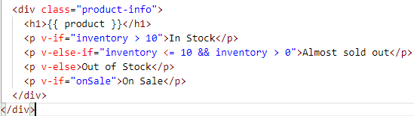

Let us check the browser:

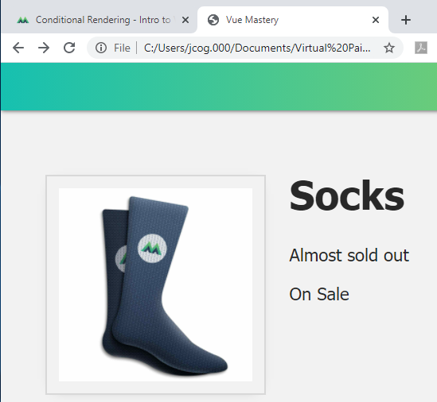

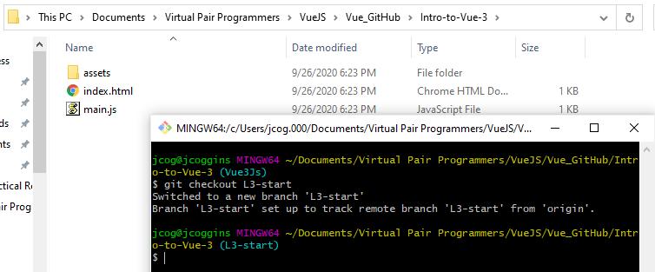

By running the command **git checkout L3-start**

you have the starting code to Attribute_Binding

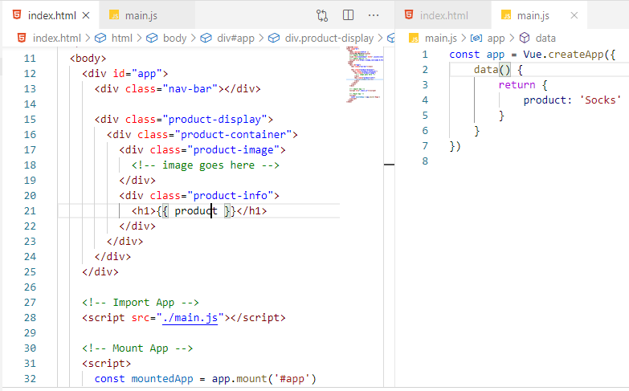

We have images that we need to target:

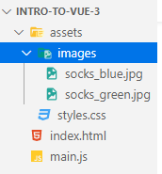

Add the targeting to the const app = Vue.createApp() structure

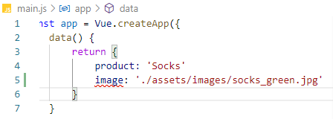

This is the relative path under Copy Relative Path (make sure to include a comma)

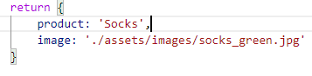

Next we want to use the targeting item image in the html template (body)

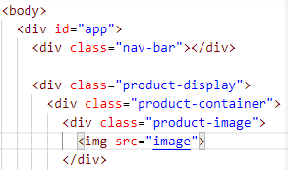

**How do we bind the src to the image?**

We used the div id before for Data items, here we have an image item

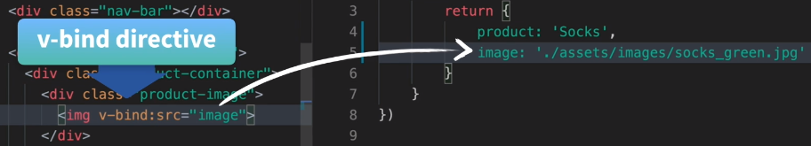



**We use the v-bind directive**

Let us check the browser:

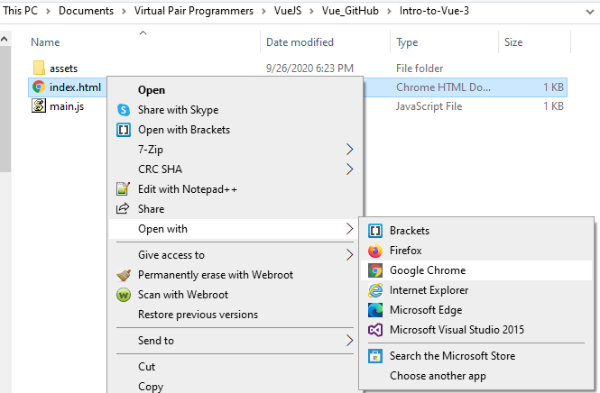

Or Launch Chrome against Localhost:

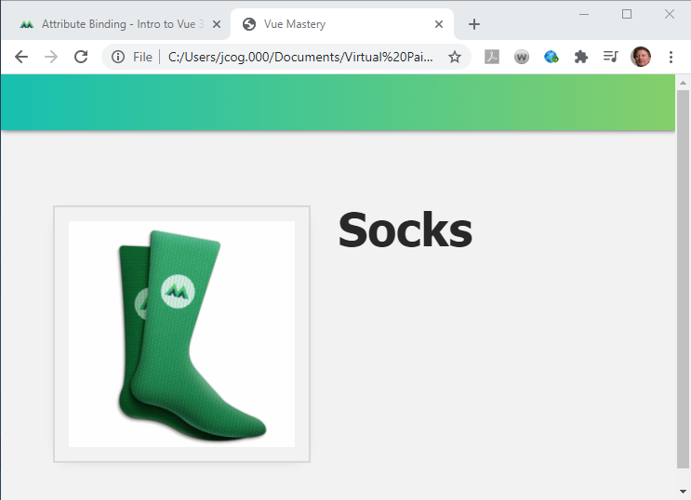

We use v-bind

To Dynamically bind an attribute to an expression

Attribute is src

Expression is “image”

Or this is the same as a {{}} example

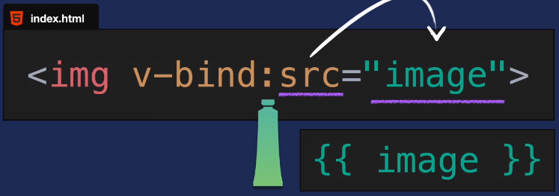

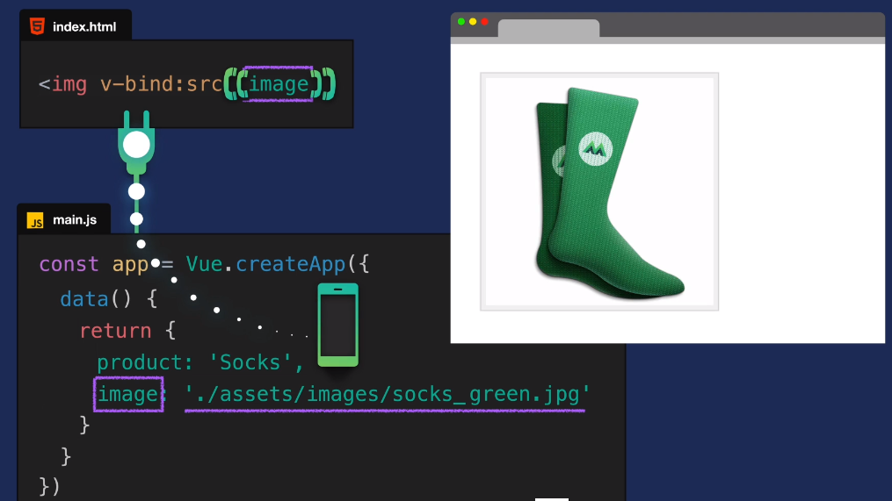

There is a shorthand for v-bind expressions:



Other examples for v-bind

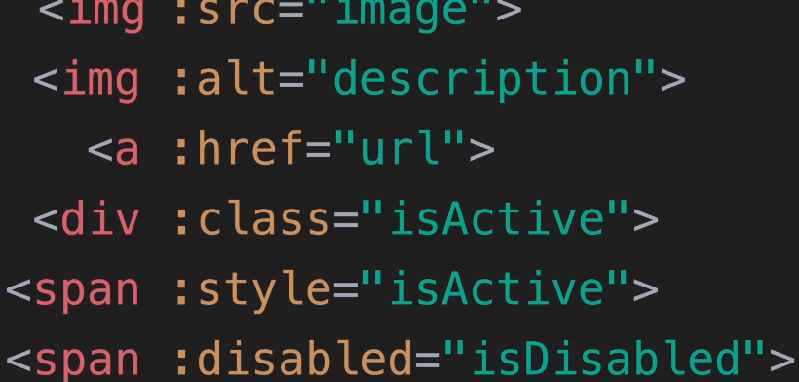

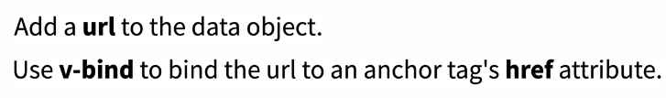

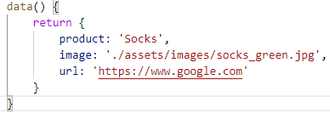

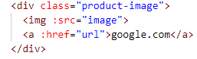

Using the File Path:

file:///C:/Users/jcog.000/Documents/Virtual%20Pair%20Programmers/VueJS/Vue_GitHub/Intro-to-Vue-3/index.html

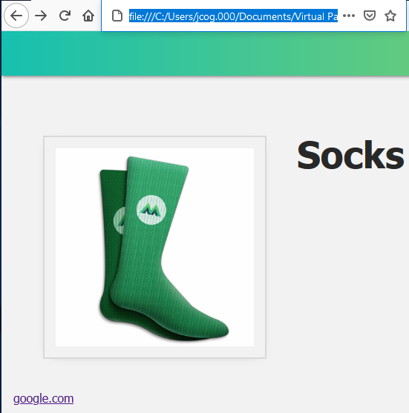

Click the google.com

