**VueJs 3**

**Course: Intro to Vue 3**

**Ch05_List_Rendering**

We start with an array of details

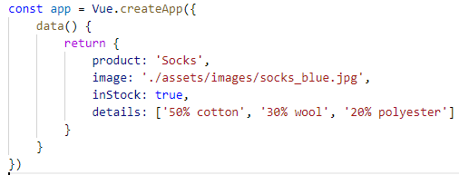

**How do we display details as a List?**

**Use the v-for** directive

With an unordered list element containing a list item we for loop through the array of details

outputting a detail list item. The detail variable is an arbitrary name.

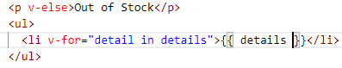

In the browser we see:

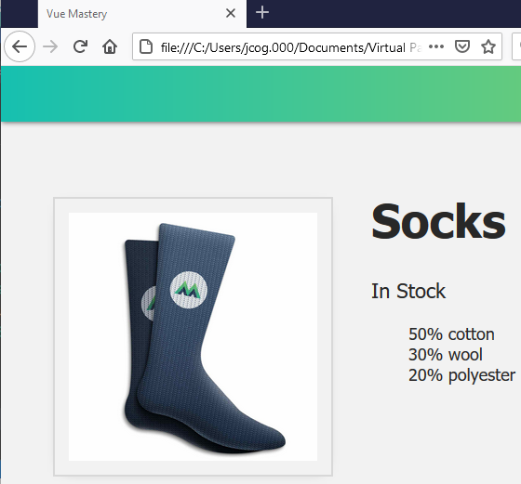

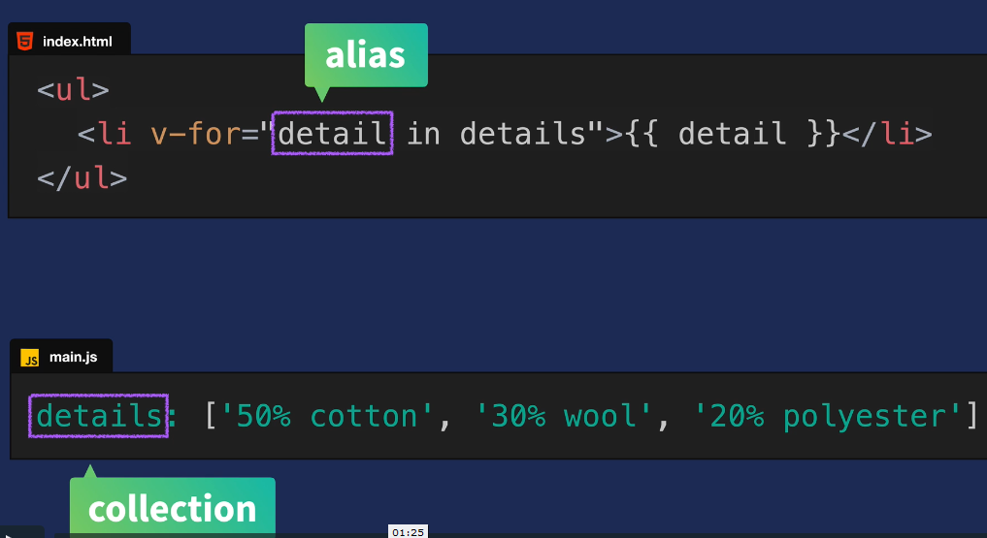

Let us create a variant array:

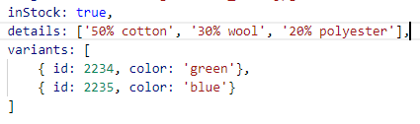

This array contains 2 objects with keys and values

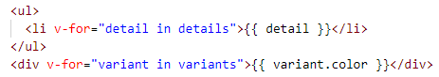

The loop will find the values green and blue

In the browser we see:

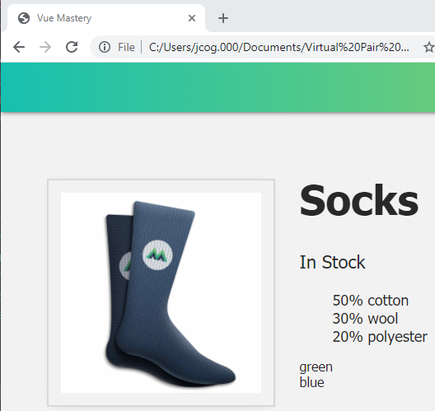

Now, utilize the keys:





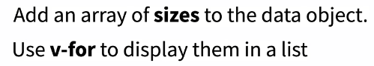

Sizes can be small, medium and large

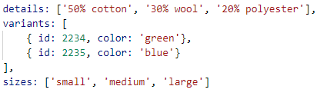

Now use a v-for over the sizes collection in ul element containing a list item:



In the browser:

