**VueJs 3**

**Course: Intro to Vue 3**

**Ch06_Event_Handling**

Starting code:

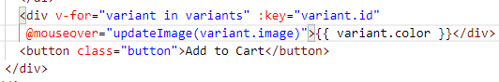

In the browser:

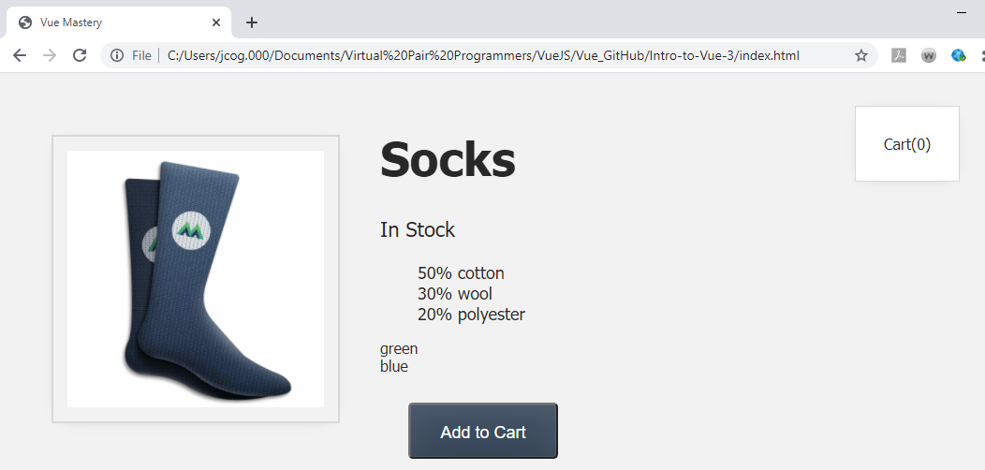

We want to click the Add to Cart button and add an item to the Cart(0)

**How do we listen for events?**

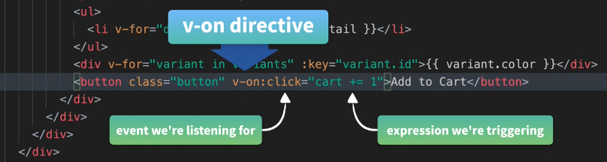



Click on the “Add to Cart” button and 1 should end up in the Cart(0)

Before:

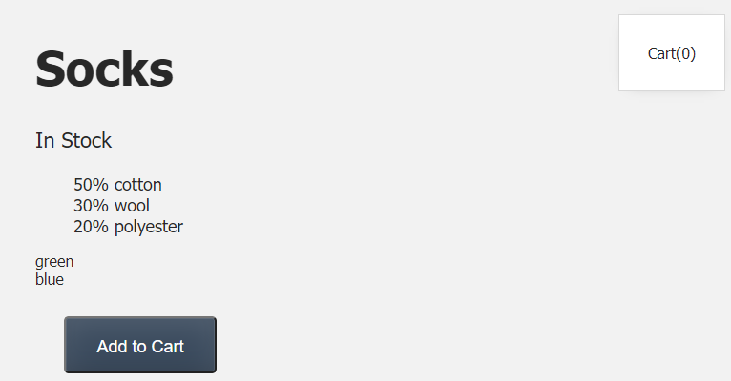

After clicking:

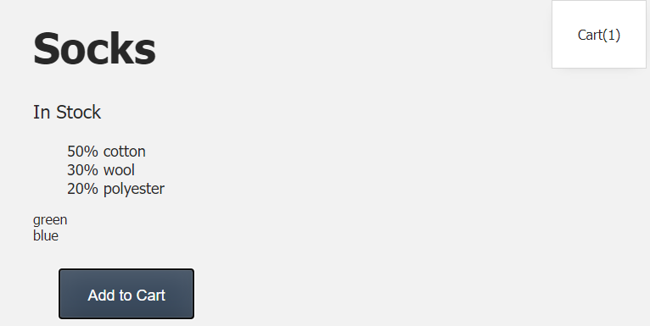

Now use a method name when the event happens “addToCart”



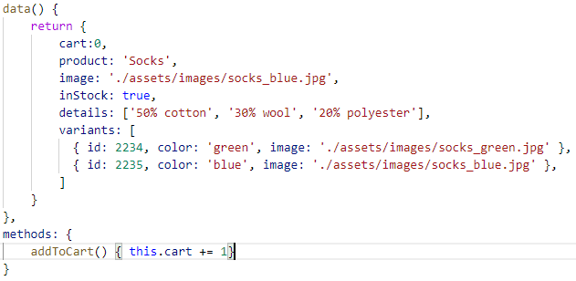

Test in the browser:

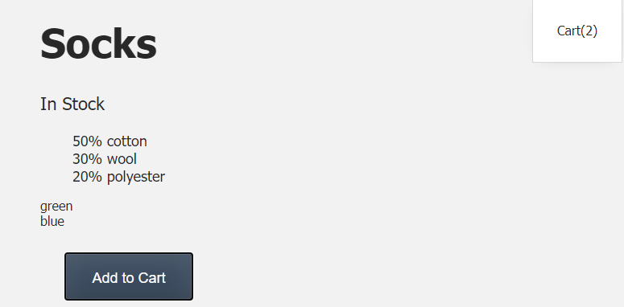

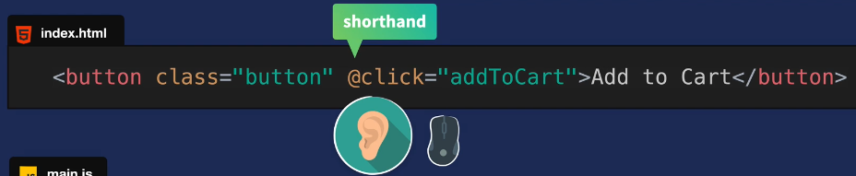

Now, when we hover over the image the blue or green updates

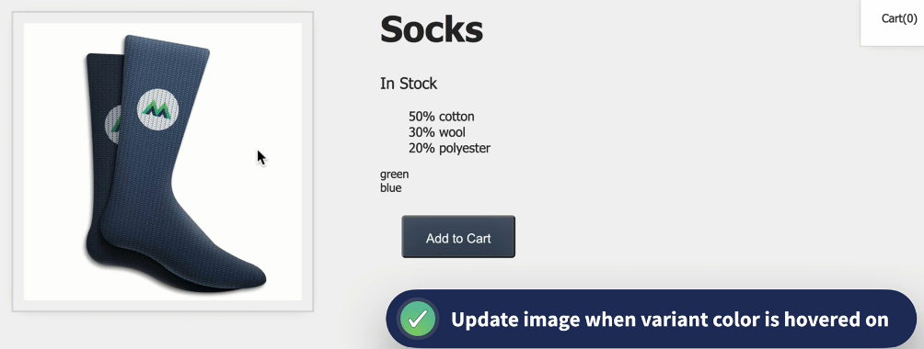

Listen for hover events on our divs

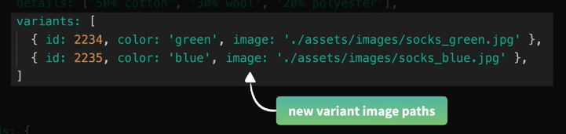

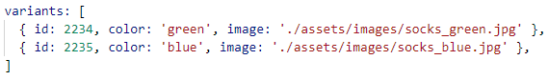

@mouseover is the vue version for hover:

Add a method updateImage(variant.image)

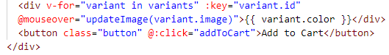

The method returns the socks that represent the color:

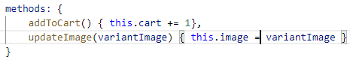

In the browser:

Hover over green words and get green socks

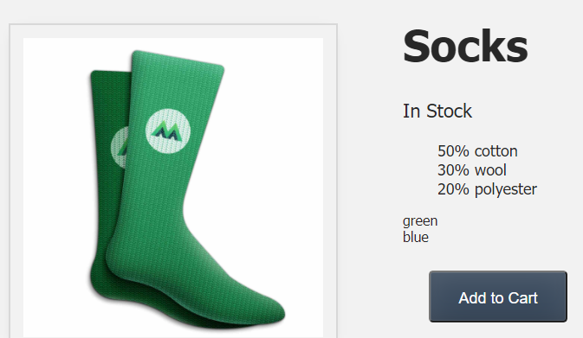

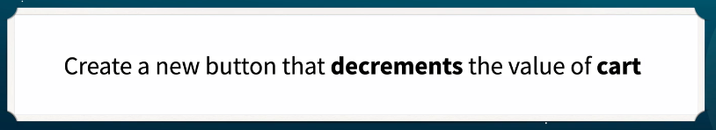

When click the button the Cart(1) goes back to Cart(0)



Add the method to the removeFromCart  
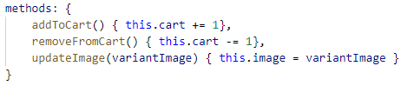

Before:

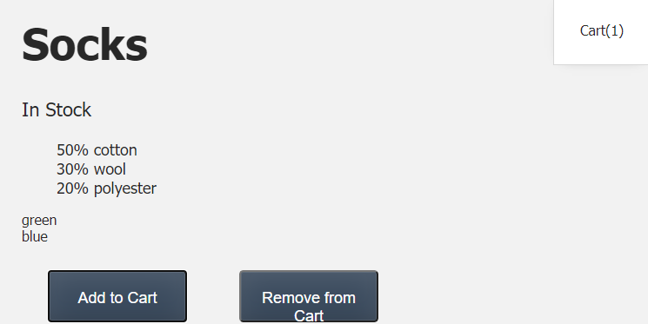

After:

