**VueJs 3**

**Course: Intro to Vue 3**

**Ch07_Class_and_Style_Binding**

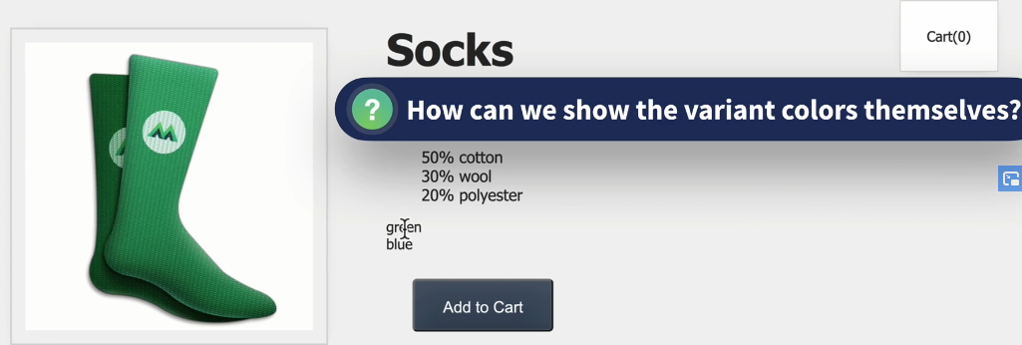

**Using style binding use the colors and not the words for hovering:**

Let us start with a new class called “color-circle”

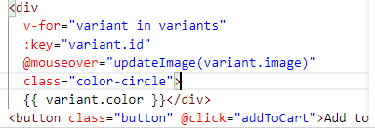

Looking in the styles.css file:

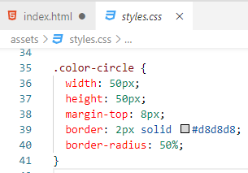

In the browser:

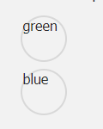

**Now, bind the style color to the background color of the circles:**

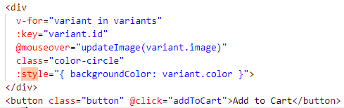

In the browser:

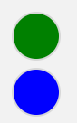

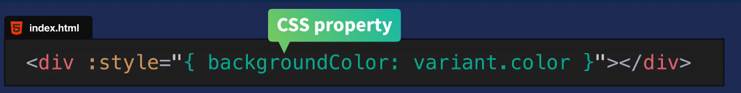

***Javascript not css is used here:***

***Notice the backgroundColor is camelCased where in CSS the property is background-color***

Kebab case imitates the CSS property but it has to be in Single Quotes!!!

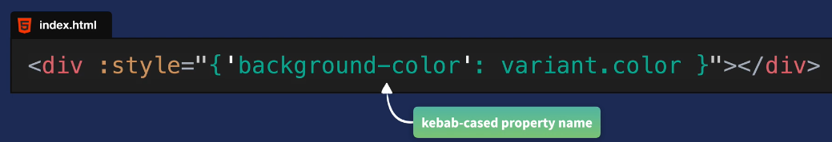

**Whenever the Out of Stock is showing the button should be disabled!!**

In the code:



Let us also change the color of the button to visually show that it is disabled:

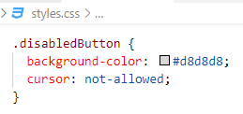

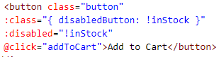

In browser:

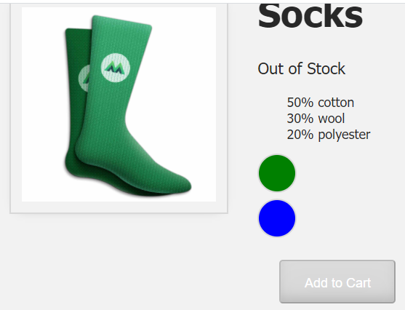

To test this open a Console:

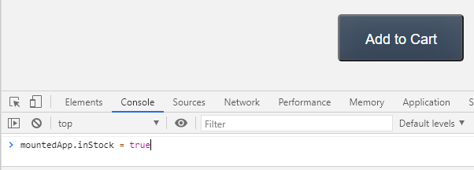

Conditionally adding the class or not

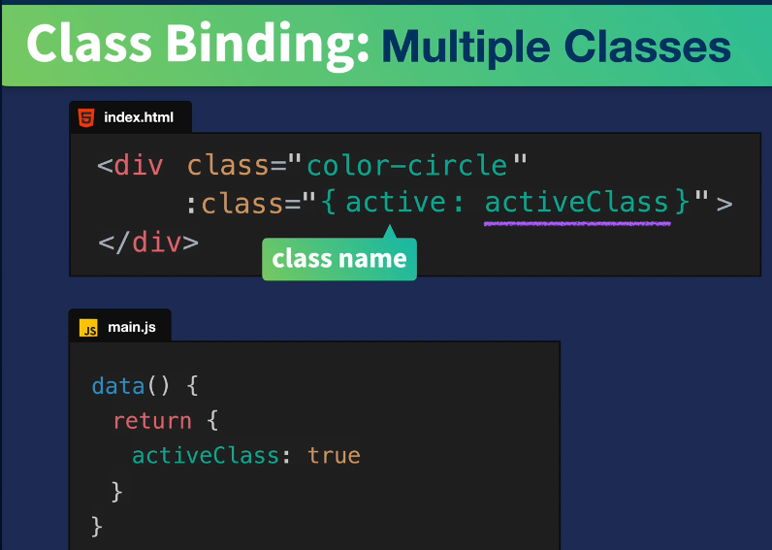

Using a ternary version

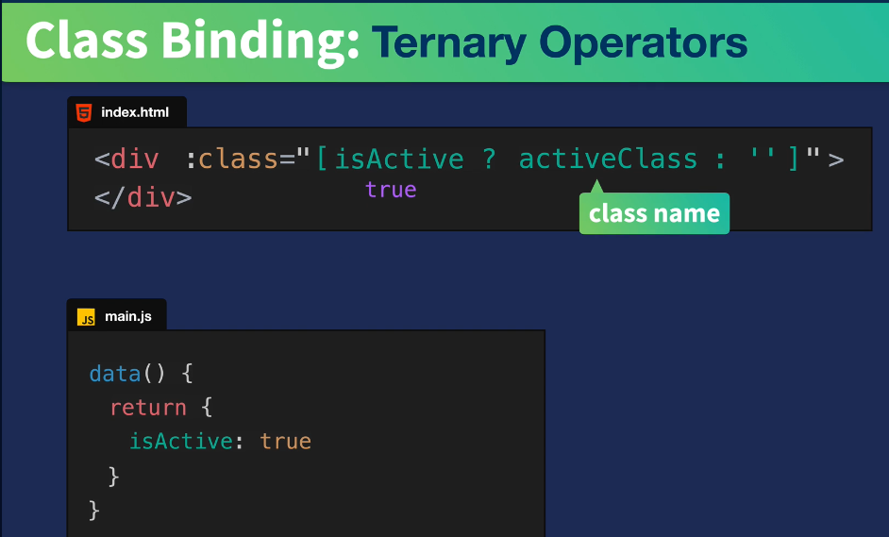

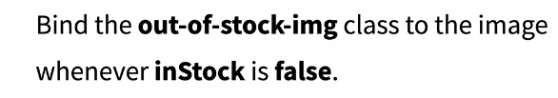

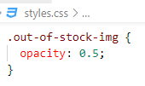



In the browser:

Out of Stock

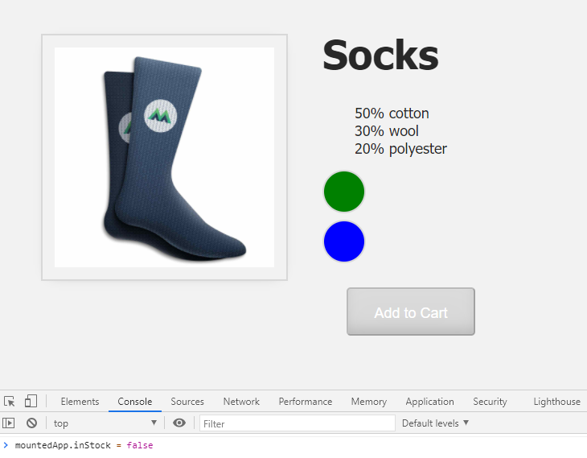

In Stock

