**VueJs 3**

**Course: Intro to Vue 3**

**Ch08_Computed_Properties**

We have a new data property: “Vue Mastery”

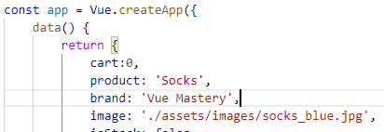

We want to combine the brand and product in our template

For example:



In browser:

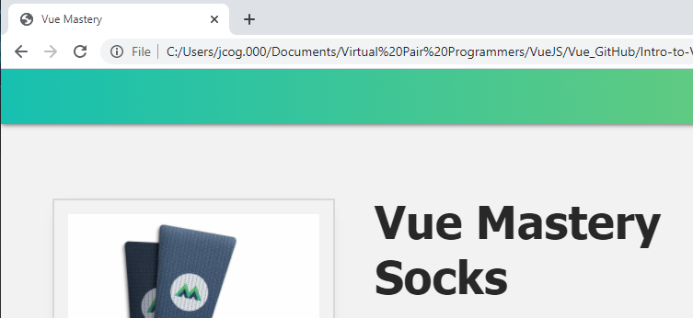

Let us encapsulate this behavior inside a computed property

Replace the template above with “title”

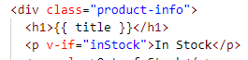

**Create the computed property - title**

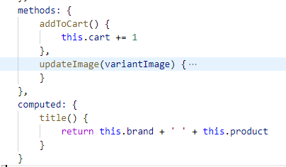

In the browser:



Now, combine the color changes with the in an out of the stock:

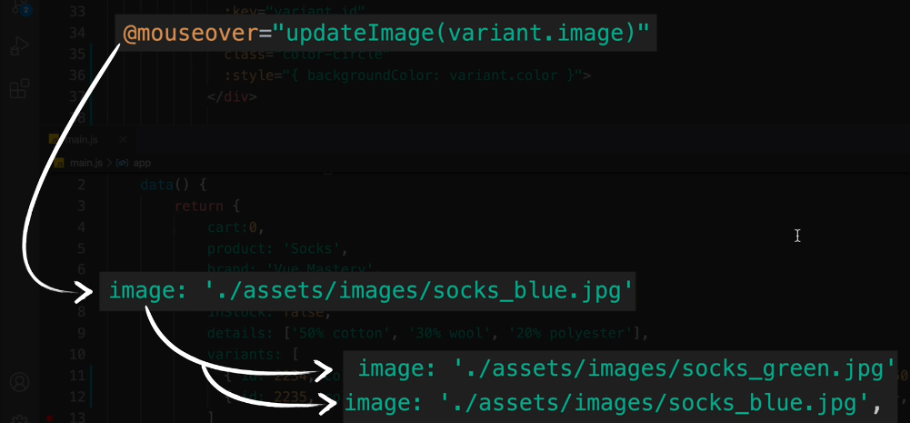

Now, if blue is 0 and green is 50 in stock, how does this effect the mouseover

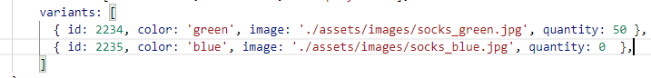



**Make 3 changes in the div:**

Loop over the index and the variant, change the method name to updateVariant(), and pass index instead of image.

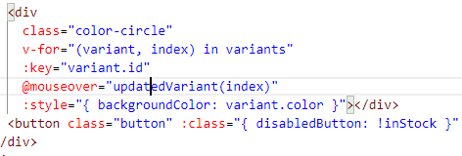

**Now in the data() property:**

Create the selectedVariant, initialized as 0 index, delete the instock and image property.

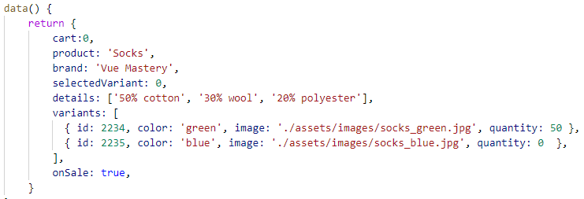

**Fix the new method()**

Change the method updatedVariant, take the parameter index and update it

This can be tested with console.log(index)

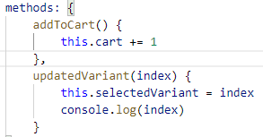

Look for the logged indexes and a warning:

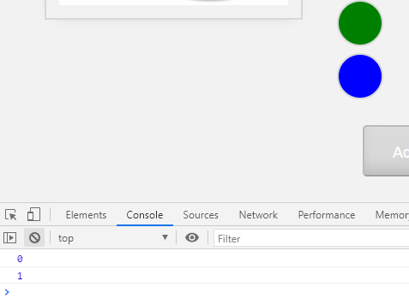

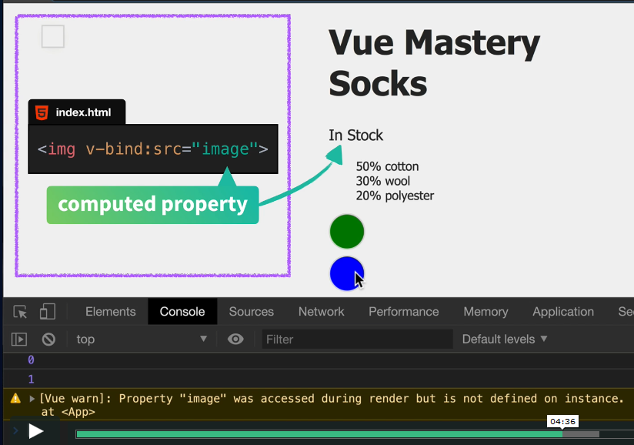

Now, replace image and in stock with a computed property

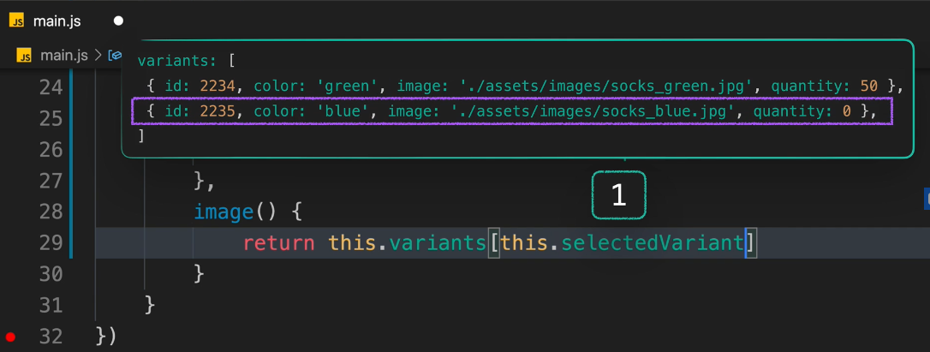

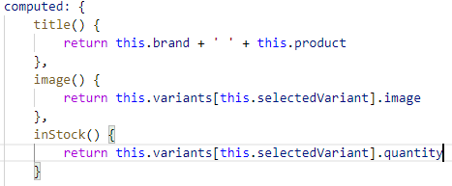

In the browser:

Over Green:

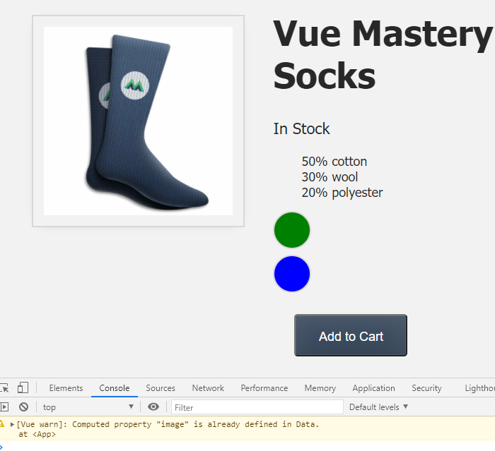Over Blue:

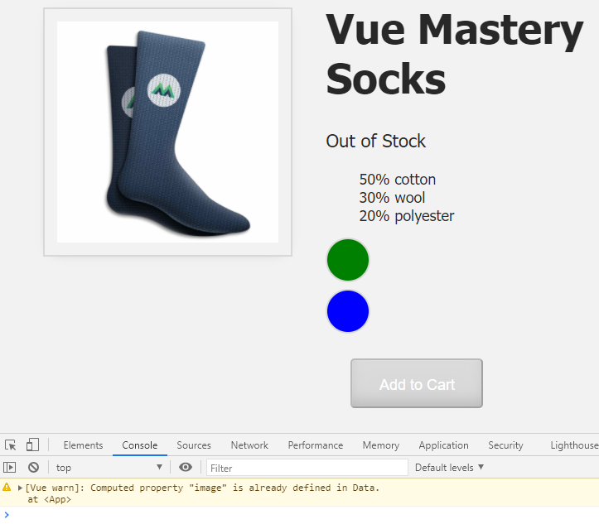

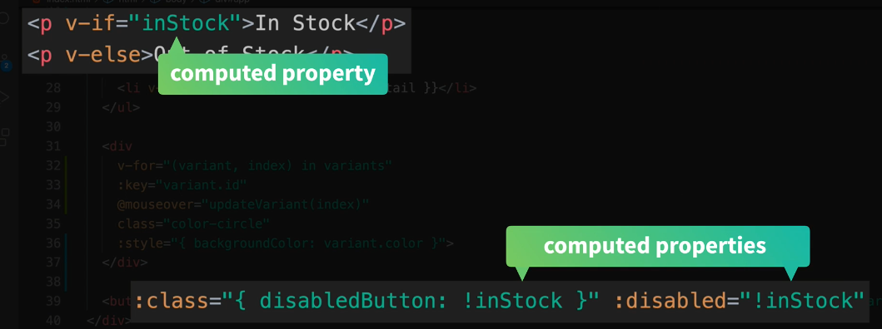

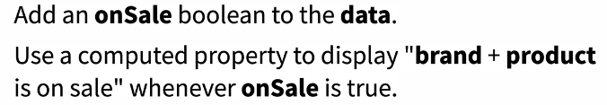

data property:

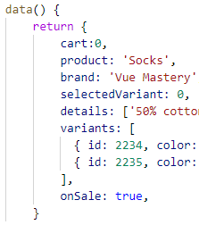

computed Property:

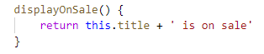

Template changes:

Have the onSale be true if the socks are inStock, so display the message otherwise do not display the message.

