**VueJs 3**

**Course: Intro to Vue 3**

**Ch10_Communicating_Events**

Because a Cart does not live or has scope in the ProductDisplay component it does not work.

Communication needs to be reestablished between the Cart button and the Cart itself.

No matter how many times you click the Add to Cart button nothing happens (no event) is registered by

Cart(0)

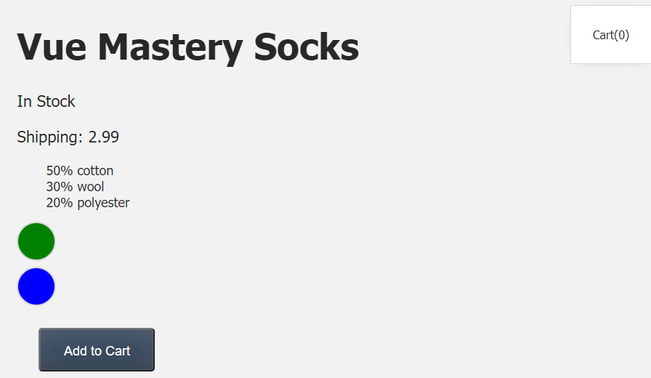

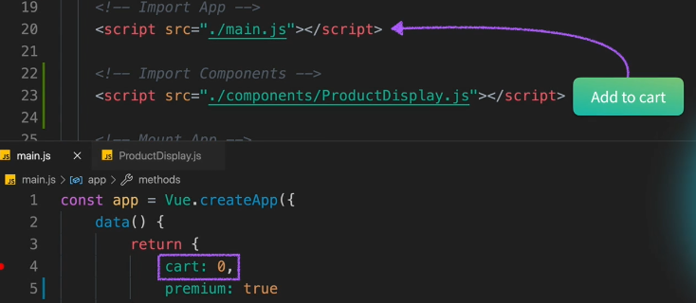

The opposite of Props is to emit the event to the Parent:

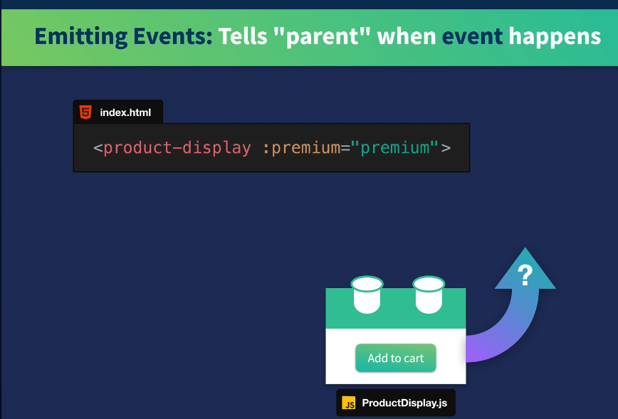

Bubble up the event with emitter this.$emit(‘add-to-cart’)

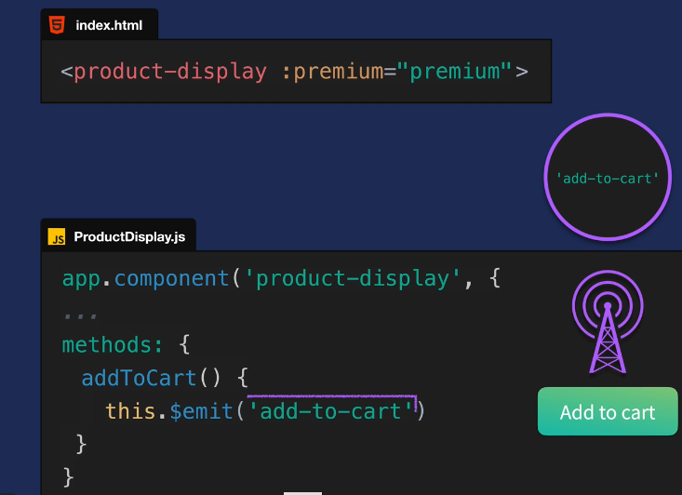

Listen for the event with a listener: @add-to-cart

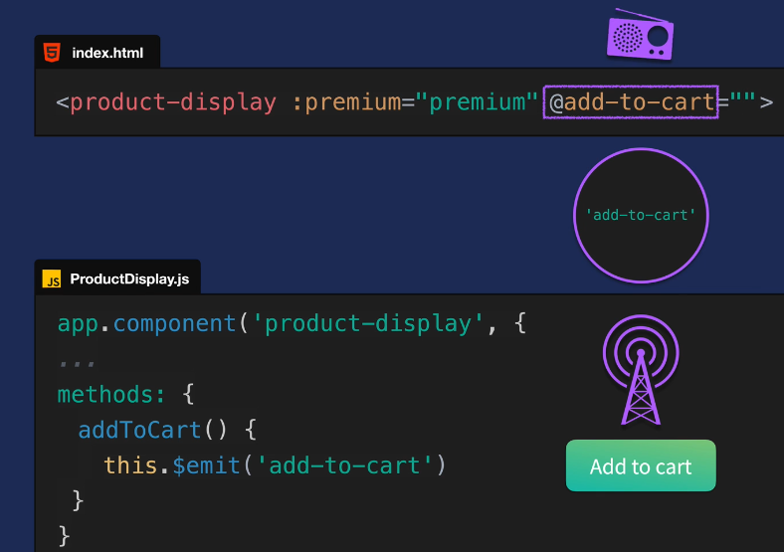

When the listener hears the message it can trigger a method to updateCart

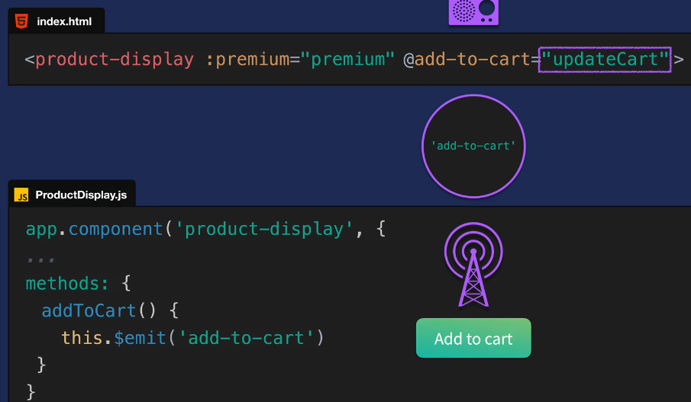

This method will update the actual cart:

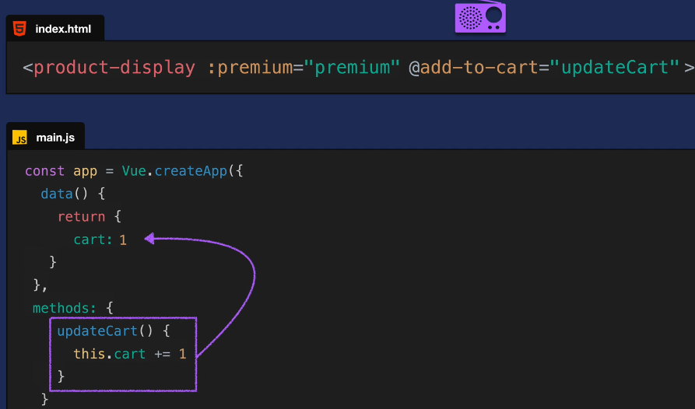

**Go to methods in ProductDisplay component:**

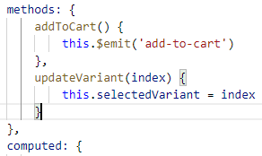

**Now, listen for the event on <productdisplay> element in main.js**



**Last, redefine the method updateCart in methods in main.js**

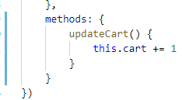

**Now, we check the browser:**

**Click the button cart(0) - > cart(1)**

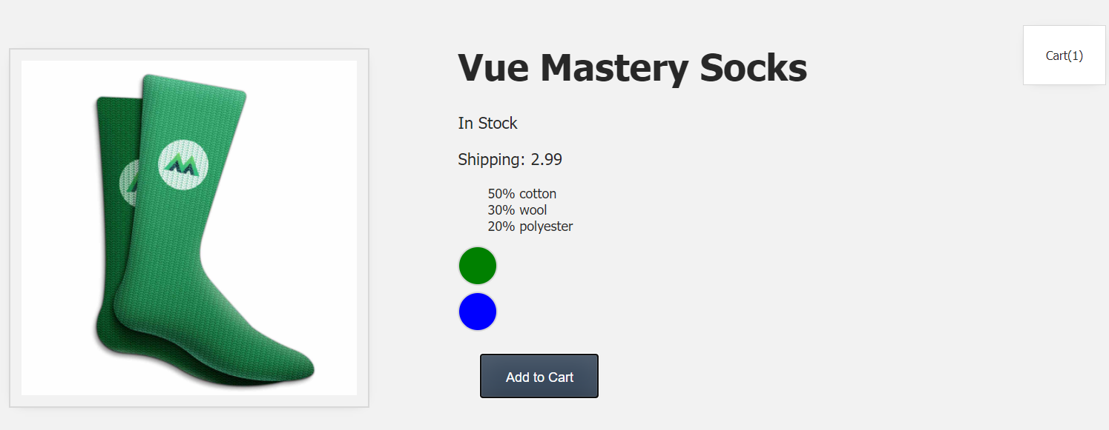

**Improve the cart by making it an array of ids**

**Change the updateCart method to pass an id into the array**

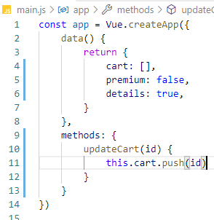

**Add a second param to the addToCart method to pass the id in ProductDisplay component**

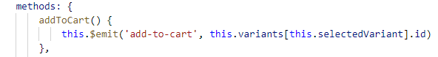

**Test this in the browser:**

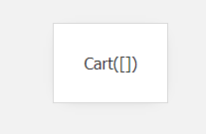

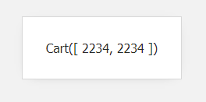

**Now, we do not need to show the ids, use length to show how many items are in the cart**



**Test in the browser:**

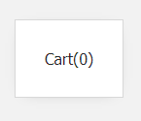

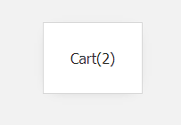

Now the exercise:

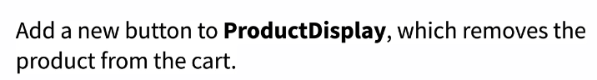

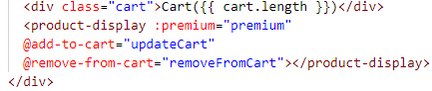

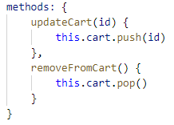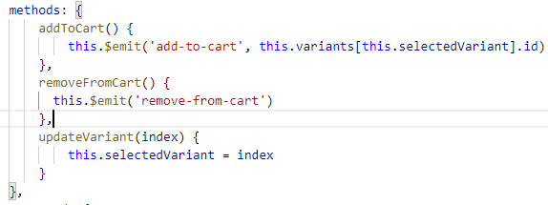

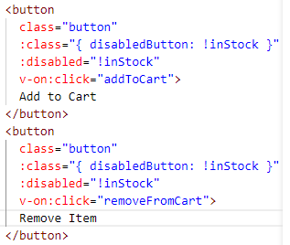

Test this:

