**VueJs 3**

**Introduction to Vue 3:**

Download the github code:

Download editor VS Code and extension E6-string-html



**In VS Code Open Folder:**

**Intro-to-vue-3**

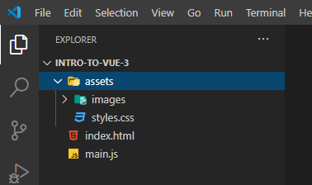

Index.js page

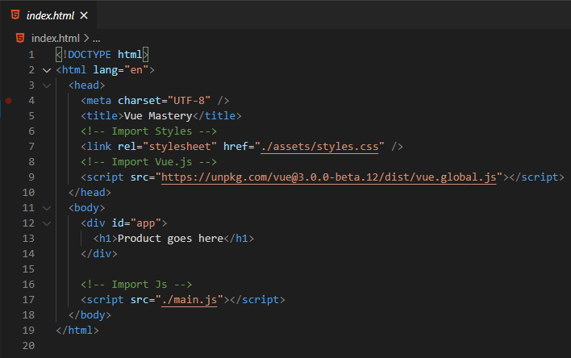

Get the non-Beta version of Vue3 from the Documentation:

**Copy the CDN link:**

<script src="https://unpkg.com/vue@next"></script>

The css is imported – see Import Styles

The vue is imported -- see Import Vue.js

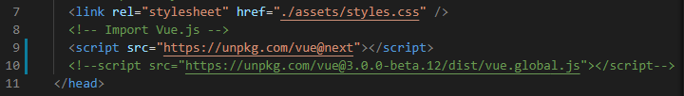

**Notice the const type product is a the string ‘Socks’**

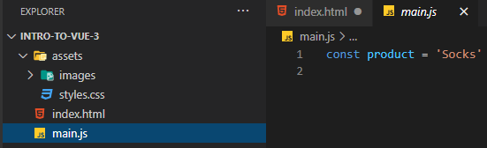

**The template is <h1>Product goes here</h1>**

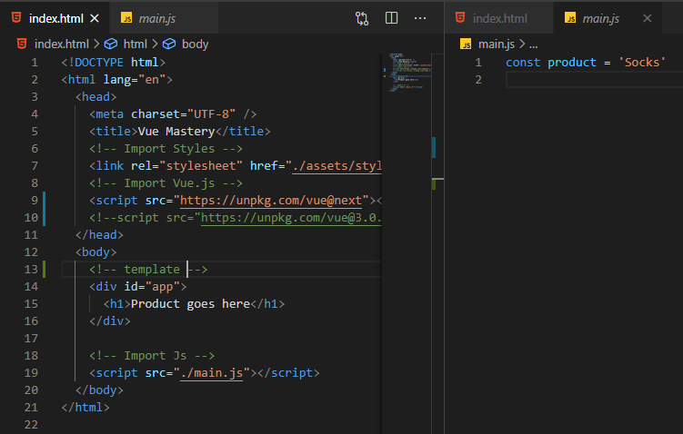

**How do we display the products using Vue.js?**

**1) Create a Vue app**

In main.js

const app = Vue.createApp

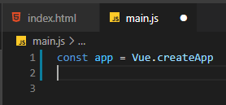

We need to create a data object {} which will be defined as a function

which will return another object {}, where we store the data items.

e.g. product: ‘Socks’

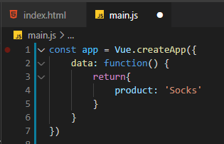

ESS shorthand allows the removal of the type of object (: function) => ()

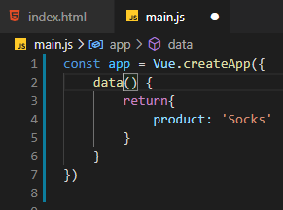

**2) With the Vue App created we can now import and mount the App:**

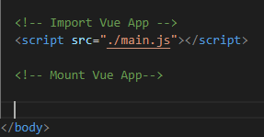

// Import app

// mount app

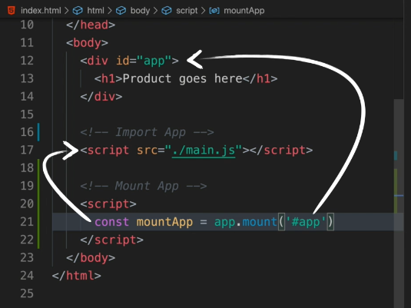

Resulting Import and Mount

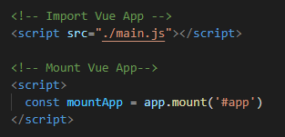

Why the # in front of app as a string?

# indicates a DOM selector for insertion into the div that contains the id=“app”

**3) We will use the Curly Brace Syntax** {{}} as the placeholder for the object product

{{}} means expose or reveal the value for product

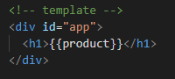

Now, let us see what the product object reveals in the Browser:

Right-click on open the index.html page

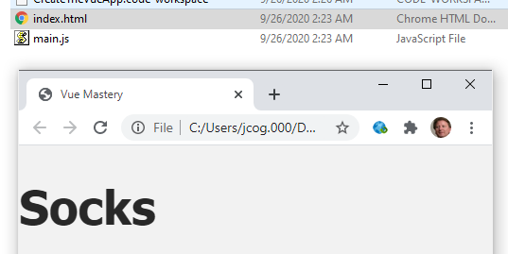

How did this happen?

We created an Options Object  
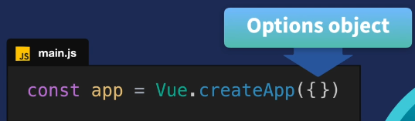

In go the properties

You always have to pass at least and empty {}

The data ‘Socks’ gets into the App

We then plug the app into the div with id=app

{{}} what is the value of product (this is also known as mustache notation)

App responds with ‘Socks’

Running valid javascript in HTML

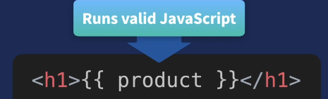

Other Expressions that can be run on data!!

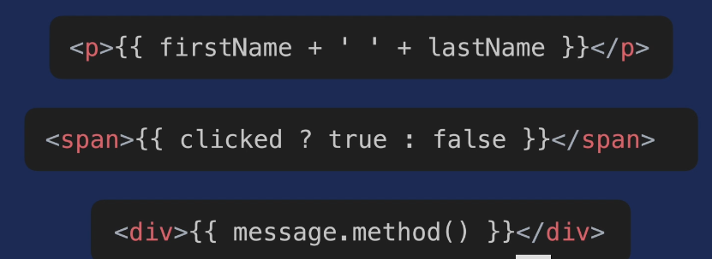

**View is referred to as Reactive:**

Change Socks to PussNBoots and change is immediate

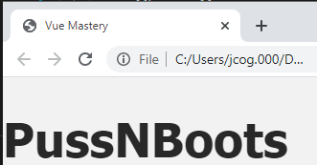

Using the Console in Chrome you can change the Data:

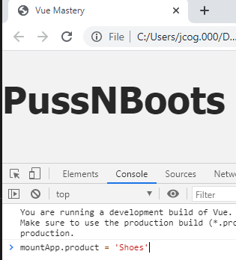

Press Enter:

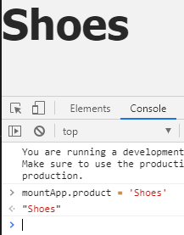

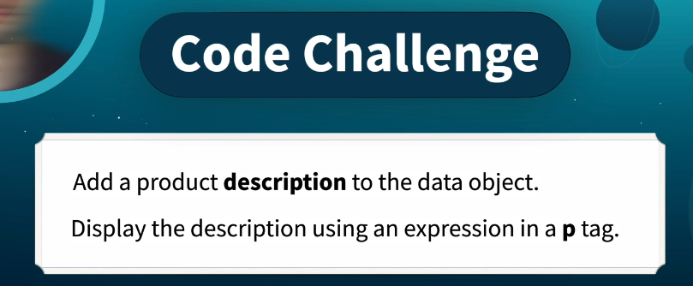

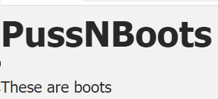

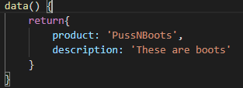

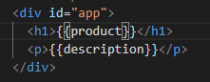

Correct!!