**VueJs 2**

**Course: Real World Vue2**

**Ch01_CreatingOurProject**

Vue CLI

**Command Line Interface:**

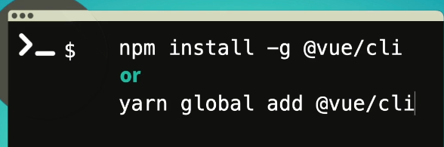

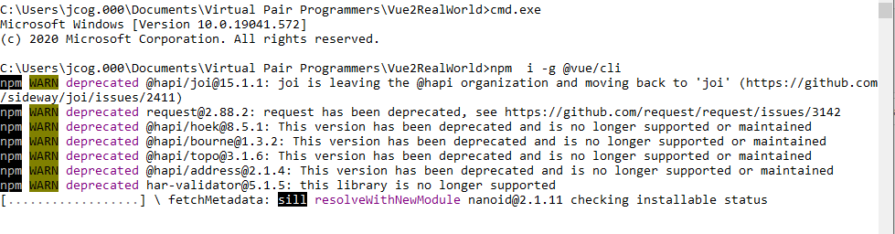

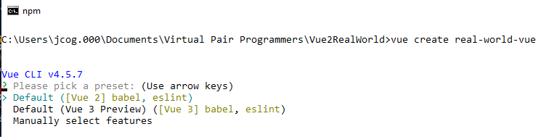

Next, name of the Project is Real World Vue 2;

>**vue create real-world-vue**

**>Manually select features**

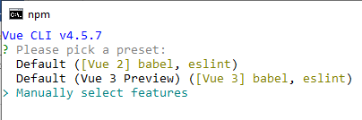

Enter

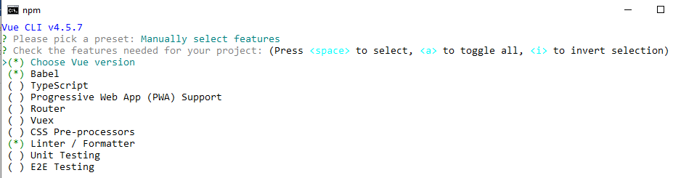

>Select the **Router** and **Vuex** use spacebar to select

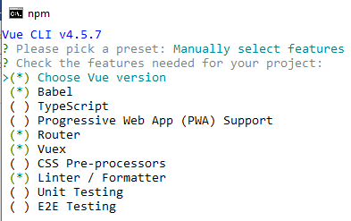

>**2.x**

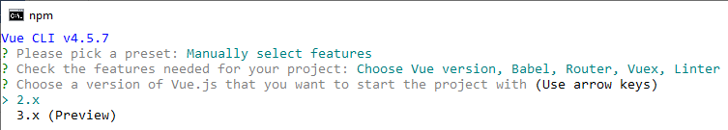

>history mode or vue router? **Y**

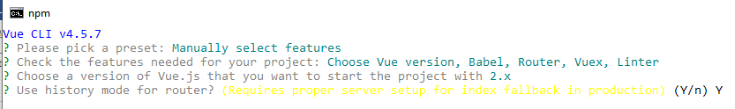

>**ESLint + Prettier**

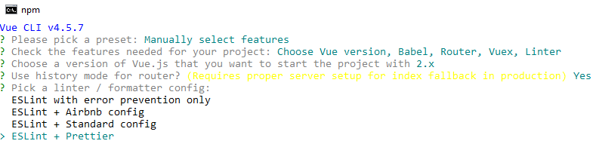

>**Lint on Save**

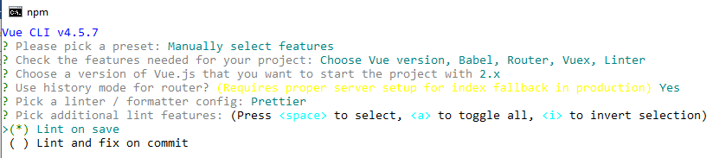

>**In** **dedicated config files**

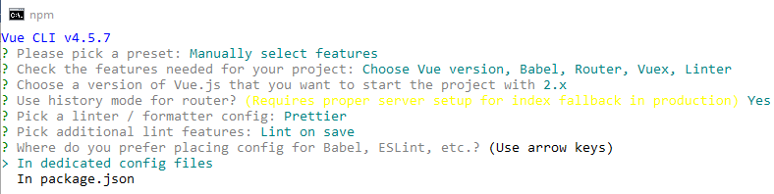

>**Save this as a preset for future projects? N**

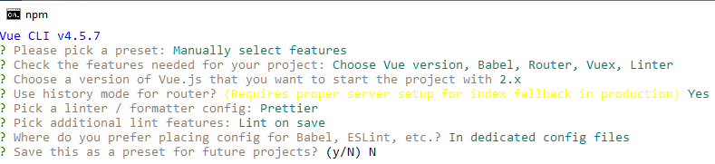

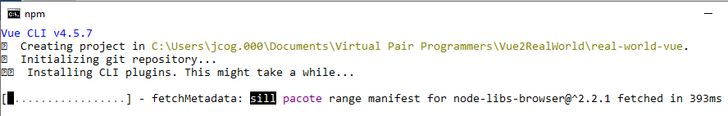

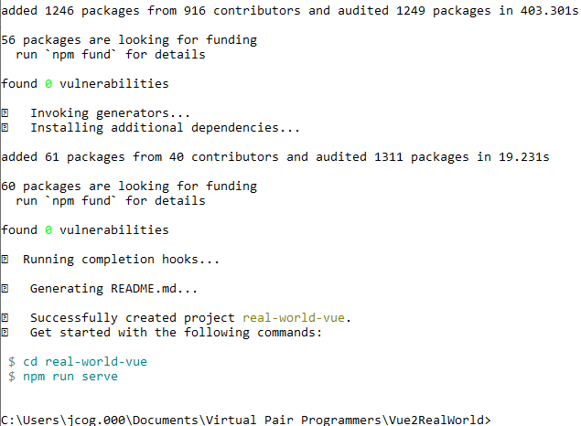

**>cd real-world-vue**

**>npm run serve**



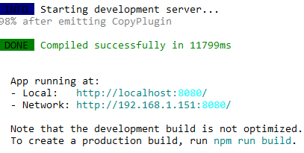

**In the browser:**

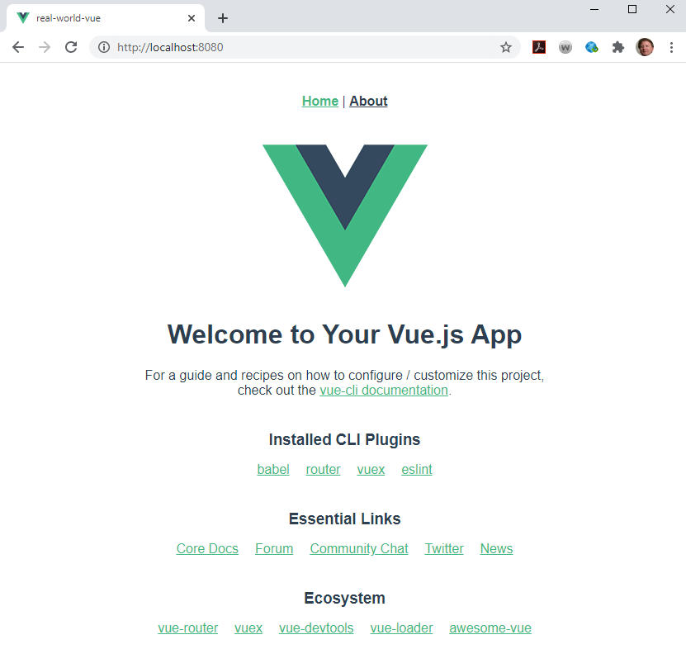

**In Vue 2 the main.js is slightly different from Vue3**

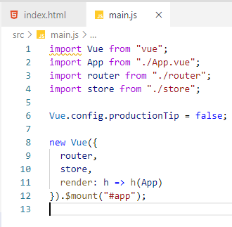

**1 Vue is imported but the createApp method is not used**

**Notice there is no dist folder:**

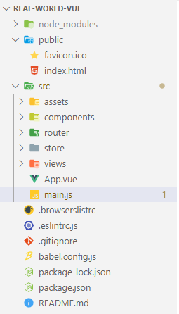

**If you run npm run build:**

**We get a prompt by using Ctrl+C**

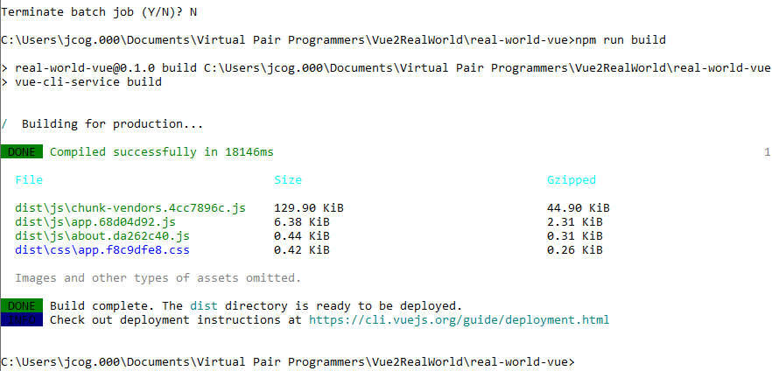

**Now, check the project and see the dist folder:**

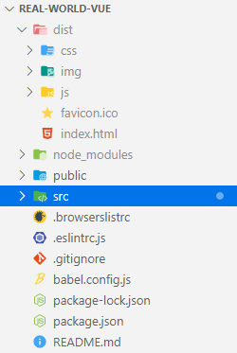

**The dist folder contains the code that does the injection into the index.html <div id=”app”></div> within our public folder**

