**VueJs 2**

**Course: Real World Vue2**

**Ch02_Optimizing_VisualStudioCode**

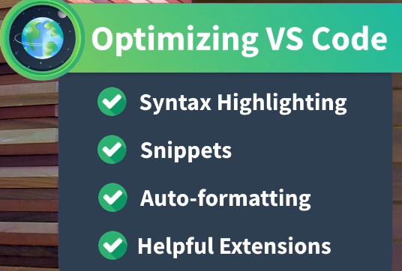

We already have Extensions installed that are giving up colorized editing

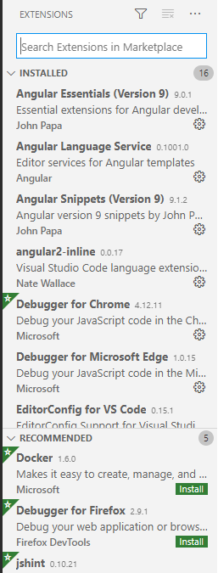

Install Vetur and reload:

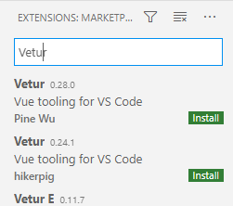

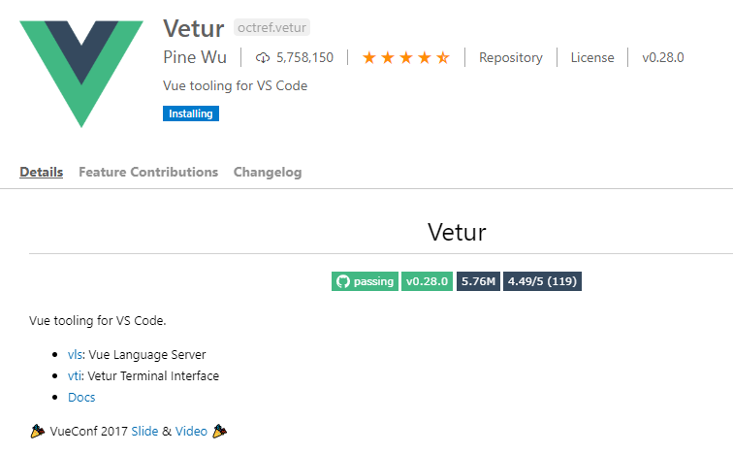

Type **vue** and take advantage of snippets

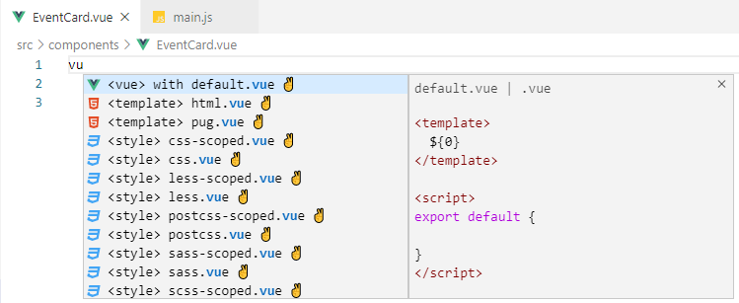

Enter

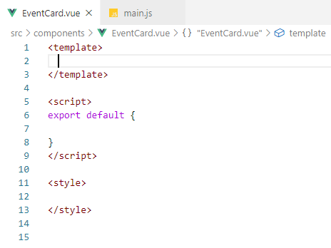

Type the start of a tag and it will be intellisensed: type **h**

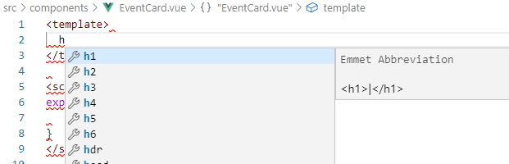

Enter

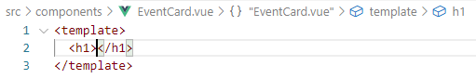

Try **div>ul>li**

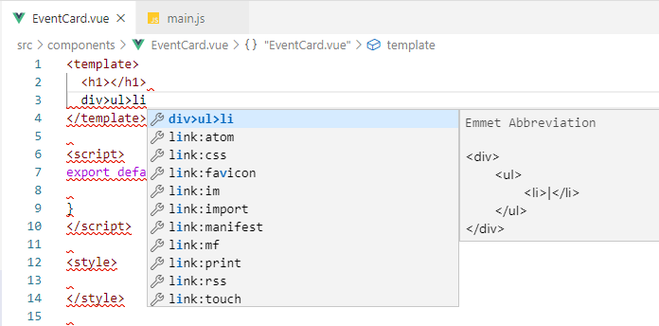

Enter

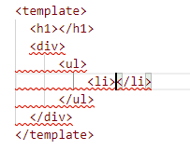

Make sure eslint and prettier are installed:

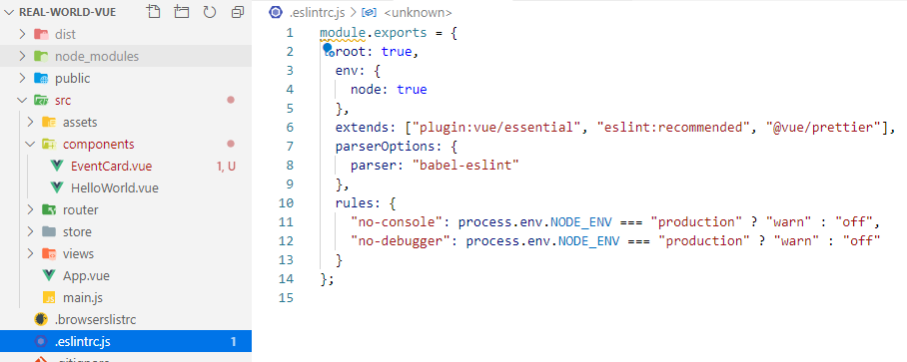

There are other snippet tools: “Sarah Drasner” in Extensions, but, I choose not to.

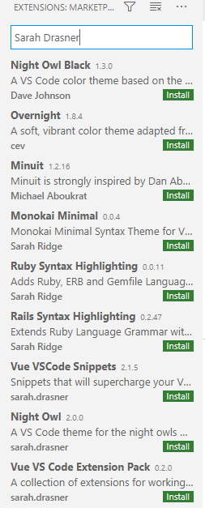

**Ctrl + Back tick** is a shortcut to open up a Terminal Window:

