**VueJs 2**

**Course: Real World Vue2**

**Ch03_Vue_Router_Basics**

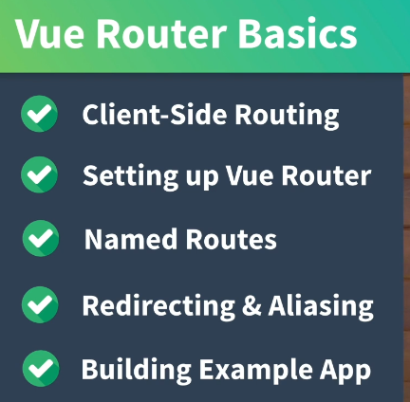

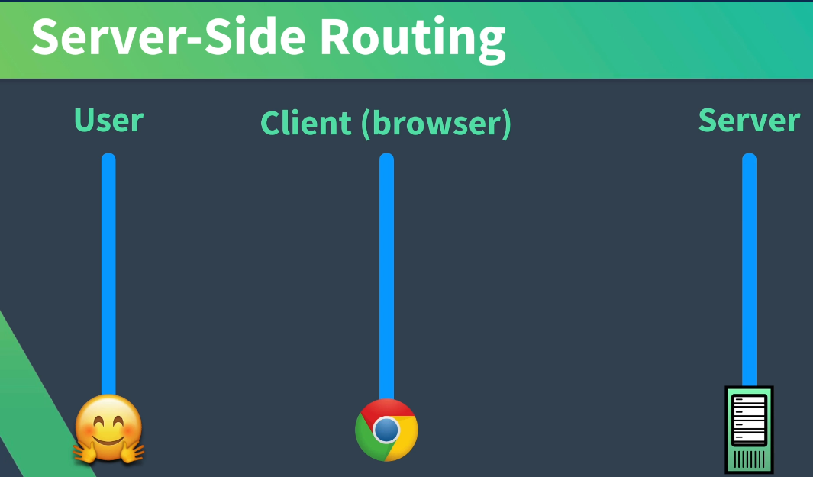

**User Events: Typing url and clicking a link**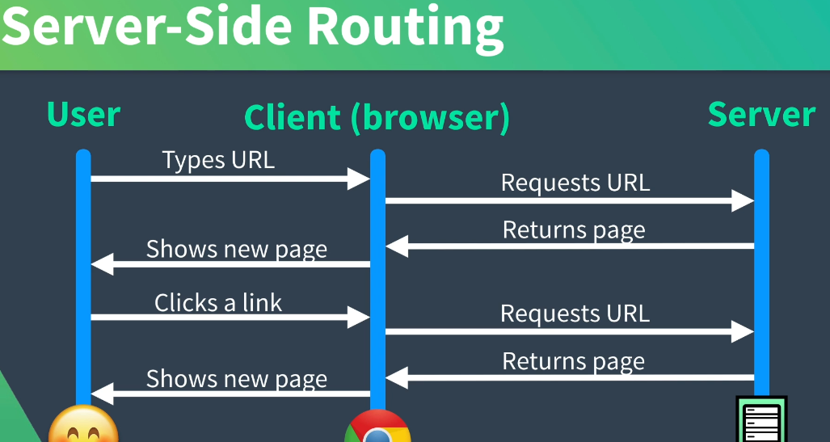

**Notice that the Server is doing less and browser does more:**

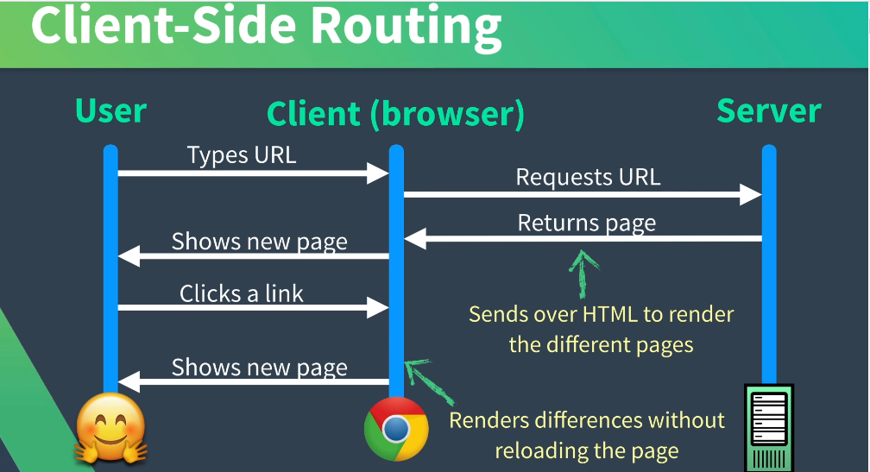

**SPA**

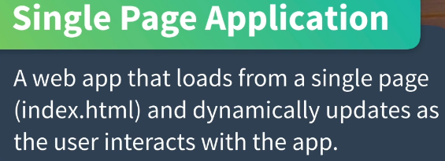

**Client-side routing:**

**To check for vue-router look in the package.json file**

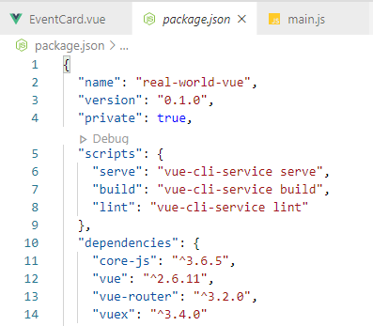

We see line 13: “vue-router”: “^3.2.0”

Now where in the app is the router located:

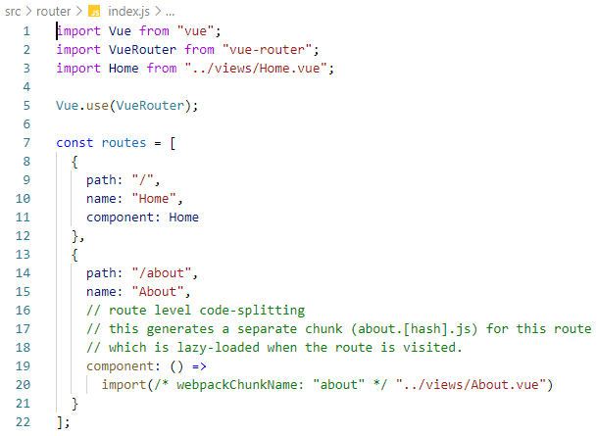

We can see on line2 that VueRouter is created

At line 5 we instruct vue to use this VueRouter.

There is a Json array of 2 routes HOME, and ABOUT at line 10, and line 15

Each Object Route has 3 parts PATH, NAME, and COMPONENT

In vue2 we used router.js instead of incorporating the route into the index.html page in vue3

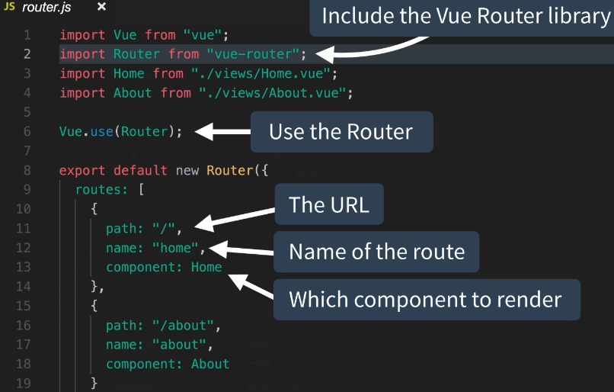

At line 3 the path to the routes in index.html has replaced the older vue2 router.js file

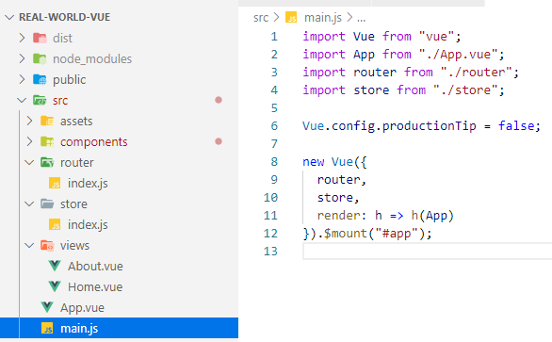

In ES6 writing router is the same as writing:

New Vue({ router: router, …

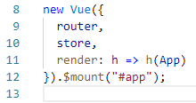

This is same as vue2

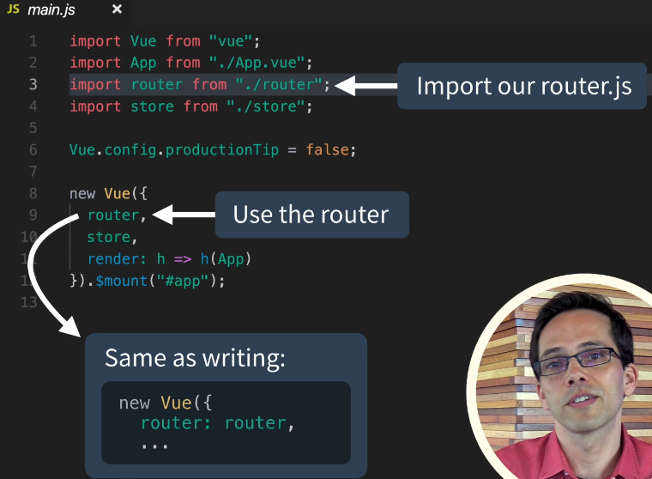

If we look at the App.vue, the router links are used: See lines 4 and 5

A link navigates to a route

A router-view is the placeholder for the matched components: See line 7

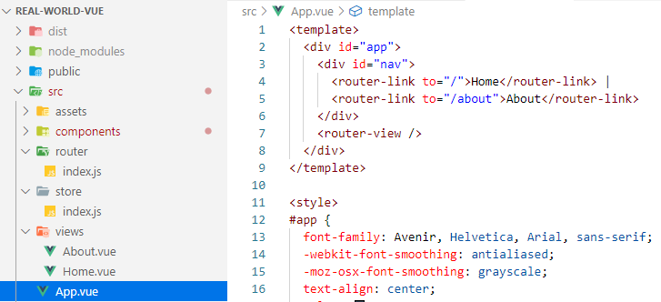

Simplify the Home page (view) to:

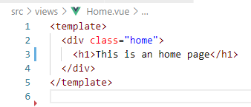

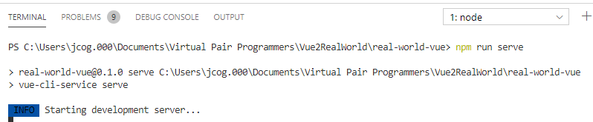

Test in the browser:

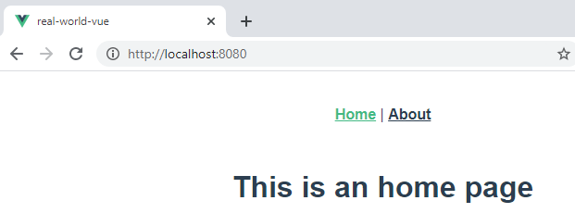

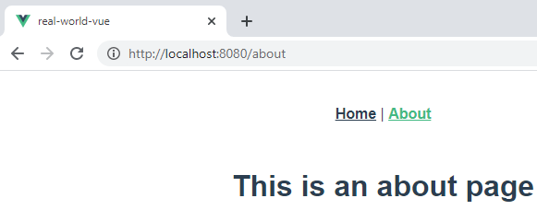

Notice the Url is first **/** and then it is **/about**

**To get the devtools to work in Chrome:**

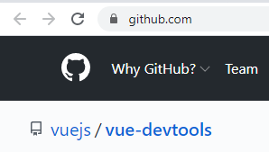

**Follow these instructions:**

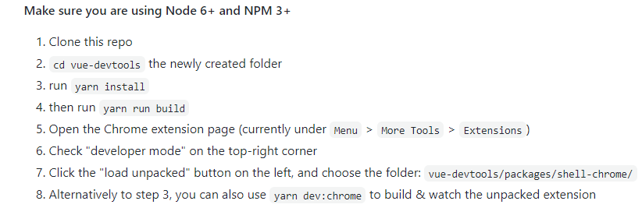

**Use the Developer Tools and look for the Vue icon and click it!**

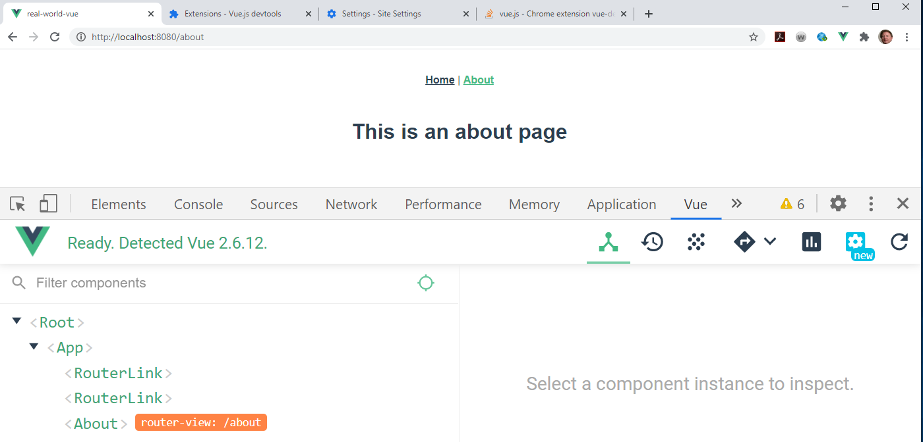

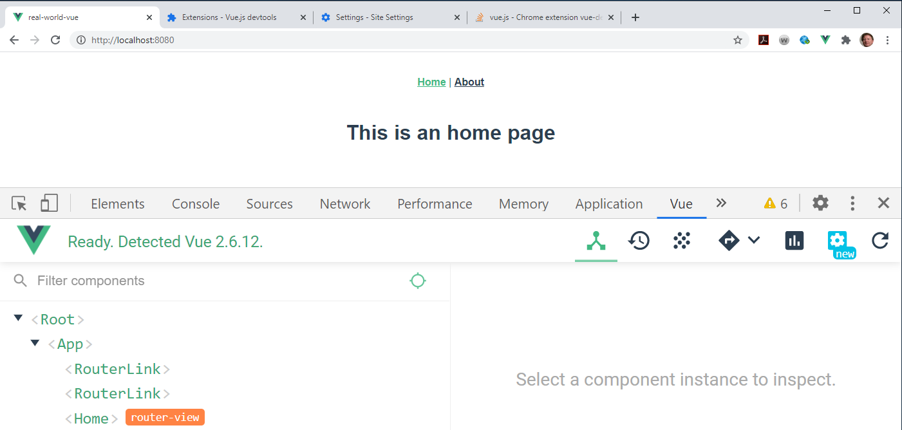

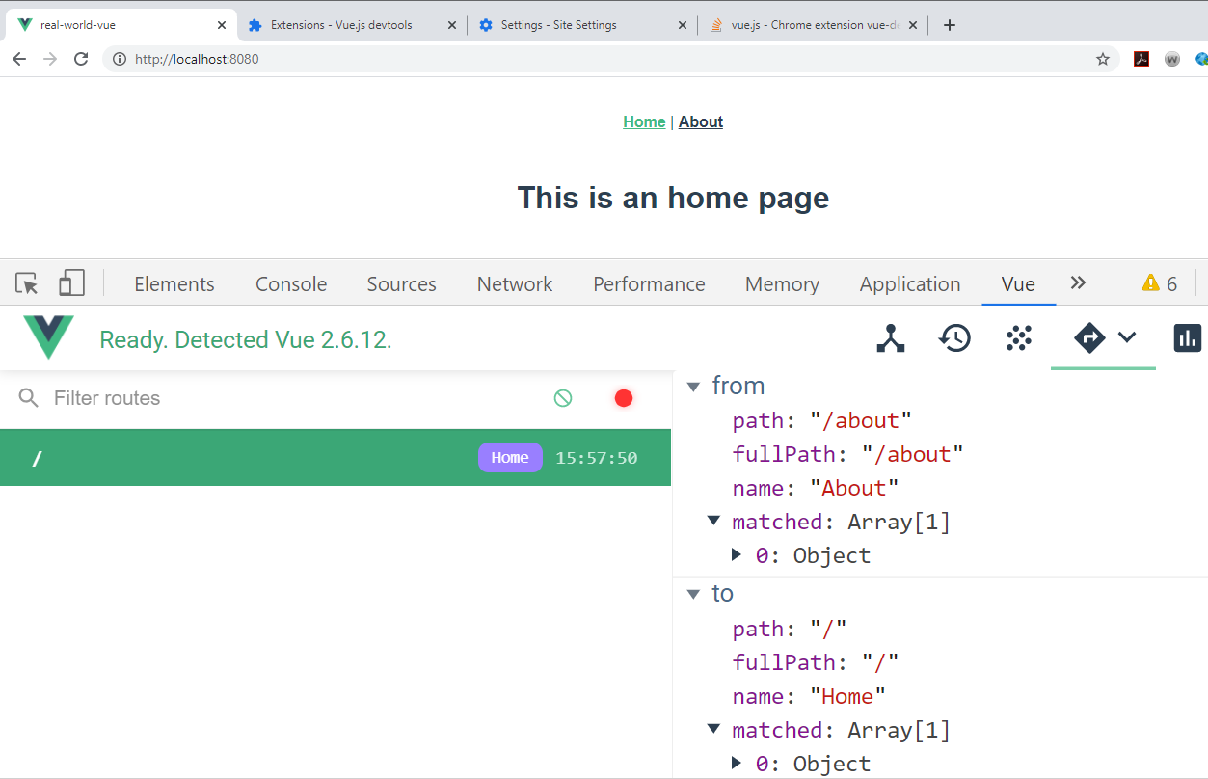

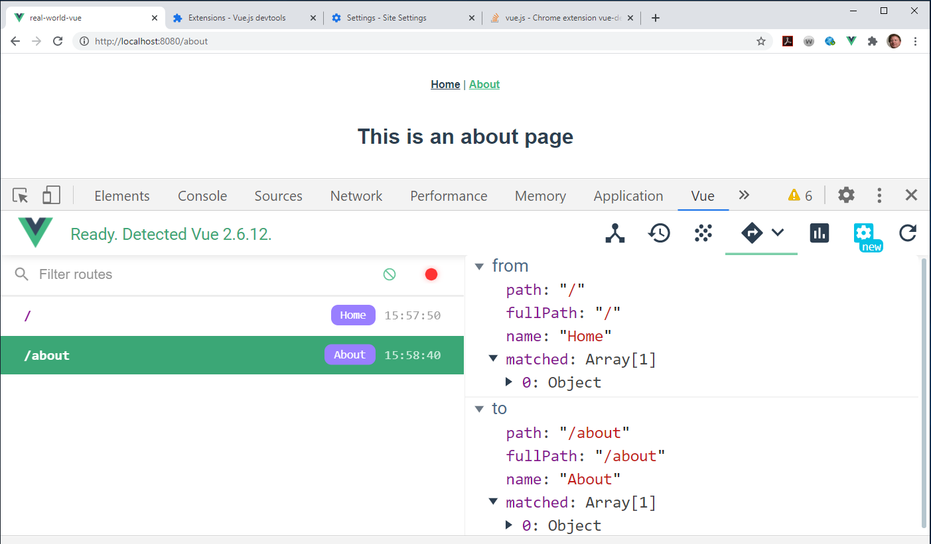

Using Network and refreshing the page shows no updates to the route: Client-Side Routing

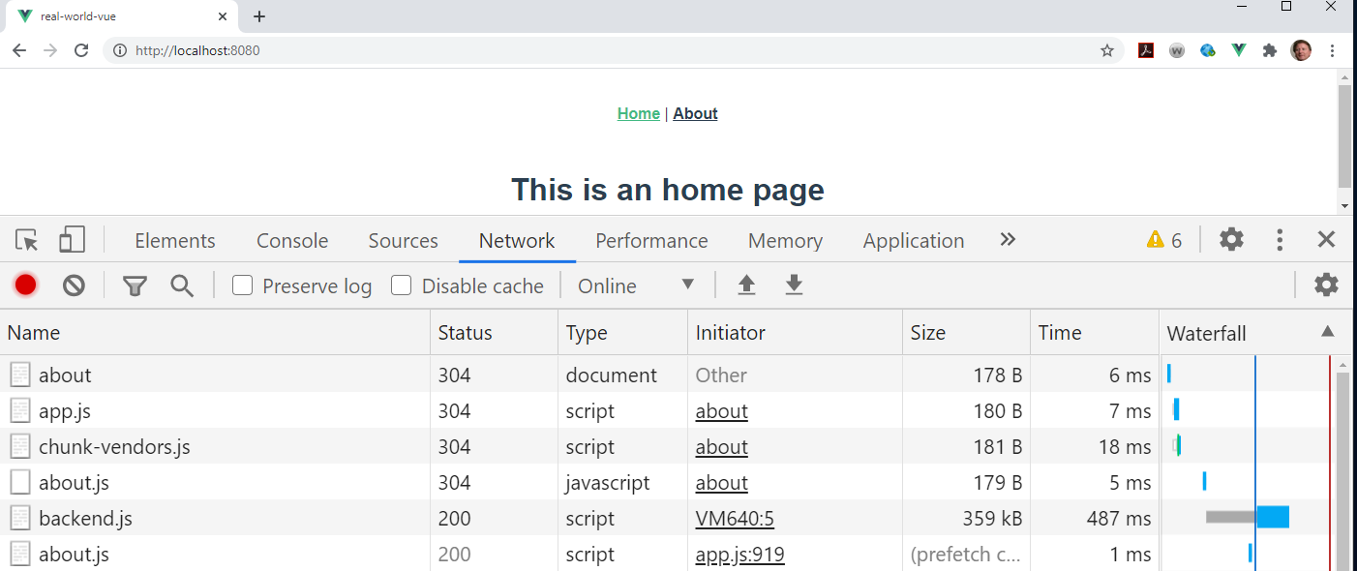



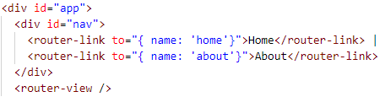

Versus



Benefit of named routes:



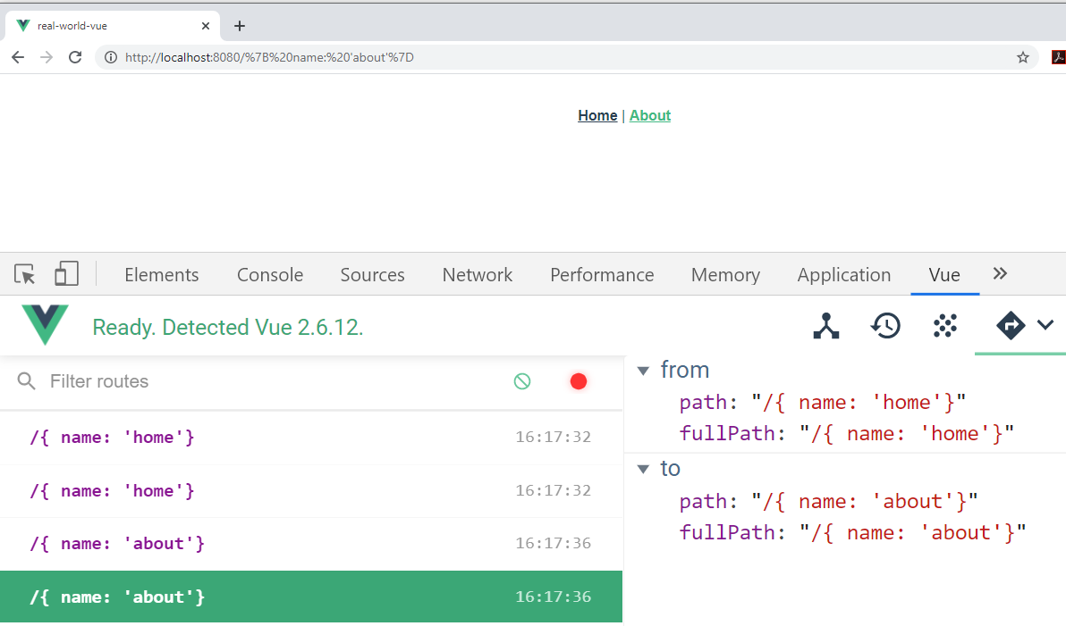

Redirecting Routes that are in current use:

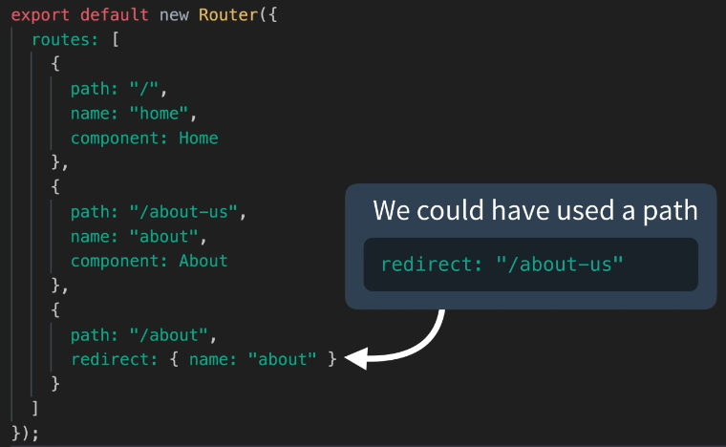

Or in Vue3

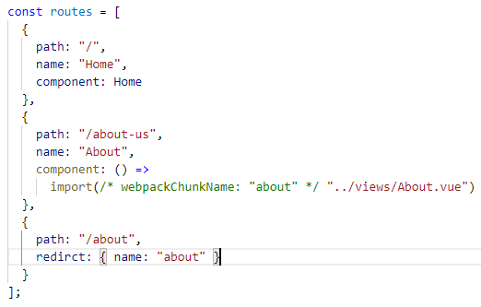

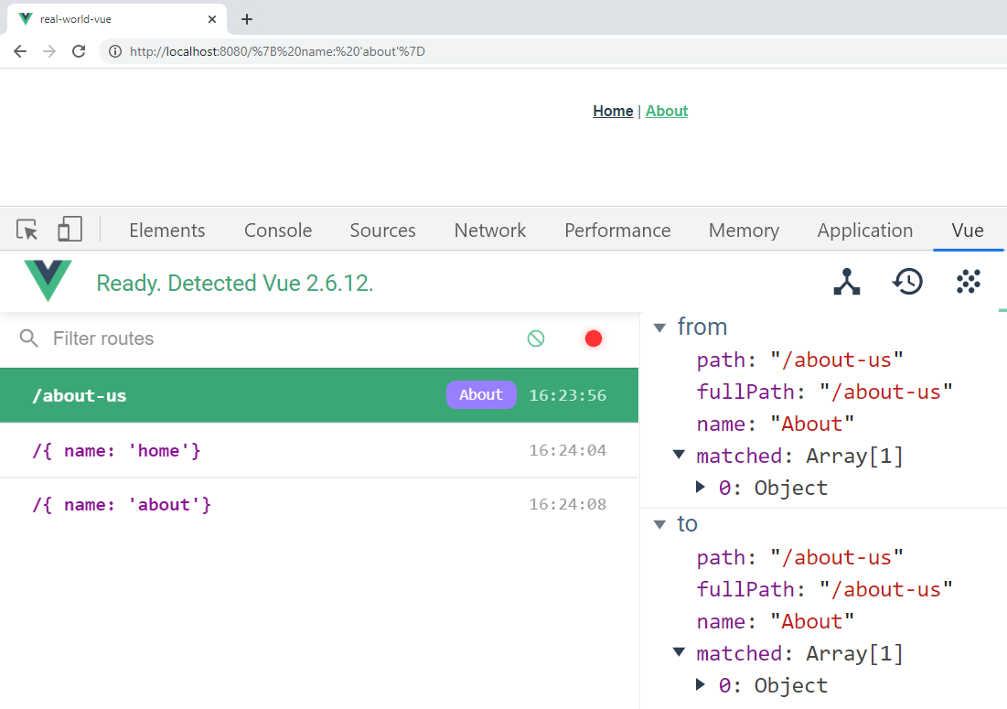

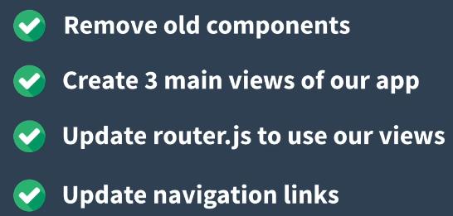

**Router**

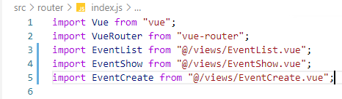

Within the router and index.js file:

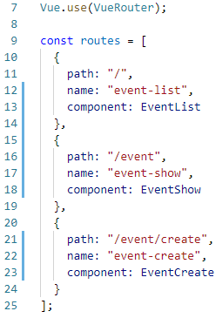

**Views:**

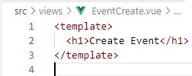

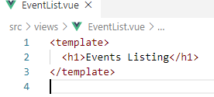

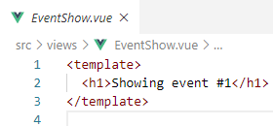

**App:**

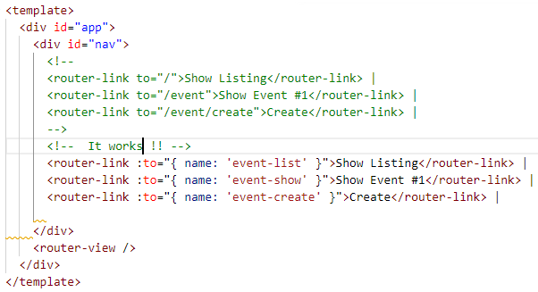

**Browser:**

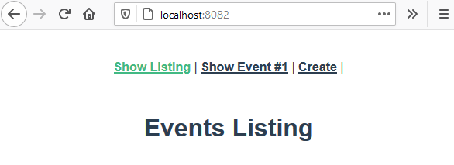

Shows the Vue3Js Setup versus the

Vue2Js route.js file and populating the export default router

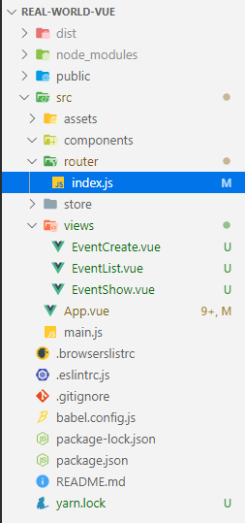

**VueJs2**

