**VueJs 2**

**Course: Real World Vue2**

**Ch04_Dynamic_Routes_History_Mode**

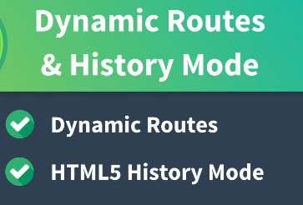

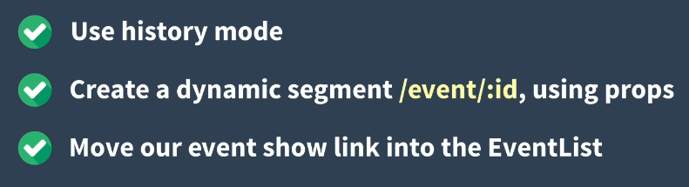

**Enable history mode:**

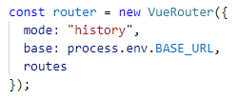

**Create a Dynamic segment:**

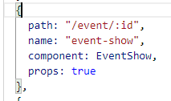

**Edit the vue that is dynamic:**

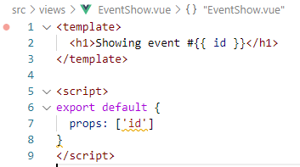

**Fix Show Event #1 link:**

**a) move the link to the vue**

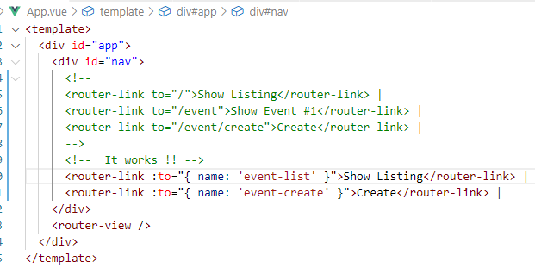

**b) add code to make the link work**

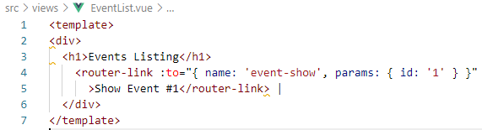

**Cleanup the Pipes:**

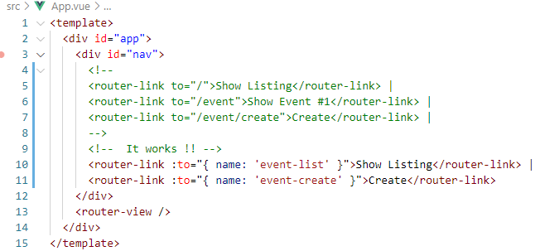

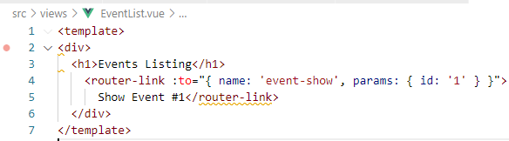

**Test in the browser:**

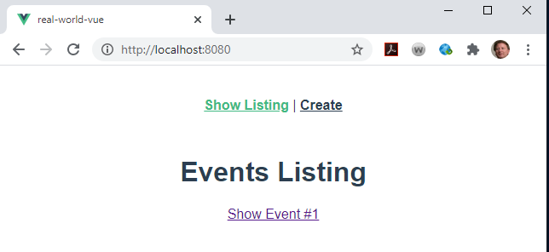

**Remove Show from ‘Show Listing’:**



**Root /**

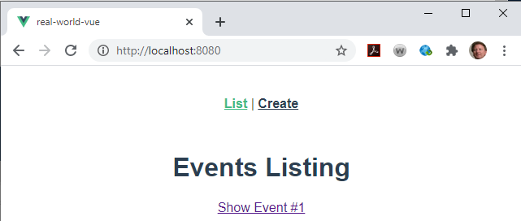

**Show Event #1**

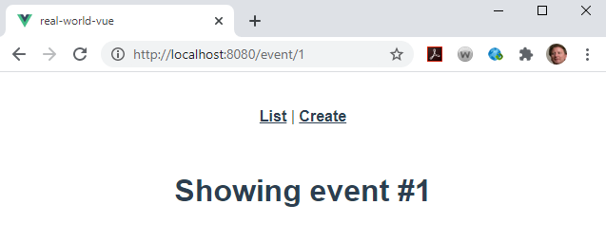

**Create**

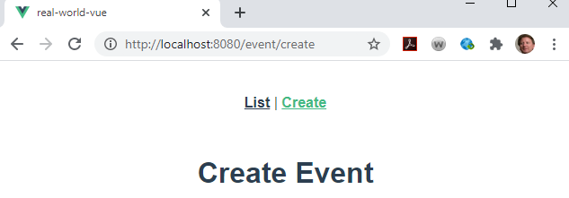

**List**

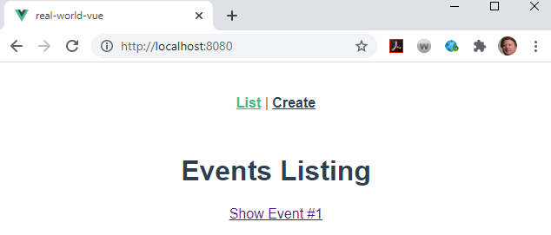

**No # in the url or history mode:**