**VueJs 2**

**Course: Real World Vue2**

**Ch05_SingleFile_Vue_Components**



**EventCard.vue:**

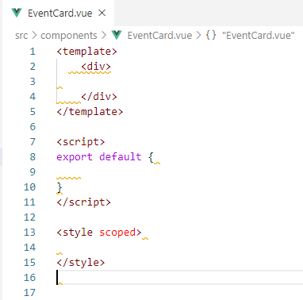

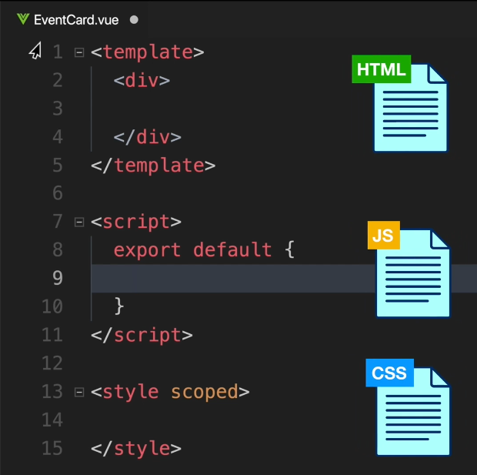

**By adding attributes we can upgrade these:**

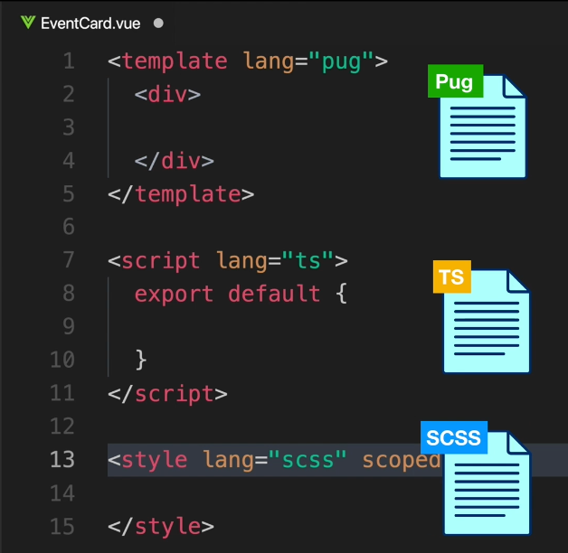

**In addition these changes required changes to Webpack and Preloaders**

npm install --save-dev sass-loader node-sass

[**https://vue-loader.vuejs.org/guide/pre-processors.html**](https://vue-loader.vuejs.org/guide/pre-processors.html)

**Reusing the EventCard.vue**

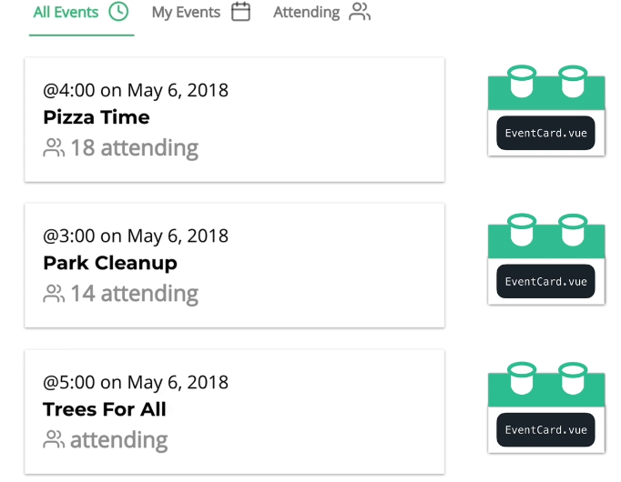

**Let us build out the EventCard.vue**

**The div provides the one root element requirement**

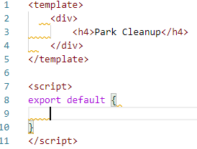

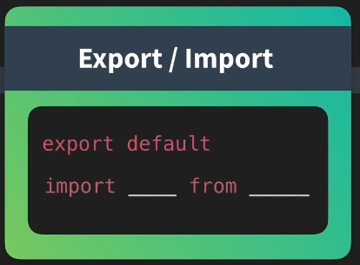

**Or you can use**

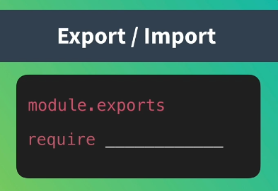

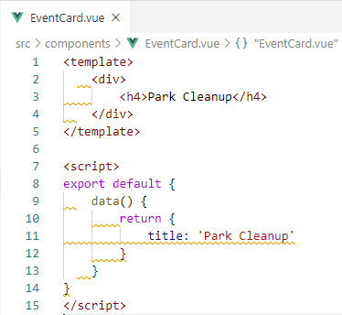

**Pull in the title with an Expression in h4**

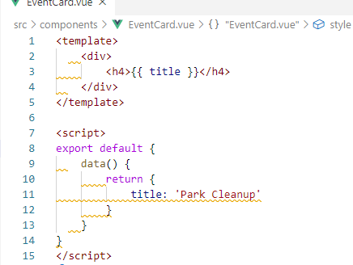

**This version of data() function is shorthand**

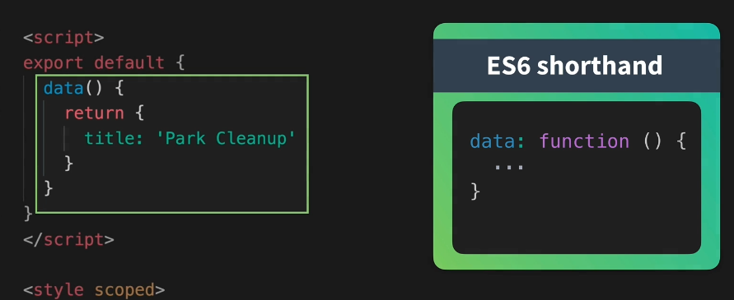

**The scoped attribute fixes the style to the component**

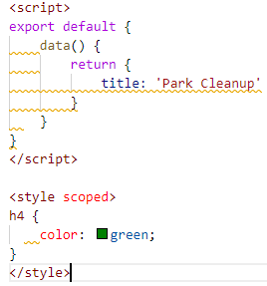



**Put the Event cards in the Event list:**

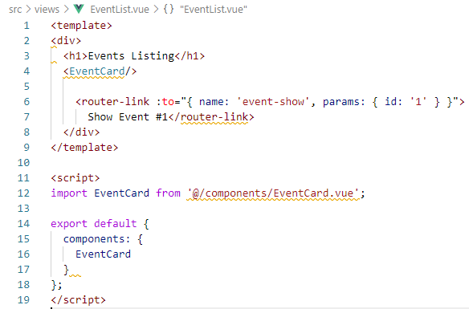

**In the browser:**

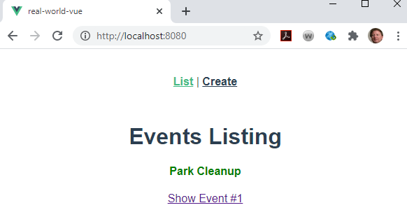

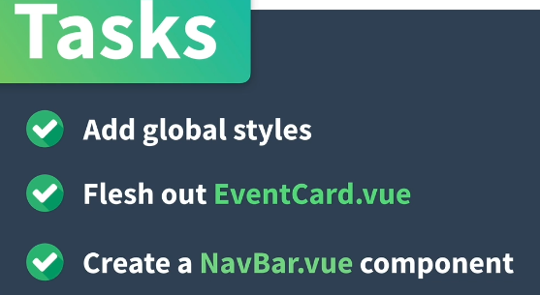



**Adding style to the App.vue are adding Global styles**

<style>

html {

-webkit-text-size-adjust: 100%;

-webkit-font-smoothing: antialiased;

-moz-osx-font-smoothing: grayscale;

}

body {

margin: 0;

font-family: 'Open Sans', sans-serif;

font-size: 16px;

line-height: 1.5;

}

#app {

box-sizing: border-box;

width: 500px;

padding: 0 20px 20px;

margin: 0 auto;

}

hr {

box-sizing: content-box;

height: 0;

overflow: visible;

}

a {

color: #39b982;

font-weight: 600;

background-color: transparent;

}

img {

border-style: none;

width: 100%;

}

h1,

h2,

h3,

h4,

h5,

h6 {

display: flex;

align-items: center;

font-family: 'Montserrat', sans-serif;

}

h1 {

font-size: 50px;

font-weight: 700;

}

h2 {

font-size: 38px;

font-weight: 700;

}

h3 {

font-size: 28px;

font-weight: 700;

}

h4 {

font-size: 21px;

font-weight: 700;

}

h5 {

font-size: 16px;

font-weight: 700;

}

h6 {

font-size: 15px;

font-weight: 700;

}

b,

strong {

font-weight: bolder;

}

small {

font-size: 80%;

}

.eyebrow {

font-size: 20px;

}

.-text-primary {

color: #39b982;

}

.-text-base {

color: #000;

}

.-text-error {

color: tomato;

}

.-text-gray {

color: rgba(0, 0, 0, 0.5);

}

.-shadow {

box-shadow: 0 1px 2px 0 rgba(0, 0, 0, 0.2), 0 1px 5px 0 rgba(0, 0, 0, 0.13);

}

.badge {

display: inline-flex;

height: 26px;

width: auto;

padding: 0 7px;

margin: 0 5px;

background: transparent;

border-radius: 13px;

font-size: 13px;

font-weight: 400;

line-height: 26px;

}

.badge.-fill-gradient {

background: linear-gradient(to right, #16c0b0, #84cf6a);

color: #fff;

}

button,

label,

input,

optgroup,

select,

textarea {

display: inline-flex;

font-family: 'Open sans', sans-serif;

font-size: 100%;

line-height: 1.15;

margin: 0;

}

button,

input {

overflow: visible;

}

button,

select {

text-transform: none;

}

button,

[type='button'],

[type='reset'],

[type='submit'] {

-webkit-appearance: none;

}

button::-moz-focus-inner,

[type='button']::-moz-focus-inner,

[type='reset']::-moz-focus-inner,

[type='submit']::-moz-focus-inner {

border-style: none;

padding: 0;

}

button:-moz-focusring,

[type='button']:-moz-focusring,

[type='reset']:-moz-focusring,

[type='submit']:-moz-focusring {

outline: 2px solid #39b982;

}

label {

color: rgba(0, 0, 0, 0.5);

font-weight: 700;

}

input,

textarea {

box-sizing: border-box;

border: solid 1px rgba(0, 0, 0, 0.4);

}

textarea {

width: 100%;

overflow: auto;

font-size: 20px;

}

[type='checkbox'],

[type='radio'] {

box-sizing: border-box;

padding: 0;

}

[type='number']::-webkit-inner-spin-button,

[type='number']::-webkit-outer-spin-button {

height: auto;

}

[type='search'] {

-webkit-appearance: textfield;

outline-offset: -2px;

}

[type='search']::-webkit-search-decoration {

-webkit-appearance: none;

}

[type='text'],

[type='number'],

[type='search'],

[type='password'] {

height: 52px;

width: 100%;

padding: 0 10px;

font-size: 20px;

}

[type='text']:focus,

[type='number']:focus,

[type='search']:focus,

[type='password']:focus {

border-color: #39b982;

}

::-webkit-file-upload-button {

-webkit-appearance: button;

font: inherit;

}

[hidden] {

display: none;

}

select {

width: 100%;

height: 52px;

padding: 0 24px 0 10px;

vertical-align: middle;

background: #fff

url("data:image/svg+xml;charset=utf8,%3Csvg xmlns='http://www.w3.org/2000/svg' viewBox='0 0 4 5'%3E%3Cpath fill='%23343a40' d='M2 0L0 2h4zm0 5L0 3h4z'/%3E%3C/svg%3E")

no-repeat right 12px center;

background-size: 8px 10px;

border: solid 1px rgba(0, 0, 0, 0.4);

border-radius: 0;

-webkit-appearance: none;

-moz-appearance: none;

appearance: none;

}

select:focus {

border-color: #39b982;

outline: 0;

}

select:focus::ms-value {

color: #000;

background: #fff;

}

select::ms-expand {

opacity: 0;

}

</style>

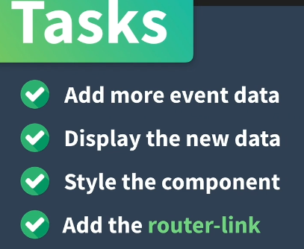

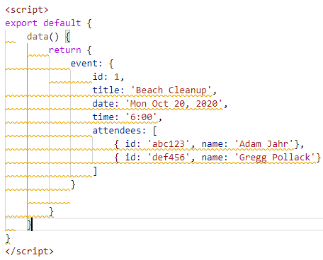

**Use dot notation to access these data elements:**

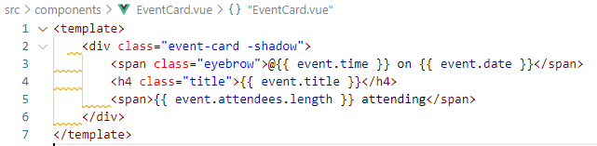

**Paste in the styles**

<style scoped>

.event-card {

padding: 20px;

margin-bottom: 24px;

transition: all 0.2s linear;

cursor: pointer;

}

.event-card:hover {

transform: scale(1.01);

box-shadow: 0 3px 12px 0 rgba(0, 0, 0, 0.2), 0 1px 15px 0 rgba(0, 0, 0, 0.19);

}

.event-card > .title {

margin: 0;

}

.event-link {

color: black;

text-decoration: none;

font-weight: 100;

}

</style>

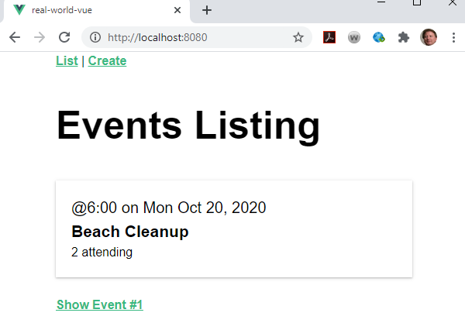

**Wrap Show Event #1 around component:**

**a) remove link**

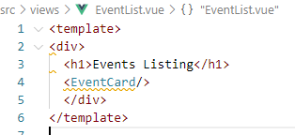

**b) wrap around div**

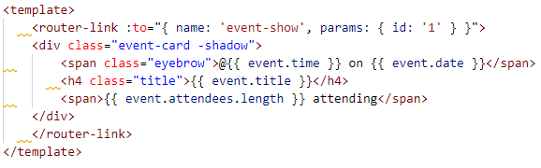

**In the browser:**

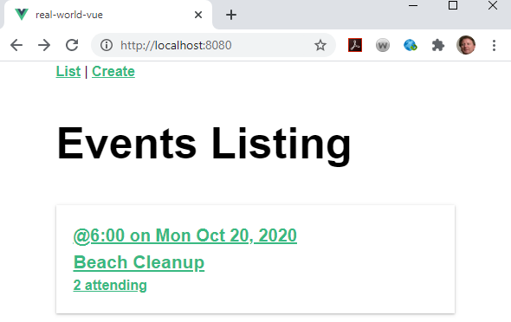

**Clickable to Show Events:**

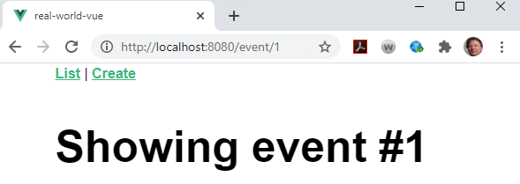



**Create a navbar.vue component:**

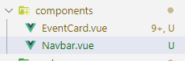

**Add a template to the new component:**

**<vue Enter**

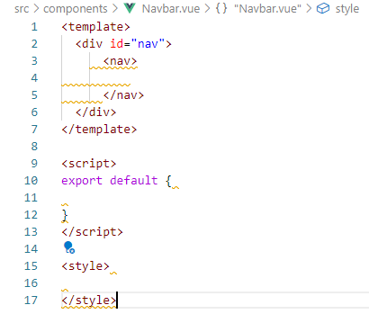

**Add the links to the nav by cutting them out of App.vue**

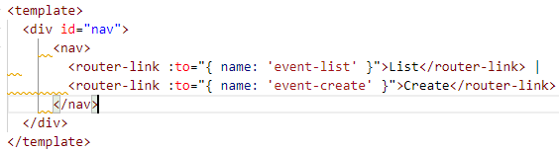

**Need a root link:**

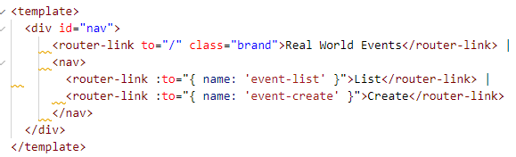

**Paste in the scoped styles:**

<style scoped>

.nav {

display: flex;

justify-content: space-between;

align-items: center;

height: 60px;

}

.nav > .brand {

font-family: 'Montserrat', sans-serif;

font-weight: 700;

font-size: 1.5em;

color: #39b982;

text-decoration: none;

}

.nav .nav-item {

box-sizing: border-box;

margin: 0 5px;

color: rgba(0, 0, 0, 0.5);

text-decoration: none;

}

.nav .nav-item.router-link-exact-active {

color: #39b982;

border-bottom: solid 2px #39b982;

}

</style>

**Now, nest the new component within the App.vue:**

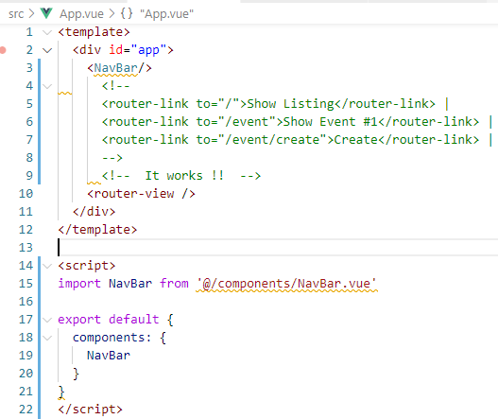

**In the browser:**

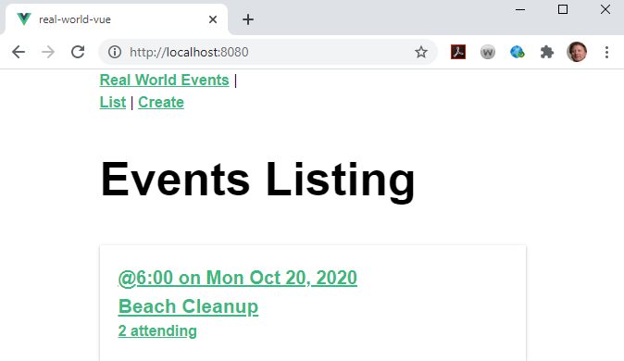

**Remove the pipe and add the class .nav**

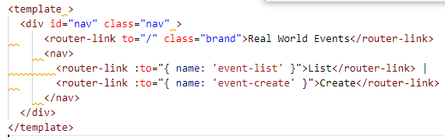

**In the browser:**

