**VueJs 2**

**Course: Real World Vue2**

**Ch06_Global _Components**

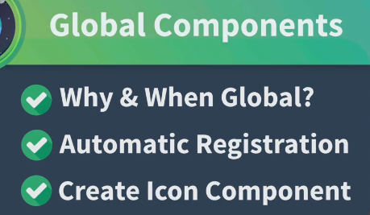

With Global Components every component in the Application will have access to that component:



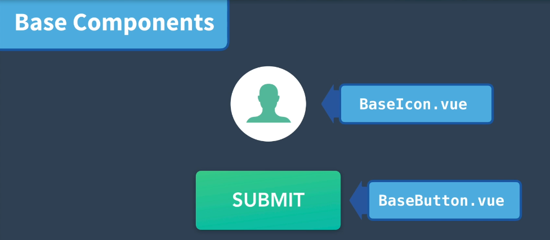

Create a BaseIcon Component:

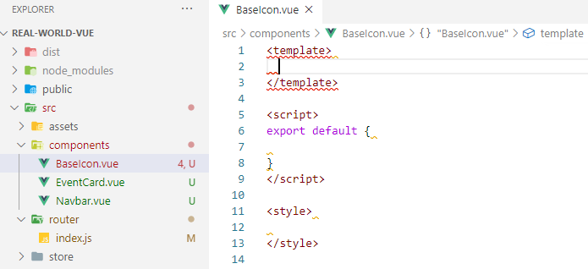

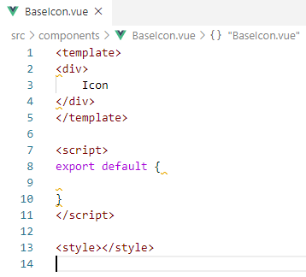

Now, globally register the BaseIcon.vue in main.js

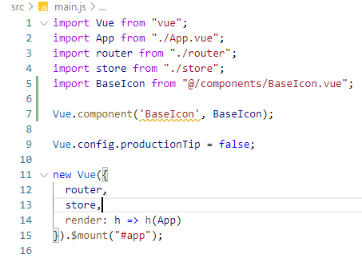

Now, use in the EventList component:

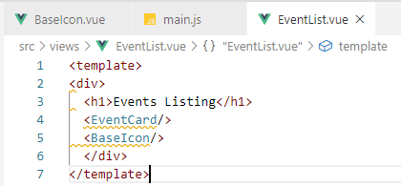

In the Browser:

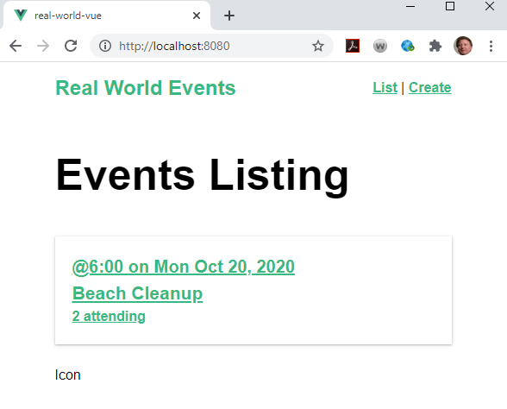



**Vue ui runs off the cmd.exe:**

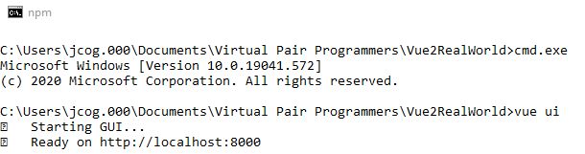

**Install lodash dependency**

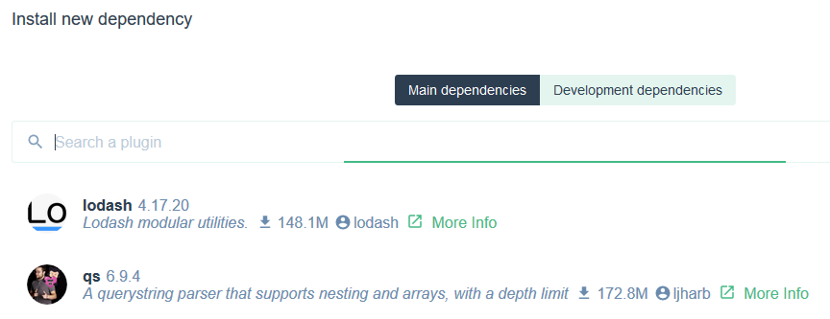

**Select and install**

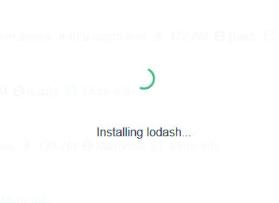

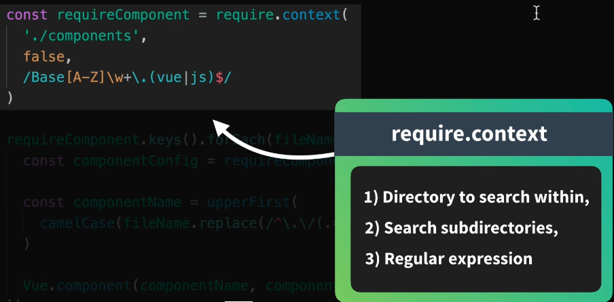

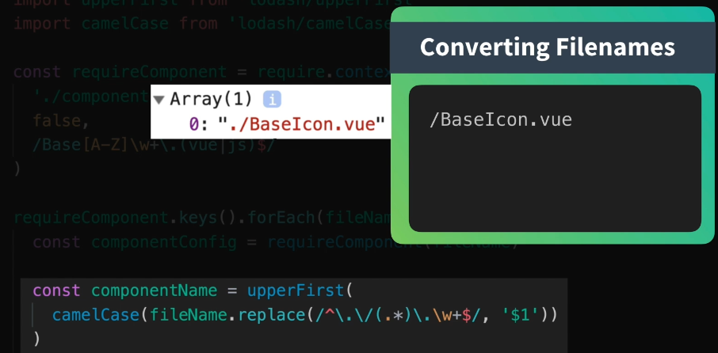

**Download the icon**

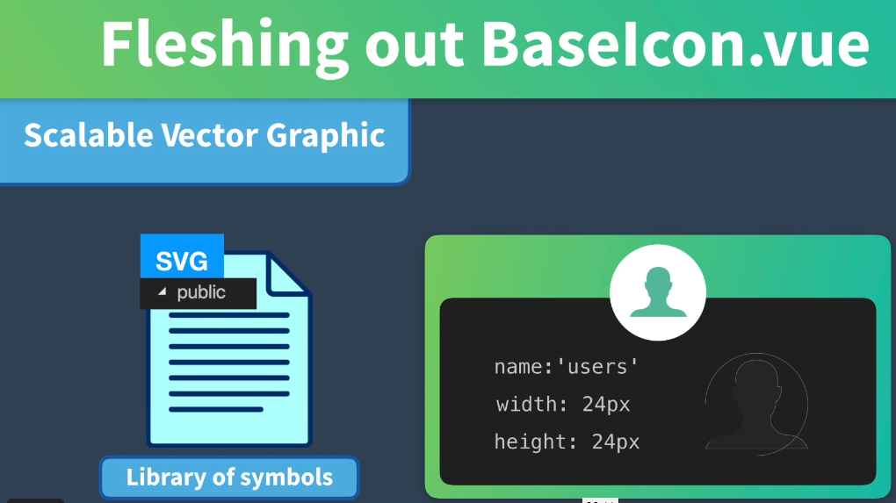

npm install feather-icons –save

**In the node modules:**

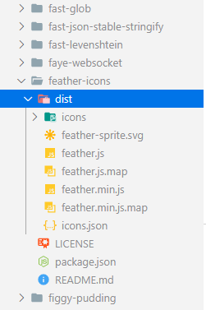

**Copied and pasted icon in public folder:**

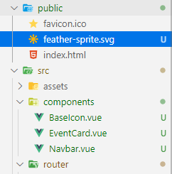

**The id of the sprite is in the top of the file:**

**Id=”activity”:**

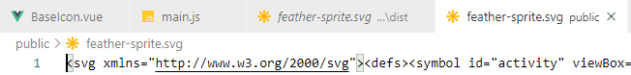

**Enter the icon path:**

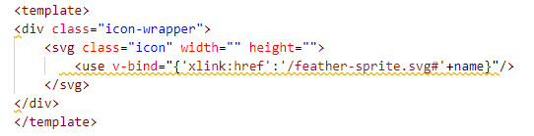

**Set the width, height and name with a prop:**

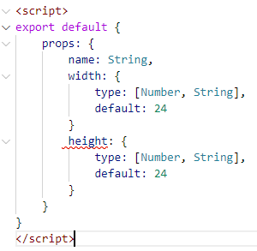

**Now, use the shorthand v-bind to bind the width, height attributes**

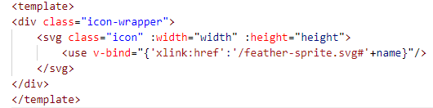

**Add the scoped styles:**

<style scoped>

.icon-wrapper {

display: inline-flex;

align-items: center;

color: rgba(0, 0, 0, 0.4);

font-size: 1rem;

font-weight: 600;

}

.icon {

stroke: currentColor;

stroke-width: 2;

stroke-linecap: round;

stroke-linejoin: round;

fill: none;

margin-right: 6px;

}

</style>

**Add the component to EventCard.vue:**

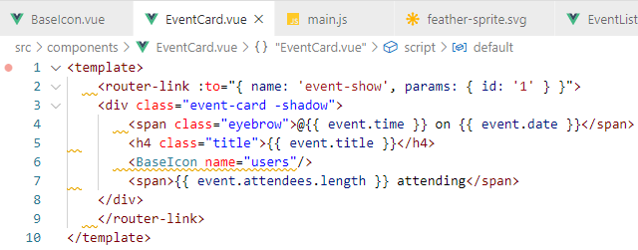

**Missed a comma:**

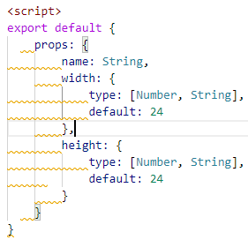

**Check Browser for the icon:**

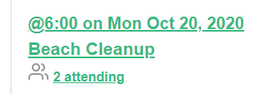

**You see the icon**