**VueJs 2**

**Course: Real World Vue2**

**Ch07_Slots:**

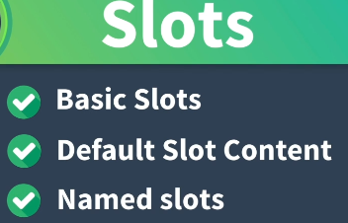

**Types of Reusable Content:**

**1) Display Elements**

**Icons, Boxes**

**2) Form elements**

**Inputs, Select fields and Buttons**

**3) Windows elements**

**Modal popups, Notifications**

**We can create and make these Base Components**

**We can configure and customize them by passing Props**

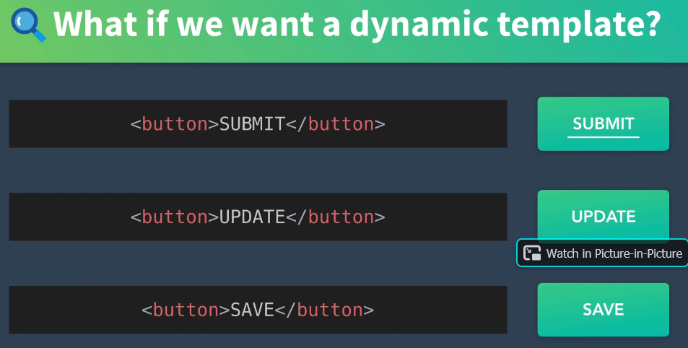

**Or use Slots**

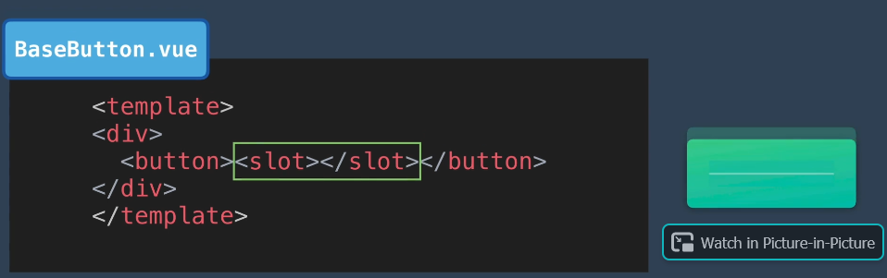

**Within a form we could put the BaseButton and the form determines the button:**

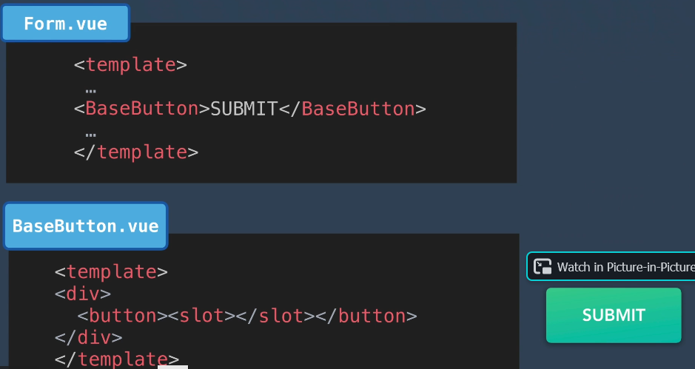

**Below the slot Submit is overwritten by the Form Save:**

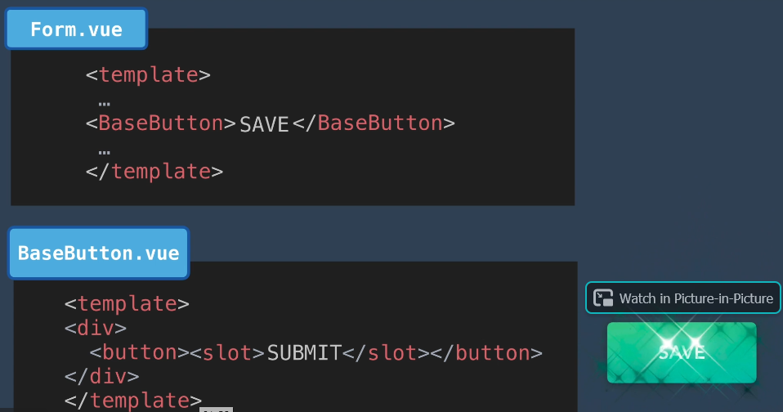



**Yes, computed and the data properties:**

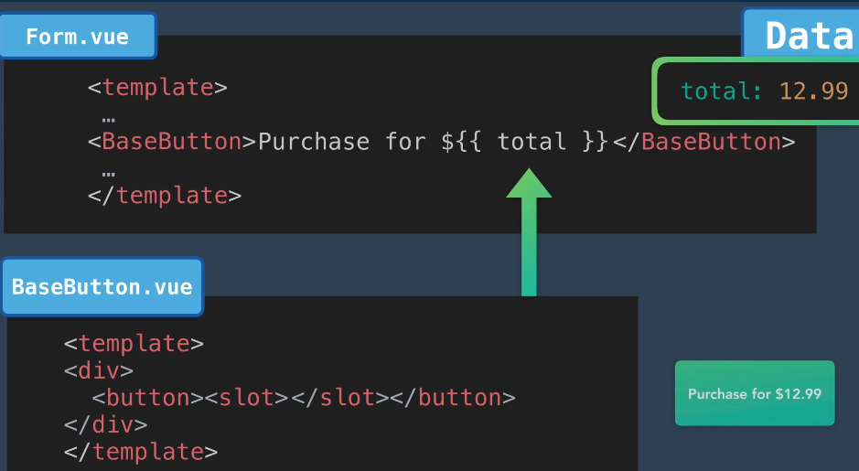

**Currently we are using a BaseIcon:**

**We are going to use a slot here:**

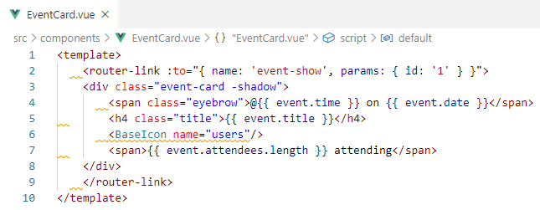

**Go to BaseIcon.vue component and add a slot**

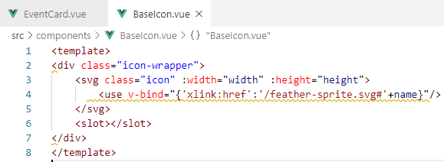

**Paste the text into the BaseIcon**

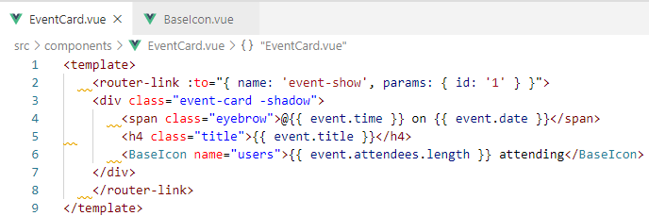

**Check browser to see the text in the icon**

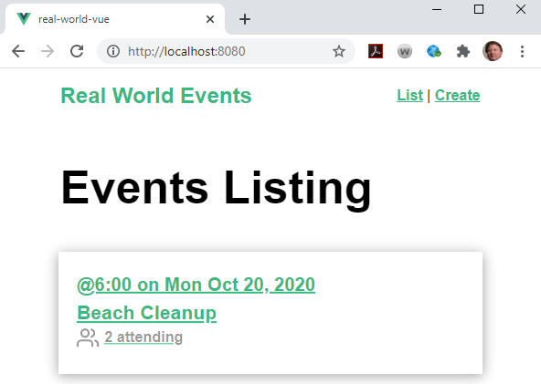

**Now, let us create a slot for a MediaBox.vue**

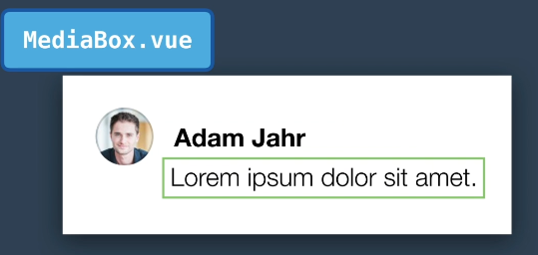

**Put a Component in for the Avitar:**

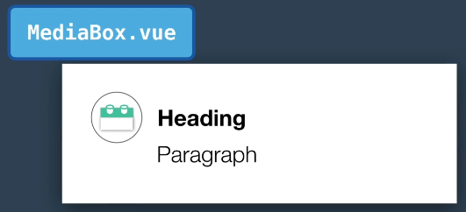

**Then slot in the heading and paragraph:**

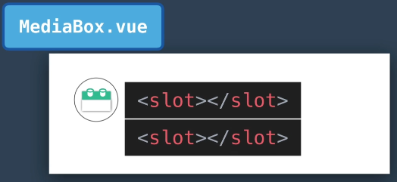

**Or**

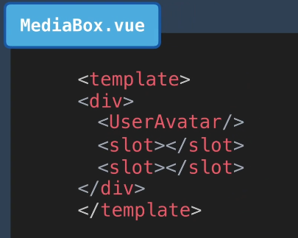

**To specify which slot gets what information from which Parent.vue is**

**to use Named Slots**



