**VueJs 2**

**Course: Real World Vue2**

**Ch07_API_Calls_With_Axios:**

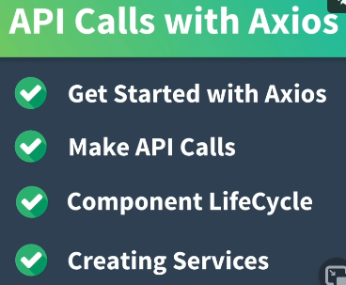

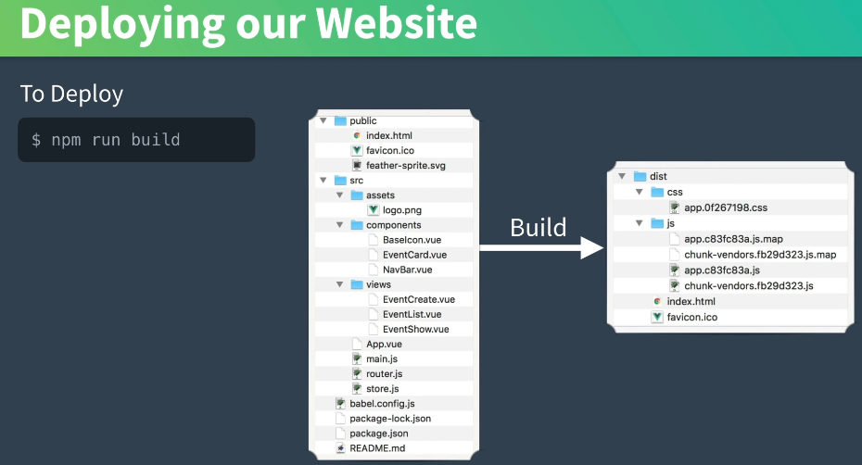

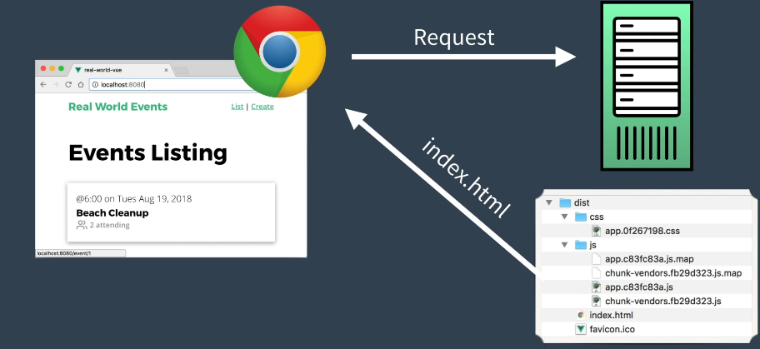

**In a real world application REST calls or request are made to a server for events. The result is a JSON response with the event data.**

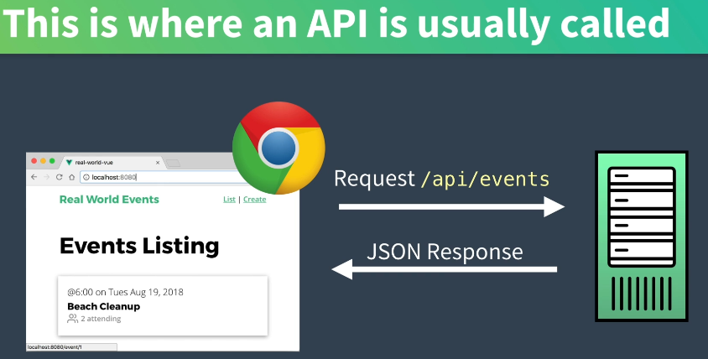

**Javascript not vue has the Axios library:**

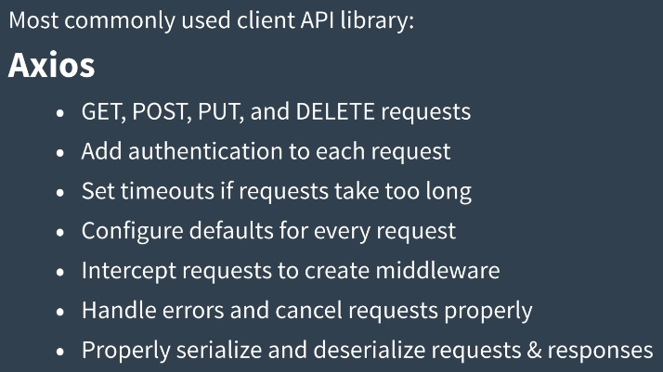

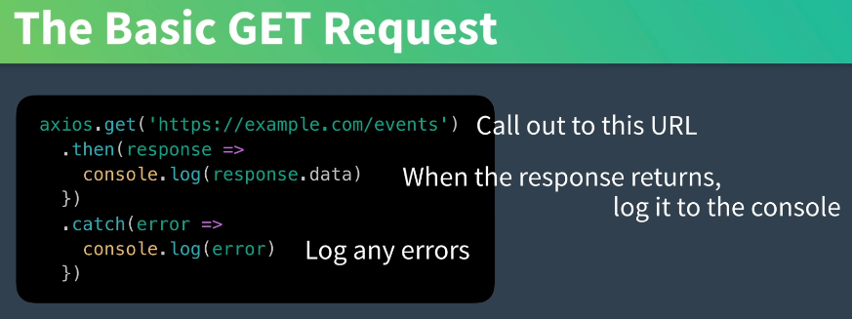

**Asynchronously running means the code does not wait to continue.**

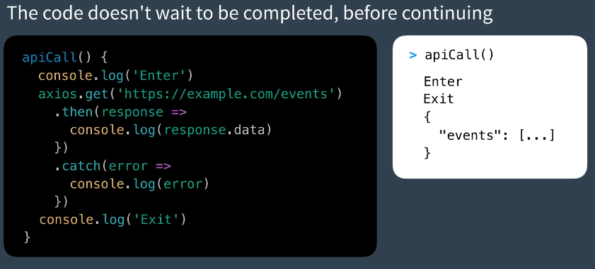

**Now, let us load events using an API**

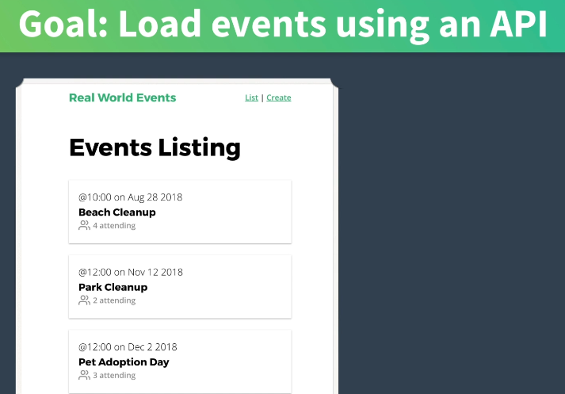

**We will test an API call:**

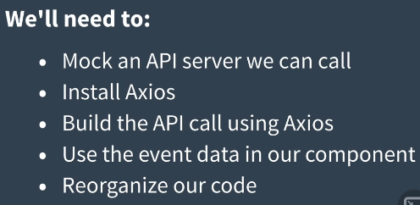

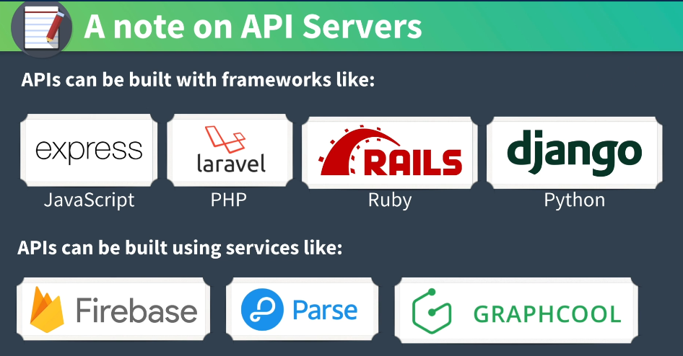

**Mock the database with db.json:**

**Create a file in the directory structure:**

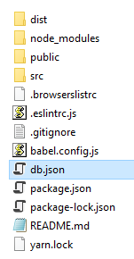

**Open the file in VSCode and paste the download contents:**

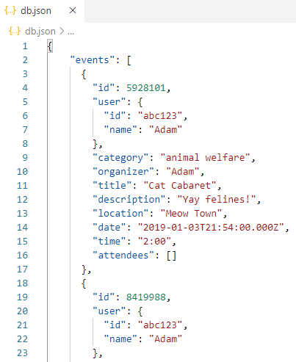

**The mock server is the >*npm install –g json-server***

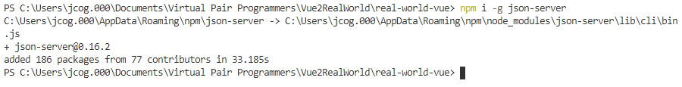

**If you run >json-server –watch db.json**

**You will see the json on port 3000**

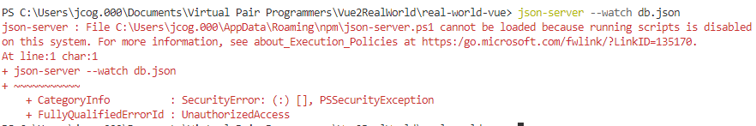

**Fix:**

**Use computername: JCOGGINS**

**Localuser: jcog**

**Pwd:**

**Then test the runas command:**

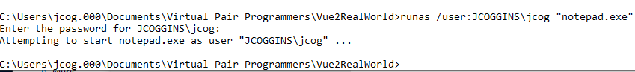

**Works but did not allow scripts!!**

**Right-click on powershell and select to runas administrator**

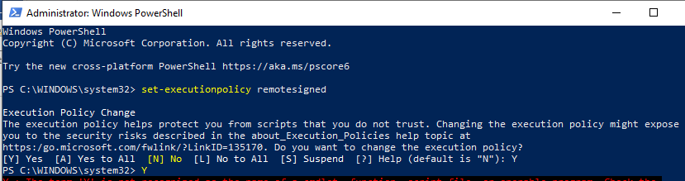

**This should allow running unsigned scripts:**

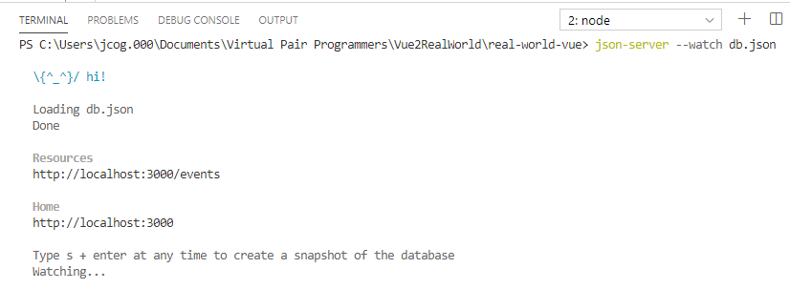

**It works!!**

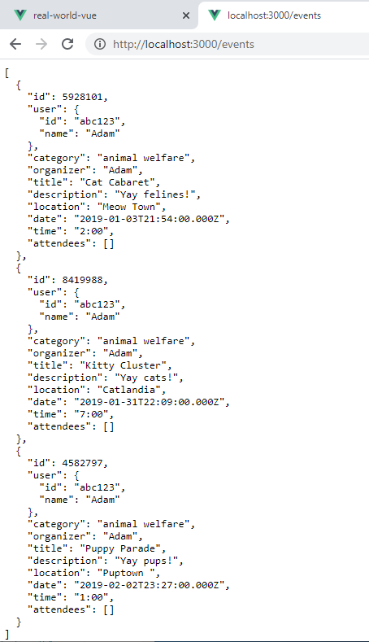

**Now run >vue ui**



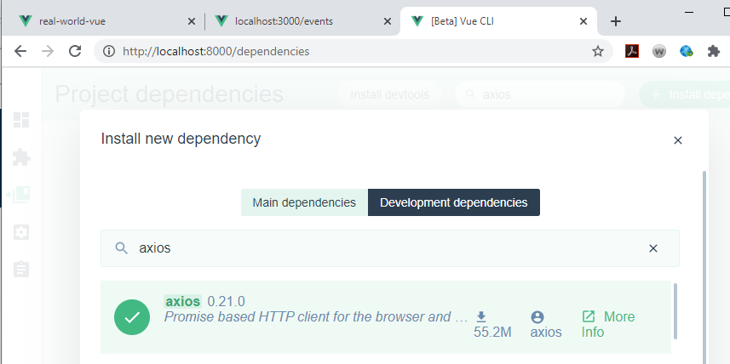

**Update the vue/cli dependency with the down arrow:**

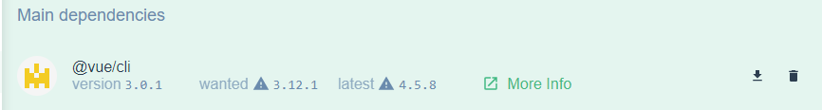

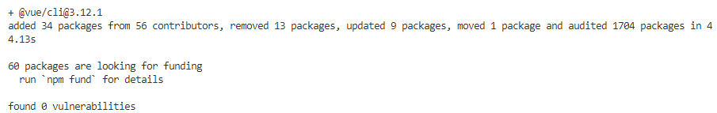

**Update all dependencies at command line:**

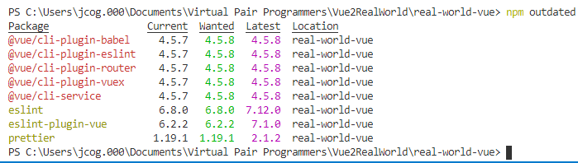

**Update everything: *>npm update***



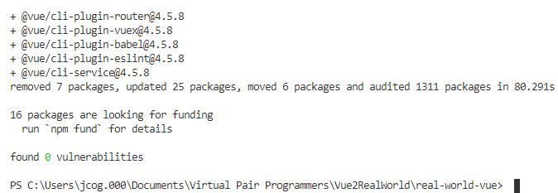

**Now, let us make an API call**

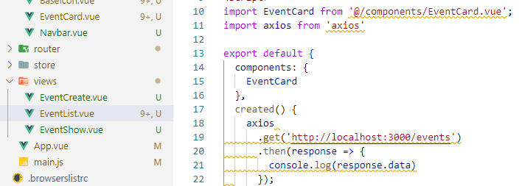

**Log the errors as well**

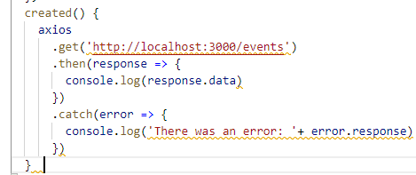

**Make sure the server is running:**

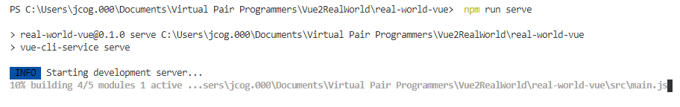

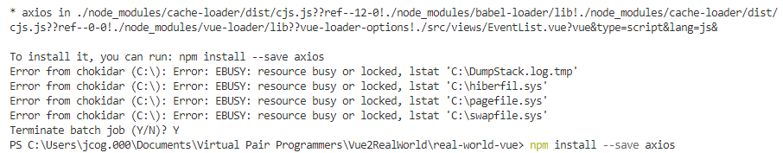

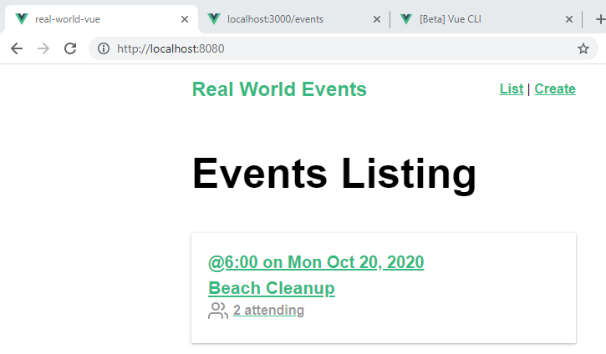

**Make sure the json-server is running as well:**

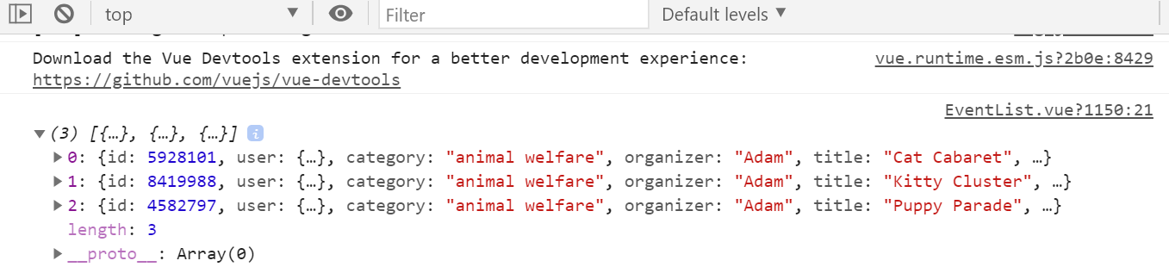

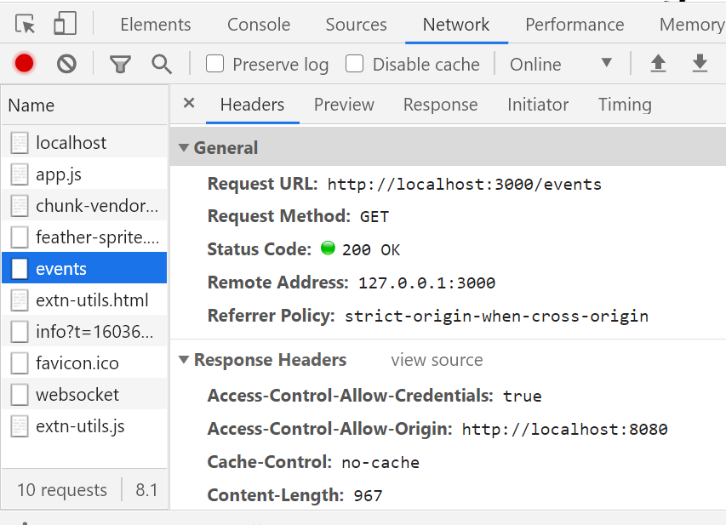

**Now, let us use the response data in out component:**

**Create a data element events as an array and assign the response to populate it**

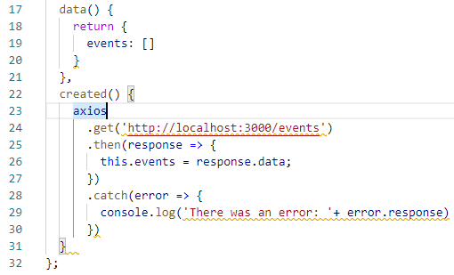

**Display the output of the response:**

**We loop through the events and bind the id, then use a prop event:**



**In EventCard component delete the local data and use the prop:**

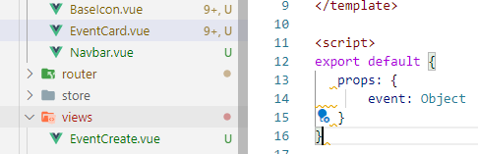

**Check the browser:**

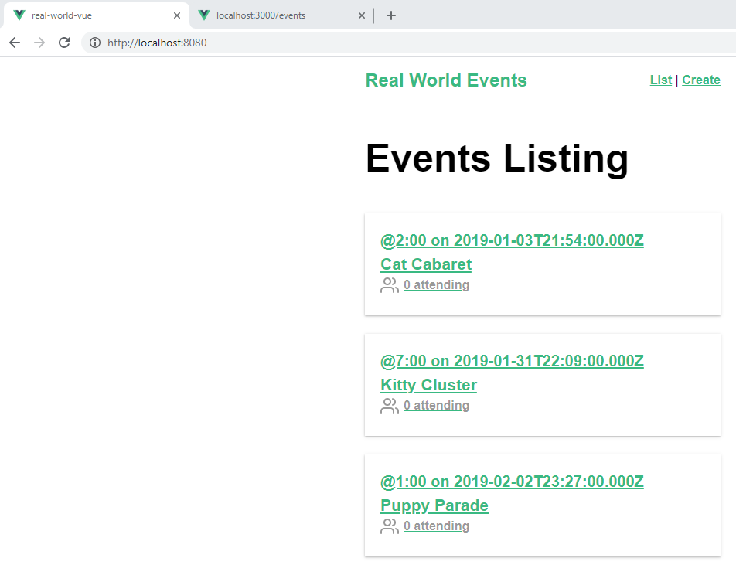

**No matter what event of 3 events I select, the result is 1**

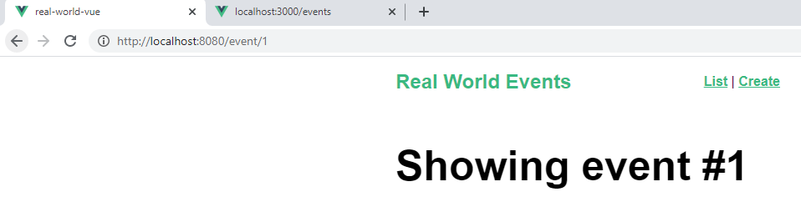

**The hard coded id of 1 needs to changed:**

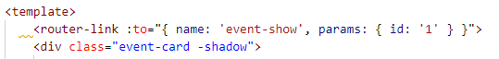

**Change**



**Looking up the id:**

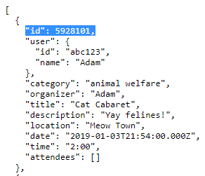

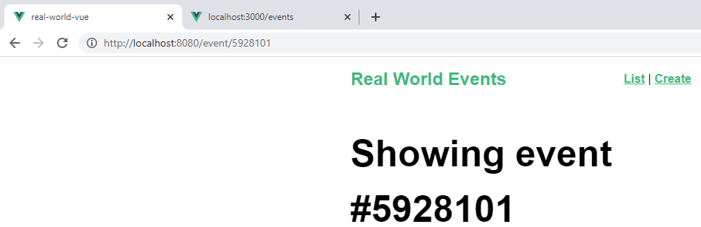



**Let us create a service component so, that all axios calls run in this location.**

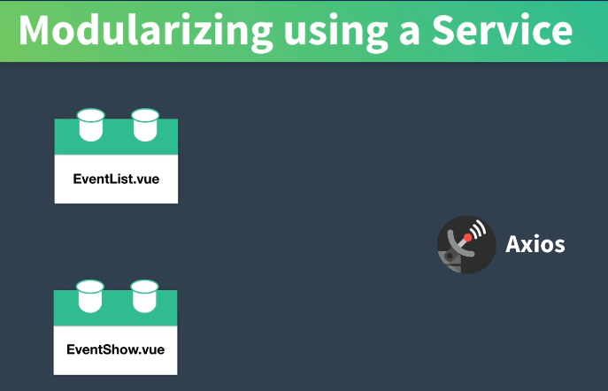

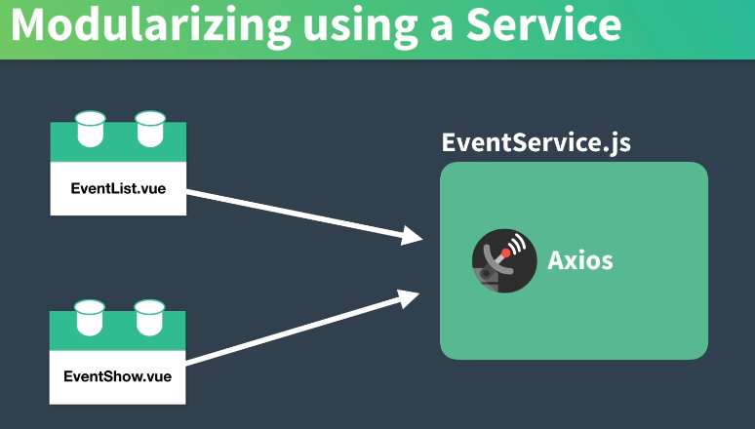

**Create the service folder and file:**

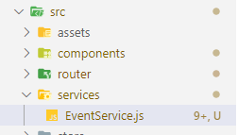

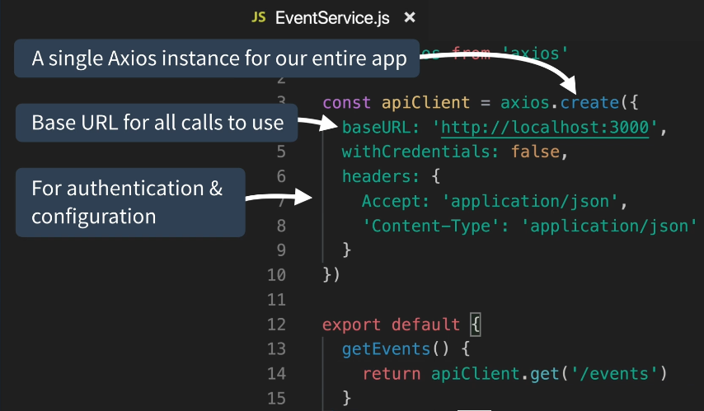

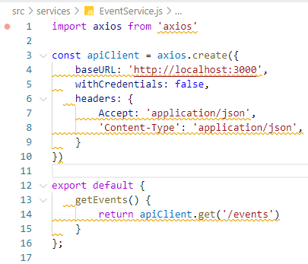

**Now, refactor to use our service:**

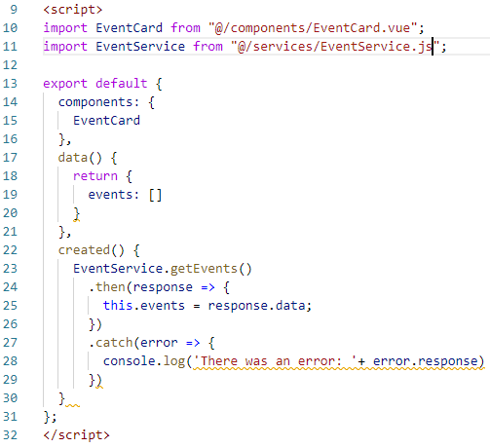

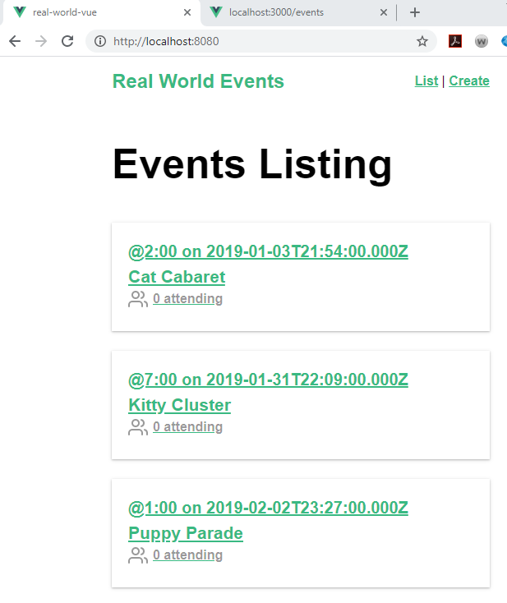

**Now, create a second service:**

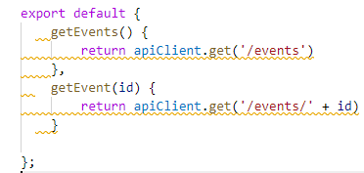

**Add the call to the EventShow**

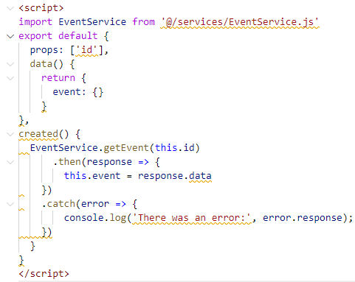

**Now print out the title of the Event that is retrieved:**

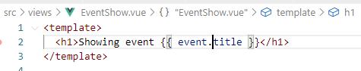

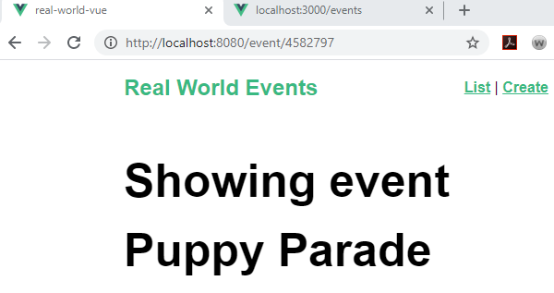

**Paste in the lesson template code in ShowEvent.vue:**

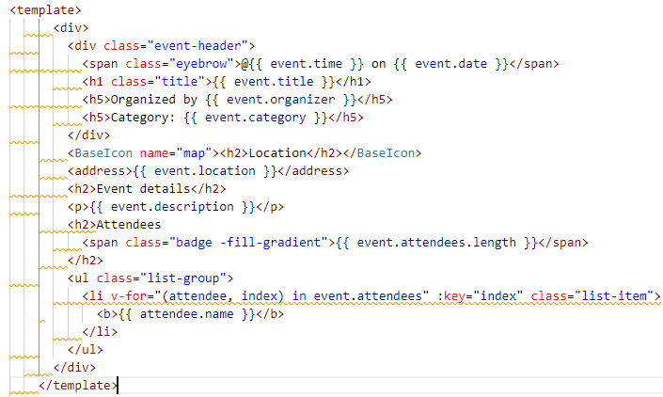

**Browser:**

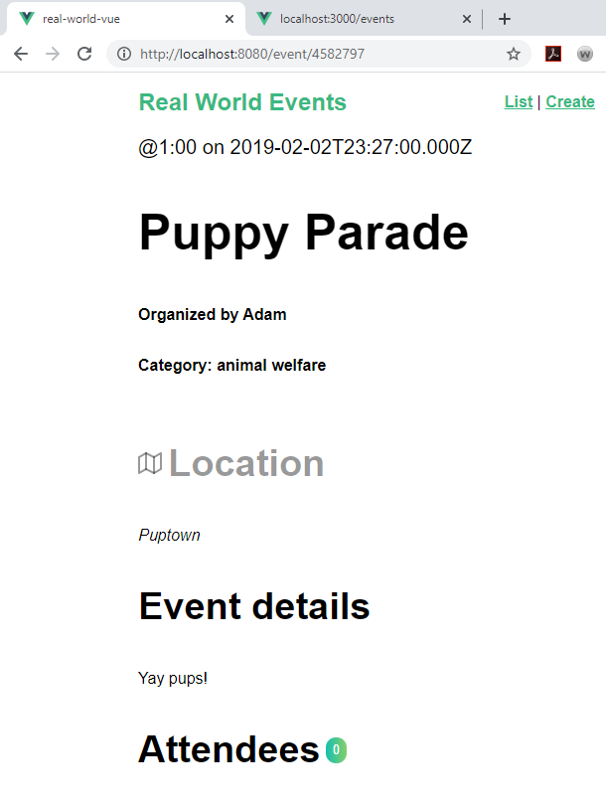

**Add styling:**

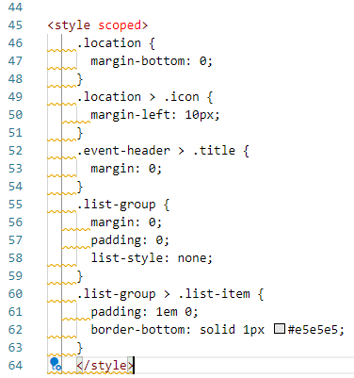

**Browser:**

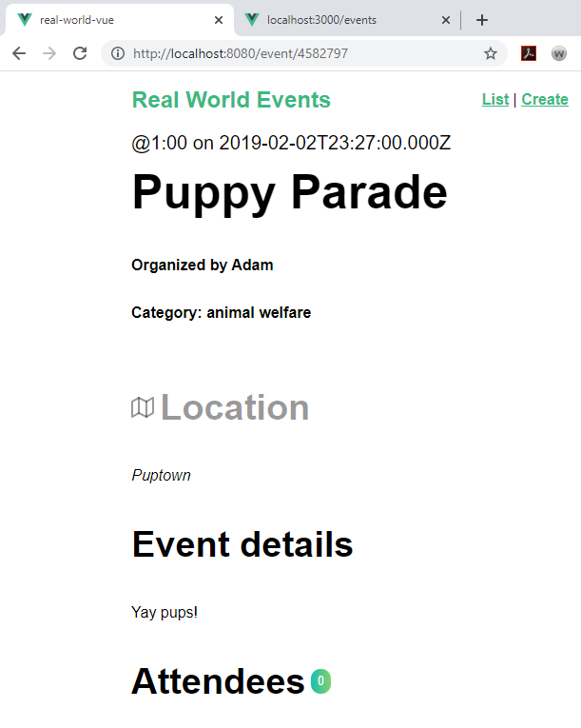

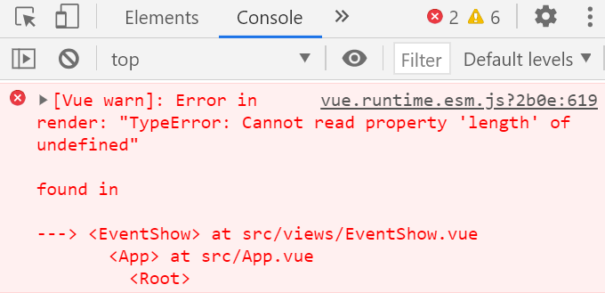

**This is because the length is 0 will be a null object:**

**Add a terniary statement to fix this:**

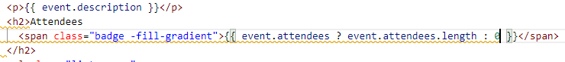

**Browser Console:**

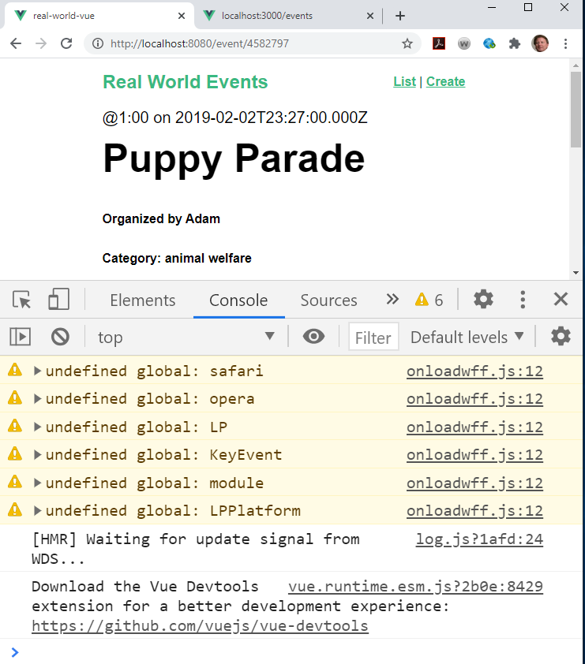

**Error is gone**