**Master SpringBoot**

**01-Manage GitHub and HelloWorld:**

**Step-04: Hello World Rest Service**

**4-A:**

* **Create git branch “02-Hello-World”**
* **Create a HelloWorld Controller**
* **Create a simple Method which returns string “Hello World”**
* **Controller: @RestController**

**- Mapping - @RequestMapping GET & Path “/helloworld”**

**- Mapping - @GetMapping & Path “/helloworld-bean”**

**4-B:**

**- Create a method which returns Bean**

**- Create a simple Method which returns a bean with some content (firstname, lastname, city) in JSON**

**- Mapping - @RequestMapping GET & Path “/helloworld-bean”**

**- Mapping - @GetMapping & Path “/helloworld-bean”**

**4-C:**

**- GIT PUSH (Command Line)**

**- Commit and Push code to remote repo**

**- Merge with Master and push code to remote repo**

**Create the new Branch from the master: git checkout –b “02-Hello-World”**

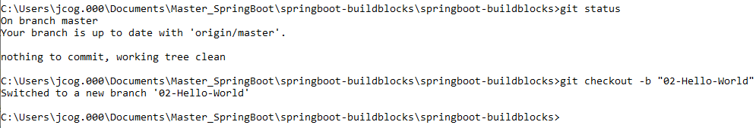

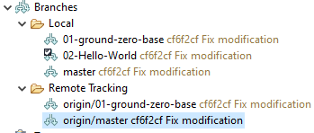

**Put the new Local branch on the Remote branch git –set-upstream origin 02-Hello-World**

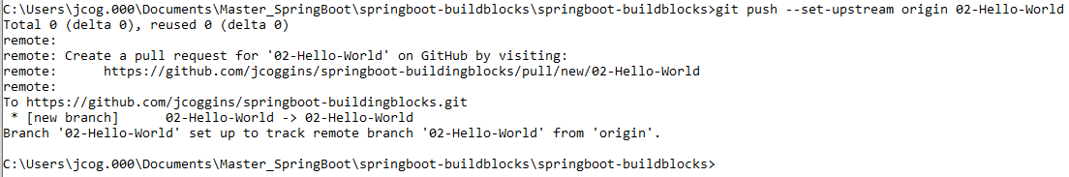

**Now, we see the Hello World branch on both Local and Remote pairs (origin/master)**

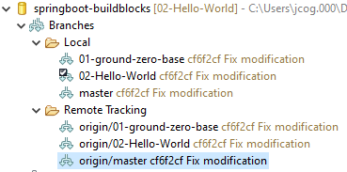

**Now, code to the Local branch: Create the HelloWorldController class and package Hello**

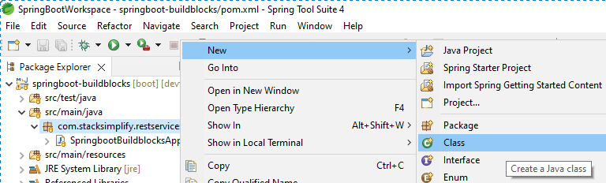

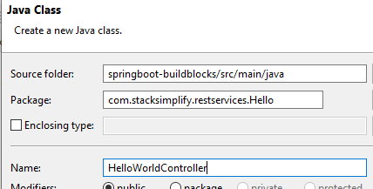

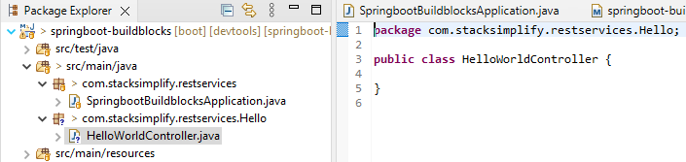

**Code the method and add the annotations:**

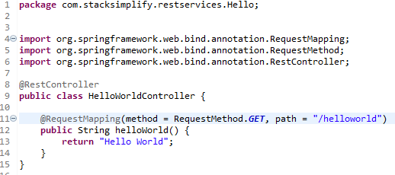

**Test the application in browser: start Spring Boot**

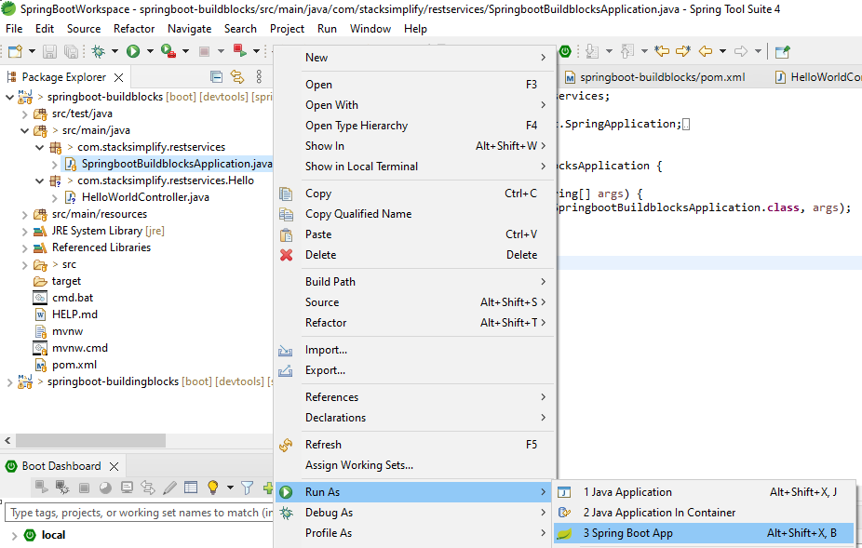

Tomcat started on port(s): 8080 (http) with context path ''

2022-01-01 10:37:17.212 INFO 7320 --- [ restartedMain] c.s.r.SpringbootBuildblocksApplication : Started SpringbootBuildblocksApplication in 6.201 seconds (JVM running for 8.034)

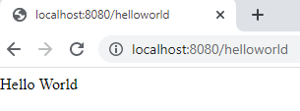

**It works!!**

**Let us use the REST VERBS or Http methods specifically, GET.**

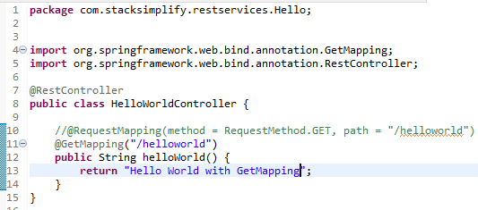

On save, Spring Boot restarts so the changes are picked up immediately

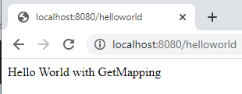

**Create the Hello Bean:**

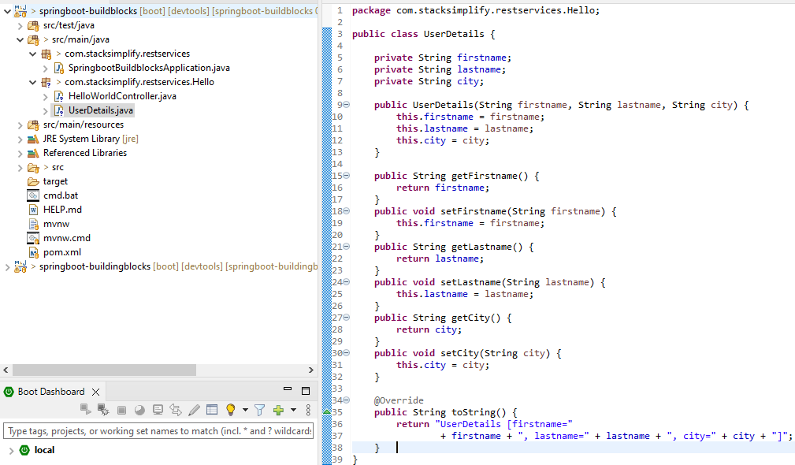

**Create the Controller method for hello world bean:**

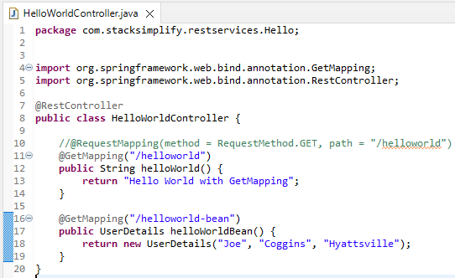

**Save and run in browser:**

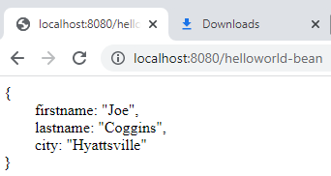

**Commit the Code to GIT (Staging): git status, git add . , git status**

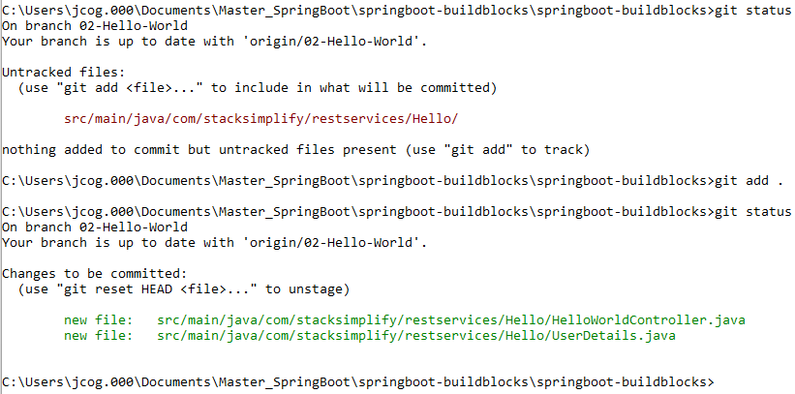

**Git Commit: git commit –am “Hello World Base” git show-branch**

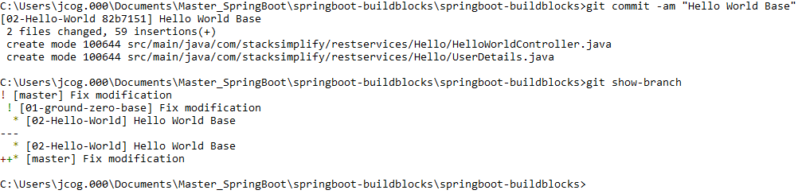

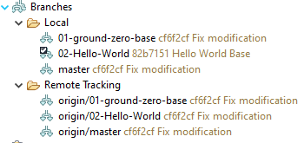

**Push to the remote branch:**

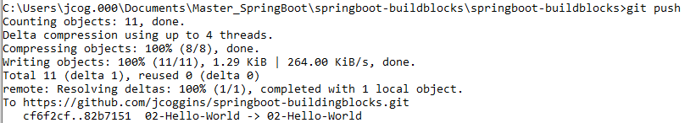

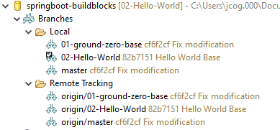

**You can see the Hello World Base now in the remote tracking**

**Now, go back master: git checkout master**

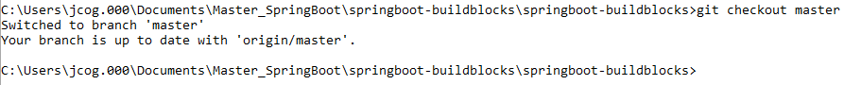

**Merge the changes to the Local Master:**

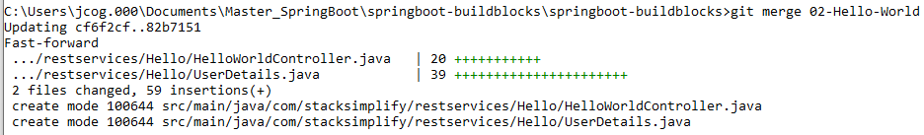

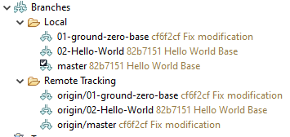

**Now make the Remote Master the same: git push**



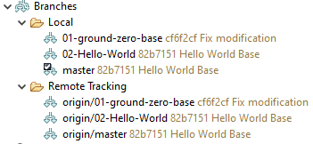

**Check the Internet Remote Master has changed to Hello World Base:**

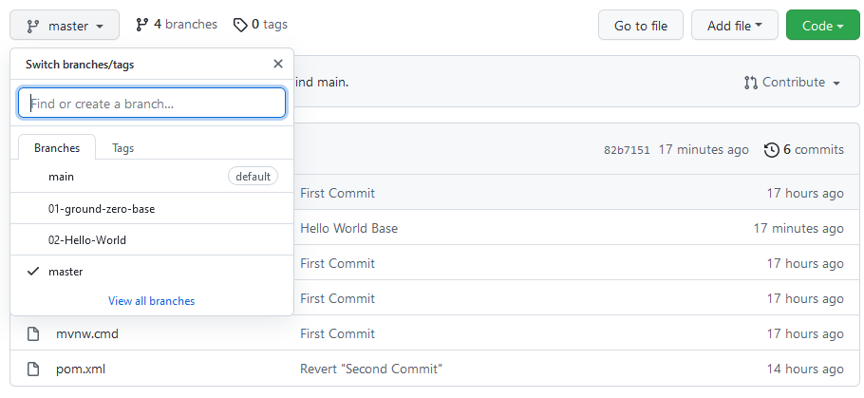

**It works at the Command Line!**