Team Assignment 03 – Weekly Activity Report

**Team Name:**  BluSh3ll

**Team Members:** Hunter Rowlette, Mitch Palmer, Andrew Chapin, Andre Herrera, Carl Bai

**Team Weekly Lead:** Carl Bai

**Accomplishments/Activities/Meetings**

* Conducted a call with Lockheed Martin contacts
* Final update to requirements based on information given
* Modified E02 (Technical Proposal for our Customer) assignment based on instructor feedback

**Issues**

* Scheduling times to work on E03 in the following week due to exams
* Updated requirements require minor additional research and changes to E02

**Open Action Items**

* Revise Technical Proposal for our Customer based on instructor feedback
* Research and Design
  + completing existing tools research
  + discuss existing tools with contact

**Plans for Next Week**

* finalize Technical Proposal based on mentor feedback
  + prepare document for final submission
* Team meeting 10/17 18:30
  + Finalize Technical Proposal
  + General architecture design kickoff

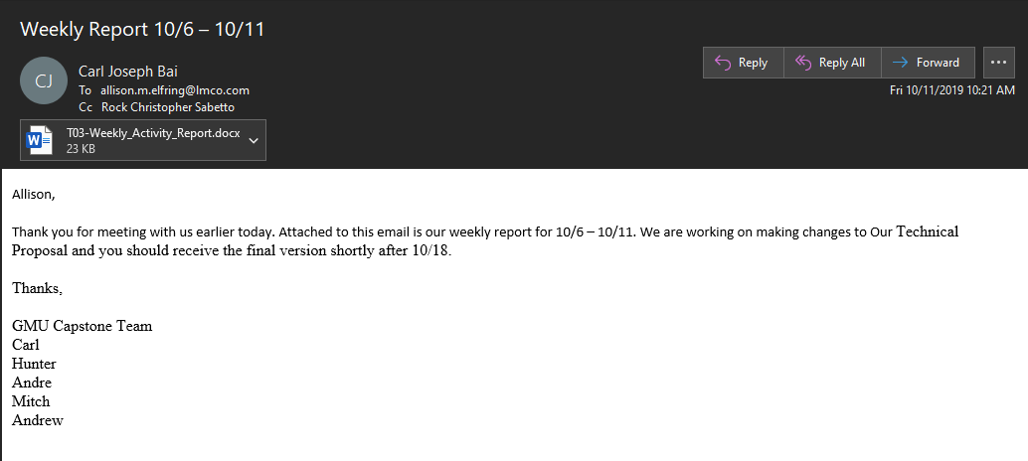

**Individual Applied Hours Matrix**

|  |  |  |  |  |  |  |  |  |  |  |  |  |
| --- | --- | --- | --- | --- | --- | --- | --- | --- | --- | --- | --- | --- |
| **Team Member** | **Wk5** | **Wk6** | **Wk7** | **Wk8** | **Wk9** | **Wk10** | **Wk11** | **Wk12** | **Wk13** | **Wk14** | **Wk15** | **Avg** |
| Andrew Chapin | 4 | 7 | 9 |  |  |  |  |  |  |  |  |  |
| Andre Herrera | 3 | 8 | 7 |  |  |  |  |  |  |  |  |  |
| Hunter Rowlette | 2 | 9 | 8 |  |  |  |  |  |  |  |  |  |
| Mitch Palmer | 1 | 9 | 8 |  |  |  |  |  |  |  |  |  |
| Carl  Bai | 1 | 8 | 9 |  |  |  |  |  |  |  |  |  |