Team Assignment 02 – Weekly Activity Report

**Team Name:**  BluSh3ll

**Team Members:** Hunter Rowlette, Mitch Palmer, Andrew Chapin, Andre Herrera, Carl Bai

**Team Weekly Lead:** Hunter Rowlette

**Accomplishments/Activities/Meetings**

* Conducted a call with Lockheed Martin contacts
* Confirmed Microsoft API’s and Libraries as well as language were going to use for our development phase
* Meet with Faculty Mentor to discuss Draft Design Review
* Made changes to Draft Design Review based off Faculty Mentors feedback

**Issues**

* N/A

**Open Action Items**

* Continue development phase.

**Plans for Next Week**

* Group meeting to sit down and do a lot of development on code.

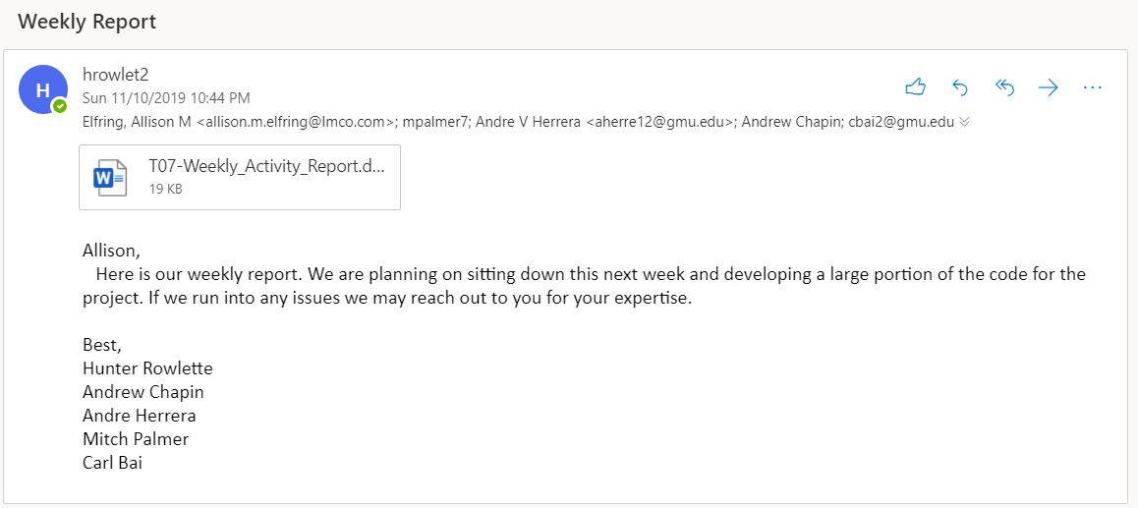

**Individual Applied Hours Matrix**

|  |  |  |  |  |  |  |  |  |  |  |  |  |
| --- | --- | --- | --- | --- | --- | --- | --- | --- | --- | --- | --- | --- |
| **Team Member** | **Wk5** | **Wk6** | **Wk7** | **Wk8** | **Wk9** | **Wk10** | **Wk11** | **Wk12** | **Wk13** | **Wk14** | **Wk15** | **Avg** |
| Andrew Chapin | 4 | 7 | 9 | 7 | 6 | 7 | 5 |  |  |  |  |  |
| Andre Herrera | 3 | 8 | 7 | 7 | 6 | 6 | 6 |  |  |  |  |  |
| Hunter Rowlette | 2 | 9 | 8 | 5 | 6 | 7 | 7 |  |  |  |  |  |
| Mitch Palmer | 1 | 9 | 8 | 5 | 6 | 7 | 8 |  |  |  |  |  |
| Carl  Bai | 1 | 8 | 9 | 7 | 6 | 6 | 7 |  |  |  |  |  |