Team Assignment 04 – Weekly Activity Report

**Team Name:**  BluSh3ll

**Team Members:** Hunter Rowlette, Mitch Palmer, Andrew Chapin, Andre Herrera, Carl Bai

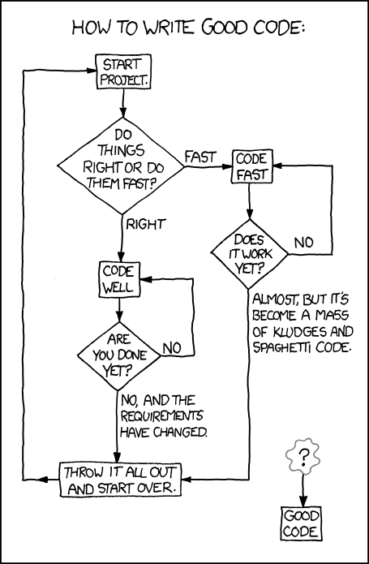**Team Weekly Lead:** Andrew Chapin

**Accomplishments/Activities/Meetings**

* Bi-Weekly conference call with SME
* Finished lots of coding on the packer
  + CLI
  + Config File Parser
  + Directory Parser
  + Basic Networking connections
  + Encryption Libraries

**Issues**

* Input sanitization is hard
* Code fast or well?

**Open Action Items**

* Work on packer network integrations with loader

**Plans for Next Week**

* Start creating test cases w/ payloads to finalize bulk of packer code

**Individual Applied Hours Matrix**

|  |  |  |
| --- | --- | --- |
| **Team Member** | **Hours** | **Contributions** |
| Andrew Chapin | 10 | Wrote code for the CLI and Config File Parser. |
| Andre Herrera | 6 | Wrote code for file parsing. |
| Hunter Rowlette | 6 | Wrote code for CLI and file parsing. |
| Mitch Palmer | 5 | Research/Code on alternative SSL library. |
| Carl Bai | 12 | Wrote code for Network communication with SSL. |

