

Lockheed Martin 10k report



March 6, 2020

Researched by TEam BluSh3ll

Table of Contents

General Information

Risk Factors

Legal Proceedings

Company Leader

Statement of Earnings

Future Strategy

Fun Facts

SWOT

10K Reference

# General Information

**Type:** Public traded as NYSE: LMT

**Industry:** Advanced Technologies, Information Security, Aerospace, Defense

**Markets Served:** Worldwide

# Risk Factors

* Heavy dependence on U.S. Government contracts
* Subject to several procurement laws and regulations
* Profitability vary based on contracts and programs, performance, and ability to control costs
* Increased competition and bit protests
* Failure of subcontractors
* International sales may pose different risks
* Likelihood of adverse cybersecurity incidents
* Involved in legal proceedings

# Legal Proceedings

“As a result of our acquisition of Sikorsky, we assumed the defense of and any potential liability for two civil False Claims Act lawsuits pending in the U.S. District Court for the Eastern District of Wisconsin.”

“In the Investigations, DOJ issued a number of Civil Investigative Demands to MSA, Lockheed Martin and the subsidiary of Lockheed Martin that performed information technology services for MSA, as well as current and former employees of each of these entities.”

# Company Leader

**Name:** Marillyn Hewson (Chairman, President, & CEO)

**Born:** December 27, 1953 (age 66)

**Total number of securities to be issued to employees and directors upon exercise of outstanding options, warrants, and rights:** $4,855,629

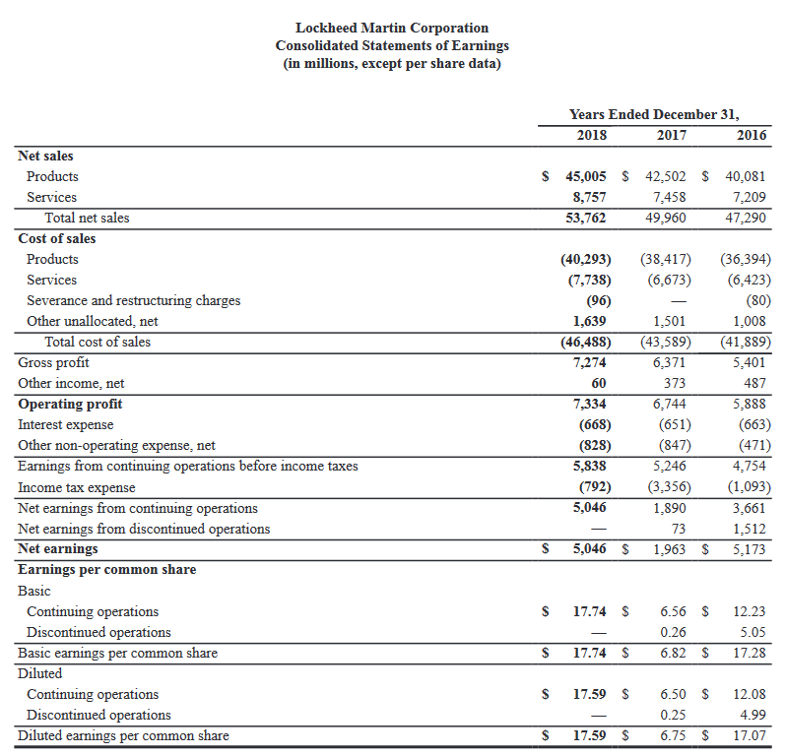

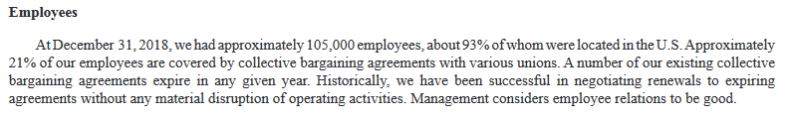

“Total business segment operating profit margin in 2019 is expected to be approximately 10.8%”

Starbucks profit margin was 13.81%

# Future Strategy

In the future, Lockheed Martin will seek to further implement artificial intelligence, human-machine teaming, and big data as a commodity that is at the forefront of their strategy. They will work to keep up with the ever-evolving world of technology and act to implement cutting edge solutions into their everyday production.

# Fun Facts

* %70 of Lockheed Martin’s net sales are rom U.S. Government contracts (either as prime or subcontractor). 28% are from international customers, and 2$ are from U.S. commercial customers.
* Lockheed Martin operates in four business segments: Aeronautics, Missiles and Fire Control (MFC), Rotary and Mission Systems (RMS), and Space.
* 7% of Lockheed Martin’s employees are located outside of the U.S.

# SWOT

**Strengths:** Lockheed Martin has many resources and locations across the globe allowing them to operate in a wide range of services across many sectors.

**Weaknesses:** Lockheed Martin is a US-based corporation that works closely to the US government constraining it to many legally binding policies. Because of its high dependence on US government contracts as a primary source of revenue, any changes to government policies can have a large impact on the business.

**Opportunities:** Lockheed Martin already does business in the fields of Aeronautics, Missiles and Fire Control (MFC), Rotary and Mission Systems (RMS), and Space; however, they have yet to create a dedicated cyber security department. An increase in cyberterrorism and cyber attacks will lead to increased demand for cybersecurity services.

**Weaknesses:** One of Lockheed Martin’s biggest weaknesses is competition from smaller contractors that can poach government contracts. Global trade barriers and government regulations can also but strains on business practices.

# Source

<https://investors.lockheedmartin.com/sec-filings/sec-filing/10-k/0000936468-19-000009>