Team Assignment 00

Team Name:  BluSh3ll

Team Photo: Hunter, Mitch, Andrew, Andre, Carl (L-R)

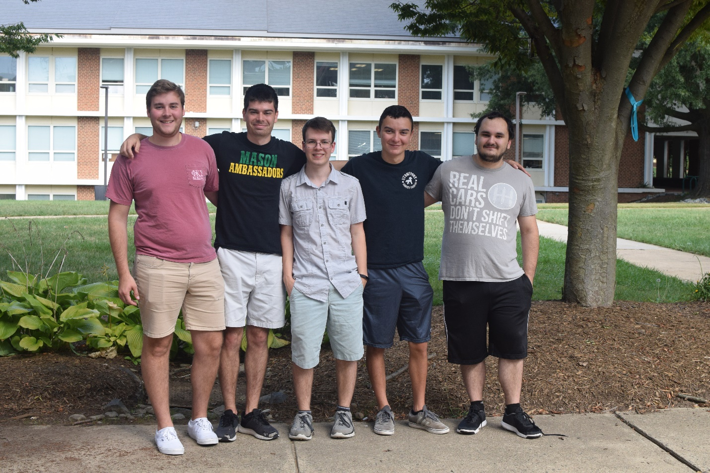

E-Mail to our SME & Customer: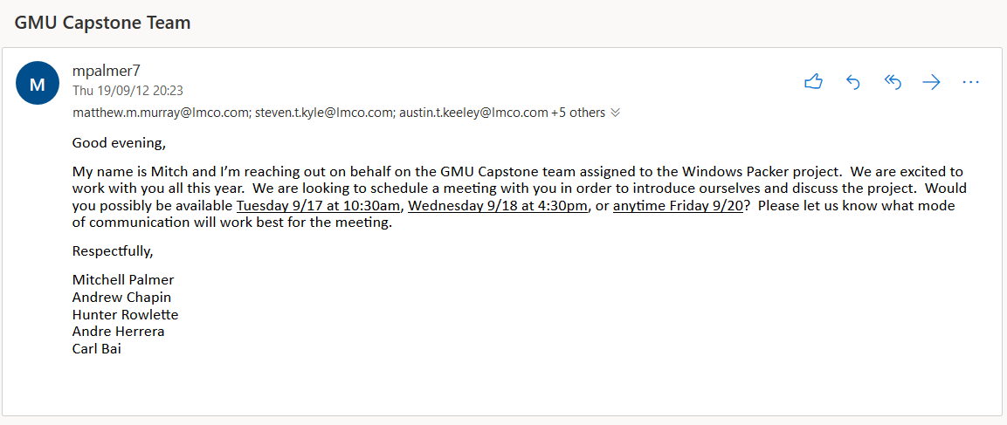

Team Leaders & Meeting Schedules:

|  |  |  |  |  |  |  |  |  |
| --- | --- | --- | --- | --- | --- | --- | --- | --- |
| **Week** | **Start Date** | **Activity** | **Individual** | **Team** | **Milestone** | **Team Lead** | **Team Meeting** | **SME Meeting** |
| 1 | 26-Aug-19 | L1 | I00 |  |  | Hunter | Thur@ 18:30 | TBD |
| 2 | 2-Sep-19 | L2 |  |  |  | Carl |
| 3 | 9-Sep-19 | TT |  |  |  | Andre |
| 4 | 16-Sep-19 | L3 |  | T00 | E01 | Andrew |
| 5 | 23-Sep-19 | M |  | T01 |  | Mitch |
| 6 | 30-Sep-19 | TT |  | T02 | E02 | Hunter |
| 7 | 7-Oct-19 | L4 |  | T03 |  | Carl |
| 8 | 14-Oct-19 | TT |  | T04 | E03 | Andre |
| 9 | 21-Oct-19 | M |  | T05 |  | Andrew |
| 10 | 28-Oct-19 | TT | I01 | T06, T11 |  | Mitch |
| 11 | 4-Nov-19 | M |  | T07 | E04 | Hunter |
| 12 | 11-Nov-19 | L5 |  | T08 |  | Carl |
| 13 | 18-Nov-19 | TT | I02, I03 | T09 |  | Andre |
| 14 | 25-Nov-19 | Break |  | T10 |  | Andrew |
| 15 | 2-Dec-19 | M | I04 | T12 | E05 | Mitch |
| 16 |  | TBD | | | | Hunter |
| 17 |  | Carl |
| 18 |  | Andre |
| 19 |  | Andrew |
| 20 |  | Mitch |
| 21 |  | Hunter |
| 22 |  | Carl |
| 23 |  | Andre |
| 24 |  | Andrew |
| 25 |  | Mitch |
| 26 |  | Hunter |
| 27 |  | Carl |

|  |  |
| --- | --- |
| Key | Lecture |
|  | Team Meeting w/ Instructor |
|  | Team Time |