JUDE WILLIAM COLEMAN
PROJECT PORTFOLIO
jwcoleman@trevecca.edu | GitHub: jcole2705
INVENTORY CONTROL SYSTEM — PYTHON / TKINTER
Self-directed desktop tool built during my engineering internship with the NC Department of Adult Correction to automate asset inventory: batch-generates serialized asset records with owner/model/status metadata from pasted lists, classifies assets (Located / Surplus / In Stock), and provides integrated file transfer with a live operation console.
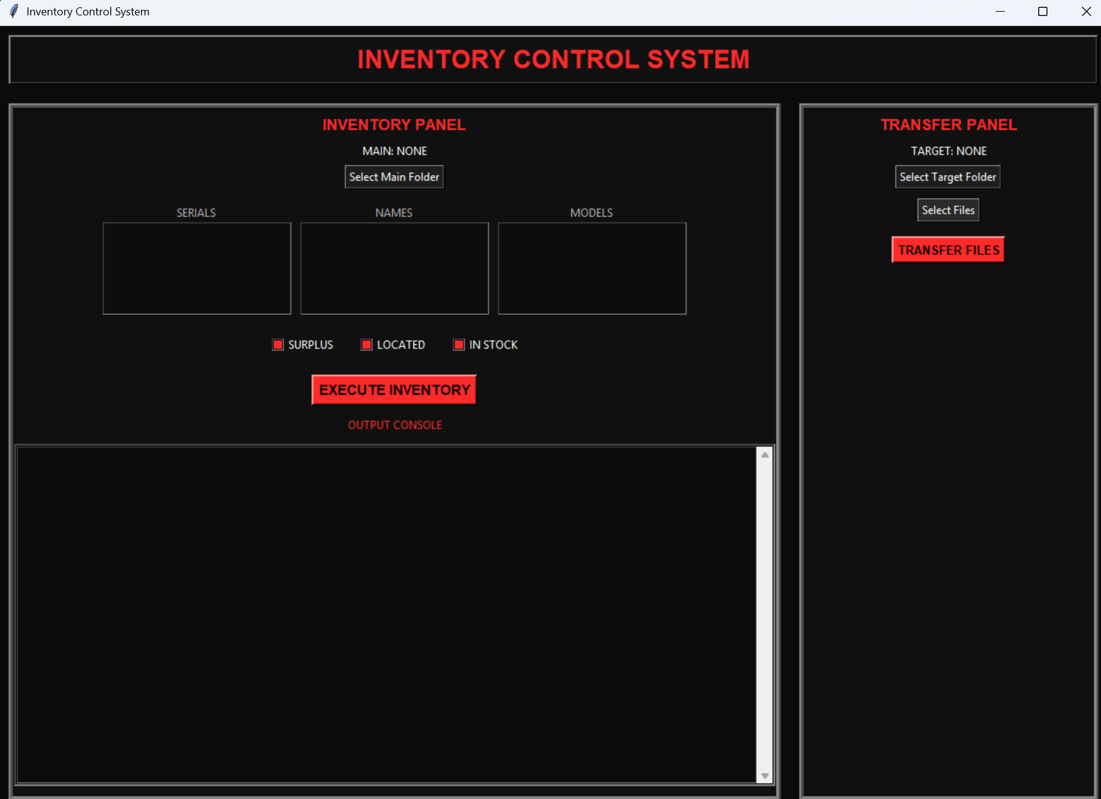
Application interface — inventory panel (batch record creation) and transfer panel.
HAYWARD POOL HEATER MONITOR MK5 — EMBEDDED C / PIC18
Industry-sponsored junior design project (Hayward Industries / Pro Charging Systems LLC). Custom KiCad PCB with 4-channel thermistor sensing, SPI micro SD logging, UART power-meter interface, and safe-shutdown logic to prevent data corruption on power loss. Firmware excerpt — interrupt-safe timekeeping and ADC-averaged temperature conversion:
// Race-safe millisecond read (PIC18, MPLAB X)
uint16_t ms_read(void) {
uint16_t temp;
INTERRUPT_GlobalInterruptHighDisable();
temp = MilliSeconds;
INTERRUPT_GlobalInterruptHighEnable();
return temp;
}

// 2000-sample ADC average -> thermistor temperature
float adc0 = sum_0 / 2000;
float vin_0 = ((adc0 / 4095) * 2.503) + .3;
float R_th0 = (4700 * (2.503 - vin_0)) / vin_0;
float t0 = (1.0f/293.15f) + (1.0f/4999.02f) * log(4500.0f / R_th0);
float c0 = ((1 / t0) - 273.15) + offset;
Full report, schematics, PCB layout, and source available on request
Report Page: jcole2705/Junior-Design-IEEE-Formatted-Report

