**Team 26 - Project 2**

**Design Discussions**

***Individual Designs***

1. **Design-1**
   1. Author

Name: Cedric Meury

GT-Id: cmeury3

* 1. Class Diagram

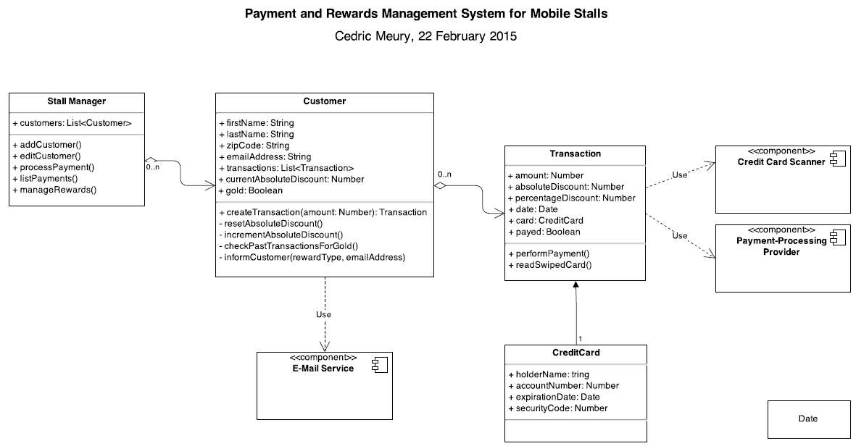

* 1. Pros
* Hides complexities regarding ‘E-Mail Service’, ‘Credit Card Scanner’ and ‘Payment-Processing Provider’ correctly as per requirements. Simple design
* Captures entities (nouns), attributes (adjectives) and relations (verbs) correctly
  1. Cons
* CreditCard should be aggregated within Transaction (show aggregation line)
* Can create separate classes for Discounts/Rewards to support future expansions and to reduce complexity
* Attribute holderName in CreditCard. Data type is having a typo. Should be ‘string’

1. **Design-2**
   1. Author

Name: Ganesh Shivashankaraiah

GT-Id: ganesh30

* 1. Class Diagram

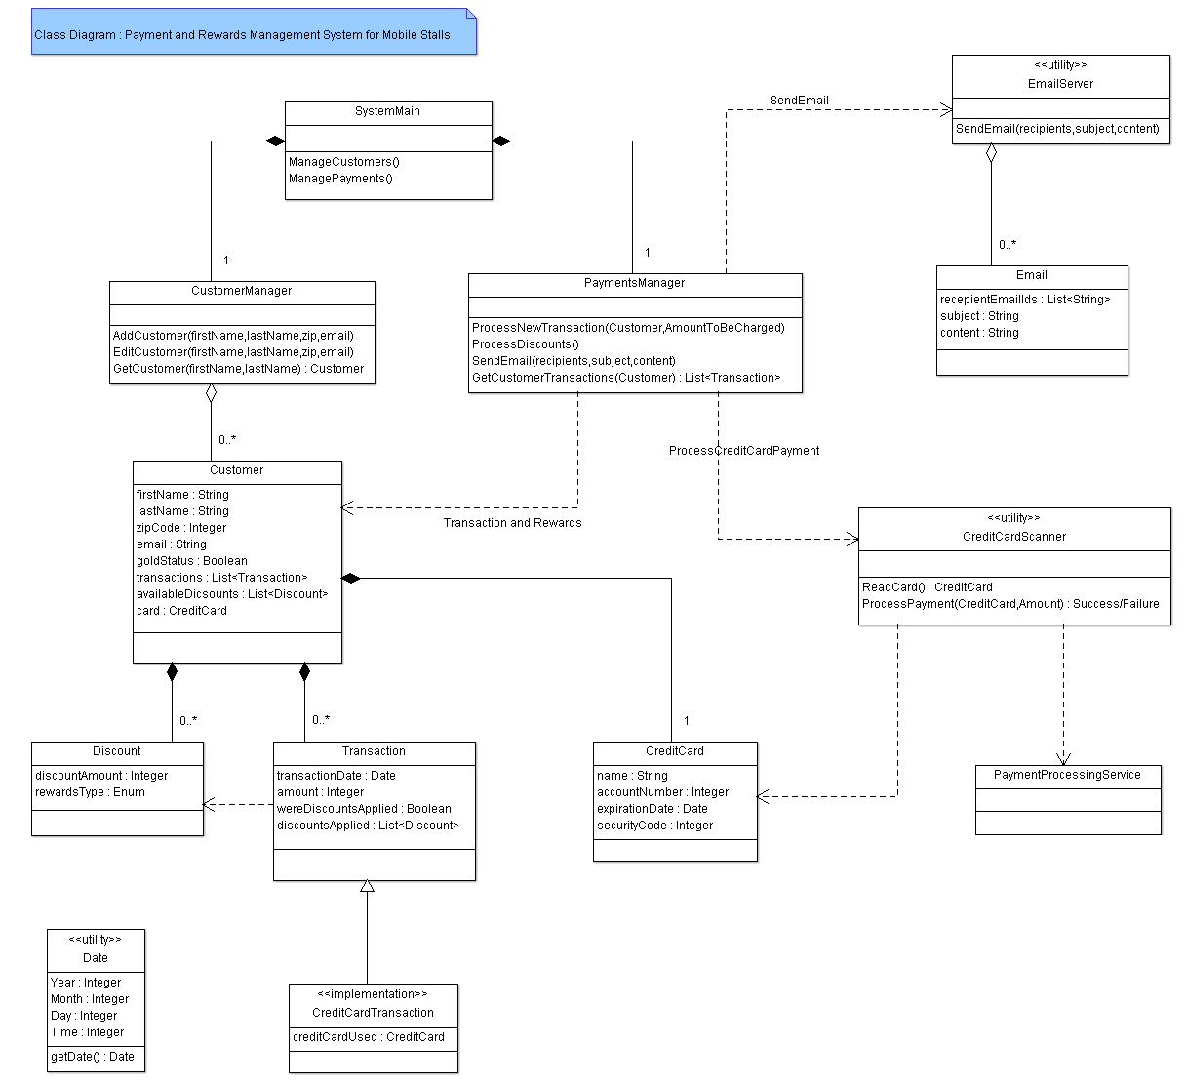

* 1. Pros
* Having CustomerManager and PaymentsManager results in separation of concern
* Having a separate EmailServer utility class
  1. Cons
* Discount can be split to have a base class with 2 child classes for each type of discount
* (Transaction – Amount) and (Discount – discountAmount) attributes can be double/Number
* CreditCardScanner and PaymentProcessingService should be components
* Remove ‘Email’ class as it encapsulates email functionality
* (Customer - Discount) multiplicity should be 0...2 (only 2 types of discounts - money, 5%)

1. **Design-3**
   1. Author

Name: Yue Li

GT-Id: yli801

* 1. Class Diagram

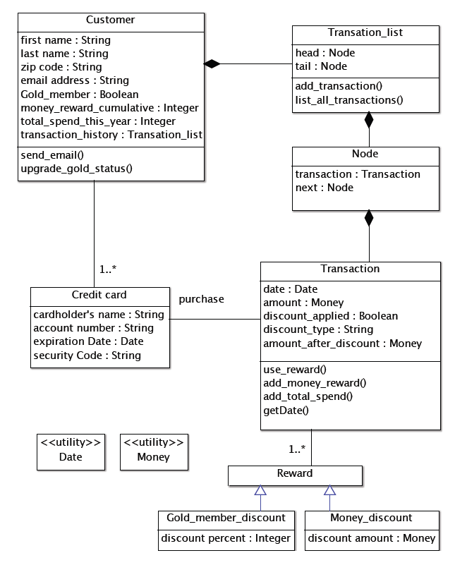

* 1. Pros
* Having a separate utility class for Money. Can handle all complexities within this class
* Having a base class for ‘Reward’. This helps in future expansion to add more type of rewards
* Having Rewards within the transaction
  1. Cons
* TransactionList, Node and Transaction have been implemented like a linked list. This can be a simple relation using just a ‘list’ object and TransactionList, Node can be removed
* (Customer – Credit Card) relation should be a composition. Can be a temporary object for simplicity
* Does not capture ‘Email’ related attributes
* Also need a main application class that ties all the entities

1. **Design-4**
   1. Author

Name: Yuchun Qin

GT-Id: yqin47

* 1. Class Diagram

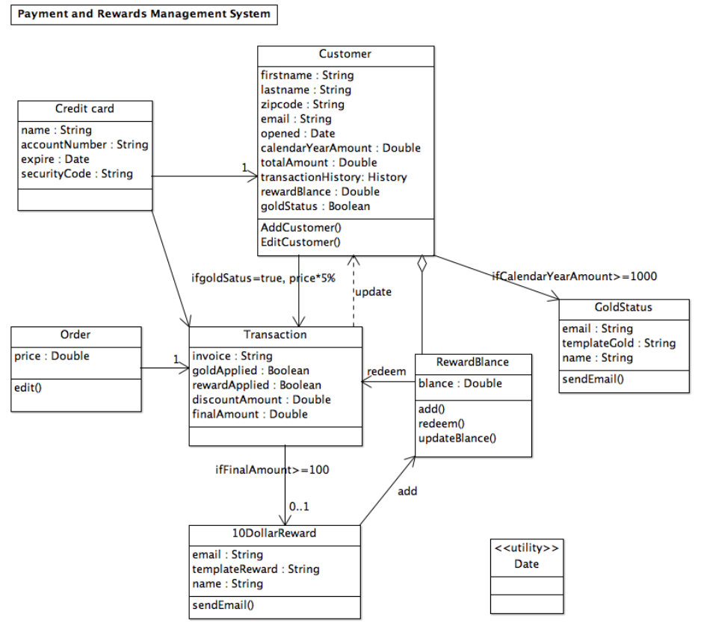

* 1. Pros
* The entities ‘Credit Card’, ‘Customer’ and their attributes are captured correctly
* The (Customer – RewardBalance) relation is correct
  1. Cons
* The functionalities (ex – ‘if’ conditions, add etc…) should not be shown in the relationships
* There should not be two relations between ‘Customer’ and ‘Transaction’
* ‘Redeem’ and ‘Add’ can be operations in the entities rather than UML relation. And ‘10DollarReward’ can be a subclass of ‘RewardBalance’
* Edit() operation in ‘Order’ may not be required. The ‘Order’ class can be removed
* Can show the components – CreditCardScanner and PaymentProcessingService

***Team Design***

* 1. **Class Diagram**
  2. **Main Commonalities and Differences**

This section discusses the main commonalities and differences between this design and the individual ones, and justifies the main design decisions

* Do we need classes such as ‘Stall Manager’ / ‘System Main’ as in the individual class diagrams?
  + We will definitely need a main class that ties all the child classes and has the overarching functionality. Maybe we can add Customer and Payment processor helper classes for having separation of concerns and to reduce complexity
* The Utility classes which are part of the standard Java/Android library need not be shown in the class diagrams. (Ex – Money, Date, Time etc…)
* Email functionality is embedded in a utility class
* All team members shared ‘Customer’ and ‘Transaction’ classes, and used utility classes
* Ganesh used Main interface and two subsystems, that makes the system easier to implement. The team design used his idea and changed their name to "Customer Management" and "Payment Management"
* The "Credit Card" class is used in all member's designs, but shows different relations. The team design connected "Credit Card" with "Transaction", because one customer may have more than one credit card.
* Cedric used a component "Email service" in his design. The team design used this part and specified the email sending conditions.
* The team design employed Yue's design to organize two type of discounts ("Gold status" and "Rewards").
  1. **Summary**

This section summarizes the lessons learnt in the process of discussing the designs, in terms of design, team work etc…

* Understood the differences between aggregation and composition and this is depicted in the team design
* Elimination of classes available in the standard library
* The implementation level attributes are not shown in the design diagrams. Ex – Lists etc…
* The design is simplified to only include the requirements. Addition of domain knowledge and features can be done once the base application is ready
* We need focus on the structure of the system, rather than the implement details
* For teamwork, it was difficult to find a common design; but we initially set a design and the rest of the team members gave feedback on the common design